MONTHLY PROGRESS REVIEW
SEPTEMBER 2026
Project ID: MKCE/R&I/Consultancy/2026/001

AI-Based Egg Tray Inventory Management System (EG-Counter)

Prepared by
Rahul S (927623BCB041)
Yasvanthpalani S (927623BCB063)
Dharaneesh Kesavan (927623BCB007)
Dharani S (927623BCB008)
Mukund Balaji B (927623BCB033)

Guided by
Dr. V. Banupriya, HoD/CSBS
Mr. T. Viswanath Kani, AP/CSBS

Department of Computer Science and Business Systems
M. Kumarasamy College of Engineering
Thalavapalayam, Karur
Report prepared 1 October 2026

1. Monthly Progress Summary
September focused on five-stack scene analysis, annotation repair, perspective-corrected diagnostic crops and a separate layer-heatmap research route. The deployed Android/backend model remained projec-mutta/2. No validated automatic 3D inventory count or new production model was established.
Current phase: controlled improvement and validation. A manually assisted total of 100 versus a 99-layer visual reference is close for one known photo, but per-stack errors and manual intervention prevent a 99% system-accuracy claim.

2. Work Completed This Month

2.1 Five-stack visual audit and live backend check
The wide photo was manually reviewed as five stacks of 20, 20, 20, 20 and 19 visible layers (99 total). A side photo showed 19 layers, overlapping the same scene and therefore not additive. A fresh HTTP 200 production Worker call returned 76 for the wide photo and 19 for the side photo; the third diagnostic slot returned 87 for a second wide view. These were diagnostic per-photo counts, not an accepted calibrated triplet.

2.2 Perspective correction and band experiment
Manually selected stack faces, rectified to flatter crops, returned 19/22/20/22/17 = 100. Only one of five stacks was exact; summed absolute stack error was seven (MAE 1.4). Independent band candidates were 12/11/19/19/10 and did not resolve the count. Automatic localization proposed eight regions for five stacks.

2.3 Photo evidence and measured counts
Saved photo / method | Manual visual reference | Model result | Count agreement
Wide original, V2 | 99 | 76 | 76.77%
Side original, V2 | 19 | 19 | 100.00% (one photo)
Wide, 5 manual rectified crops | 99 total | 100 total | 98.99% total only
Same five crops, stack-level | 20/20/20/20/19 | 19/22/20/22/17 | 1/5 exact stacks
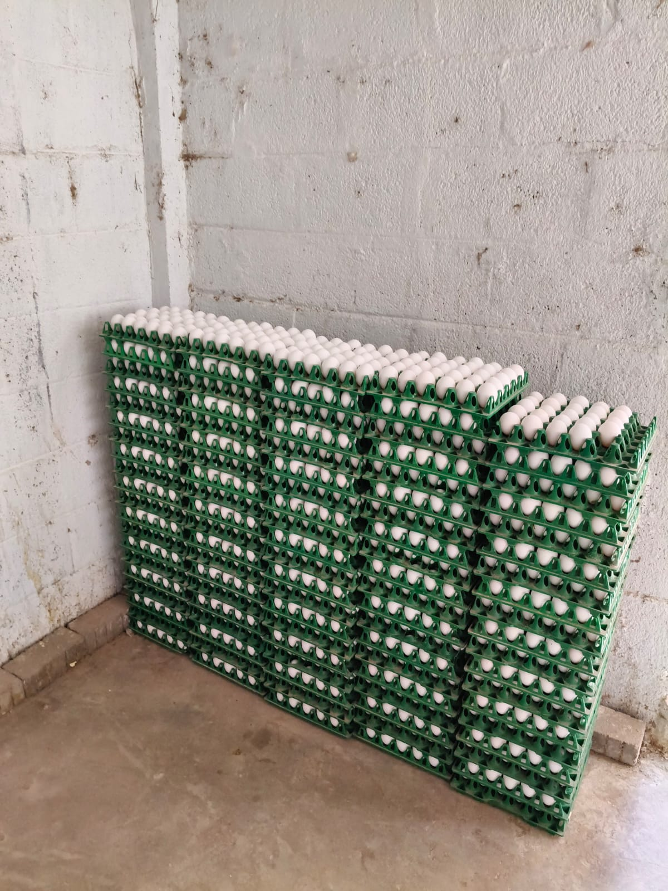 | 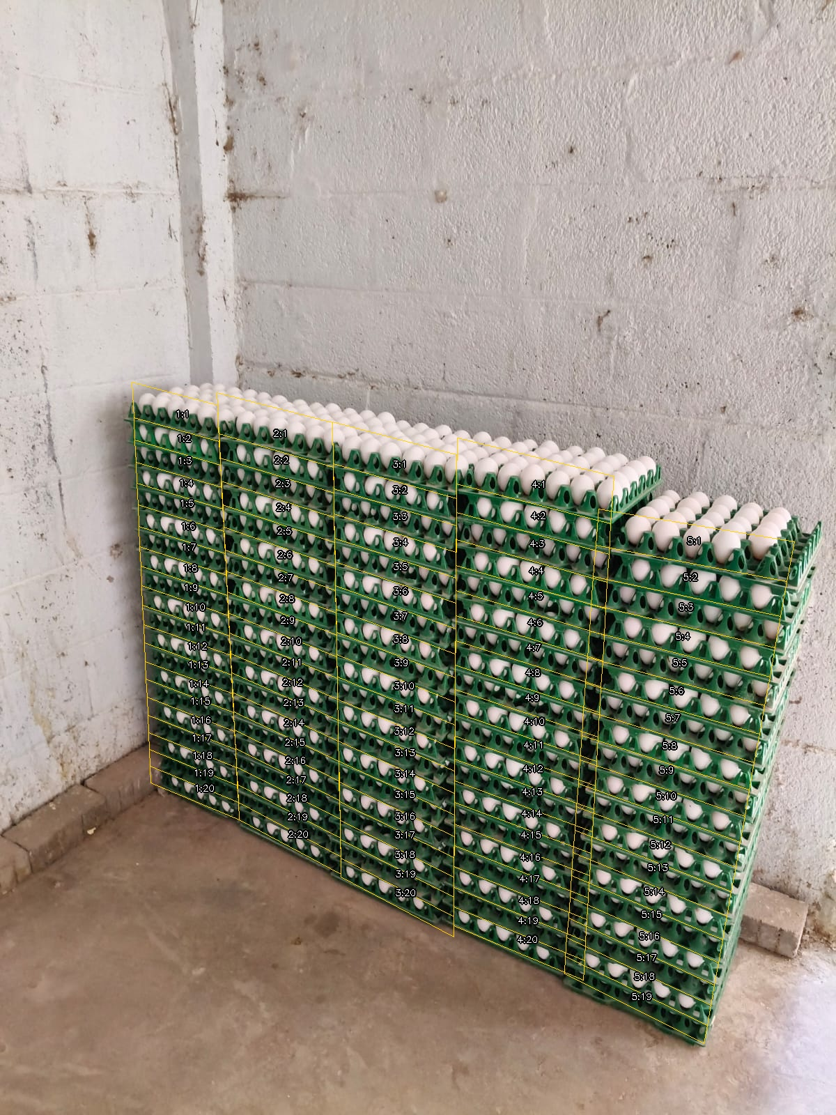
Original five-stack photograph used for September diagnostics. | Numbered visual review: 99 layer references, not a physical recount.

2.4 Mobile scan result for a reported 90 tray scene
The supplied mobile screenshot shows a scene described by the user as six stacks of 15 trays, or 90 trays. The app displayed 89 left, 92 right and 92 straight per-photo detections using projec-mutta/2. Relative to the user-reported count, those are 98.89%, 97.78% and 97.78% count agreement respectively. The screenshot says COUNT NOT VERIFIED; it provides no accepted fused total. The 90-tray reference has not been independently checked against the original capture photos.
Reference | Left | Right | Straight | App outcome
90 user-reported | 89 | 92 | 92 | Count not verified

Figure 2 Mobile scan evidence
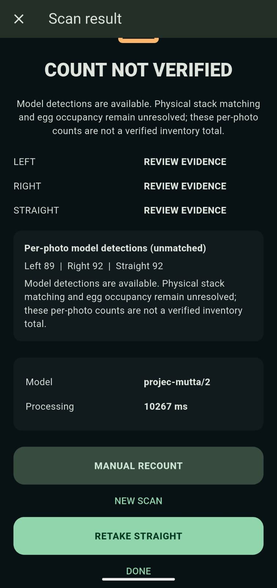
Screenshot supplied by the user. The mobile application reports per-photo detections and withholds a verified inventory total.

3. Challenges Faced
• The near-correct total concealed offsetting stack errors; perspective correction still missed and duplicated individual tray layers.
• Bands may track eggs or tray rims and cannot be converted to trays by a fixed +1 rule.
• Two photos did not establish calibrated camera pose, physical stack identity or hidden egg occupancy; 3D reconstruction and warehouse total remained unverified.
• Training examples had duplicate/scene-leakage risk; 118 approximate corrections were assigned to TRAIN only, with no independent acceptance evidence.

4. Plan for October
• Collect unchanged-scene front, left and right captures with physical per-stack filled/empty recounts and camera-quality metadata.
• Train a controlled V5 candidate only after curated split and annotation review; compare with unchanged V2 on unseen scenes.
• Measure automatic stack localization, exact per-stack and scene rates, MAE, false acceptance and rescan coverage before APK/backend promotion.
• Keep lighting, blur, angle and cut-off warnings active; use bands/edges as supporting evidence rather than self-validating tray counts.

5. Overall Project Status
Phase | Status at 30 September | Measured progress
Manual visual annotations | Known scene reviewed | 99 wide + 19 overlapping side
Deployed V2 mobile/backend | Unchanged; per-photo errors persist | 76/99 wide; 19/19 side
Assisted crop analysis | Diagnostic only | 100/99 total; 1/5 exact stacks
Heatmap research | Not production-ready | 3/11 exact best count-selected arm
Exact warehouse inventory | Not verified | No physical holdout acceptance

5.1 Overall Progress
A 98.99% count-agreement figure applies only to the summed output of one manually cropped, known photo. It is not a measured 99% field accuracy rate. The September heatmap comparison was development-only (11 reviewed faces, two retained groups, zero of two groups exact); it was not deployed. Exact egg-filled inventory remains a future acceptance milestone.
Evidence: reports/two-view-20260924/manual-corrections/README.md and fresh-backend.json; crop-experiment/README.md and results.json; reports/stack-heatmap-followup-20260928/README.md; PROGRESS.md; user-supplied mobile-scan-90-reference.png. Photo and screenshot capture dates are not asserted here.

