WEEKLY PROGRESS REPORT
OCTOBER 2026 • WEEK 1 (1-7 OCTOBER 2026)
Project ID: MKCE/R&I/Consultancy/2026/001

AI-Based Egg Tray Inventory Management System (EG-Counter)

Prepared by
Rahul S (927623BCB041)
Yasvanthpalani S (927623BCB063)
Dharaneesh Kesavan (927623BCB007)
Dharani S (927623BCB008)
Mukund Balaji B (927623BCB033)

Guided by
Dr. V. Banupriya, HoD/CSBS
Mr. T. Viswanath Kani, AP/CSBS

Department of Computer Science and Business Systems
M. Kumarasamy College of Engineering
Thalavapalayam, Karur
Report prepared 3 November 2026 from the project record

1. Summary of the Week
The user sent 52 farm photos with the tray totals written on them by hand. The team ran the existing tray-counting model on every photo without changing it. The count was usually close when one block filled the photo, straight on. It failed on angled, corner and distant photos. The team also put an experimental "3D" photo-matching service on Amazon's cloud and built a test version of the app that can display it. Its dots are matched picture points, not trays, so it gives no tray count. The monthly progress reviews for August and September were also finished and made easier to read in print.
Phase: Field-photo baseline testing and an experimental cloud 3D check.

2. Work Completed This Week

2.1 First test on 52 hand-labelled farm photos (7 Oct)
The 52 photos were copied unchanged into the project, with a fingerprint (checksum) file that proves they were not altered. The handwritten totals were typed into labels.csv. The unchanged production counter, Roboflow model projec-mutta/2, was then run on every photo. The model was not shown the labels. 5 of 52 photos were exact, the average miss (mean absolute error, MAE) was 45.1 trays, and the model's total was 2839 against a label total of 5041.

2.2 Cloud 3D diagnostic service on AWS (5-7 Oct)
On 5 Oct the first attempt stopped part-way because the AWS connection lost its authorisation. On 6 Oct a diagnostic service was deployed to AWS Lambda (Amazon's pay-per-use cloud functions) in the ap-south-1 region. Run on saved warehouse photos, it found 16 candidate regions, accepted zero matches and returned no tray total. On 7 Oct a route that matches two photos was added. It found 175 matches, 125 of which passed a consistency check (called 'inliers'), and 76/94/100 3D points under three focal-length assumptions. The run took 10.703 seconds.

2.3 Test app 0.3.4+10 with a 3D evidence viewer (7 Oct)
A test build of the app was made. It can send two photos through the test (staging) copy of the cloud server, a Cloudflare Worker, to AWS. It then shows the matched points in a view you can rotate. Before release, the automated tests passed: 82 backend, 20 Worker and 66 Flutter. The app was installed on the BlueStacks Android emulator, where it displayed 76 points / 125 inliers / 0.376 px. The production app and the production server were not changed.

2.4 August and September monthly reviews (1 Oct)
Formal August and September 2026 reviews were made as editable DOCX and print-ready PDF files. They were then rebuilt for A4 print: 12 pt body text and table text of at least 10.5 pt. The August PDF has three pages and the September PDF has five. The September review adds a phone screenshot of a scene the user reported as 90 trays. The model counted 89 on the left photo, 92 on the right and 92 straight on, and the app showed COUNT NOT VERIFIED.

2.5 App and server checks on the emulator (5 Oct)
The live production server reported the model projec-mutta/2. The existing app 0.3.3+9 was installed on the BlueStacks emulator. It launched, showed SERVER REACHABLE and opened the three-photo upload screen. This only checked the connection and screens. No count was tested.

3. Measured Results
Measurement | Value | What it shows
All 52 labelled photos: exact matches, average miss, and total counted vs total labelled | 5/52 exact, MAE 45.1, V2 sum 2839 vs label sum 5041 | The model was compared with totals the user wrote by hand on WhatsApp copies of the photos. These were not physical recounts done by the team. Some handwritten readings and what they cover still await the user's confirmation. Several photos are near-duplicates or the same block from different angles, so the 52 photos are not independent samples. Overall, the model counted far fewer trays than the labels.
Block-face photos only (photos of a whole block of stacks) | 1/39 exact, 6/39 within 2, MAE 59.1 | On the photos that matter most for a store-room count, only one total matched the handwritten label exactly. These are scene totals only. There is no count for each separate stack yet, and no split between full and empty trays.
Results by how the photo was taken (block faces) | frontal fill-frame 12/18 within 5% (median 4.2%); angled/corner/multi-block 0/16 (median 70.2%); distant/wide 0/5 (median 94.5%) | Straight-on photos where one face fills the frame were usually close. Angled and distant photos all failed. The assistant tagged photos by type after it had seen the errors, so this split may be biased by hindsight.
Same block photographed from different angles | block 80 gives 81 frontal, 52 oblique, 18/20 steep side; block 109 gives 117 frontal, 60 corner; wide scenes collapse (358 to 1; 205/204 to 0) | Each block was compared only with itself, so the photo-type tags do not affect this check. It shows that camera angle and distance, not the block, cause the large errors. The reference numbers are still the user's handwritten totals.
AWS two-photo 3D matching on the overlapping wide warehouse pair | 175 matches, 125 fundamental inliers, 76/94/100 sparse points under focal factors 0.7/1.0/1.4, 10.703 seconds | The cloud service runs and gives the same answer each time (a second run returned identical output in 10.568 seconds). The points are matched picture details such as tray and egg texture or background. They are not trays. There is no real-world scale and no tray count.
Hosted stack diagnostic on saved warehouse photos (6 Oct) | 16 proposed regions, zero accepted matches, null tray/egg-filled totals, verified=false, recapture_required | This shows the cloud service can be reached and runs correctly. It could not match any stack between photos, so it gave no count. It is not a 3D or counting success.
None of these figures is a physical recount of trays: the references are handwritten labels, counts made by eye from photos, or software checks, as each row says.

4. Photo Evidence
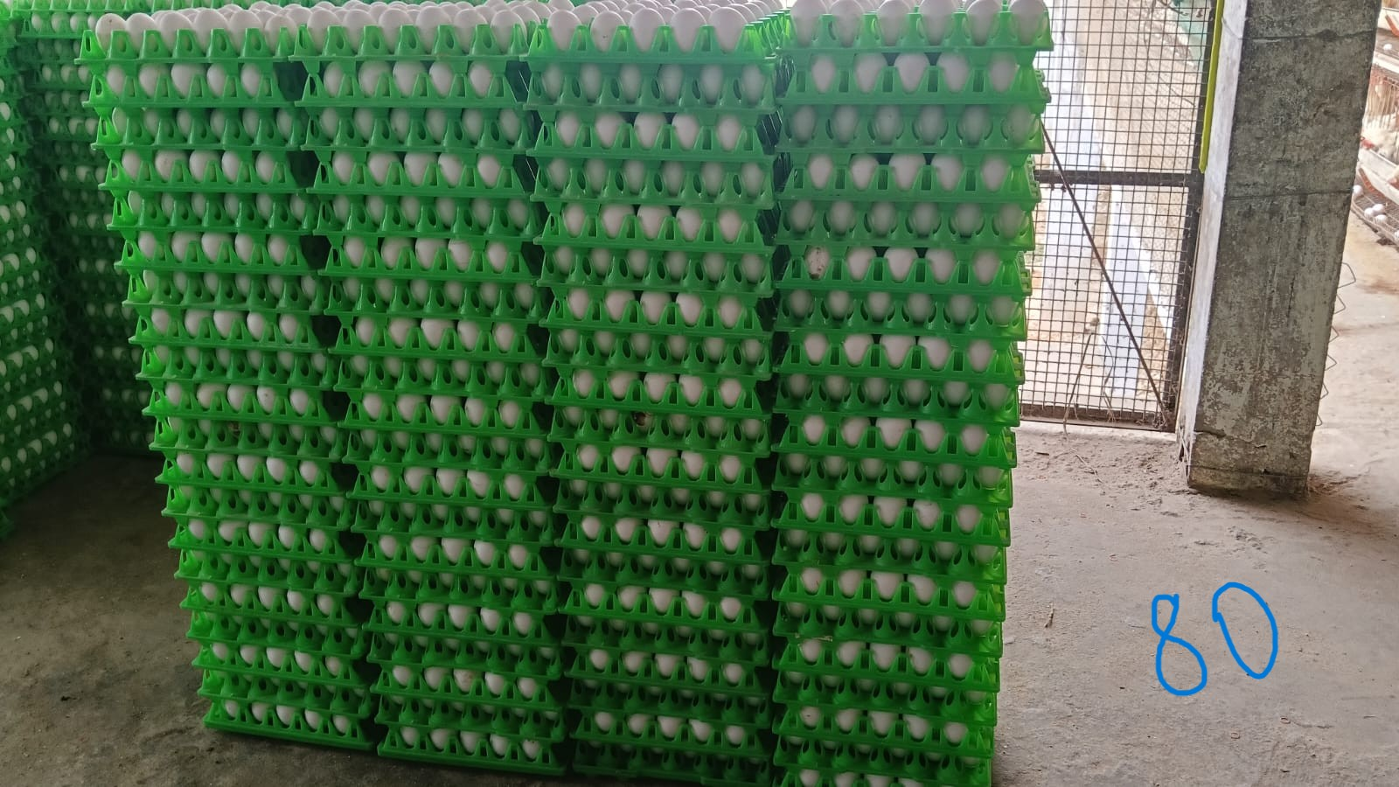 | 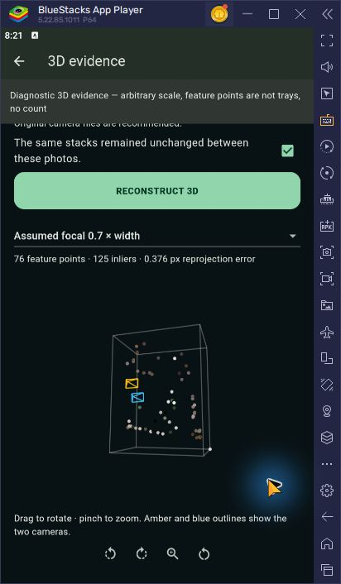
Photo 30 of the user's 52 labelled farm photos: a block of green trays, with the handwritten total 80 drawn in blue. On this straight-on view the unchanged model counted 81. An angled photo of the same block (photo 31) gave only 52. | Test app 0.3.4+10 on the BlueStacks emulator, showing the diagnostic '3D evidence' screen: 76 feature points, 125 inliers, 0.376 px error. The dots are matched picture points, not trays. The screen itself says 'no count'.

5. Challenges Faced
• Angled, corner and distant photos fail badly. None of the 16 angled or 5 distant block photos came within 5%, and one wide scene labelled 358 was counted as 1. The project notes say each tray layer may become too small after the model shrinks the image to 640 px.
• The user expected a recognisable 3D model of the trays. The current method only matches scattered picture points between two photos. It has no surface model, no real-world scale, does not identify trays, and gives no count.
• The labelled photos are WhatsApp copies (0.2-1.9 megapixels, no camera data) with ink drawn on them. Some handwritten readings and what they cover still need the user's confirmation. There is still no physical count for each stack and no split between full and empty trays.
• Tooling problems slowed the cloud work: the AWS connector lost authorisation and then reported 'Unknown tool'. The AWS build service quota was zero, so a temporary build machine was needed. A connection limit caused an HTTP 503 error on first start-up. The BlueStacks emulator first showed a white screen (EGL_BAD_MATCH). Work from 5-7 October was left uncommitted at the end of the week.

6. Plan for the Next Week
• User confirms the transcribed handwritten labels and sends the original photos without ink, if available.
• Add a capture check (gate) to the app that accepts only straight-on photos where one face fills the frame.
• Test cutting wide or angled photos into tiles or single faces before counting the failed ones (needs Roboflow calls).
• Label per-stack counts that agree with the user's totals for the planned three-check per-stack counter, and keep a held-out subset untouched for later testing.
• Finish the outstanding app screen checks for the 3D viewer, and check tray/stack matches with overlay images.
• Test calibrated overlapping photos for a denser 3D model, separately from counting, against physically counted held-out scenes. Do not redeploy production, commit or push unless the user asks.

7. Status at the End of the Week
Production app 0.3.3+9 is unchanged, and so is the production Cloudflare Worker: Roboflow projec-mutta/2, with no production deployment this week. Test app 0.3.4+10 was built, its signature verified with the debug certificate, and installed on the BlueStacks emulator only (SHA256 B42252BF5910EDC9A5E017A8EE08B4A23652CA62104564AA3724E87156ED150B). It points at the staging Worker, version bae12d3c-5069-4c88-97e2-8b2e5e89f452, which advertises reconstruct_v1. AWS Lambda egg-tray-vision-pilot (ap-south-1) runs image pilot-20261007-integration, digest sha256:8511bd3af2afb02a8d7c8107bc83f2032c14299eefbd504cf6105e0d30218dba, and is marked diagnostic only. The 5-7 October work was left uncommitted. The only commit dated this week is 58aeac1 (5 Oct, the monthly reviews).
Evidence: PROGRESS.md (entries 2026-10-01 to 2026-10-07, lines 1273-1567); reports/field-labelled-20261007/README.md; reports/field-labelled-20261007/results.csv; reports/field-labelled-20261007/summary.json; reports/field-labelled-20261007/capture_tags.csv; datasets/field-2026-10/labelled-20261007/labels.csv; datasets/field-2026-10/labelled-20261007/manifest.json; reports/reconstruct-integration-20261007/README.md; reports/aws-reconstruction-deploy-20261007/README.md; reports/aws-user-test-20261007/README.md; reports/aws-vision-check-20261006/README.md; reports/aws-vision-check-20261005/README.md; reports/monthly-review-2026/August_2026_Monthly_Progress_Review.pdf; reports/monthly-review-2026/September_2026_Monthly_Progress_Review.pdf; docs/CLAUDE_CODE_HANDOFF.md; git commit 58aeac1 (2026-10-05): the only commit dated 1-7 Oct. The 5-7 Oct report folders were committed later in badf693 (2026-10-09).

