WEEKLY PROGRESS REPORT
OCTOBER 2026 • WEEK 3 (15-21 OCTOBER 2026)
Project ID: MKCE/R&I/Consultancy/2026/001

AI-Based Egg Tray Inventory Management System (EG-Counter)

Prepared by
Rahul S (927623BCB041)
Yasvanthpalani S (927623BCB063)
Dharaneesh Kesavan (927623BCB007)
Dharani S (927623BCB008)
Mukund Balaji B (927623BCB033)

Guided by
Dr. V. Banupriya, HoD/CSBS
Mr. T. Viswanath Kani, AP/CSBS

Department of Computer Science and Business Systems
M. Kumarasamy College of Engineering
Thalavapalayam, Karur
Report prepared 3 November 2026 from the project record

1. Summary of the Week
This week the team finished version 0.4.12 of the app and of the cloud server (Cloudflare Worker). In this version each phone gets its own secret key, which an administrator must approve, and a scan that is cut off can be resumed instead of lost. All automated tests passed on the laptop and the code was merged on 17 October, but the new version was not put on the server or the phone. Offline checks on saved photos found a counting bug that adds layers that are not there. A fix for it was tested as an experiment only. The checks also showed that the main missing piece is trays counted by hand on real stacks.
Phase: Release 0.4.12 code complete; offline evaluation on existing photos.

2. Work Completed This Week

2.1 Each phone gets its own key, approved by the administrator
Before this, every route on the cloud server (Cloudflare Worker) was open, so anyone could use the paid detector or overwrite a manual count. In 0.4.12 the phone creates its own ID and secret on first launch and keeps them in Android secure storage, never in the APK. The administrator approves or revokes a phone with scripts/devices.py. An 'observe' mode keeps the installed 0.4.11 app working during the switch-over. Worker tests: 111/111.

2.2 Scans that survive a bad connection
Each scan is now stored once on the server as a 'job'. A retried upload gets the stored result back instead of being counted again. In 0.4.11, 3 attempts meant 9 detector calls. App 0.4.12+23 makes a new scan ID for each retake and keeps unfinished scans on the phone with RESUME/DISCARD. It tells five kinds of failure apart and has a NETWORK TEST screen. flutter test: 167/167.

2.3 Current counting rules scored on the labelled photos
The counting logic running on staging was scored offline on saved detections of the count-labelled WhatsApp photos. Result: 22 label clusters gave 10 accepted, 9 exact, 1 wrong (img-30, 78 vs 80) and 12 withheld. 9 of the 10 accepted clusters are photos the rules were tuned on; only img-47 is out of sample. An errata note also showed that img02 and img06 are the same photograph (1,075 matching points), yet they carry two different labels (60 and 21).

2.4 Found and tested a fix for an overcounting bug (experiment only)
The deployed 'walk' counter adds layers to fill gaps between detected trays. After one fill it lowers its idea of a layer's height, so ordinary gaps start counting as 2 layers. Example: img-04 stack f has 17 boxes and a span of 19, but the walk reads 27. A fix, V4, was chosen by a rule fixed before any label was looked at. With V4, pairs of equal stacks that differ by more than 1 fell from 15 to 11 of 29, and filled layers fell from 92 to 58. 0 of the 19 accepted totals changed. V4 is not in 0.4.12.

2.5 Stack-face experiment: where do errors come from?
Stack outlines were drawn by hand on 20 photos (99 reviewed polygons). Counting inside these perfect outlines removed only 2 of 18 error trays, so most errors come from counting layers, not from finding stacks. A new automatic stack separation ('arm C') found 58 of 71 target stacks correctly, against 48 of 71 for the current logic.

3. Measured Results
Measurement | Value | What it shows
Automated tests on the final 0.4.12 code (cloud server / app / scripts) | Worker npm test 111/111; flutter test 167/167; scripts/tests 75/75 | All automated checks passed on the laptop. This is not a test on the phone or on the live server; 0.4.12 was not deployed or installed this week. The backend suite also passed in one run; its OpenCV tests are recorded as intermittently flaky.
Current counting rules on the labelled photos (offline, saved detections) | 22 label clusters to 10 accepted, 9 exact, 1 wrong (img-30, 78 vs 80), 12 withheld | The reference numbers are counts the user wrote on WhatsApp photos, not physical recounts. 9 of the 10 accepted clusters are photos the rules were tuned on (only img-47 is out of sample), so this is a development-set figure, not a held-out accuracy.
Overcounting fix V4: equal-extent stack pairs that differ by more than 1 layer | 15 to 11 of 29 (25 physical pairs); sum of differences 97 to 47; filled layers 92 to 58 | A consistency check made without labels: two stacks of the same height should give the same count. It shows the fix makes readings more consistent. It does not measure correctness against a counted truth. 0 of 53 reference columns and 0 of 19 accepted totals changed.
The 'user-100' far face (five stacks reported as 20 each) under the old walk and under V4 | 16/26/24/15/14 (deployed walk V0); 16/16/18/15/14 (V4), against 20 | With the overcount removed, far-away stacks read too low. The 20-per-stack figure is the user's report, not a physical recount. This points to the detector missing small, distant trays, or to photos taken too far away.
Automatic stack separation (arm C) vs current logic | 58/71 target stacks vs 48/71 | Measured against stack outlines drawn by hand on the photos, which is a visual reference and not a tray count. C's extra exact results on the labels are development results, because its designer had already seen those labels.
Error left with perfect stack outlines | manual polygons remove 2 of 18 error trays | Even when the stacks are outlined perfectly by hand, 16 of the 18 wrong trays remain. Finding the stack is not the main problem; counting its layers is. 14 of the 16 come from two photos whose label scope is unconfirmed.
None of these figures is a physical recount of trays: the references are handwritten labels, counts made by eye from photos, or software checks, as each row says.

4. Photo Evidence
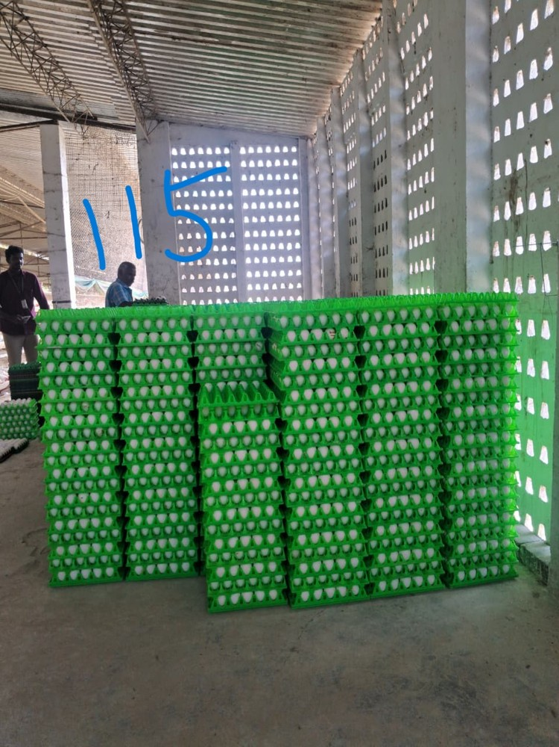 | 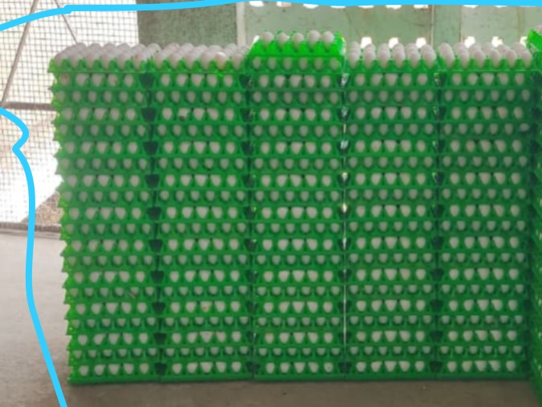
Field photo img-04 (resized copy), with the count 115 the user wrote on it, which is not a physical recount. On one stack in this photo (stack f), the old counting rule read 27 layers from 17 detected boxes spanning 19. The V4 fix tested this week reads 16. | The 'user-100' face: five stacks the user reported as 20 trays each. This week's offline check read them 16/26/24/15/14 with the old rule and 16/16/18/15/14 with the V4 fix, so far-away stacks are still undercounted.

5. Challenges Faced
• The new version could not be put live. The cloud login (wrangler OAuth) had expired on 14 Oct 16:52 UTC, and the Redmi phone had not been connected since the evening of 14 Oct. So staging stayed on 0.4.11 and the phone kept 0.4.11.
• No physical truth to test against. There were 0 physical per-stack counts and 0 counted genuine three-view sets. The only references are numbers the user wrote on photos, and 9 of the 10 accepted results are on photos the rules were tuned on.
• Far-away stacks are undercounted. This happens where one tray layer is under about 3% of the photo height (3 blocks). With these data it is impossible to tell whether the detector misses small trays or the photos are simply taken too far away.
• Some labels and data are unreliable. img02 and img06 are the same photo with two different labels (60 and 21). Two scans stored in the cloud could not be downloaded, because the expired token gave HTTP 403.

6. Plan for the Next Week
• Log in to Cloudflare again (npx wrangler login) and set the admin token on staging. Deploy 0.4.12 to staging in 'observe' mode.
• Build APK 0.4.12+23, install it on the Redmi and approve the phone with scripts/devices.py. Then run Settings > Diagnostics > NETWORK TEST and collect the EGGNET log lines.
• Do one complete gallery scan with a manual count. Then switch staging to 'enforce' and check that requests without a key are refused (401/403).
• Next milestone: count trays by hand, stack by stack, on 3 or more new blocks, photographed as STRAIGHT/LEFT/RIGHT sets at about 1.5/3/5 m. Then retrain the detector on far and cross-stacked faces, holding photos out by block.
• Meanwhile, run V4 and stack separation C in 'shadow mode' (computed and logged, not shown), and add a check for a side photo that repeats the same face.

7. Status at the End of the Week
Code: app 0.4.12+23 and Worker 0.4.12 committed (7971117) and merged to main (PR #1, 1800db9) on 17 Oct. Not deployed, not built and not installed. Staging was still 47cb2378 (0.4.11), production 4c1480e6 was unchanged, and the Redmi phone still ran 0.4.11 build 22.
Evidence: PROGRESS.md (lines 669-776: entries 2026-10-15 (later) and 2026-10-15/17); git commit 7971117 (2026-10-17) and merge 1800db9 (PR #1, 2026-10-17); docs/SCAN_JOBS_AND_DEVICES.md; reports/eval-20261015/README.md; reports/experiment-walk-fill-20261015/README.md; reports/experiment-stack-faces-20261015/README.md; accuracy-evaluation/ERRATA-20261015.md.

