WEEKLY PROGRESS REPORT
OCTOBER 2026 • WEEK 5 (29-31 OCTOBER 2026)
Project ID: MKCE/R&I/Consultancy/2026/001

AI-Based Egg Tray Inventory Management System (EG-Counter)

Prepared by
Rahul S (927623BCB041)
Yasvanthpalani S (927623BCB063)
Dharaneesh Kesavan (927623BCB007)
Dharani S (927623BCB008)
Mukund Balaji B (927623BCB033)

Guided by
Dr. V. Banupriya, HoD/CSBS
Mr. T. Viswanath Kani, AP/CSBS

Department of Computer Science and Business Systems
M. Kumarasamy College of Engineering
Thalavapalayam, Karur
Report prepared 3 November 2026 from the project record

1. Summary of the Week
This week the app was tested from start to finish, first on a laptop phone emulator and then on the real Redmi phone over a Jio mobile connection. Registering the phone, sending photos, getting the result and saving a manual count all worked. A comparison on the team's older field photos showed that the tray counts are right for close, straight-on photos, but also that wrong photo roles could produce a confident wrong total (500 for a 100-tray block). A guard that uses the phone's motion sensor to check that the side photos really show the sides was built and tested, but it is not yet on the server or the phone.
Phase: Test-server rollout on the phone, and checks on field photos.

2. Work Completed This Week

2.1 Same-face guard: side photos must really show the sides (Worker 0.4.13, app 0.4.13+24)
The app now uses the phone's gyroscope (a turn sensor) to record which way the camera faces. It refuses a side photo taken without turning at least 45 degrees, and LEFT and RIGHT must be at least 90 degrees apart. The cloud server (Cloudflare Worker) gives no total (needs_view) when a side repeats the front. A review raised 9 issues and 8 were confirmed and fixed. Automated tests passed: Worker 122/122, app 176/176.

2.2 Field photos (MUTAA): hand count compared with the server's count
8 photo sets of real blocks were sent to the test server (21 detector calls) and also counted by eye by 3 independent counting agents plus a reconciler. On close, straight-on faces the server matched the eye count on 9 of 10 stacks, and the 10th was off by 1. On block L-100 the LEFT and RIGHT photos were really front photos, and the server returned 500 "estimated" for a 100-tray block. None of the 8 sets was a real front/left/right trio.

2.3 App 0.4.12 installed on the Redmi phone and approved on the test server
The Redmi Note 9 Pro (Android 12) got APK 0.4.12 (build 23), was pointed at the test (staging) server and approved as device F39D-8C65. A network test on Jio LTE had no failures: 20/20 health checks over each of IPv4 and IPv6, and 3/3 photo uploads. A gallery scan of the 99-tray test block gave 5 x 1 stacks, 20/20/20/20/19, total 99, the same as the emulator.

2.4 Full app test on the laptop emulator against the test server (29 Oct)
On an Android emulator the app registered itself, was approved, uploaded the 99-tray photo set, got a stored result (total 99, labelled "BLOCK ESTIMATE") and sent a test manual count. This showed every step works. It did not show counting accuracy, because the photo set was put together for the test and was already used to tune the counter. The release-signing change (a new signing key for the APK) was committed the same day.

2.5 APK 0.4.13 built and signed
egg-tray-counter-0.4.13-block-staging.apk is 62,558,741 bytes and is signed with the same release key as 0.4.12 (29013b98...), so it can update the phone without uninstalling. No admin token or keystore password is in the APK.

3. Measured Results
Measurement | Value | What it shows
Automated tests after the same-face guard | Worker npm test 122/122; Flutter analyze clean, flutter test 176/176 | All code checks pass, including 11 new side-check tests and 8 heading tests. This checks the program logic. It does not measure counting accuracy on real blocks.
99-tray test block scan, emulator (29 Oct) and Redmi phone (31 Oct) | 5 x 1, 20/20/20/20/19, total 99 ("BLOCK ESTIMATE / faces differ by one layer") | Shows the whole chain works: phone, upload, server, result. It is NOT an accuracy result. The photo set was put together for the test (LEFT and RIGHT both show the same 19-tray end stack), the photos were used to tune the counter, and the app itself calls the result an estimate.
Network test on Jio LTE (Redmi phone) | health ipv4 20/20 (mean total 1574 ms); health ipv6 20/20 (868 ms); upload 3 x 500 KB 3/3 (4624 ms) | No failed requests on that day over either IPv4 or IPv6. This is one day's sample: on 12-14 Oct IPv6 lost 40-66% of requests, so the IPv4-first setting stays.
Close, straight-on faces: server per-stack count vs eye count | 9/10 stacks equal, 1 off by 1 (CORNER 14, L-80, L-100) | The reference is a visual count from photos by 3 counting agents, NOT a physical recount. For L-80 and L-100 the eye count also equals the user's handwritten totals (80 and 100), but that is only 2 blocks.
Wrong total from wrong photo roles (block L-100) | 500 "estimated" for a 100-tray block | The LEFT and RIGHT photos were front photos, so the server thought the block was 5 x 5. This was the most dangerous error found: a wrong total that looked confident. It led to the same-face guard.
Replay of saved results with the new side check | Withheld: L-100 500, mechanics trio 399, 9b4c783e 165; kept: the 99-block in all 5 saved scans | On stored server responses the guard removes the known wrong totals and keeps the correct one-stack-deep 99 block. 165 was also withheld because it had no camera heading. Not yet tested on the phone with a real walk around a block.
None of these figures is a physical recount of trays: the references are handwritten labels, counts made by eye from photos, or software checks, as each row says.

4. Photo Evidence
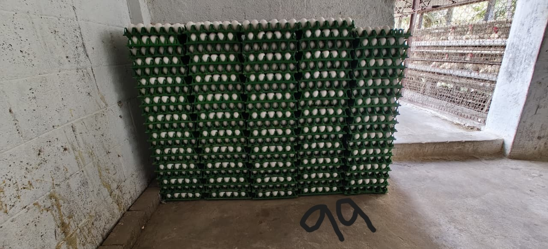
Front photo of the 99-tray test block (5 stacks; "99" is the user's handwritten total). It was the front photo in this week's test scans on the emulator (29 Oct) and the Redmi phone (31 Oct). Both read 20/20/20/20/19 = 99. The photo was used to tune the counter, so this shows the system works, not how accurate it is.

5. Challenges Faced
• Wrong photo roles gave a confident wrong total: three front photos of L-100 produced 500 "estimated" for a 100-tray block, because nothing checked that a side photo showed a side. The guard is built but not yet deployed or installed.
• There is still no real ground truth. The field photos contain no genuine front/left/right trio, the hand counts are visual counts from photos, and there are still 0 physical counts.
• Far and large blocks are hard. On far faces (M16-NEAR) the server read 8 to 10 trays too few per stack, though the capture check refused those photos. In big blocks most trays are hidden inside (W05: 196 visible of about 1366), and the eye counters disagreed widely on depth (L-115: 771 / 897 / 1455).
• Moving to a new signing key meant uninstalling 0.4.11 from the phone. No counts CSV export was found, so the phone's 0.4.11 history and any counts saved only on the phone were lost. After a fresh install the app also defaults to the production server URL.

6. Plan for November
• Deploy Worker 0.4.13 to the test server (staging is still ef7c1dd3, 0.4.12) and install APK 0.4.13 on the Redmi.
• Check the heading guard on the phone: walk around a block and confirm that a second front photo is refused.
• Take a genuine close front/left/right photo set of real blocks, with independent physical (hand) counts, as the field round.
• Retrain the tray detector on far faces, keeping some blocks aside to test it.
• Set a rule for the hidden inside of big blocks: confirmed by the operator, or marked as estimated with the visible share shown.
• Switch the test server to enforce mode (AUTH_MODE enforce, check that unauthorised requests get 401), and test portrait and sideways capture by hand.

7. Status at the End of the Week
App 0.4.12+23 installed on the Redmi Note 9 Pro (approved on staging as F39D-8C65) and on the laptop emulator (1179-C06A). APK 0.4.13+24 built (62,558,741 bytes, release key 29013b98...) but not installed. Test server (staging) ef7c1dd3 running worker-0.4.12 in observe mode; Worker 0.4.13 built and tested (122/122) but not deployed. Production was last recorded as 4c1480e6 (2026-09-23) in the 26 Oct entry.
Evidence: PROGRESS.md (entries 2026-10-29, 2026-10-31, 2026-10-31 (later), 2026-10-31 (later still); lines 324-507); reports/mutaa-manual-vs-backend-20261031/README.md; reports/mutaa-manual-vs-backend-20261031/comparison.json; reports/mutaa-manual-vs-backend-20261031/manual-consensus.json; reports/mutaa-manual-vs-backend-20261031/backend-summary.json; reports/rollout-20261031/network-test-logcat.txt; docs/SCAN_JOBS_AND_DEVICES.md ("Side-face check"); context.md (2026-10-31 notes); cloudflare-worker/src/index.ts; cloudflare-worker/test/side_check.test.mjs; mobile/lib/services/heading_tracker.dart; mobile/test/heading_tracker_test.dart; mobile/android/app/build.gradle.kts (commit 3989f95, 29 Oct); git commits 3989f95, ac2666c, 614c886, 855d5b6, e651191, d124006.

