**TITLEOFPROJECT**

**AProjectWorkReport**

*Submittedinthepartialfulfilmentfortheawardofthedegreeof*

**BACHELOROF** E**NGINEERING**

**IN**

**NAME_OF_SPECIALIZED_BRANCH**

**Submittedby:**

**S.V.N.RAHUL**

**19BCS4539**

**UndertheSupervisionof:**

**DURGESH SIR**

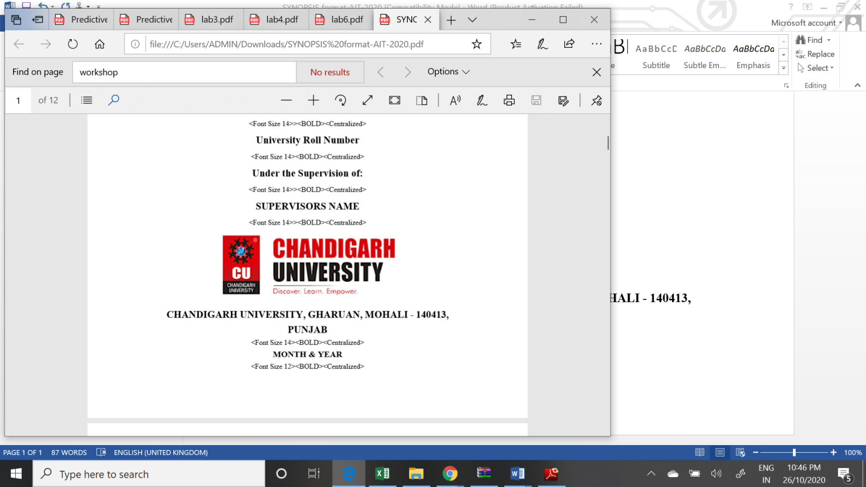

**CHANDIGARHUNIVERSITY,GHARUAN,MOHALI-140413,PUNJAB**

**December, 2020**

Name and signature of student(s)

S.V.N.Rahul

Rahul

Name and signature of Supervisor

# 

# PROJECT COMPLETION CERTIFICATE

## Hospital Management System

This is to certify that the S.V.N.RAHUL_ has successfully completed the project work titled “HospitalManagementSystem” *Submittedinthepartialfulfilmentfortheawardofthedegree of* **BACHELOROF** E**NGINEERINGIN INTERNET OF THINGS**

This project is the record of authentic work carried out during the academic year 2

**_____________________**

Project Guide

**Date:**

# DECLARATION

I the undersigned solemnly declare that the project report is based on my own work carried out during the course of our study under the supervision of Durgesh sir__________. I assert the statements made and conclusions drawn are an outcome of my work. I further certify that the work contained in the report is original and has been done by me under the general supervision of my supervisor.

II. The work has not been submitted to any other Institution for any other degree/diploma/certificate in this university or any other University of India or abroad.

III. We have followed the guidelines provided by the university in writing the report.

IV. Whenever we have used materials (data, theoretical analysis, and text) from other sources, we have given due credit to them in the text of the report and giving their details in the references.

S.V.N.Rahul

19BCS4539

# ACKNOWLEDGEMENT

I have taken efforts in this project. However, it would not have been possible without the kind support and help of many individuals and organizations. I would like to extend my sincere thanks to all of them.

I am highly indebted to (Name of your Organization Guide) for their guidance and constant supervision as well as for providing necessary information regarding the project & also for their support in completing the project.

I would like to express my gratitude towards my parents and my department for their kind co-operation and encouragement which help me in completion of this project.

THANKS AGAIN TO ALL WHO HELPED

Chapter 1: Introduction to project

Chapter 2: Project Requirements (Software/Hardware requirements)

Chapter 3: Implementation Details (Algorithm, code )

Chapter 4: Output Analysis (screenshots)

**Chapter 1:**

**Introduction:** The project mainly aims at providing a management system. It is titled as Hospital Management system. This is done by using

Java and DBMS .In this project the following things can be done :

1. ***USER CREATION***
2. ***DOCTOR CREATION***
3. ***LOGIN DETAILS***
4. ***CREATE APPOINTMENT***
5. ***DOCTOR APPOINTMENT***
6. ***SIGNOUT***

USER CREATION:

This is the user details of the user who is a part of hospital and only he can access the details and he have his own login details and he can access only based on his profession for example: If a doctor wants to access and he has the details of patients and appointment.

In this management system I have taken the users as doctor pharmacist and receptionist.

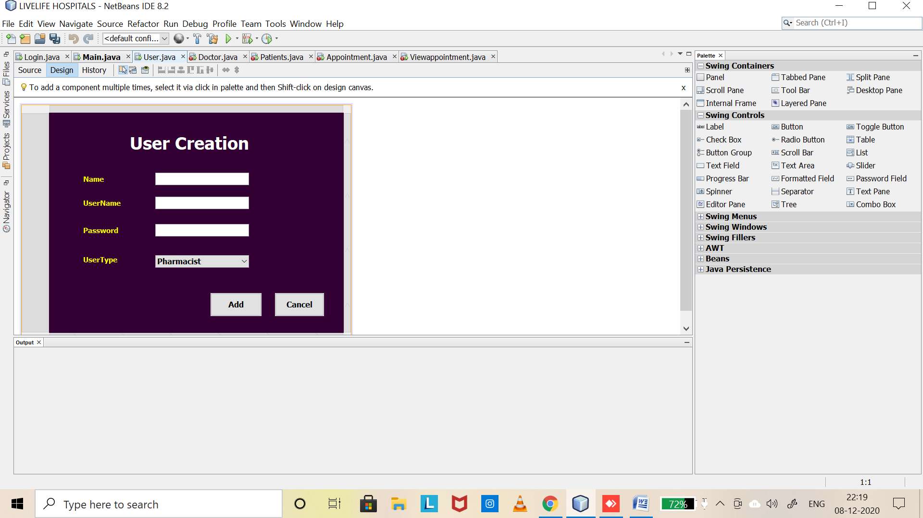

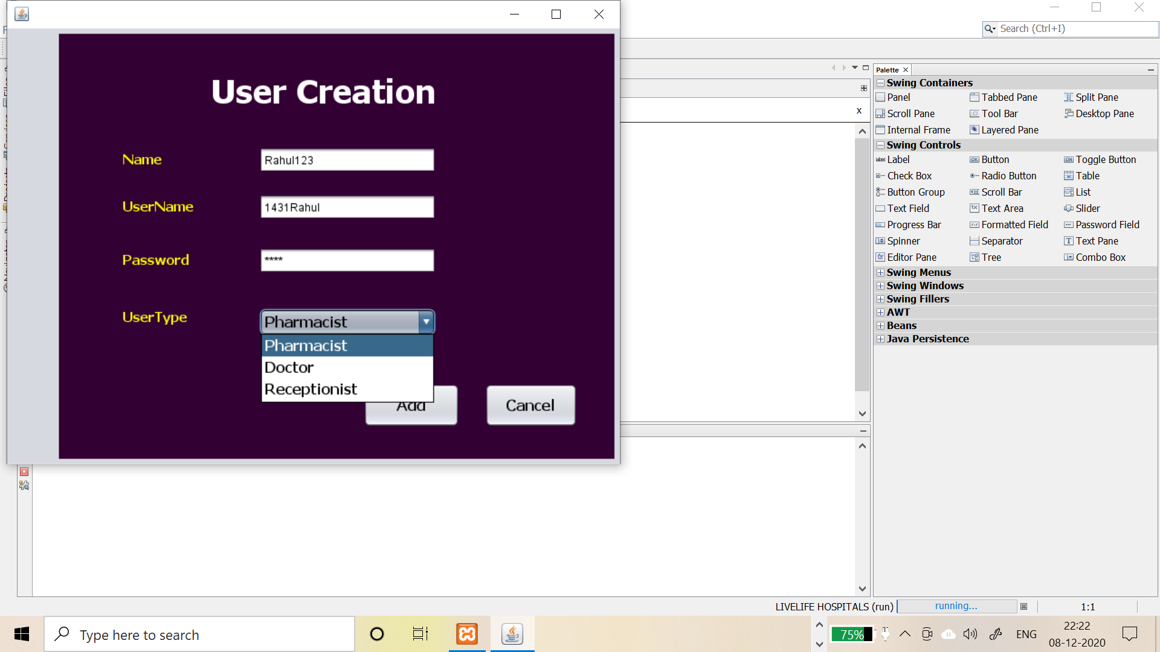

Doctor Creation:

This includes the new doctor registration and his details like specialization,address,phone,nameetc.

Login Details :

This includes the details like his username and password of specified user and after creating a user and login by his details and now you will need to press ok button and it takes to the main page where you’r username and Usertype displays.

Patient Details:

This patient details are filled by receptionist and receptionist has to login and fill the details like patient name ,doctor he want to visit, patient contact ,address etc.

Appointment Registration:

This is also done by Receptionist by taking the details of patient and after registering then the appointment will go to the doctor he wants to visit.

View Appointment :

This is to view the appointment which has been registered and all the details of appointment.

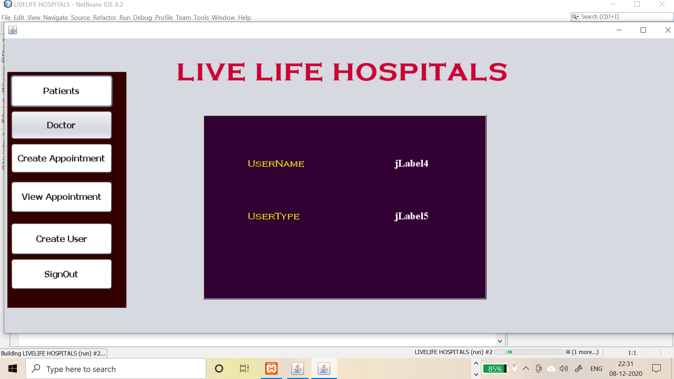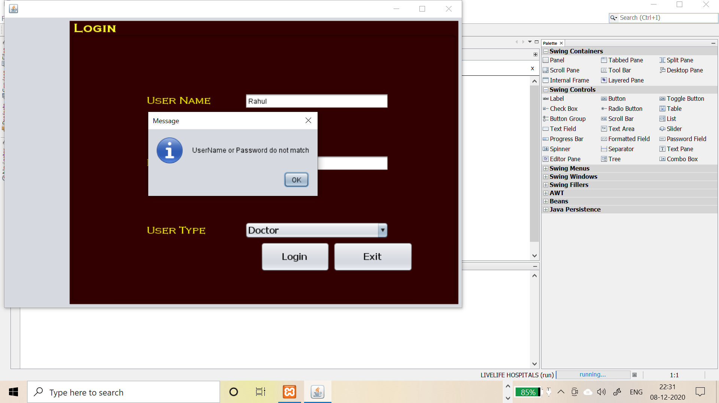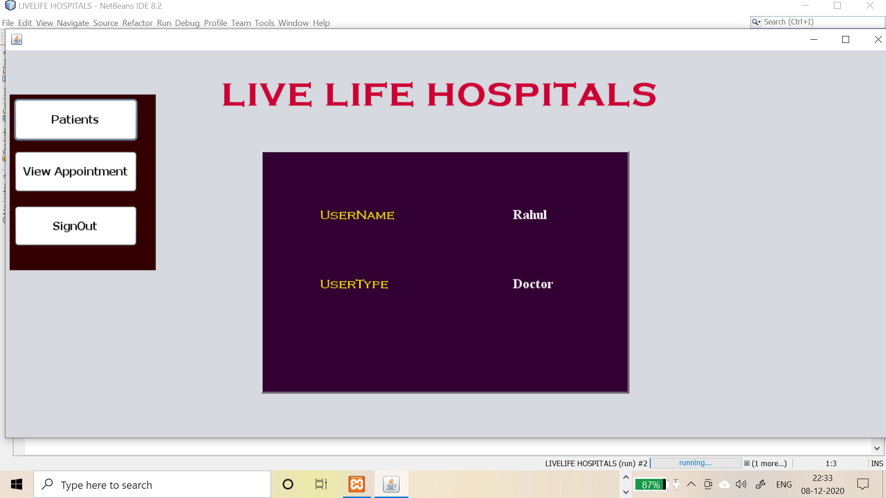

XAMPP server:

In this project XAMPP plays a vital role in storing data of each and every thing in this project I have created a database livelifehospitals in xampp and make sure that xampp runs background when you run the project. XAMPP store the data like patient data user data doctordata

Etc.

MySQL Java connector:

In this project inorder to run the project another important thing is connector and make sure that you download and add this into your project library.

Netbeans :

IDE This entire project is based and built on Netbeans using Jframeform and Labels.The best feature of this IDE Is that sourcecode is auto generated.We just need to add the functions.

Sourcecode of Main:

/*

* To change this license header, choose License Headers in Project Properties.

* To change this template file, choose Tools | Templates

* and open the template in the editor.

*/

/**

*

* @author RAHULSARABU

*/

public class Main extends javax.swing.JFrame {

/**

* Creates new form Main

*/

public Main() {

initComponents();

}

int idd;

int newid;

String uctype;

String uname;

String utype;

public Main(int id,String username,String utype)

{

initComponents();

this.uname = username;

jLabel4.setText(uname);

this.utype = utype;

jLabel5.setText(utype);

this.newid = id;

jLabel4.setText(uname);

idd = newid;

uctype = jLabel5.getText();

if(uctype.equals("Doctor"))

{

jButton2.setVisible(false);

jButton3.setVisible(false);

jButton7.setVisible(false);

}

else if(uctype.equals("Receptionist"))

{

jButton2.setVisible(false);

}

else if(uctype.equals("Pharmacist"))

{

jButton1.setVisible(false);

jButton2.setVisible(false);

jButton3.setVisible(false);

jButton4.setVisible(false);

jButton7.setVisible(false);

}

}

/**

* This method is called from within the constructor to initialize the form.

* WARNING: Do NOT modify this code. The content of this method is always

* regenerated by the Form Editor.

*/

@SuppressWarnings("unchecked")

// <editor-fold defaultstate="collapsed" desc="Generated Code">

private void initComponents() {

jPanel1 = new javax.swing.JPanel();

jButton1 = new javax.swing.JButton();

jButton2 = new javax.swing.JButton();

jButton3 = new javax.swing.JButton();

jButton4 = new javax.swing.JButton();

jButton7 = new javax.swing.JButton();

jButton9 = new javax.swing.JButton();

jLabel1 = new javax.swing.JLabel();

jPanel3 = new javax.swing.JPanel();

jLabel2 = new javax.swing.JLabel();

jLabel3 = new javax.swing.JLabel();

jLabel4 = new javax.swing.JLabel();

jLabel5 = new javax.swing.JLabel();

setDefaultCloseOperation(javax.swing.WindowConstants.EXIT_ON_CLOSE);

setBackground(new java.awt.Color(255, 255, 102));

setForeground(new java.awt.Color(255, 255, 51));

jPanel1.setBackground(new java.awt.Color(51, 0, 0));

jButton1.setBackground(new java.awt.Color(255, 255, 255));

jButton1.setFont(new java.awt.Font("Tahoma", 1, 16)); // NOI18N

jButton1.setText("Patients");

jButton1.addActionListener(new java.awt.event.ActionListener() {

public void actionPerformed(java.awt.event.ActionEvent evt) {

jButton1ActionPerformed(evt);

}

});

jButton2.setFont(new java.awt.Font("Tahoma", 1, 16)); // NOI18N

jButton2.setText("Doctor");

jButton2.addActionListener(new java.awt.event.ActionListener() {

public void actionPerformed(java.awt.event.ActionEvent evt) {

jButton2ActionPerformed(evt);

}

});

jButton3.setBackground(new java.awt.Color(255, 255, 255));

jButton3.setFont(new java.awt.Font("Tahoma", 1, 16)); // NOI18N

jButton3.setText("Create Appointment");

jButton3.addActionListener(new java.awt.event.ActionListener() {

public void actionPerformed(java.awt.event.ActionEvent evt) {

jButton3ActionPerformed(evt);

}

});

jButton4.setBackground(new java.awt.Color(255, 255, 255));

jButton4.setFont(new java.awt.Font("Tahoma", 1, 16)); // NOI18N

jButton4.setText("View Appointment");

jButton4.addActionListener(new java.awt.event.ActionListener() {

public void actionPerformed(java.awt.event.ActionEvent evt) {

jButton4ActionPerformed(evt);

}

});

jButton7.setBackground(new java.awt.Color(255, 255, 255));

jButton7.setFont(new java.awt.Font("Tahoma", 1, 16)); // NOI18N

jButton7.setText("Create User");

jButton7.addActionListener(new java.awt.event.ActionListener() {

public void actionPerformed(java.awt.event.ActionEvent evt) {

jButton7ActionPerformed(evt);

}

});

jButton9.setBackground(new java.awt.Color(255, 255, 255));

jButton9.setFont(new java.awt.Font("Tahoma", 1, 16)); // NOI18N

jButton9.setText("SignOut");

jButton9.addActionListener(new java.awt.event.ActionListener() {

public void actionPerformed(java.awt.event.ActionEvent evt) {

jButton9ActionPerformed(evt);

}

});

javax.swing.GroupLayout jPanel1Layout = new javax.swing.GroupLayout(jPanel1);

jPanel1.setLayout(jPanel1Layout);

jPanel1Layout.setHorizontalGroup(

jPanel1Layout.createParallelGroup(javax.swing.GroupLayout.Alignment.LEADING)

.addGroup(jPanel1Layout.createSequentialGroup()

.addContainerGap()

.addGroup(jPanel1Layout.createParallelGroup(javax.swing.GroupLayout.Alignment.LEADING, false)

.addComponent(jButton9, javax.swing.GroupLayout.DEFAULT_SIZE, javax.swing.GroupLayout.DEFAULT_SIZE, Short.MAX_VALUE)

.addComponent(jButton7, javax.swing.GroupLayout.DEFAULT_SIZE, javax.swing.GroupLayout.DEFAULT_SIZE, Short.MAX_VALUE)

.addComponent(jButton4, javax.swing.GroupLayout.DEFAULT_SIZE, javax.swing.GroupLayout.DEFAULT_SIZE, Short.MAX_VALUE)

.addComponent(jButton1, javax.swing.GroupLayout.DEFAULT_SIZE, javax.swing.GroupLayout.DEFAULT_SIZE, Short.MAX_VALUE)

.addComponent(jButton3, javax.swing.GroupLayout.DEFAULT_SIZE, javax.swing.GroupLayout.DEFAULT_SIZE, Short.MAX_VALUE)

.addComponent(jButton2, javax.swing.GroupLayout.DEFAULT_SIZE, javax.swing.GroupLayout.DEFAULT_SIZE, Short.MAX_VALUE))

.addContainerGap(26, Short.MAX_VALUE))

);

jPanel1Layout.setVerticalGroup(

jPanel1Layout.createParallelGroup(javax.swing.GroupLayout.Alignment.LEADING)

.addGroup(jPanel1Layout.createSequentialGroup()

.addContainerGap()

.addComponent(jButton1, javax.swing.GroupLayout.PREFERRED_SIZE, 61, javax.swing.GroupLayout.PREFERRED_SIZE)

.addPreferredGap(javax.swing.LayoutStyle.ComponentPlacement.RELATED)

.addComponent(jButton2, javax.swing.GroupLayout.PREFERRED_SIZE, 56, javax.swing.GroupLayout.PREFERRED_SIZE)

.addPreferredGap(javax.swing.LayoutStyle.ComponentPlacement.RELATED)

.addComponent(jButton3, javax.swing.GroupLayout.PREFERRED_SIZE, 58, javax.swing.GroupLayout.PREFERRED_SIZE)

.addGap(14, 14, 14)

.addComponent(jButton4, javax.swing.GroupLayout.PREFERRED_SIZE, 61, javax.swing.GroupLayout.PREFERRED_SIZE)

.addGap(18, 18, 18)

.addComponent(jButton7, javax.swing.GroupLayout.PREFERRED_SIZE, 62, javax.swing.GroupLayout.PREFERRED_SIZE)

.addPreferredGap(javax.swing.LayoutStyle.ComponentPlacement.RELATED)

.addComponent(jButton9, javax.swing.GroupLayout.PREFERRED_SIZE, 60, javax.swing.GroupLayout.PREFERRED_SIZE)

.addContainerGap(34, Short.MAX_VALUE))

);

jLabel1.setBackground(new java.awt.Color(255, 255, 153));

jLabel1.setFont(new java.awt.Font("Copperplate Gothic Bold", 1, 48)); // NOI18N

jLabel1.setForeground(new java.awt.Color(204, 0, 51));

jLabel1.setText("LIVE LIFE HOSPITALS");

jLabel1.setBorder(new javax.swing.border.MatteBorder(null));

jPanel3.setBackground(new java.awt.Color(51, 0, 51));

jPanel3.setBorder(javax.swing.BorderFactory.createBevelBorder(javax.swing.border.BevelBorder.RAISED, java.awt.Color.white, java.awt.Color.darkGray, null, java.awt.Color.lightGray));

jLabel2.setFont(new java.awt.Font("Copperplate Gothic Light", 1, 18)); // NOI18N

jLabel2.setForeground(new java.awt.Color(255, 255, 0));

jLabel2.setText("UserName");

jLabel3.setFont(new java.awt.Font("Copperplate Gothic Light", 1, 18)); // NOI18N

jLabel3.setForeground(new java.awt.Color(255, 255, 0));

jLabel3.setText("UserType");

jLabel4.setFont(new java.awt.Font("Times New Roman", 1, 20)); // NOI18N

jLabel4.setForeground(new java.awt.Color(255, 255, 255));

jLabel4.setText("jLabel4");

jLabel5.setFont(new java.awt.Font("Times New Roman", 1, 20)); // NOI18N

jLabel5.setForeground(new java.awt.Color(255, 255, 255));

jLabel5.setText("jLabel5");

javax.swing.GroupLayout jPanel3Layout = new javax.swing.GroupLayout(jPanel3);

jPanel3.setLayout(jPanel3Layout);

jPanel3Layout.setHorizontalGroup(

jPanel3Layout.createParallelGroup(javax.swing.GroupLayout.Alignment.LEADING)

.addGroup(jPanel3Layout.createSequentialGroup()

.addGap(82, 82, 82)

.addGroup(jPanel3Layout.createParallelGroup(javax.swing.GroupLayout.Alignment.LEADING, false)

.addComponent(jLabel3, javax.swing.GroupLayout.DEFAULT_SIZE, javax.swing.GroupLayout.DEFAULT_SIZE, Short.MAX_VALUE)

.addComponent(jLabel2, javax.swing.GroupLayout.DEFAULT_SIZE, javax.swing.GroupLayout.DEFAULT_SIZE, Short.MAX_VALUE))

.addGap(171, 171, 171)

.addGroup(jPanel3Layout.createParallelGroup(javax.swing.GroupLayout.Alignment.LEADING, false)

.addComponent(jLabel4, javax.swing.GroupLayout.DEFAULT_SIZE, javax.swing.GroupLayout.DEFAULT_SIZE, Short.MAX_VALUE)

.addComponent(jLabel5, javax.swing.GroupLayout.DEFAULT_SIZE, javax.swing.GroupLayout.DEFAULT_SIZE, Short.MAX_VALUE))

.addContainerGap(108, Short.MAX_VALUE))

);

jPanel3Layout.setVerticalGroup(

jPanel3Layout.createParallelGroup(javax.swing.GroupLayout.Alignment.LEADING)

.addGroup(jPanel3Layout.createSequentialGroup()

.addGap(77, 77, 77)

.addGroup(jPanel3Layout.createParallelGroup(javax.swing.GroupLayout.Alignment.BASELINE)

.addComponent(jLabel2)

.addComponent(jLabel4))

.addGap(76, 76, 76)

.addGroup(jPanel3Layout.createParallelGroup(javax.swing.GroupLayout.Alignment.BASELINE)

.addComponent(jLabel3)

.addComponent(jLabel5))

.addContainerGap(145, Short.MAX_VALUE))

);

javax.swing.GroupLayout layout = new javax.swing.GroupLayout(getContentPane());

getContentPane().setLayout(layout);

layout.setHorizontalGroup(

layout.createParallelGroup(javax.swing.GroupLayout.Alignment.LEADING)

.addGroup(layout.createSequentialGroup()

.addContainerGap()

.addComponent(jPanel1, javax.swing.GroupLayout.PREFERRED_SIZE, javax.swing.GroupLayout.DEFAULT_SIZE, javax.swing.GroupLayout.PREFERRED_SIZE)

.addGroup(layout.createParallelGroup(javax.swing.GroupLayout.Alignment.LEADING)

.addGroup(layout.createSequentialGroup()

.addGap(95, 95, 95)

.addComponent(jLabel1))

.addGroup(layout.createSequentialGroup()

.addPreferredGap(javax.swing.LayoutStyle.ComponentPlacement.RELATED, javax.swing.GroupLayout.DEFAULT_SIZE, Short.MAX_VALUE)

.addComponent(jPanel3, javax.swing.GroupLayout.PREFERRED_SIZE, javax.swing.GroupLayout.DEFAULT_SIZE, javax.swing.GroupLayout.PREFERRED_SIZE)

.addGap(40, 40, 40)))

.addContainerGap(1050, Short.MAX_VALUE))

);

layout.setVerticalGroup(

layout.createParallelGroup(javax.swing.GroupLayout.Alignment.LEADING)

.addGroup(layout.createSequentialGroup()

.addGroup(layout.createParallelGroup(javax.swing.GroupLayout.Alignment.LEADING)

.addGroup(layout.createSequentialGroup()

.addGap(38, 38, 38)

.addComponent(jLabel1)

.addGap(56, 56, 56)

.addComponent(jPanel3, javax.swing.GroupLayout.PREFERRED_SIZE, javax.swing.GroupLayout.DEFAULT_SIZE, javax.swing.GroupLayout.PREFERRED_SIZE))

.addGroup(layout.createSequentialGroup()

.addGap(64, 64, 64)

.addComponent(jPanel1, javax.swing.GroupLayout.PREFERRED_SIZE, javax.swing.GroupLayout.DEFAULT_SIZE, javax.swing.GroupLayout.PREFERRED_SIZE)))

.addGap(0, 48, Short.MAX_VALUE))

);

pack();

setLocationRelativeTo(null);

}// </editor-fold>

private void jButton2ActionPerformed(java.awt.event.ActionEvent evt) {

// TODO add your handling code here:

if(uctype.equals("Doctor"))

{

new Doctor(idd,uctype).setVisible(true);

}

}

private void jButton1ActionPerformed(java.awt.event.ActionEvent evt) {

// TODO add your handling code here:

Patients p = new Patients();

p.setVisible(true);

}

private void jButton3ActionPerformed(java.awt.event.ActionEvent evt) {

// TODO add your handling code here:

Appointment a = new Appointment();

a.setVisible(true);

}

private void jButton4ActionPerformed(java.awt.event.ActionEvent evt) {

// TODO add your handling code here:

new Viewappointment(idd).setVisible(true);

}

private void jButton7ActionPerformed(java.awt.event.ActionEvent evt) {

// TODO add your handling code here:

User u = new User();

u.setVisible(true);

}

private void jButton9ActionPerformed(java.awt.event.ActionEvent evt) {

// TODO add your handling code here:

this.setVisible(false);

}

/**

* @param args the command line arguments

*/

public static void main(String args[]) {

/* Set the Nimbus look and feel */

//<editor-fold defaultstate="collapsed" desc=" Look and feel setting code (optional) ">

/* If Nimbus (introduced in Java SE 6) is not available, stay with the default look and feel.

* For details see http://download.oracle.com/javase/tutorial/uiswing/lookandfeel/plaf.html

*/

try {

for (javax.swing.UIManager.LookAndFeelInfo info : javax.swing.UIManager.getInstalledLookAndFeels()) {

if ("Nimbus".equals(info.getName())) {

javax.swing.UIManager.setLookAndFeel(info.getClassName());

break;

}

}

} catch (ClassNotFoundException ex) {

java.util.logging.Logger.getLogger(Main.class.getName()).log(java.util.logging.Level.SEVERE, null, ex);

} catch (InstantiationException ex) {

java.util.logging.Logger.getLogger(Main.class.getName()).log(java.util.logging.Level.SEVERE, null, ex);

} catch (IllegalAccessException ex) {

java.util.logging.Logger.getLogger(Main.class.getName()).log(java.util.logging.Level.SEVERE, null, ex);

} catch (javax.swing.UnsupportedLookAndFeelException ex) {

java.util.logging.Logger.getLogger(Main.class.getName()).log(java.util.logging.Level.SEVERE, null, ex);

}

//</editor-fold>

/* Create and display the form */

java.awt.EventQueue.invokeLater(new Runnable() {

public void run() {

new Main().setVisible(true);

}

});

}

// Variables declaration - do not modify

private javax.swing.JButton jButton1;

private javax.swing.JButton jButton2;

private javax.swing.JButton jButton3;

private javax.swing.JButton jButton4;

private javax.swing.JButton jButton7;

private javax.swing.JButton jButton9;

private javax.swing.JLabel jLabel1;

private javax.swing.JLabel jLabel2;

private javax.swing.JLabel jLabel3;

private javax.swing.JLabel jLabel4;

private javax.swing.JLabel jLabel5;

private javax.swing.JPanel jPanel1;

private javax.swing.JPanel jPanel3;

// End of variables declaration

}

Sourcecode of User creation

import java.sql.Connection;

import java.sql.DriverManager;

import java.sql.PreparedStatement;

import java.sql.SQLException;

import java.util.logging.Level;

import java.util.logging.Logger;

import javax.swing.JOptionPane;

import java.util.EventListener;

/*

* To change this license header, choose License Headers in Project Properties.

* To change this template file, choose Tools | Templates

* and open the template in the editor.

*/

/**

*

* @author RAHULSARABU

*/

public class User extends javax.swing.JFrame {

/**

* Creates new form User

*/

public User() {

initComponents();

Connect();

}

Connection con;

PreparedStatement pst;

public void Connect()

{

try {

Class.forName("com.mysql.jdbc.Driver");

con = DriverManager.getConnection("jdbc:mysql://localhost/livelife hospitals","root","");

} catch (ClassNotFoundException | SQLException ex) {

Logger.getLogger(User.class.getName()).log(Level.SEVERE, null, ex);

}

}

/**

* This method is called from within the constructor to initialize the form.

* WARNING: Do NOT modify this code. The content of this method is always

* regenerated by the Form Editor.

*/

@SuppressWarnings("unchecked")

// <editor-fold defaultstate="collapsed" desc="Generated Code">

private void initComponents() {

jPanel1 = new javax.swing.JPanel();

jLabel1 = new javax.swing.JLabel();

jLabel2 = new javax.swing.JLabel();

jLabel3 = new javax.swing.JLabel();

jLabel4 = new javax.swing.JLabel();

jLabel5 = new javax.swing.JLabel();

txtname = new javax.swing.JTextField();

txtusername = new javax.swing.JTextField();

txtpassword = new javax.swing.JPasswordField();

txtutype = new javax.swing.JComboBox<>();

jButton1 = new javax.swing.JButton();

jButton2 = new javax.swing.JButton();

setDefaultCloseOperation(javax.swing.WindowConstants.EXIT_ON_CLOSE);

jPanel1.setBackground(new java.awt.Color(51, 0, 51));

jPanel1.setForeground(new java.awt.Color(255, 255, 255));

jPanel1.setFont(new java.awt.Font("Tahoma", 1, 15)); // NOI18N

jLabel1.setFont(new java.awt.Font("Tahoma", 1, 15)); // NOI18N

jLabel1.setForeground(new java.awt.Color(255, 255, 0));

jLabel1.setText("Name");

jLabel2.setFont(new java.awt.Font("Tahoma", 1, 15)); // NOI18N

jLabel2.setForeground(new java.awt.Color(255, 255, 0));

jLabel2.setText("UserName");

jLabel3.setFont(new java.awt.Font("Tahoma", 1, 15)); // NOI18N

jLabel3.setForeground(new java.awt.Color(255, 255, 0));

jLabel3.setText("Password");

jLabel4.setFont(new java.awt.Font("Tahoma", 1, 15)); // NOI18N

jLabel4.setForeground(new java.awt.Color(255, 255, 0));

jLabel4.setText("UserType");

jLabel5.setFont(new java.awt.Font("Tahoma", 1, 36)); // NOI18N

jLabel5.setForeground(new java.awt.Color(255, 255, 255));

jLabel5.setText("User Creation");

txtutype.setFont(new java.awt.Font("Tahoma", 1, 16)); // NOI18N

txtutype.setModel(new javax.swing.DefaultComboBoxModel<>(new String[] { "Pharmacist", "Doctor", "Receptionist" }));

jButton1.setFont(new java.awt.Font("Tahoma", 1, 16)); // NOI18N

jButton1.setText("Add");

jButton1.addActionListener(new java.awt.event.ActionListener() {

public void actionPerformed(java.awt.event.ActionEvent evt) {

jButton1ActionPerformed(evt);

}

});

jButton2.setFont(new java.awt.Font("Tahoma", 1, 16)); // NOI18N

jButton2.setText("Cancel");

jButton2.addActionListener(new java.awt.event.ActionListener() {

public void actionPerformed(java.awt.event.ActionEvent evt) {

jButton2ActionPerformed(evt);

}

});

javax.swing.GroupLayout jPanel1Layout = new javax.swing.GroupLayout(jPanel1);

jPanel1.setLayout(jPanel1Layout);

jPanel1Layout.setHorizontalGroup(

jPanel1Layout.createParallelGroup(javax.swing.GroupLayout.Alignment.LEADING)

.addGroup(jPanel1Layout.createSequentialGroup()

.addGap(71, 71, 71)

.addGroup(jPanel1Layout.createParallelGroup(javax.swing.GroupLayout.Alignment.TRAILING)

.addGroup(jPanel1Layout.createSequentialGroup()

.addGroup(jPanel1Layout.createParallelGroup(javax.swing.GroupLayout.Alignment.LEADING, false)

.addComponent(jLabel4, javax.swing.GroupLayout.DEFAULT_SIZE, javax.swing.GroupLayout.DEFAULT_SIZE, Short.MAX_VALUE)

.addComponent(jLabel3, javax.swing.GroupLayout.DEFAULT_SIZE, javax.swing.GroupLayout.DEFAULT_SIZE, Short.MAX_VALUE)

.addComponent(jLabel1, javax.swing.GroupLayout.DEFAULT_SIZE, javax.swing.GroupLayout.DEFAULT_SIZE, Short.MAX_VALUE)

.addComponent(jLabel2, javax.swing.GroupLayout.DEFAULT_SIZE, javax.swing.GroupLayout.DEFAULT_SIZE, Short.MAX_VALUE))

.addGap(72, 72, 72)

.addGroup(jPanel1Layout.createParallelGroup(javax.swing.GroupLayout.Alignment.LEADING, false)

.addComponent(txtname)

.addComponent(txtusername)

.addComponent(txtpassword)

.addComponent(txtutype, 0, 195, Short.MAX_VALUE)))

.addComponent(jLabel5))

.addContainerGap(197, Short.MAX_VALUE))

.addGroup(javax.swing.GroupLayout.Alignment.TRAILING, jPanel1Layout.createSequentialGroup()

.addContainerGap(javax.swing.GroupLayout.DEFAULT_SIZE, Short.MAX_VALUE)

.addComponent(jButton1, javax.swing.GroupLayout.PREFERRED_SIZE, 106, javax.swing.GroupLayout.PREFERRED_SIZE)

.addGap(28, 28, 28)

.addComponent(jButton2, javax.swing.GroupLayout.PREFERRED_SIZE, 102, javax.swing.GroupLayout.PREFERRED_SIZE)

.addGap(41, 41, 41))

);

jPanel1Layout.setVerticalGroup(

jPanel1Layout.createParallelGroup(javax.swing.GroupLayout.Alignment.LEADING)

.addGroup(jPanel1Layout.createSequentialGroup()

.addGap(41, 41, 41)

.addComponent(jLabel5)

.addGap(40, 40, 40)

.addGroup(jPanel1Layout.createParallelGroup(javax.swing.GroupLayout.Alignment.BASELINE)

.addComponent(jLabel1)

.addComponent(txtname, javax.swing.GroupLayout.PREFERRED_SIZE, javax.swing.GroupLayout.DEFAULT_SIZE, javax.swing.GroupLayout.PREFERRED_SIZE))

.addGap(24, 24, 24)

.addGroup(jPanel1Layout.createParallelGroup(javax.swing.GroupLayout.Alignment.BASELINE)

.addComponent(jLabel2)

.addComponent(txtusername, javax.swing.GroupLayout.PREFERRED_SIZE, javax.swing.GroupLayout.DEFAULT_SIZE, javax.swing.GroupLayout.PREFERRED_SIZE))

.addGap(31, 31, 31)

.addGroup(jPanel1Layout.createParallelGroup(javax.swing.GroupLayout.Alignment.BASELINE)

.addComponent(jLabel3)

.addComponent(txtpassword, javax.swing.GroupLayout.PREFERRED_SIZE, javax.swing.GroupLayout.DEFAULT_SIZE, javax.swing.GroupLayout.PREFERRED_SIZE))

.addGap(39, 39, 39)

.addGroup(jPanel1Layout.createParallelGroup(javax.swing.GroupLayout.Alignment.LEADING)

.addComponent(jLabel4)

.addComponent(txtutype, javax.swing.GroupLayout.PREFERRED_SIZE, javax.swing.GroupLayout.DEFAULT_SIZE, javax.swing.GroupLayout.PREFERRED_SIZE))

.addGap(53, 53, 53)

.addGroup(jPanel1Layout.createParallelGroup(javax.swing.GroupLayout.Alignment.LEADING, false)

.addComponent(jButton2, javax.swing.GroupLayout.DEFAULT_SIZE, 48, Short.MAX_VALUE)

.addComponent(jButton1, javax.swing.GroupLayout.DEFAULT_SIZE, javax.swing.GroupLayout.DEFAULT_SIZE, Short.MAX_VALUE))

.addContainerGap(35, Short.MAX_VALUE))

);

javax.swing.GroupLayout layout = new javax.swing.GroupLayout(getContentPane());

getContentPane().setLayout(layout);

layout.setHorizontalGroup(

layout.createParallelGroup(javax.swing.GroupLayout.Alignment.LEADING)

.addGroup(layout.createSequentialGroup()

.addGap(57, 57, 57)

.addComponent(jPanel1, javax.swing.GroupLayout.PREFERRED_SIZE, javax.swing.GroupLayout.DEFAULT_SIZE, javax.swing.GroupLayout.PREFERRED_SIZE)

.addContainerGap(javax.swing.GroupLayout.DEFAULT_SIZE, Short.MAX_VALUE))

);

layout.setVerticalGroup(

layout.createParallelGroup(javax.swing.GroupLayout.Alignment.LEADING)

.addGroup(layout.createSequentialGroup()

.addContainerGap()

.addComponent(jPanel1, javax.swing.GroupLayout.PREFERRED_SIZE, javax.swing.GroupLayout.DEFAULT_SIZE, javax.swing.GroupLayout.PREFERRED_SIZE)

.addContainerGap(javax.swing.GroupLayout.DEFAULT_SIZE, Short.MAX_VALUE))

);

pack();

}// </editor-fold>

private void jButton1ActionPerformed(java.awt.event.ActionEvent evt) {

// TODO add your handling code here:

String name = txtname.getText();

String username = txtusername.getText();

String password = txtpassword.getText();

String usertype = txtutype.getSelectedItem().toString();

Connect();

try {

pst=con.prepareStatement("insert into user(name,username,password,utype)values(?,?,?,?)");

pst.setString(1,name);

pst.setString(2,username);

pst.setString(3,password);

pst.setString(4,usertype);

pst.executeUpdate();

JOptionPane.showMessageDialog(this, "STUDENT createddd");

txtname.setText("");

txtusername.setText("");

txtpassword.setText("");

txtutype.setSelectedIndex(-1);

txtname.requestFocus();

} catch (SQLException ex) {

Logger.getLogger(User.class.getName()).log(Level.SEVERE, null, ex);

}

}

private void jButton2ActionPerformed(java.awt.event.ActionEvent evt) {

// TODO add your handling code here:

this.setVisible(false);

}

/**

* @param args the command line arguments

*/

public static void main(String args[]) {

/* Set the Nimbus look and feel */

//<editor-fold defaultstate="collapsed" desc=" Look and feel setting code (optional) ">

/* If Nimbus (introduced in Java SE 6) is not available, stay with the default look and feel.

* For details see http://download.oracle.com/javase/tutorial/uiswing/lookandfeel/plaf.html

*/

try {

for (javax.swing.UIManager.LookAndFeelInfo info : javax.swing.UIManager.getInstalledLookAndFeels()) {

if ("Nimbus".equals(info.getName())) {

javax.swing.UIManager.setLookAndFeel(info.getClassName());

break;

}

}

} catch (ClassNotFoundException | InstantiationException | IllegalAccessException | javax.swing.UnsupportedLookAndFeelException ex) {

java.util.logging.Logger.getLogger(User.class.getName()).log(java.util.logging.Level.SEVERE, null, ex);

}

//</editor-fold>

//</editor-fold>

/* Create and display the form */

java.awt.EventQueue.invokeLater(() -> {

new User().setVisible(true);

});

}

// Variables declaration - do not modify

private javax.swing.JButton jButton1;

private javax.swing.JButton jButton2;

private javax.swing.JLabel jLabel1;

private javax.swing.JLabel jLabel2;

private javax.swing.JLabel jLabel3;

private javax.swing.JLabel jLabel4;

private javax.swing.JLabel jLabel5;

private javax.swing.JPanel jPanel1;

private javax.swing.JTextField txtname;

private javax.swing.JPasswordField txtpassword;

private javax.swing.JTextField txtusername;

private javax.swing.JComboBox<String> txtutype;

// End of variables declaration

}

Source code of Doctor:

import java.sql.Connection;

import java.sql.DriverManager;

import java.sql.PreparedStatement;

import java.sql.ResultSet;

import java.sql.ResultSetMetaData;

import java.sql.SQLException;

import java.sql.Statement;

import java.util.Vector;

import java.util.logging.Level;

import java.util.logging.Logger;

import javax.swing.JOptionPane;

import javax.swing.table.DefaultTableModel;

/*

* To change this license header, choose License Headers in Project Properties.

* To change this template file, choose Tools | Templates

* and open the template in the editor.

*/

/**

*

* @author RAHULSARABU

*/

public class Doctor extends javax.swing.JFrame {

/**

* Creates new form Patients

*/

public Doctor() {

initComponents();

}

int id;

String uctype;

int newid;

public Doctor(int id,String utype) {

initComponents();

this.id = id;

this.uctype = uctype;

newid = id;

// JOptionPane.showMessageDialog(this, newid);

Connect();

AutoID();

Doctor_table();

}

Connection con;

PreparedStatement pst;

ResultSet rs;

public void Connect()

{

try {

Class.forName("com.mysql.jdbc.Driver");

con = DriverManager.getConnection("jdbc:mysql://localhost/livelife hospitals","root","");

} catch (ClassNotFoundException | SQLException ex) {

Logger.getLogger(User.class.getName()).log(Level.SEVERE, null, ex);

}

}

public void AutoID()

{

try {

Statement s = con.createStatement();

rs = s.executeQuery("select MAX(doctorno) from doctor");

rs.next();

rs.getString("MAX(doctorno)");

if(rs.getString("MAX(doctorno)") == null)

{

lbldno.setText("DR001");

}

else

{

long id = Long.parseLong(rs.getString("MAX(doctorno)").substring(2,rs.getString("MAX(doctorno)").length()));

id++;

lbldno.setText("DR"+String.format("%03d", id));

}

} catch (SQLException ex) {

Logger.getLogger(Patients.class.getName()).log(Level.SEVERE, null, ex);

}

}

public void Doctor_table()

{

try {

pst = con.prepareStatement("select * from doctor where log_id =?");

pst.setInt(1, newid);

rs = pst.executeQuery();

ResultSetMetaData Rsm = rs.getMetaData();

int c;

c = Rsm.getColumnCount();

DefaultTableModel df = (DefaultTableModel)jTable1.getModel();

df.setRowCount(0);

while(rs.next())

{

Vector v2 = new Vector();

for(int i = 1; i<c; i++)

{

v2.add(rs.getString("doctorno"));

v2.add(rs.getString("name"));

v2.add(rs.getString("specialization"));

v2.add(rs.getString("qualification"));

v2.add(rs.getString("appointmentfee"));

v2.add(rs.getString("phone"));

v2.add(rs.getString("room"));

v2.add(rs.getInt("log_id"));

}

df.addRow(v2);

}

} catch (SQLException ex) {

Logger.getLogger(Doctor.class.getName()).log(Level.SEVERE, null, ex);

}

}

/**

* This method is called from within the constructor to initialize the form.

* WARNING: Do NOT modify this code. The content of this method is always

* regenerated by the Form Editor.

*/

@SuppressWarnings("unchecked")

// <editor-fold defaultstate="collapsed" desc="Generated Code">

private void initComponents() {

jPanel1 = new javax.swing.JPanel();

jPanel2 = new javax.swing.JPanel();

jLabel1 = new javax.swing.JLabel();

jLabel2 = new javax.swing.JLabel();

jLabel3 = new javax.swing.JLabel();

jLabel4 = new javax.swing.JLabel();

lbldno = new javax.swing.JLabel();

txtdname = new javax.swing.JTextField();

txtspl = new javax.swing.JTextField();

jButton1 = new javax.swing.JButton();

jButton4 = new javax.swing.JButton();

txtqual = new javax.swing.JTextField();

jLabel6 = new javax.swing.JLabel();

txtappfee = new javax.swing.JTextField();

jLabel7 = new javax.swing.JLabel();

txtphone = new javax.swing.JTextField();

jLabel8 = new javax.swing.JLabel();

txtroom = new javax.swing.JSpinner();

jScrollPane2 = new javax.swing.JScrollPane();

jTable1 = new javax.swing.JTable();

jLabel5 = new javax.swing.JLabel();

setDefaultCloseOperation(javax.swing.WindowConstants.EXIT_ON_CLOSE);

setName(null);

jPanel1.setBackground(new java.awt.Color(51, 0, 0));

jPanel2.setBackground(new java.awt.Color(0, 0, 255));

jPanel2.setBorder(javax.swing.BorderFactory.createTitledBorder(null, "Doctor Registration", javax.swing.border.TitledBorder.DEFAULT_JUSTIFICATION, javax.swing.border.TitledBorder.DEFAULT_POSITION, new java.awt.Font("Copperplate Gothic Bold", 1, 20), new java.awt.Color(255, 255, 0))); // NOI18N

jPanel2.setToolTipText("");

jLabel1.setFont(new java.awt.Font("Copperplate Gothic Bold", 1, 18)); // NOI18N

jLabel1.setForeground(new java.awt.Color(255, 255, 51));

jLabel1.setText("Doctor ID");

jLabel1.setToolTipText("");

jLabel2.setFont(new java.awt.Font("Copperplate Gothic Bold", 1, 18)); // NOI18N

jLabel2.setForeground(new java.awt.Color(255, 255, 51));

jLabel2.setText("Doctor Name");

jLabel2.setToolTipText("");

jLabel3.setFont(new java.awt.Font("Copperplate Gothic Bold", 1, 18)); // NOI18N

jLabel3.setForeground(new java.awt.Color(255, 255, 51));

jLabel3.setText("Specialization");

jLabel3.setToolTipText("");

jLabel4.setFont(new java.awt.Font("Copperplate Gothic Bold", 1, 18)); // NOI18N

jLabel4.setForeground(new java.awt.Color(255, 255, 51));

jLabel4.setText("Qualification");

jLabel4.setToolTipText("");

lbldno.setFont(new java.awt.Font("Tahoma", 1, 17)); // NOI18N

lbldno.setForeground(new java.awt.Color(255, 255, 0));

lbldno.setText("jLabel5");

txtdname.setText("jTextField1");

txtspl.setText("jTextField2");

jButton1.setFont(new java.awt.Font("Tahoma", 1, 16)); // NOI18N

jButton1.setText("Register");

jButton1.addActionListener(new java.awt.event.ActionListener() {

public void actionPerformed(java.awt.event.ActionEvent evt) {

jButton1ActionPerformed(evt);

}

});

jButton4.setFont(new java.awt.Font("Tahoma", 1, 16)); // NOI18N

jButton4.setText("Exit");

jButton4.addActionListener(new java.awt.event.ActionListener() {

public void actionPerformed(java.awt.event.ActionEvent evt) {

jButton4ActionPerformed(evt);

}

});

txtqual.setText("jTextField1");

txtqual.addActionListener(new java.awt.event.ActionListener() {

public void actionPerformed(java.awt.event.ActionEvent evt) {

txtqualActionPerformed(evt);

}

});

jLabel6.setFont(new java.awt.Font("Copperplate Gothic Bold", 1, 18)); // NOI18N

jLabel6.setForeground(new java.awt.Color(255, 255, 51));

jLabel6.setText("Appointment fee");

jLabel6.setToolTipText("");

jLabel7.setFont(new java.awt.Font("Copperplate Gothic Bold", 1, 18)); // NOI18N

jLabel7.setForeground(new java.awt.Color(255, 255, 51));

jLabel7.setText("phone");

jLabel7.setToolTipText("");

jLabel8.setFont(new java.awt.Font("Copperplate Gothic Bold", 1, 18)); // NOI18N

jLabel8.setForeground(new java.awt.Color(255, 255, 51));

jLabel8.setText("ROOM");

jLabel8.setToolTipText("");

javax.swing.GroupLayout jPanel2Layout = new javax.swing.GroupLayout(jPanel2);

jPanel2.setLayout(jPanel2Layout);

jPanel2Layout.setHorizontalGroup(

jPanel2Layout.createParallelGroup(javax.swing.GroupLayout.Alignment.LEADING)

.addGroup(jPanel2Layout.createSequentialGroup()

.addGroup(jPanel2Layout.createParallelGroup(javax.swing.GroupLayout.Alignment.LEADING)

.addGroup(jPanel2Layout.createSequentialGroup()

.addGap(251, 251, 251)

.addComponent(jButton1, javax.swing.GroupLayout.PREFERRED_SIZE, 127, javax.swing.GroupLayout.PREFERRED_SIZE)

.addPreferredGap(javax.swing.LayoutStyle.ComponentPlacement.RELATED)

.addComponent(jButton4, javax.swing.GroupLayout.DEFAULT_SIZE, javax.swing.GroupLayout.DEFAULT_SIZE, Short.MAX_VALUE))

.addGroup(javax.swing.GroupLayout.Alignment.TRAILING, jPanel2Layout.createSequentialGroup()

.addContainerGap()

.addGroup(jPanel2Layout.createParallelGroup(javax.swing.GroupLayout.Alignment.LEADING)

.addGroup(jPanel2Layout.createSequentialGroup()

.addGroup(jPanel2Layout.createParallelGroup(javax.swing.GroupLayout.Alignment.LEADING)

.addGroup(javax.swing.GroupLayout.Alignment.TRAILING, jPanel2Layout.createSequentialGroup()

.addGap(0, 0, Short.MAX_VALUE)

.addGroup(jPanel2Layout.createParallelGroup(javax.swing.GroupLayout.Alignment.LEADING, false)

.addGroup(jPanel2Layout.createSequentialGroup()

.addComponent(jLabel7)

.addGap(120, 120, 120))

.addComponent(jLabel6, javax.swing.GroupLayout.Alignment.TRAILING)))

.addComponent(jLabel2, javax.swing.GroupLayout.DEFAULT_SIZE, javax.swing.GroupLayout.DEFAULT_SIZE, Short.MAX_VALUE)

.addComponent(jLabel3, javax.swing.GroupLayout.DEFAULT_SIZE, javax.swing.GroupLayout.DEFAULT_SIZE, Short.MAX_VALUE)

.addComponent(jLabel4, javax.swing.GroupLayout.DEFAULT_SIZE, javax.swing.GroupLayout.DEFAULT_SIZE, Short.MAX_VALUE))

.addPreferredGap(javax.swing.LayoutStyle.ComponentPlacement.RELATED))

.addGroup(javax.swing.GroupLayout.Alignment.TRAILING, jPanel2Layout.createSequentialGroup()

.addComponent(jLabel8)

.addGap(124, 124, 124)))

.addGroup(jPanel2Layout.createParallelGroup(javax.swing.GroupLayout.Alignment.LEADING)

.addComponent(txtqual, javax.swing.GroupLayout.PREFERRED_SIZE, 269, javax.swing.GroupLayout.PREFERRED_SIZE)

.addGroup(jPanel2Layout.createParallelGroup(javax.swing.GroupLayout.Alignment.LEADING, false)

.addComponent(txtappfee, javax.swing.GroupLayout.Alignment.TRAILING, javax.swing.GroupLayout.PREFERRED_SIZE, 270, javax.swing.GroupLayout.PREFERRED_SIZE)

.addComponent(txtphone, javax.swing.GroupLayout.Alignment.TRAILING, javax.swing.GroupLayout.PREFERRED_SIZE, 270, javax.swing.GroupLayout.PREFERRED_SIZE))

.addComponent(txtspl, javax.swing.GroupLayout.PREFERRED_SIZE, 269, javax.swing.GroupLayout.PREFERRED_SIZE)

.addComponent(txtdname, javax.swing.GroupLayout.PREFERRED_SIZE, 269, javax.swing.GroupLayout.PREFERRED_SIZE)

.addComponent(lbldno, javax.swing.GroupLayout.PREFERRED_SIZE, 269, javax.swing.GroupLayout.PREFERRED_SIZE)

.addComponent(txtroom, javax.swing.GroupLayout.PREFERRED_SIZE, 61, javax.swing.GroupLayout.PREFERRED_SIZE))

.addGap(8, 8, 8))

.addGroup(jPanel2Layout.createSequentialGroup()

.addContainerGap()

.addComponent(jLabel1)))

.addContainerGap())

);

jPanel2Layout.setVerticalGroup(

jPanel2Layout.createParallelGroup(javax.swing.GroupLayout.Alignment.LEADING)

.addGroup(jPanel2Layout.createSequentialGroup()

.addGap(25, 25, 25)

.addGroup(jPanel2Layout.createParallelGroup(javax.swing.GroupLayout.Alignment.BASELINE)

.addComponent(jLabel1)

.addComponent(lbldno))

.addPreferredGap(javax.swing.LayoutStyle.ComponentPlacement.RELATED, 40, Short.MAX_VALUE)

.addGroup(jPanel2Layout.createParallelGroup(javax.swing.GroupLayout.Alignment.BASELINE)

.addComponent(jLabel2, javax.swing.GroupLayout.PREFERRED_SIZE, 26, javax.swing.GroupLayout.PREFERRED_SIZE)

.addComponent(txtdname, javax.swing.GroupLayout.PREFERRED_SIZE, javax.swing.GroupLayout.DEFAULT_SIZE, javax.swing.GroupLayout.PREFERRED_SIZE))

.addGap(30, 30, 30)

.addGroup(jPanel2Layout.createParallelGroup(javax.swing.GroupLayout.Alignment.BASELINE)

.addComponent(txtspl, javax.swing.GroupLayout.PREFERRED_SIZE, javax.swing.GroupLayout.DEFAULT_SIZE, javax.swing.GroupLayout.PREFERRED_SIZE)

.addComponent(jLabel3))

.addGap(45, 45, 45)

.addGroup(jPanel2Layout.createParallelGroup(javax.swing.GroupLayout.Alignment.BASELINE)

.addComponent(txtqual, javax.swing.GroupLayout.PREFERRED_SIZE, javax.swing.GroupLayout.DEFAULT_SIZE, javax.swing.GroupLayout.PREFERRED_SIZE)

.addComponent(jLabel4))

.addGap(50, 50, 50)

.addGroup(jPanel2Layout.createParallelGroup(javax.swing.GroupLayout.Alignment.BASELINE)

.addComponent(txtappfee, javax.swing.GroupLayout.PREFERRED_SIZE, javax.swing.GroupLayout.DEFAULT_SIZE, javax.swing.GroupLayout.PREFERRED_SIZE)

.addComponent(jLabel6, javax.swing.GroupLayout.PREFERRED_SIZE, 36, javax.swing.GroupLayout.PREFERRED_SIZE))

.addPreferredGap(javax.swing.LayoutStyle.ComponentPlacement.UNRELATED)

.addGroup(jPanel2Layout.createParallelGroup(javax.swing.GroupLayout.Alignment.BASELINE)

.addComponent(txtphone, javax.swing.GroupLayout.PREFERRED_SIZE, javax.swing.GroupLayout.DEFAULT_SIZE, javax.swing.GroupLayout.PREFERRED_SIZE)

.addComponent(jLabel7))

.addGap(28, 28, 28)

.addGroup(jPanel2Layout.createParallelGroup(javax.swing.GroupLayout.Alignment.BASELINE)

.addComponent(jLabel8)

.addComponent(txtroom, javax.swing.GroupLayout.PREFERRED_SIZE, javax.swing.GroupLayout.DEFAULT_SIZE, javax.swing.GroupLayout.PREFERRED_SIZE))

.addGap(19, 19, 19)

.addGroup(jPanel2Layout.createParallelGroup(javax.swing.GroupLayout.Alignment.BASELINE)

.addComponent(jButton4, javax.swing.GroupLayout.PREFERRED_SIZE, 63, javax.swing.GroupLayout.PREFERRED_SIZE)

.addComponent(jButton1, javax.swing.GroupLayout.PREFERRED_SIZE, 63, javax.swing.GroupLayout.PREFERRED_SIZE))

.addGap(7, 7, 7))

);

jTable1.setFont(new java.awt.Font("Tahoma", 1, 16)); // NOI18N

jTable1.setModel(new javax.swing.table.DefaultTableModel(

new Object [][] {

},

new String [] {

"Doctor Id", "Dr Name", "Special", "Qualification", "App Fee", "Phone", "Room"

}

) {

Class[] types = new Class [] {

java.lang.String.class, java.lang.String.class, java.lang.String.class, java.lang.String.class, java.lang.Integer.class, java.lang.Integer.class, java.lang.Integer.class

};

public Class getColumnClass(int columnIndex) {

return types [columnIndex];

}

});

jTable1.addMouseListener(new java.awt.event.MouseAdapter() {

public void mouseClicked(java.awt.event.MouseEvent evt) {

jTable1MouseClicked(evt);

}

});

jScrollPane2.setViewportView(jTable1);

jLabel5.setFont(new java.awt.Font("Times New Roman", 1, 48)); // NOI18N

jLabel5.setForeground(new java.awt.Color(255, 255, 0));

jLabel5.setText("Patient Registration");

jLabel5.setBorder(new javax.swing.border.MatteBorder(null));

javax.swing.GroupLayout jPanel1Layout = new javax.swing.GroupLayout(jPanel1);

jPanel1.setLayout(jPanel1Layout);

jPanel1Layout.setHorizontalGroup(

jPanel1Layout.createParallelGroup(javax.swing.GroupLayout.Alignment.LEADING)

.addGroup(jPanel1Layout.createSequentialGroup()

.addContainerGap()

.addComponent(jPanel2, javax.swing.GroupLayout.PREFERRED_SIZE, javax.swing.GroupLayout.DEFAULT_SIZE, javax.swing.GroupLayout.PREFERRED_SIZE)

.addPreferredGap(javax.swing.LayoutStyle.ComponentPlacement.RELATED)

.addComponent(jScrollPane2, javax.swing.GroupLayout.PREFERRED_SIZE, 725, javax.swing.GroupLayout.PREFERRED_SIZE)

.addGap(59, 59, 59)

.addComponent(jLabel5)

.addContainerGap(javax.swing.GroupLayout.DEFAULT_SIZE, Short.MAX_VALUE))

);

jPanel1Layout.setVerticalGroup(

jPanel1Layout.createParallelGroup(javax.swing.GroupLayout.Alignment.LEADING)

.addGroup(jPanel1Layout.createSequentialGroup()

.addContainerGap(javax.swing.GroupLayout.DEFAULT_SIZE, Short.MAX_VALUE)

.addComponent(jLabel5)

.addGap(649, 649, 649))

.addGroup(jPanel1Layout.createSequentialGroup()

.addGap(34, 34, 34)

.addGroup(jPanel1Layout.createParallelGroup(javax.swing.GroupLayout.Alignment.LEADING)

.addComponent(jScrollPane2, javax.swing.GroupLayout.PREFERRED_SIZE, 573, javax.swing.GroupLayout.PREFERRED_SIZE)

.addComponent(jPanel2, javax.swing.GroupLayout.PREFERRED_SIZE, javax.swing.GroupLayout.DEFAULT_SIZE, javax.swing.GroupLayout.PREFERRED_SIZE))

.addContainerGap(javax.swing.GroupLayout.DEFAULT_SIZE, Short.MAX_VALUE))

);

javax.swing.GroupLayout layout = new javax.swing.GroupLayout(getContentPane());

getContentPane().setLayout(layout);

layout.setHorizontalGroup(

layout.createParallelGroup(javax.swing.GroupLayout.Alignment.LEADING)

.addGroup(layout.createSequentialGroup()

.addComponent(jPanel1, javax.swing.GroupLayout.PREFERRED_SIZE, 1324, javax.swing.GroupLayout.PREFERRED_SIZE)

.addGap(0, 0, Short.MAX_VALUE))

);

layout.setVerticalGroup(

layout.createParallelGroup(javax.swing.GroupLayout.Alignment.LEADING)

.addGroup(layout.createSequentialGroup()

.addComponent(jPanel1, javax.swing.GroupLayout.PREFERRED_SIZE, 616, javax.swing.GroupLayout.PREFERRED_SIZE)

.addGap(0, 168, Short.MAX_VALUE))

);

pack();

setLocationRelativeTo(null);

}// </editor-fold>

private void jButton4ActionPerformed(java.awt.event.ActionEvent evt) {

// TODO add your handling code here:

this.setVisible(false);

}

private void jButton1ActionPerformed(java.awt.event.ActionEvent evt) {

// TODO add your handling code here:

String doctorno = lbldno.getText();

String name = txtdname.getText();

String specialization = txtspl.getText();

String qualification =txtqual.getText();

String appointmentfee =txtappfee.getText();

String phone =txtphone.getText();

String room =txtroom.getValue().toString();

try {

pst = con.prepareStatement("insert into doctor(doctorno,name,specialization,qualification,appointmentfee,phone,room,log_id)values(?,?,?,?,?,?,?,?)");

pst.setString(1,doctorno);

pst.setString(2,name);

pst.setString(3,specialization);

pst.setString(4,qualification);

pst.setString(5, appointmentfee);

pst.setString(6, phone);

pst.setString(7, room);

pst.setInt(8, newid);

pst.executeUpdate();

JOptionPane.showMessageDialog(this,"Doctor Insertedd");

AutoID();

txtdname.setText("");

txtspl.setText("");

txtqual.setText("");

txtappfee.setText("");

txtphone.setText("");

txtroom.setValue(0);

Doctor_table();

} catch (SQLException ex) {

Logger.getLogger(Patients.class.getName()).log(Level.SEVERE, null, ex);

}

}

private void jTable1MouseClicked(java.awt.event.MouseEvent evt) {

// TODO add your handling code here:

DefaultTableModel d1 = (DefaultTableModel)jTable1.getModel();

int SelectedIndex = jTable1.getSelectedRow();

lbldno.setText(d1.getValueAt(SelectedIndex, 0).toString());

txtdname.setText(d1.getValueAt(SelectedIndex, 1).toString());

txtspl.setText(d1.getValueAt(SelectedIndex, 2).toString());

txtaddress.setText(d1.getValueAt(SelectedIndex, 3).toString());

jButton1.setEnabled(false);

}

private void txtqualActionPerformed(java.awt.event.ActionEvent evt) {

// TODO add your handling code here:

}

/**

* @param args the command line arguments

*/

public static void main(String args[]) {

/* Set the Nimbus look and feel */

//<editor-fold defaultstate="collapsed" desc=" Look and feel setting code (optional) ">

/* If Nimbus (introduced in Java SE 6) is not available, stay with the default look and feel.

* For details see http://download.oracle.com/javase/tutorial/uiswing/lookandfeel/plaf.html

*/

try {

for (javax.swing.UIManager.LookAndFeelInfo info : javax.swing.UIManager.getInstalledLookAndFeels()) {

if ("Nimbus".equals(info.getName())) {

javax.swing.UIManager.setLookAndFeel(info.getClassName());

break;

}

}

} catch (ClassNotFoundException ex) {

java.util.logging.Logger.getLogger(Patients.class.getName()).log(java.util.logging.Level.SEVERE, null, ex);

} catch (InstantiationException ex) {

java.util.logging.Logger.getLogger(Patients.class.getName()).log(java.util.logging.Level.SEVERE, null, ex);

} catch (IllegalAccessException ex) {

java.util.logging.Logger.getLogger(Patients.class.getName()).log(java.util.logging.Level.SEVERE, null, ex);

} catch (javax.swing.UnsupportedLookAndFeelException ex) {

java.util.logging.Logger.getLogger(Patients.class.getName()).log(java.util.logging.Level.SEVERE, null, ex);

}

//</editor-fold>

/* Create and display the form */

java.awt.EventQueue.invokeLater(new Runnable() {

public void run() {

new Patients().setVisible(true);

}

});

}

// Variables declaration - do not modify

private javax.swing.JButton jButton1;

private javax.swing.JButton jButton4;

private javax.swing.JLabel jLabel1;

private javax.swing.JLabel jLabel2;

private javax.swing.JLabel jLabel3;

private javax.swing.JLabel jLabel4;

private javax.swing.JLabel jLabel5;

private javax.swing.JLabel jLabel6;

private javax.swing.JLabel jLabel7;

private javax.swing.JLabel jLabel8;

private javax.swing.JPanel jPanel1;

private javax.swing.JPanel jPanel2;

private javax.swing.JScrollPane jScrollPane2;

private javax.swing.JTable jTable1;

private javax.swing.JLabel lbldno;

private javax.swing.JTextField txtappfee;

private javax.swing.JTextField txtdname;

private javax.swing.JTextField txtphone;

private javax.swing.JTextField txtqual;

private javax.swing.JSpinner txtroom;

private javax.swing.JTextField txtspl;

// End of variables declaration

}

Sourcecode of patient:

import java.sql.Connection;

import java.sql.DriverManager;

import java.sql.PreparedStatement;

import java.sql.ResultSet;

import java.sql.ResultSetMetaData;

import java.sql.SQLException;

import java.sql.Statement;

import java.util.Vector;

import java.util.logging.Level;

import java.util.logging.Logger;

import javax.swing.JOptionPane;

import javax.swing.table.DefaultTableModel;

/*

* To change this license header, choose License Headers in Project Properties.

* To change this template file, choose Tools | Templates

* and open the template in the editor.

*/

/**

*

* @author RAHULSARABU

*/

public class Patients extends javax.swing.JFrame {

/**

* Creates new form Patients

*/

public Patients() {

initComponents();

Connect();

AutoID();

patient_table();

}

Connection con;

PreparedStatement pst;

ResultSet rs;

public void Connect()

{

try {

Class.forName("com.mysql.jdbc.Driver");

con = DriverManager.getConnection("jdbc:mysql://localhost/livelife hospitals","root","");

} catch (ClassNotFoundException | SQLException ex) {

Logger.getLogger(User.class.getName()).log(Level.SEVERE, null, ex);

}

}

public void AutoID()

{

try {

Statement s = con.createStatement();

rs = s.executeQuery("select MAX(patientno) from patient");

rs.next();

rs.getString("MAX(patientno)");

if(rs.getString("MAX(patientno)") == null)

{

lblpno.setText("PS001");

}

else

{

long id = Long.parseLong(rs.getString("MAX(patientno)").substring(2,rs.getString("MAX(patientno)").length()));

id++;

lblpno.setText("PS"+String.format("%03d", id));

}

} catch (SQLException ex) {

Logger.getLogger(Patients.class.getName()).log(Level.SEVERE, null, ex);

}

}

public void patient_table()

{

try {

pst = con.prepareStatement("select * from patient");

rs = pst.executeQuery();

ResultSetMetaData Rsm = rs.getMetaData();

int c;

c = Rsm.getColumnCount();

DefaultTableModel df = (DefaultTableModel)jTable1.getModel();

df.setRowCount(0);

while(rs.next())

{

Vector v2 = new Vector();

for(int i = 1; i<c; i++)

{

v2.add(rs.getString("patientno"));

v2.add(rs.getString("name"));

v2.add(rs.getString("phone"));

v2.add(rs.getString("address"));

}

df.addRow(v2);

}

} catch (SQLException ex) {

Logger.getLogger(Patients.class.getName()).log(Level.SEVERE, null, ex);

}

}

/**

* This method is called from within the constructor to initialize the form.

* WARNING: Do NOT modify this code. The content of this method is always

* regenerated by the Form Editor.

*/

@SuppressWarnings("unchecked")

// <editor-fold defaultstate="collapsed" desc="Generated Code">

private void initComponents() {

jPanel1 = new javax.swing.JPanel();

jPanel2 = new javax.swing.JPanel();

jLabel1 = new javax.swing.JLabel();

jLabel2 = new javax.swing.JLabel();

jLabel3 = new javax.swing.JLabel();

jLabel4 = new javax.swing.JLabel();

lblpno = new javax.swing.JLabel();

txtpname = new javax.swing.JTextField();

jScrollPane1 = new javax.swing.JScrollPane();

txtaddress = new javax.swing.JTextArea();

txtphone = new javax.swing.JTextField();

jButton1 = new javax.swing.JButton();

jButton4 = new javax.swing.JButton();

jLabel5 = new javax.swing.JLabel();

setDefaultCloseOperation(javax.swing.WindowConstants.EXIT_ON_CLOSE);

jPanel1.setBackground(new java.awt.Color(51, 0, 0));

jPanel2.setBackground(new java.awt.Color(0, 0, 255));

jPanel2.setBorder(javax.swing.BorderFactory.createTitledBorder(null, "Patient Registration", javax.swing.border.TitledBorder.DEFAULT_JUSTIFICATION, javax.swing.border.TitledBorder.DEFAULT_POSITION, new java.awt.Font("Copperplate Gothic Bold", 1, 20), new java.awt.Color(255, 255, 0))); // NOI18N

jPanel2.setToolTipText("");

jLabel1.setFont(new java.awt.Font("Copperplate Gothic Light", 1, 20)); // NOI18N

jLabel1.setForeground(new java.awt.Color(255, 255, 0));

jLabel1.setText("Patient number");

jLabel1.setToolTipText("");

jLabel2.setFont(new java.awt.Font("Copperplate Gothic Light", 1, 18)); // NOI18N

jLabel2.setForeground(new java.awt.Color(255, 255, 0));

jLabel2.setText("Name");

jLabel2.setToolTipText("");

jLabel3.setFont(new java.awt.Font("Copperplate Gothic Light", 1, 20)); // NOI18N

jLabel3.setForeground(new java.awt.Color(255, 255, 0));

jLabel3.setText("Phone Number");

jLabel3.setToolTipText("");

jLabel4.setFont(new java.awt.Font("Copperplate Gothic Light", 1, 20)); // NOI18N

jLabel4.setForeground(new java.awt.Color(255, 255, 0));

jLabel4.setText("Address");

jLabel4.setToolTipText("");

lblpno.setFont(new java.awt.Font("Tahoma", 1, 17)); // NOI18N

lblpno.setForeground(new java.awt.Color(255, 255, 0));

lblpno.setText("jLabel5");

txtpname.setText("jTextField1");

txtaddress.setColumns(20);

txtaddress.setRows(5);

jScrollPane1.setViewportView(txtaddress);

txtphone.setText("jTextField2");

jButton1.setFont(new java.awt.Font("Tahoma", 1, 16)); // NOI18N

jButton1.setText("Add");

jButton1.addActionListener(new java.awt.event.ActionListener() {

public void actionPerformed(java.awt.event.ActionEvent evt) {

jButton1ActionPerformed(evt);

}

});

jButton4.setFont(new java.awt.Font("Tahoma", 1, 16)); // NOI18N

jButton4.setText("Exit");

jButton4.addActionListener(new java.awt.event.ActionListener() {

public void actionPerformed(java.awt.event.ActionEvent evt) {

jButton4ActionPerformed(evt);

}

});

javax.swing.GroupLayout jPanel2Layout = new javax.swing.GroupLayout(jPanel2);

jPanel2.setLayout(jPanel2Layout);

jPanel2Layout.setHorizontalGroup(

jPanel2Layout.createParallelGroup(javax.swing.GroupLayout.Alignment.LEADING)

.addGroup(jPanel2Layout.createSequentialGroup()

.addContainerGap(javax.swing.GroupLayout.DEFAULT_SIZE, Short.MAX_VALUE)

.addGroup(jPanel2Layout.createParallelGroup(javax.swing.GroupLayout.Alignment.LEADING)

.addComponent(jLabel1)

.addComponent(jLabel3)

.addComponent(jLabel4)

.addComponent(jLabel2, javax.swing.GroupLayout.PREFERRED_SIZE, 73, javax.swing.GroupLayout.PREFERRED_SIZE))

.addGap(13, 13, 13)

.addGroup(jPanel2Layout.createParallelGroup(javax.swing.GroupLayout.Alignment.LEADING, false)

.addComponent(lblpno, javax.swing.GroupLayout.DEFAULT_SIZE, javax.swing.GroupLayout.DEFAULT_SIZE, Short.MAX_VALUE)

.addComponent(txtpname)

.addComponent(txtphone, javax.swing.GroupLayout.Alignment.TRAILING)

.addComponent(jScrollPane1, javax.swing.GroupLayout.DEFAULT_SIZE, 269, Short.MAX_VALUE)))

.addGroup(jPanel2Layout.createSequentialGroup()

.addGap(251, 251, 251)

.addComponent(jButton1, javax.swing.GroupLayout.PREFERRED_SIZE, 127, javax.swing.GroupLayout.PREFERRED_SIZE)

.addPreferredGap(javax.swing.LayoutStyle.ComponentPlacement.RELATED)

.addComponent(jButton4, javax.swing.GroupLayout.DEFAULT_SIZE, 88, Short.MAX_VALUE)

.addContainerGap())

);

jPanel2Layout.setVerticalGroup(

jPanel2Layout.createParallelGroup(javax.swing.GroupLayout.Alignment.LEADING)

.addGroup(jPanel2Layout.createSequentialGroup()

.addContainerGap(40, Short.MAX_VALUE)

.addGroup(jPanel2Layout.createParallelGroup(javax.swing.GroupLayout.Alignment.BASELINE)

.addComponent(jLabel1)

.addComponent(lblpno))

.addGap(36, 36, 36)

.addGroup(jPanel2Layout.createParallelGroup(javax.swing.GroupLayout.Alignment.BASELINE)

.addComponent(jLabel2)

.addComponent(txtpname, javax.swing.GroupLayout.PREFERRED_SIZE, javax.swing.GroupLayout.DEFAULT_SIZE, javax.swing.GroupLayout.PREFERRED_SIZE))

.addGap(46, 46, 46)

.addGroup(jPanel2Layout.createParallelGroup(javax.swing.GroupLayout.Alignment.BASELINE)

.addComponent(jLabel3)

.addComponent(txtphone, javax.swing.GroupLayout.PREFERRED_SIZE, javax.swing.GroupLayout.DEFAULT_SIZE, javax.swing.GroupLayout.PREFERRED_SIZE))

.addGroup(jPanel2Layout.createParallelGroup(javax.swing.GroupLayout.Alignment.LEADING)

.addGroup(jPanel2Layout.createSequentialGroup()

.addGap(30, 30, 30)

.addComponent(jLabel4))

.addGroup(jPanel2Layout.createSequentialGroup()

.addPreferredGap(javax.swing.LayoutStyle.ComponentPlacement.UNRELATED)

.addComponent(jScrollPane1, javax.swing.GroupLayout.PREFERRED_SIZE, 168, javax.swing.GroupLayout.PREFERRED_SIZE)))

.addGap(18, 18, 18)

.addGroup(jPanel2Layout.createParallelGroup(javax.swing.GroupLayout.Alignment.BASELINE)

.addComponent(jButton4, javax.swing.GroupLayout.PREFERRED_SIZE, 63, javax.swing.GroupLayout.PREFERRED_SIZE)

.addComponent(jButton1, javax.swing.GroupLayout.PREFERRED_SIZE, 63, javax.swing.GroupLayout.PREFERRED_SIZE))

.addGap(7, 7, 7))

);

jLabel5.setFont(new java.awt.Font("Times New Roman", 1, 48)); // NOI18N

jLabel5.setForeground(new java.awt.Color(255, 255, 0));

jLabel5.setText("Patient Registration");

jLabel5.setBorder(new javax.swing.border.MatteBorder(null));

javax.swing.GroupLayout jPanel1Layout = new javax.swing.GroupLayout(jPanel1);

jPanel1.setLayout(jPanel1Layout);

jPanel1Layout.setHorizontalGroup(

jPanel1Layout.createParallelGroup(javax.swing.GroupLayout.Alignment.LEADING)

.addGroup(jPanel1Layout.createSequentialGroup()

.addGap(301, 301, 301)

.addComponent(jPanel2, javax.swing.GroupLayout.PREFERRED_SIZE, javax.swing.GroupLayout.DEFAULT_SIZE, javax.swing.GroupLayout.PREFERRED_SIZE)

.addGap(524, 524, 524)

.addComponent(jLabel5)

.addContainerGap(javax.swing.GroupLayout.DEFAULT_SIZE, Short.MAX_VALUE))

);

jPanel1Layout.setVerticalGroup(

jPanel1Layout.createParallelGroup(javax.swing.GroupLayout.Alignment.LEADING)

.addGroup(javax.swing.GroupLayout.Alignment.TRAILING, jPanel1Layout.createSequentialGroup()

.addContainerGap(javax.swing.GroupLayout.DEFAULT_SIZE, Short.MAX_VALUE)

.addGroup(jPanel1Layout.createParallelGroup(javax.swing.GroupLayout.Alignment.LEADING)

.addComponent(jPanel2, javax.swing.GroupLayout.PREFERRED_SIZE, javax.swing.GroupLayout.DEFAULT_SIZE, javax.swing.GroupLayout.PREFERRED_SIZE)

.addComponent(jLabel5))

.addGap(206, 206, 206))

);

javax.swing.GroupLayout layout = new javax.swing.GroupLayout(getContentPane());

getContentPane().setLayout(layout);

layout.setHorizontalGroup(

layout.createParallelGroup(javax.swing.GroupLayout.Alignment.LEADING)

.addGroup(layout.createSequentialGroup()

.addComponent(jPanel1, javax.swing.GroupLayout.PREFERRED_SIZE, 1324, javax.swing.GroupLayout.PREFERRED_SIZE)

.addGap(0, 0, Short.MAX_VALUE))

);

layout.setVerticalGroup(

layout.createParallelGroup(javax.swing.GroupLayout.Alignment.LEADING)

.addGroup(layout.createSequentialGroup()

.addComponent(jPanel1, javax.swing.GroupLayout.PREFERRED_SIZE, 616, javax.swing.GroupLayout.PREFERRED_SIZE)

.addGap(0, 168, Short.MAX_VALUE))

);

pack();

setLocationRelativeTo(null);

}// </editor-fold>

private void jButton4ActionPerformed(java.awt.event.ActionEvent evt) {

// TODO add your handling code here:

this.setVisible(false);

}

private void jButton1ActionPerformed(java.awt.event.ActionEvent evt) {

// TODO add your handling code here:

String pno = lblpno.getText();

String pname = txtpname.getText();

String phone = txtphone.getText();

String address =txtaddress.getText();

try {

pst = con.prepareStatement("insert into patient(patientno,name,phone,address)values(?,?,?,?)");

pst.setString(1,pno);

pst.setString(2,pname);

pst.setString(3,phone);

pst.setString(4,address);

pst.executeUpdate();

JOptionPane.showMessageDialog(this,"Patient Insertedd");

AutoID();

txtpname.setText("");

txtphone.setText("");

txtaddress.setText("");

txtpname.requestFocus();

patient_table();

} catch (SQLException ex) {

Logger.getLogger(Patients.class.getName()).log(Level.SEVERE, null, ex);

}

}

/**

* @param args the command line arguments

*/

public static void main(String args[]) {

/* Set the Nimbus look and feel */

//<editor-fold defaultstate="collapsed" desc=" Look and feel setting code (optional) ">

/* If Nimbus (introduced in Java SE 6) is not available, stay with the default look and feel.

* For details see http://download.oracle.com/javase/tutorial/uiswing/lookandfeel/plaf.html

*/

try {

for (javax.swing.UIManager.LookAndFeelInfo info : javax.swing.UIManager.getInstalledLookAndFeels()) {

if ("Nimbus".equals(info.getName())) {

javax.swing.UIManager.setLookAndFeel(info.getClassName());

break;

}

}

} catch (ClassNotFoundException ex) {

java.util.logging.Logger.getLogger(Patients.class.getName()).log(java.util.logging.Level.SEVERE, null, ex);

} catch (InstantiationException ex) {

java.util.logging.Logger.getLogger(Patients.class.getName()).log(java.util.logging.Level.SEVERE, null, ex);

} catch (IllegalAccessException ex) {

java.util.logging.Logger.getLogger(Patients.class.getName()).log(java.util.logging.Level.SEVERE, null, ex);

} catch (javax.swing.UnsupportedLookAndFeelException ex) {

java.util.logging.Logger.getLogger(Patients.class.getName()).log(java.util.logging.Level.SEVERE, null, ex);

}

//</editor-fold>

/* Create and display the form */

java.awt.EventQueue.invokeLater(new Runnable() {

public void run() {

new Patients().setVisible(true);

}

});

}

// Variables declaration - do not modify

private javax.swing.JButton jButton1;

private javax.swing.JButton jButton4;

private javax.swing.JLabel jLabel1;

private javax.swing.JLabel jLabel2;

private javax.swing.JLabel jLabel3;

private javax.swing.JLabel jLabel4;

private javax.swing.JLabel jLabel5;

private javax.swing.JPanel jPanel1;

private javax.swing.JPanel jPanel2;

private javax.swing.JScrollPane jScrollPane1;

private javax.swing.JLabel lblpno;

private javax.swing.JTextArea txtaddress;

private javax.swing.JTextField txtphone;

private javax.swing.JTextField txtpname;

// End of variables declaration

}

Sourcecode of Appointment registration

import java.sql.Connection;

import java.sql.DriverManager;

import java.sql.PreparedStatement;

import java.sql.ResultSet;

import java.sql.ResultSetMetaData;

import java.sql.SQLException;

import java.sql.Statement;

import java.util.Vector;

import java.util.logging.Level;

import java.util.logging.Logger;

import javax.swing.JOptionPane;

import javax.swing.table.DefaultTableModel;

/*

* To change this license header, choose License Headers in Project Properties.

* To change this template file, choose Tools | Templates

* and open the template in the editor.

*/

/**

*

* @author RAHULSARABU

*/

public class Appointment extends javax.swing.JFrame {

/**

* Creates new form Appointment

*/

public Appointment() {

initComponents();

Connect();

AutoID();

LoadDoctor();

LoadPatient();

Appointment_table();

}

public class Doctor

{

String id;

String name;

public Doctor(String id,String name)

{

this.id = id;

this.name = name;

}

public String toString()

{

return name;

}

}

public class Patient

{

String id;

String name;

public Patient(String id,String name)

{

this.id = id;

this.name = name;

}

public String toString()

{

return name;

}

}

public void LoadPatient()

{

try {

pst = con.prepareStatement("select * from patient");

rs = pst.executeQuery();

txtpname.removeAll();

while(rs.next()){

txtpname.addItem(new Patient(rs.getString(1),rs.getString(2)));

}

} catch (SQLException ex) {

Logger.getLogger(Appointment.class.getName()).log(Level.SEVERE, null, ex);

}

}

public void LoadDoctor()

{

try {

pst = con.prepareStatement("select * from doctor");

rs = pst.executeQuery();

txtdname.removeAll();

while(rs.next()){

txtdname.addItem(new Doctor(rs.getString(1),rs.getString(2)));

}

} catch (SQLException ex) {

Logger.getLogger(Appointment.class.getName()).log(Level.SEVERE, null, ex);

}

}

Connection con;

PreparedStatement pst;

ResultSet rs;

public void Connect()

{

try {

Class.forName("com.mysql.jdbc.Driver");

con = DriverManager.getConnection("jdbc:mysql://localhost/livelife hospitals","root","");

} catch (ClassNotFoundException | SQLException ex) {

Logger.getLogger(User.class.getName()).log(Level.SEVERE, null, ex);

}

}

public void AutoID()

{

try {

Statement s = con.createStatement();

rs = s.executeQuery("select MAX(appointmentno) from appointment");

rs.next();

rs.getString("MAX(appointmentno)");

if(rs.getString("MAX(appointmentno)") == null)

{

lblano.setText("AN001");

}

else

{

long id = Long.parseLong(rs.getString("MAX(appointmentno)").substring(2,rs.getString("MAX(appointmentno)").length()));

id++;

lblano.setText("AN"+String.format("%03d", id));

}

} catch (SQLException ex) {

Logger.getLogger(Patients.class.getName()).log(Level.SEVERE, null, ex);

}

}

public void Appointment_table()

{

try {

pst = con.prepareStatement("select * from Appointment");

rs = pst.executeQuery();

ResultSetMetaData Rsm = rs.getMetaData();

int c;

c = Rsm.getColumnCount();

DefaultTableModel df = (DefaultTableModel)jTable1.getModel();

df.setRowCount(0);

while(rs.next())

{

Vector v2 = new Vector();

for(int i = 1; i<c; i++)

{

v2.add(rs.getString("appointmentno"));

v2.add(rs.getString("doctorname"));

v2.add(rs.getString("patientname"));

v2.add(rs.getString("room"));

}

df.addRow(v2);

}

} catch (SQLException ex) {

Logger.getLogger(Doctor.class.getName()).log(Level.SEVERE, null, ex);

}

}

/**

* This method is called from within the constructor to initialize the form.

* WARNING: Do NOT modify this code. The content of this method is always

* regenerated by the Form Editor.

*/

@SuppressWarnings("unchecked")

// <editor-fold defaultstate="collapsed" desc="Generated Code">

private void initComponents() {

jPanel1 = new javax.swing.JPanel();

jPanel2 = new javax.swing.JPanel();

jLabel1 = new javax.swing.JLabel();

jLabel2 = new javax.swing.JLabel();

jLabel3 = new javax.swing.JLabel();

jLabel4 = new javax.swing.JLabel();

lblano = new javax.swing.JLabel();

txtdname = new javax.swing.JComboBox();

txtpname = new javax.swing.JComboBox();

txtroom = new javax.swing.JSpinner();

jButton1 = new javax.swing.JButton();

jButton2 = new javax.swing.JButton();

jScrollPane1 = new javax.swing.JScrollPane();

jTable1 = new javax.swing.JTable();

jLabel5 = new javax.swing.JLabel();

setDefaultCloseOperation(javax.swing.WindowConstants.EXIT_ON_CLOSE);

setBackground(new java.awt.Color(51, 0, 51));

jPanel1.setBackground(new java.awt.Color(51, 0, 51));

jPanel2.setBackground(new java.awt.Color(51, 51, 255));

jPanel2.setBorder(javax.swing.BorderFactory.createTitledBorder(null, "APPOINTMENT REGISTRATION", javax.swing.border.TitledBorder.DEFAULT_JUSTIFICATION, javax.swing.border.TitledBorder.DEFAULT_POSITION, new java.awt.Font("Copperplate Gothic Bold", 1, 20), new java.awt.Color(255, 255, 0))); // NOI18N

jLabel1.setFont(new java.awt.Font("Times New Roman", 1, 16)); // NOI18N

jLabel1.setForeground(new java.awt.Color(255, 255, 102));

jLabel1.setText("APPOINTMENT NO");

jLabel2.setFont(new java.awt.Font("Times New Roman", 1, 16)); // NOI18N

jLabel2.setForeground(new java.awt.Color(255, 255, 102));

jLabel2.setText("DOCTOR");

jLabel3.setFont(new java.awt.Font("Times New Roman", 1, 16)); // NOI18N

jLabel3.setForeground(new java.awt.Color(255, 255, 102));

jLabel3.setText("PATIENT");

jLabel4.setFont(new java.awt.Font("Times New Roman", 1, 16)); // NOI18N

jLabel4.setForeground(new java.awt.Color(255, 255, 102));

jLabel4.setText("ROOM NO");

lblano.setFont(new java.awt.Font("Times New Roman", 1, 18)); // NOI18N

lblano.setForeground(new java.awt.Color(255, 255, 255));

lblano.setText("jLabel5");

jButton1.setFont(new java.awt.Font("Tahoma", 1, 16)); // NOI18N

jButton1.setText("Create");

jButton1.addActionListener(new java.awt.event.ActionListener() {

public void actionPerformed(java.awt.event.ActionEvent evt) {

jButton1ActionPerformed(evt);

}

});

jButton2.setFont(new java.awt.Font("Tahoma", 1, 16)); // NOI18N

jButton2.setText("Cancel");

jButton2.addActionListener(new java.awt.event.ActionListener() {

public void actionPerformed(java.awt.event.ActionEvent evt) {

jButton2ActionPerformed(evt);

}

});

javax.swing.GroupLayout jPanel2Layout = new javax.swing.GroupLayout(jPanel2);

jPanel2.setLayout(jPanel2Layout);

jPanel2Layout.setHorizontalGroup(

jPanel2Layout.createParallelGroup(javax.swing.GroupLayout.Alignment.LEADING)

.addGroup(jPanel2Layout.createSequentialGroup()

.addContainerGap()

.addGroup(jPanel2Layout.createParallelGroup(javax.swing.GroupLayout.Alignment.LEADING, false)

.addComponent(jLabel2, javax.swing.GroupLayout.DEFAULT_SIZE, javax.swing.GroupLayout.DEFAULT_SIZE, Short.MAX_VALUE)

.addComponent(jLabel1, javax.swing.GroupLayout.DEFAULT_SIZE, javax.swing.GroupLayout.DEFAULT_SIZE, Short.MAX_VALUE)

.addComponent(jLabel3, javax.swing.GroupLayout.DEFAULT_SIZE, javax.swing.GroupLayout.DEFAULT_SIZE, Short.MAX_VALUE)

.addComponent(jLabel4, javax.swing.GroupLayout.DEFAULT_SIZE, javax.swing.GroupLayout.DEFAULT_SIZE, Short.MAX_VALUE))

.addGap(57, 57, 57)

.addGroup(jPanel2Layout.createParallelGroup(javax.swing.GroupLayout.Alignment.LEADING)

.addComponent(lblano, javax.swing.GroupLayout.DEFAULT_SIZE, 177, Short.MAX_VALUE)

.addComponent(txtdname, 0, javax.swing.GroupLayout.DEFAULT_SIZE, Short.MAX_VALUE)

.addComponent(txtpname, 0, javax.swing.GroupLayout.DEFAULT_SIZE, Short.MAX_VALUE)

.addGroup(jPanel2Layout.createSequentialGroup()

.addComponent(txtroom, javax.swing.GroupLayout.PREFERRED_SIZE, 55, javax.swing.GroupLayout.PREFERRED_SIZE)

.addGap(0, 0, Short.MAX_VALUE)))

.addContainerGap())

.addGroup(jPanel2Layout.createSequentialGroup()

.addContainerGap(javax.swing.GroupLayout.DEFAULT_SIZE, Short.MAX_VALUE)

.addComponent(jButton1)

.addGap(53, 53, 53)

.addComponent(jButton2)

.addGap(40, 40, 40))

);

jPanel2Layout.setVerticalGroup(

jPanel2Layout.createParallelGroup(javax.swing.GroupLayout.Alignment.LEADING)

.addGroup(jPanel2Layout.createSequentialGroup()

.addGap(48, 48, 48)

.addGroup(jPanel2Layout.createParallelGroup(javax.swing.GroupLayout.Alignment.BASELINE)

.addComponent(jLabel1)

.addComponent(lblano))

.addGap(44, 44, 44)

.addGroup(jPanel2Layout.createParallelGroup(javax.swing.GroupLayout.Alignment.BASELINE)

.addComponent(jLabel2)

.addComponent(txtdname, javax.swing.GroupLayout.PREFERRED_SIZE, javax.swing.GroupLayout.DEFAULT_SIZE, javax.swing.GroupLayout.PREFERRED_SIZE))

.addGap(45, 45, 45)

.addGroup(jPanel2Layout.createParallelGroup(javax.swing.GroupLayout.Alignment.BASELINE)

.addComponent(jLabel3)

.addComponent(txtpname, javax.swing.GroupLayout.PREFERRED_SIZE, javax.swing.GroupLayout.DEFAULT_SIZE, javax.swing.GroupLayout.PREFERRED_SIZE))

.addGap(54, 54, 54)

.addGroup(jPanel2Layout.createParallelGroup(javax.swing.GroupLayout.Alignment.BASELINE)

.addComponent(jLabel4)

.addComponent(txtroom, javax.swing.GroupLayout.PREFERRED_SIZE, javax.swing.GroupLayout.DEFAULT_SIZE, javax.swing.GroupLayout.PREFERRED_SIZE))

.addPreferredGap(javax.swing.LayoutStyle.ComponentPlacement.RELATED, javax.swing.GroupLayout.DEFAULT_SIZE, Short.MAX_VALUE)

.addGroup(jPanel2Layout.createParallelGroup(javax.swing.GroupLayout.Alignment.BASELINE)

.addComponent(jButton2, javax.swing.GroupLayout.PREFERRED_SIZE, 41, javax.swing.GroupLayout.PREFERRED_SIZE)

.addComponent(jButton1, javax.swing.GroupLayout.PREFERRED_SIZE, 41, javax.swing.GroupLayout.PREFERRED_SIZE))

.addGap(35, 35, 35))

);

jTable1.setFont(new java.awt.Font("Tahoma", 1, 16)); // NOI18N

jTable1.setModel(new javax.swing.table.DefaultTableModel(

new Object [][] {

},

new String [] {

"Appointment No", "Dr Name", "Patient", "Room"

}

) {

Class[] types = new Class [] {

java.lang.Integer.class, java.lang.String.class, java.lang.String.class, java.lang.Integer.class

};

public Class getColumnClass(int columnIndex) {

return types [columnIndex];

}

});

jTable1.addMouseListener(new java.awt.event.MouseAdapter() {

public void mouseClicked(java.awt.event.MouseEvent evt) {

jTable1MouseClicked(evt);

}

});

jScrollPane1.setViewportView(jTable1);

jLabel5.setFont(new java.awt.Font("Tahoma", 1, 24)); // NOI18N

jLabel5.setForeground(new java.awt.Color(255, 255, 255));

jLabel5.setText("Appointment Registration");

jLabel5.setBorder(javax.swing.BorderFactory.createMatteBorder(1, 1, 1, 1, new java.awt.Color(255, 255, 0)));

javax.swing.GroupLayout jPanel1Layout = new javax.swing.GroupLayout(jPanel1);

jPanel1.setLayout(jPanel1Layout);

jPanel1Layout.setHorizontalGroup(

jPanel1Layout.createParallelGroup(javax.swing.GroupLayout.Alignment.LEADING)

.addGroup(jPanel1Layout.createSequentialGroup()

.addContainerGap()

.addComponent(jPanel2, javax.swing.GroupLayout.PREFERRED_SIZE, javax.swing.GroupLayout.DEFAULT_SIZE, javax.swing.GroupLayout.PREFERRED_SIZE)

.addPreferredGap(javax.swing.LayoutStyle.ComponentPlacement.RELATED)

.addComponent(jScrollPane1, javax.swing.GroupLayout.DEFAULT_SIZE, 635, Short.MAX_VALUE)

.addGap(24, 24, 24))

.addGroup(jPanel1Layout.createSequentialGroup()

.addGap(347, 347, 347)

.addComponent(jLabel5)

.addContainerGap(javax.swing.GroupLayout.DEFAULT_SIZE, Short.MAX_VALUE))

);

jPanel1Layout.setVerticalGroup(

jPanel1Layout.createParallelGroup(javax.swing.GroupLayout.Alignment.LEADING)

.addGroup(jPanel1Layout.createSequentialGroup()

.addGap(34, 34, 34)

.addComponent(jLabel5, javax.swing.GroupLayout.PREFERRED_SIZE, 59, javax.swing.GroupLayout.PREFERRED_SIZE)

.addGap(18, 18, 18)

.addGroup(jPanel1Layout.createParallelGroup(javax.swing.GroupLayout.Alignment.LEADING, false)

.addComponent(jPanel2, javax.swing.GroupLayout.DEFAULT_SIZE, javax.swing.GroupLayout.DEFAULT_SIZE, Short.MAX_VALUE)

.addComponent(jScrollPane1, javax.swing.GroupLayout.DEFAULT_SIZE, 439, Short.MAX_VALUE))

.addContainerGap(26, Short.MAX_VALUE))

);

javax.swing.GroupLayout layout = new javax.swing.GroupLayout(getContentPane());

getContentPane().setLayout(layout);

layout.setHorizontalGroup(

layout.createParallelGroup(javax.swing.GroupLayout.Alignment.LEADING)

.addComponent(jPanel1, javax.swing.GroupLayout.DEFAULT_SIZE, javax.swing.GroupLayout.DEFAULT_SIZE, Short.MAX_VALUE)

);

layout.setVerticalGroup(

layout.createParallelGroup(javax.swing.GroupLayout.Alignment.LEADING)

.addComponent(jPanel1, javax.swing.GroupLayout.DEFAULT_SIZE, javax.swing.GroupLayout.DEFAULT_SIZE, Short.MAX_VALUE)

);

pack();

setLocationRelativeTo(null);

}// </editor-fold>

private void jButton1ActionPerformed(java.awt.event.ActionEvent evt) {

// TODO add your handling code here:

String appointmentno = lblano.getText();

Doctor d = (Doctor) txtdname.getSelectedItem();

Patient p = (Patient) txtpname.getSelectedItem();

String room =txtroom.getValue().toString();

try {

pst = con.prepareStatement("insert into appointment(appointmentno,doctorname,patientname,room)values(?,?,?,?)");

pst.setString(1,appointmentno);

pst.setString(2,d.id);

pst.setString(3,p.id);

pst.setString(4,room);

pst.executeUpdate();

JOptionPane.showMessageDialog(this,"You are Registered Successfully");

AutoID();

lblano.setText("")`;

txtdname.setSelectedIndex(-1);

txtpname.setSelectedIndex(-1);

txtroom.setValue(0);

Appointment_table();

} catch (SQLException ex) {

Logger.getLogger(Patients.class.getName()).log(Level.SEVERE, null, ex);

}

}

private void jButton2ActionPerformed(java.awt.event.ActionEvent evt) {

// TODO add your handling code here:

this.setVisible(false);

}

private void jTable1MouseClicked(java.awt.event.MouseEvent evt) {

// TODO add your handling code here:

}

/**

* @param args the command line arguments

*/

public static void main(String args[]) {

/* Set the Nimbus look and feel */

//<editor-fold defaultstate="collapsed" desc=" Look and feel setting code (optional) ">

/* If Nimbus (introduced in Java SE 6) is not available, stay with the default look and feel.

* For details see http://download.oracle.com/javase/tutorial/uiswing/lookandfeel/plaf.html

*/

try {

for (javax.swing.UIManager.LookAndFeelInfo info : javax.swing.UIManager.getInstalledLookAndFeels()) {

if ("Nimbus".equals(info.getName())) {

javax.swing.UIManager.setLookAndFeel(info.getClassName());

break;

}

}

} catch (ClassNotFoundException ex) {

java.util.logging.Logger.getLogger(Appointment.class.getName()).log(java.util.logging.Level.SEVERE, null, ex);

} catch (InstantiationException ex) {

java.util.logging.Logger.getLogger(Appointment.class.getName()).log(java.util.logging.Level.SEVERE, null, ex);

} catch (IllegalAccessException ex) {

java.util.logging.Logger.getLogger(Appointment.class.getName()).log(java.util.logging.Level.SEVERE, null, ex);

} catch (javax.swing.UnsupportedLookAndFeelException ex) {

java.util.logging.Logger.getLogger(Appointment.class.getName()).log(java.util.logging.Level.SEVERE, null, ex);

}

//</editor-fold>

/* Create and display the form */

java.awt.EventQueue.invokeLater(new Runnable() {

public void run() {

new Appointment().setVisible(true);

}

});

}

// Variables declaration - do not modify

private javax.swing.JButton jButton1;

private javax.swing.JButton jButton2;

private javax.swing.JLabel jLabel1;

private javax.swing.JLabel jLabel2;

private javax.swing.JLabel jLabel3;

private javax.swing.JLabel jLabel4;

private javax.swing.JLabel jLabel5;

private javax.swing.JPanel jPanel1;

private javax.swing.JPanel jPanel2;

private javax.swing.JScrollPane jScrollPane1;

private javax.swing.JTable jTable1;

private javax.swing.JLabel lblano;

private javax.swing.JComboBox txtdname;

private javax.swing.JComboBox txtpname;

private javax.swing.JSpinner txtroom;

// End of variables declaration

}

}

Sourcecode to view the Appointment

import java.sql.Connection;

import java.sql.DriverManager;

import java.sql.PreparedStatement;

import java.sql.ResultSet;

import java.sql.SQLException;

import java.util.logging.Level;

import java.util.logging.Logger;

import javax.swing.JOptionPane;

/*

* To change this license header, choose License Headers in Project Properties.

* To change this template file, choose Tools | Templates

* and open the template in the editor.

*/

/**

*

* @author RAHULSARABU

*/

public class Viewappointment extends javax.swing.JFrame {

/**

* Creates new form Viewappointment

*/

public Viewappointment(){

initComponents();

Connect();

}

Connection con;

PreparedStatement pst;

ResultSet rs;

public void Connect()

{

try {

Class.forName("com.mysql.jdbc.Driver");

con = DriverManager.getConnection("jdbc:mysql://localhost/livelife hospitals","root","");

} catch (ClassNotFoundException | SQLException ex) {

Logger.getLogger(User.class.getName()).log(Level.SEVERE, null, ex);

}

}

int id;

int newid;

public Viewappointment(int id) {

initComponents();

this.id = id;

newid = id;

JOptionPane.showMessageDialog(this, newid);

}

/**

* This method is called from within the constructor to initialize the form.

* WARNING: Do NOT modify this code. The content of this method is always

* regenerated by the Form Editor.

*/

@SuppressWarnings("unchecked")

// <editor-fold defaultstate="collapsed" desc="Generated Code">

private void initComponents() {

jPanel2 = new javax.swing.JPanel();

jPanel1 = new javax.swing.JPanel();

jLabel1 = new javax.swing.JLabel();

jScrollPane1 = new javax.swing.JScrollPane();

jTable1 = new javax.swing.JTable();

jButton1 = new javax.swing.JButton();

javax.swing.GroupLayout jPanel2Layout = new javax.swing.GroupLayout(jPanel2);

jPanel2.setLayout(jPanel2Layout);

jPanel2Layout.setHorizontalGroup(

jPanel2Layout.createParallelGroup(javax.swing.GroupLayout.Alignment.LEADING)

.addGap(0, 100, Short.MAX_VALUE)

);

jPanel2Layout.setVerticalGroup(

jPanel2Layout.createParallelGroup(javax.swing.GroupLayout.Alignment.LEADING)

.addGap(0, 100, Short.MAX_VALUE)

);

setDefaultCloseOperation(javax.swing.WindowConstants.EXIT_ON_CLOSE);

jPanel1.setBackground(new java.awt.Color(51, 0, 51));

jLabel1.setFont(new java.awt.Font("Tahoma", 1, 26)); // NOI18N

jLabel1.setForeground(new java.awt.Color(255, 255, 51));

jLabel1.setText("View Appointment");

jLabel1.setBorder(javax.swing.BorderFactory.createMatteBorder(1, 1, 1, 1, new java.awt.Color(255, 255, 255)));

jTable1.setFont(new java.awt.Font("Tahoma", 1, 16)); // NOI18N

jTable1.setModel(new javax.swing.table.DefaultTableModel(

new Object [][] {

},

new String [] {

"Appointment No", "Dr Name", "Patient", "Room"

}

) {

Class[] types = new Class [] {

java.lang.Integer.class, java.lang.String.class, java.lang.String.class, java.lang.Integer.class

};

public Class getColumnClass(int columnIndex) {

return types [columnIndex];

}

});

jTable1.addMouseListener(new java.awt.event.MouseAdapter() {

public void mouseClicked(java.awt.event.MouseEvent evt) {

jTable1MouseClicked(evt);

}

});

jScrollPane1.setViewportView(jTable1);

jButton1.setFont(new java.awt.Font("Tahoma", 1, 18)); // NOI18N

jButton1.setText("Exit");

jButton1.addActionListener(new java.awt.event.ActionListener() {

public void actionPerformed(java.awt.event.ActionEvent evt) {

jButton1ActionPerformed(evt);

}

});

javax.swing.GroupLayout jPanel1Layout = new javax.swing.GroupLayout(jPanel1);

jPanel1.setLayout(jPanel1Layout);

jPanel1Layout.setHorizontalGroup(

jPanel1Layout.createParallelGroup(javax.swing.GroupLayout.Alignment.LEADING)

.addGroup(jPanel1Layout.createSequentialGroup()

.addGap(315, 315, 315)

.addComponent(jLabel1)

.addContainerGap(385, Short.MAX_VALUE))

.addGroup(jPanel1Layout.createSequentialGroup()

.addContainerGap()

.addGroup(jPanel1Layout.createParallelGroup(javax.swing.GroupLayout.Alignment.LEADING)

.addComponent(jScrollPane1)

.addGroup(javax.swing.GroupLayout.Alignment.TRAILING, jPanel1Layout.createSequentialGroup()

.addGap(0, 0, Short.MAX_VALUE)

.addComponent(jButton1, javax.swing.GroupLayout.PREFERRED_SIZE, 124, javax.swing.GroupLayout.PREFERRED_SIZE)))

.addContainerGap())

);

jPanel1Layout.setVerticalGroup(

jPanel1Layout.createParallelGroup(javax.swing.GroupLayout.Alignment.LEADING)

.addGroup(jPanel1Layout.createSequentialGroup()

.addComponent(jLabel1, javax.swing.GroupLayout.PREFERRED_SIZE, 60, javax.swing.GroupLayout.PREFERRED_SIZE)

.addPreferredGap(javax.swing.LayoutStyle.ComponentPlacement.RELATED)

.addComponent(jScrollPane1, javax.swing.GroupLayout.PREFERRED_SIZE, 461, javax.swing.GroupLayout.PREFERRED_SIZE)

.addPreferredGap(javax.swing.LayoutStyle.ComponentPlacement.RELATED)

.addComponent(jButton1, javax.swing.GroupLayout.DEFAULT_SIZE, 45, Short.MAX_VALUE)

.addGap(31, 31, 31))

);

javax.swing.GroupLayout layout = new javax.swing.GroupLayout(getContentPane());

getContentPane().setLayout(layout);

layout.setHorizontalGroup(

layout.createParallelGroup(javax.swing.GroupLayout.Alignment.LEADING)

.addComponent(jPanel1, javax.swing.GroupLayout.Alignment.TRAILING, javax.swing.GroupLayout.DEFAULT_SIZE, javax.swing.GroupLayout.DEFAULT_SIZE, Short.MAX_VALUE)

);

layout.setVerticalGroup(

layout.createParallelGroup(javax.swing.GroupLayout.Alignment.LEADING)

.addGroup(javax.swing.GroupLayout.Alignment.TRAILING, layout.createSequentialGroup()

.addContainerGap()

.addComponent(jPanel1, javax.swing.GroupLayout.DEFAULT_SIZE, javax.swing.GroupLayout.DEFAULT_SIZE, Short.MAX_VALUE))

);

pack();

setLocationRelativeTo(null);

}// </editor-fold>

private void jTable1MouseClicked(java.awt.event.MouseEvent evt) {

// TODO add your handling code here:

public static void main(String args[]) {

/* Set the Nimbus look and feel */

//<editor-fold defaultstate="collapsed" desc=" Look and feel setting code (optional) ">

/* If Nimbus (introduced in Java SE 6) is not available, stay with the default look and feel.

* For details see http://download.oracle.com/javase/tutorial/uiswing/lookandfeel/plaf.html

*/

try {

for (javax.swing.UIManager.LookAndFeelInfo info : javax.swing.UIManager.getInstalledLookAndFeels()) {

if ("Nimbus".equals(info.getName())) {

javax.swing.UIManager.setLookAndFeel(info.getClassName());

break;

}

}

} catch (ClassNotFoundException ex) {

java.util.logging.Logger.getLogger(Viewappointment.class.getName()).log(java.util.logging.Level.SEVERE, null, ex);

} catch (InstantiationException ex) {

java.util.logging.Logger.getLogger(Viewappointment.class.getName()).log(java.util.logging.Level.SEVERE, null, ex);

} catch (IllegalAccessException ex) {

java.util.logging.Logger.getLogger(Viewappointment.class.getName()).log(java.util.logging.Level.SEVERE, null, ex);

} catch (javax.swing.UnsupportedLookAndFeelException ex) {

java.util.logging.Logger.getLogger(Viewappointment.class.getName()).log(java.util.logging.Level.SEVERE, null, ex);

}

//</editor-fold

/* Create and display the form */

java.awt.EventQueue.invokeLater(new Runnable(){

public void run() {

new Viewappointment().setVisible(true);

})}

}

private void jButton1ActionPerformed(java.awt.event.ActionEvent evt) {

// TODO add your handling code here:

this.setVisible(false);

}

/**

* @param args the command line arguments

*/

// Variables declaration - do not modify

private javax.swing.JButton jButton1;

private javax.swing.JLabel jLabel1;

private javax.swing.JPanel jPanel1;

private javax.swing.JPanel jPanel2;

private javax.swing.JScrollPane jScrollPane1;

private javax.swing.JTable jTable1;

// End of variables declaration

}

}

Source code to establish the connection between the database XAMPP and Netbeans Java IDE

Connection con;

PreparedStatement pst;

ResultSet rs;

public void Connect()

{

try {

Class.forName("com.mysql.jdbc.Driver");

con = DriverManager.getConnection("jdbc:mysql://localhost/livelife hospitals","root","");

} catch (ClassNotFoundException | SQLException ex) {

Logger.getLogger(User.class.getName()).log(Level.SEVERE, null, ex);

}

}

While creating the project in source code you will need to import some things to the java in order to get that output without errors.

**NOTE IMPORTANT POINTS WHILE RUNNING THE PROJECT:**

* Make sure that Netbeans IDE Is Customized the source you need to run.
* Make sure that XAMPP Is running.

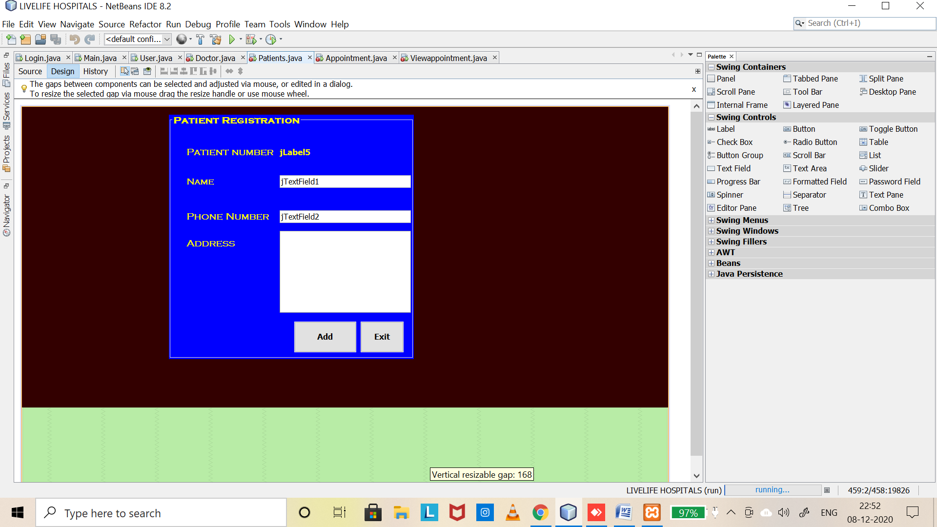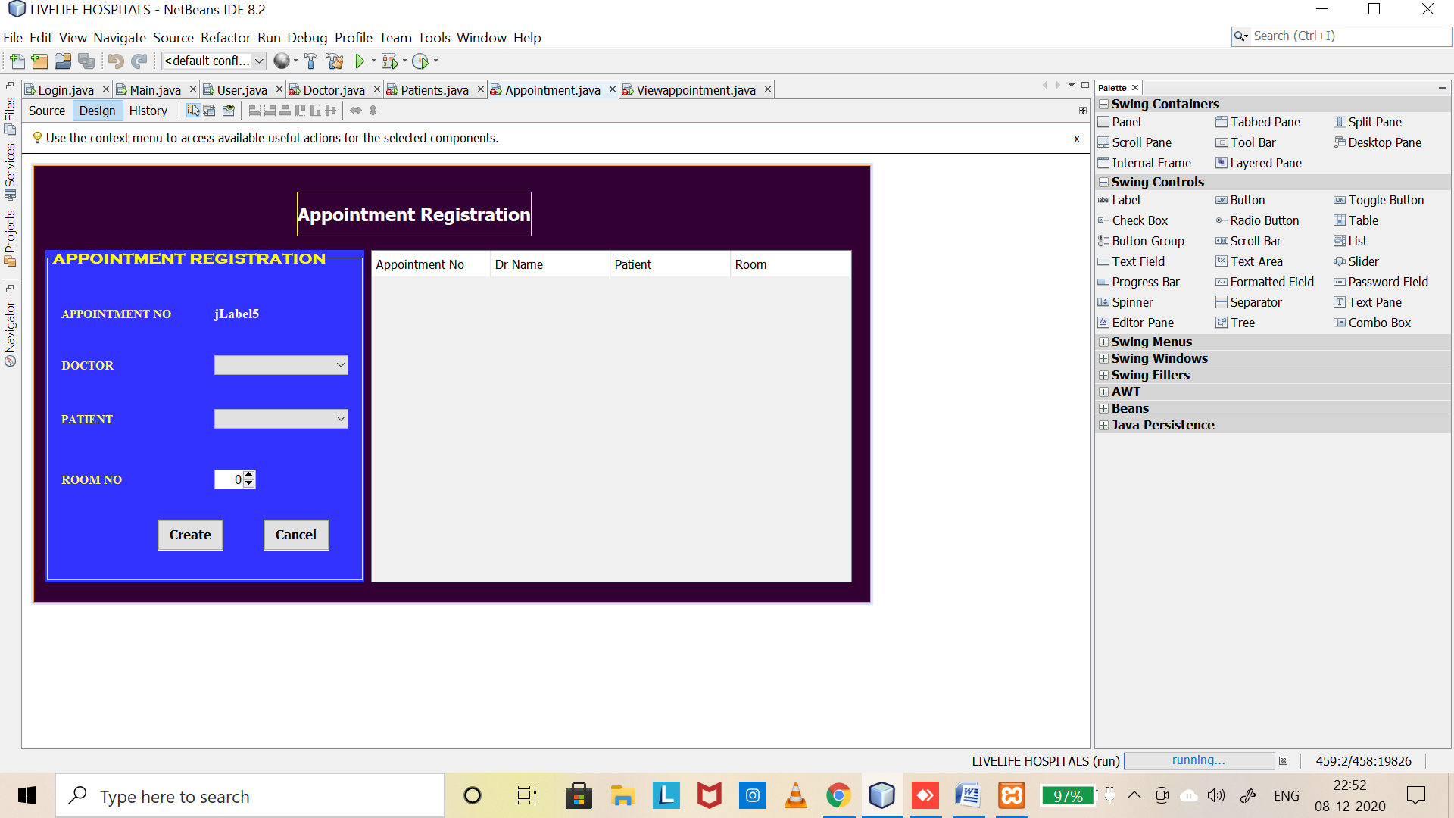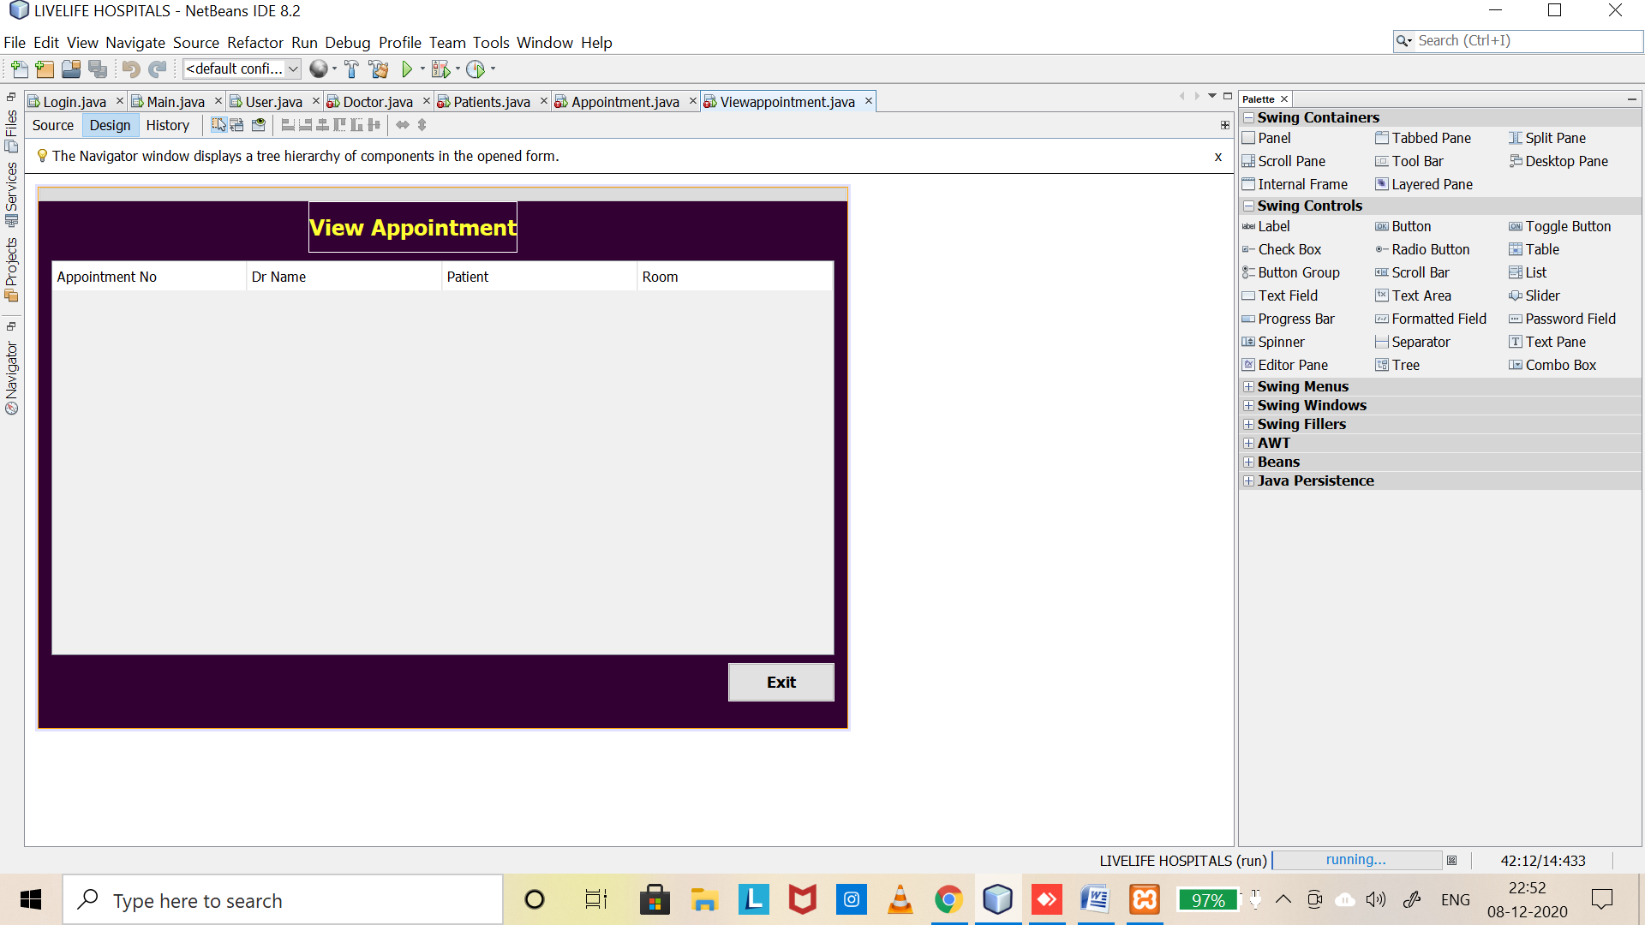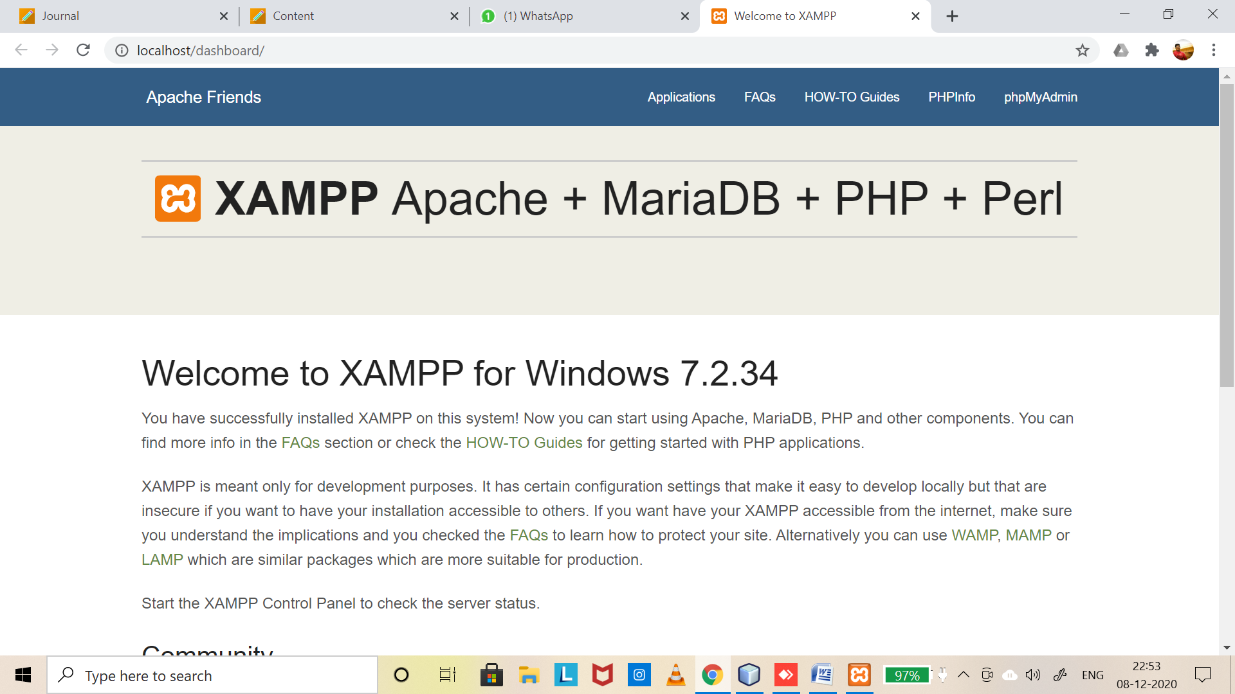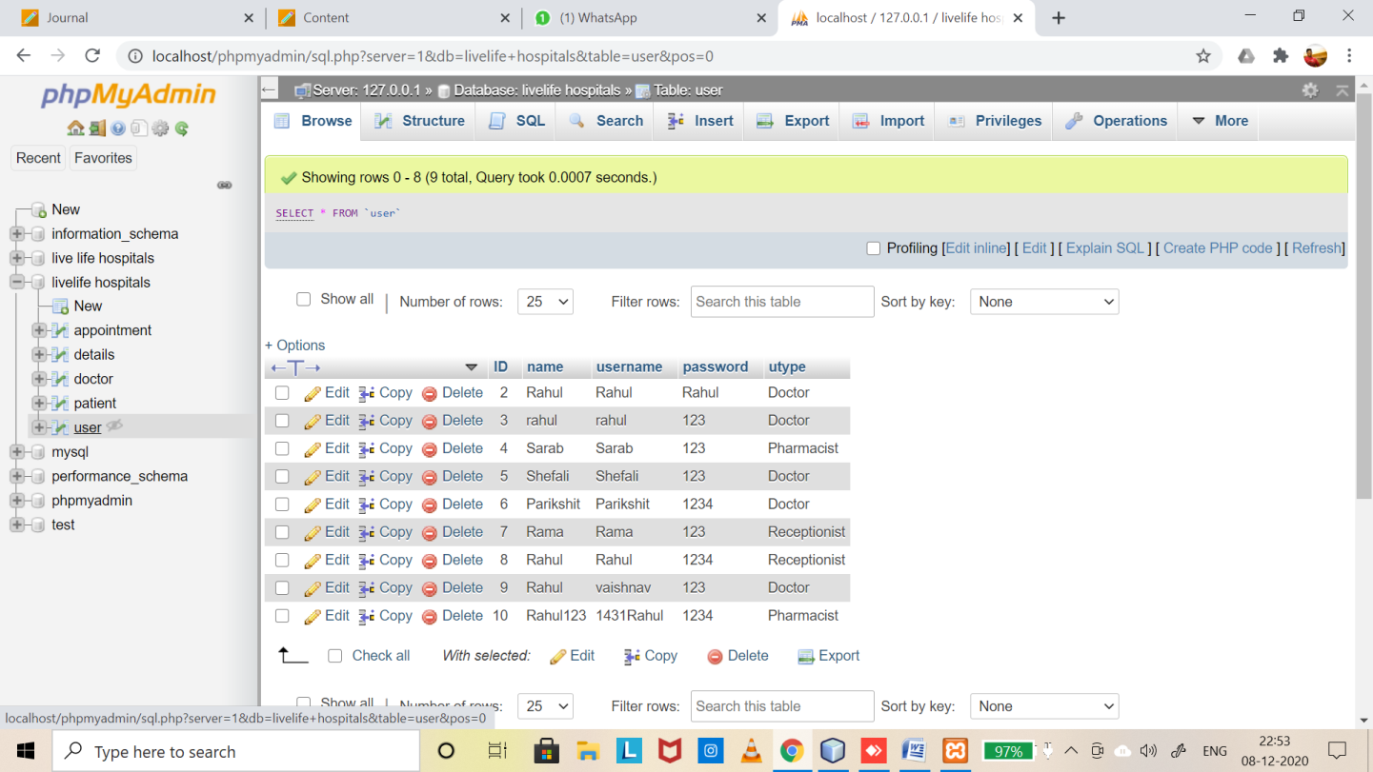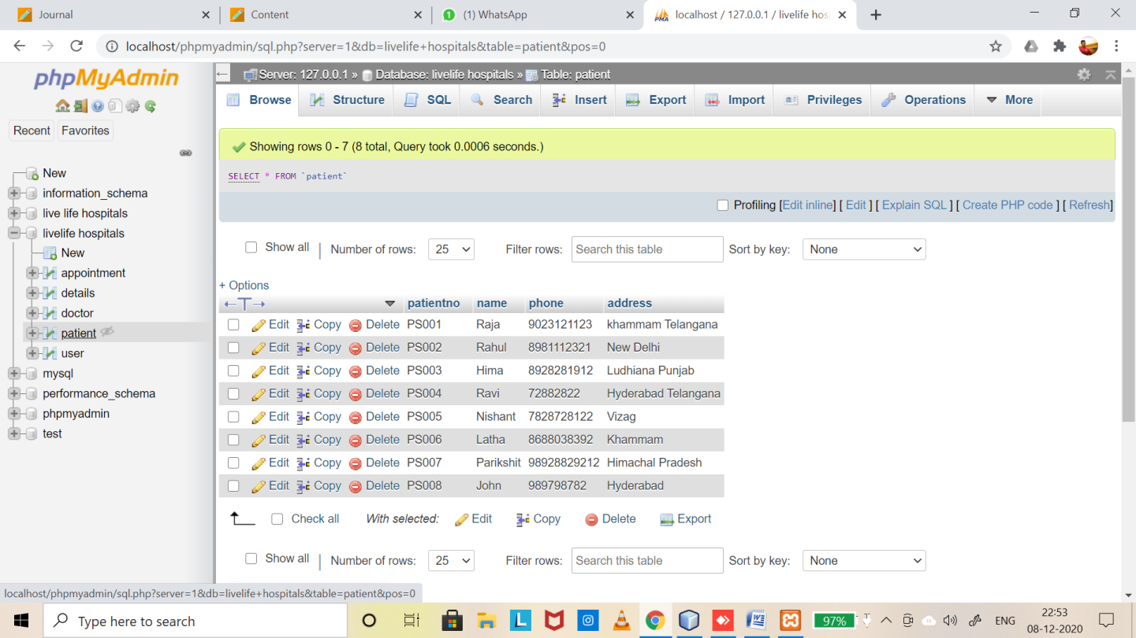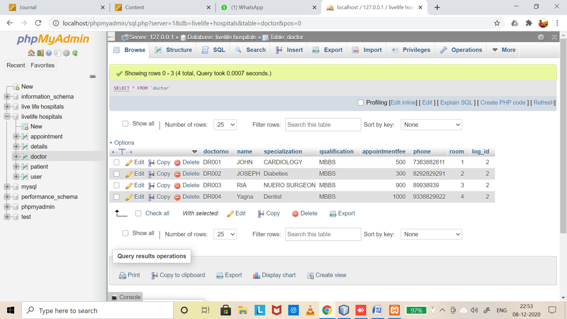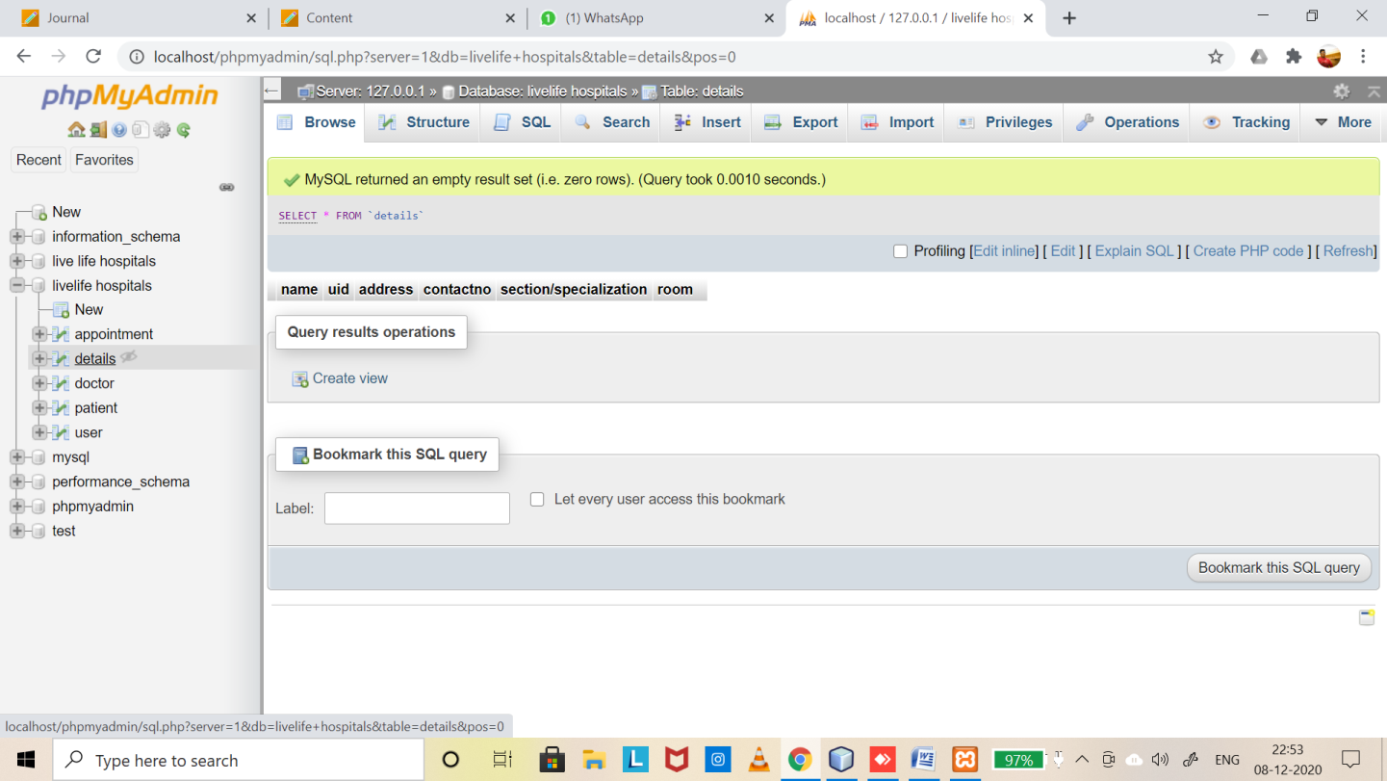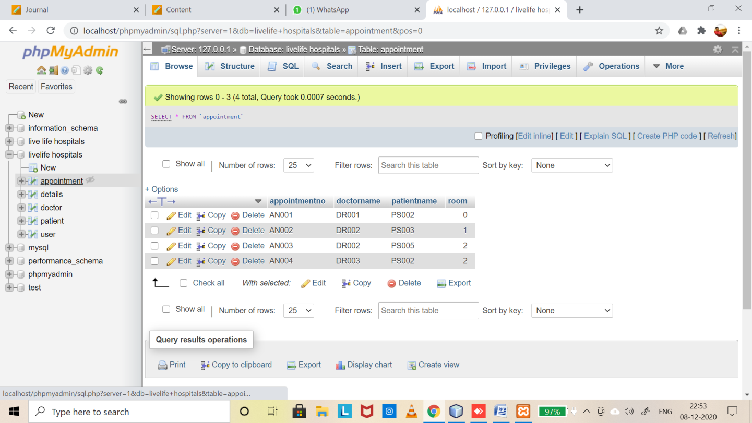

Learning Outcomes:

* I have learnt how to design sung jframe form,database connection,run the project ,store the values into database and create a management system,and I have also learnt the experience of java dbms project and their connectivity.

THANKYOU EVERYONE FOR GIVING ME SUCH WONDERFUL PROJECT .

S.V.N.Rahul

19bcs4539