Requirement - Create a Bapi Program to Change Contract Number Start Date & Contract_Number – End_date and Save the Message into Application log (taken basic Requirement so that we can know how to save Message in Application log ).

**Q). What is Application Log ?**

Application logging records the progress of the execution of an application so that you can Re-Check it later if necessary. We can use the application log to record application-specific events. Use the transaction SLG0 to define entries for your own applications in the application log. Use the transaction SLG1 to analyze the application log.

**First Let’s Create a Application Log using t-code SLG0.**

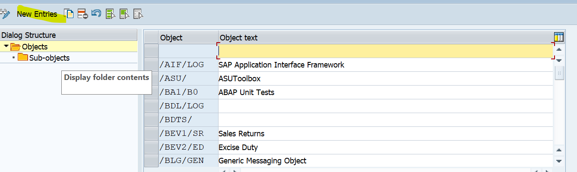

Now Click on New Entries .

Give the Object Name and Description, and click on the Save button.

It will ask for the workbench TR, save it.

Now, After Creating the Object, you will see your Object will display in the main screen of Object Overview.

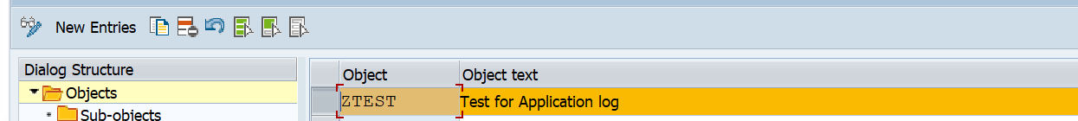

Now select that line and click on Sub-objects to create a Sub-object for that object.

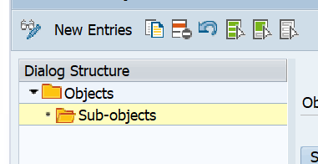

Now, Click on New Entries.

Now go to tcode se24 and create a Global Class in my case it is ZCL_APP_LOG_TEST.

We will create 7 Instance Method:-

1. Constructor Method – to take the Selection Screen Value from the main program, which will call this Global Class.
2. Process_Data method – Where we will write the logic for BAPI to change the Contract Date.
3. Display_data Method – In this method, we will display the Message on the Alv Screen, which will be interactive.
4. F_bal_log_create – This method will create the Application log.
5. F_bal_log_msg_add – This method will add the messages to the application log.
6. F_bal_DB_save – This method will save the data into the application log.
7. User_command – This method is an Event handler Method used to display the application log from the ALV report output.

Global Attributes:-

Constant Class to –

Global Output Structure

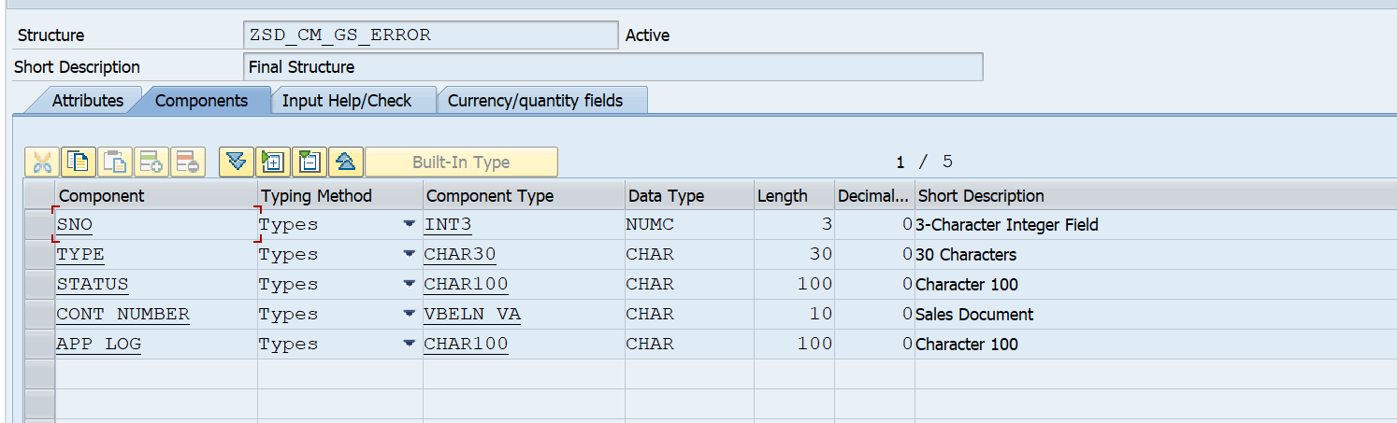

Global table line, which will be the output in ALV:-

Constructor method Code

Define the importing parameter

And code written in the constructor method

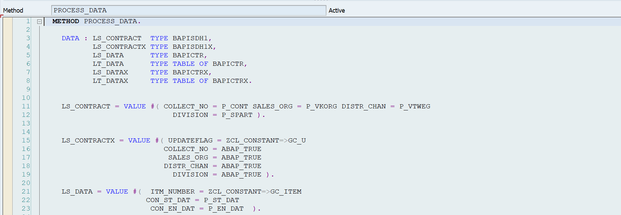

Code for Method Display_data.

Text symbol

Method F_bal_log_Create

Method f_bal_log_msg_add

Method – f_bal_Db_save

For the method user_command, first, we need to define an Event handler to handle interaction.

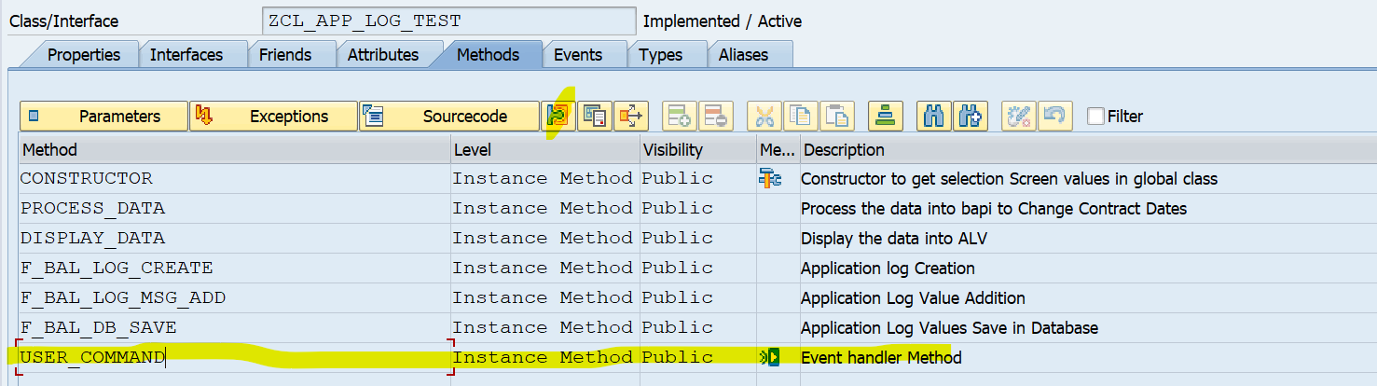

Put cursor on method , then click on properties button.

Give class – cl_Salv_events_table

Event – link_click

Write code in user_command

Now, let's write a program that will call this global program.

Now let’s test our program.

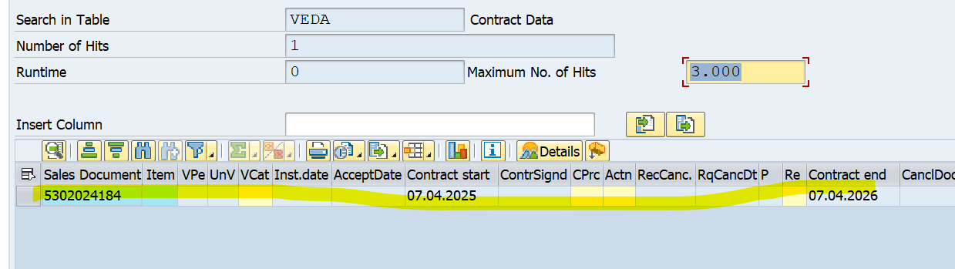

We will test with sales document 5302024184, and we can see the contract start date is 07.04.2025 and the contract end date is 07.04.2026.

Now we try to change the contract date of this sales document of contract start date from 07.04.2025 to 18.04.2025 and contract end date from 07.04.2026 to 18.04.2026.

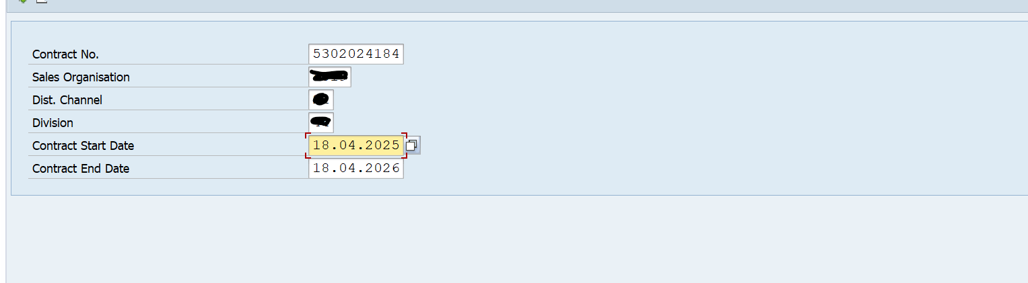

In the selection screen, give the Contract No. , Sales org. , Dist. Channel, division, contract start date, contract end date, and execute the program.

We can see our date has successfully changed.

And let's check in the table.

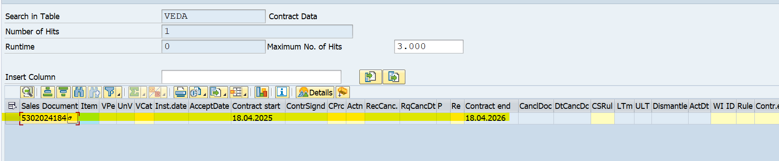

We can see our date has successfully changed.

Now, let's check whether the message is saved in the application log or not.

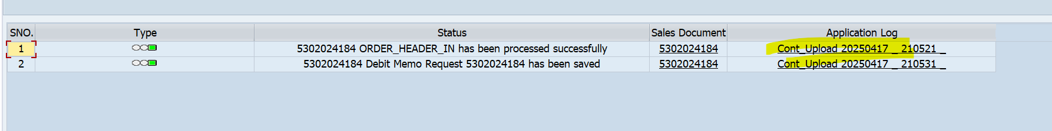

Let's click on any row of the application log.

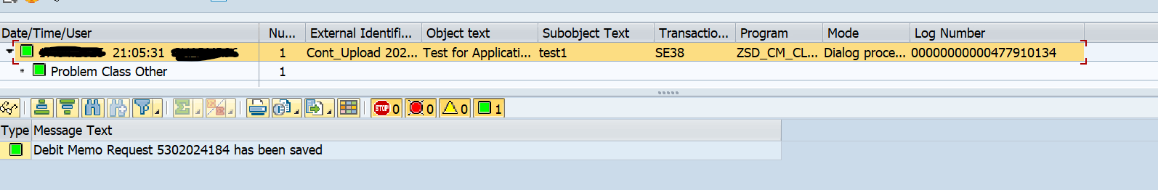

We can see it showing in the application log, and it is also saved.

Now let's check it once through t-code SLG1.

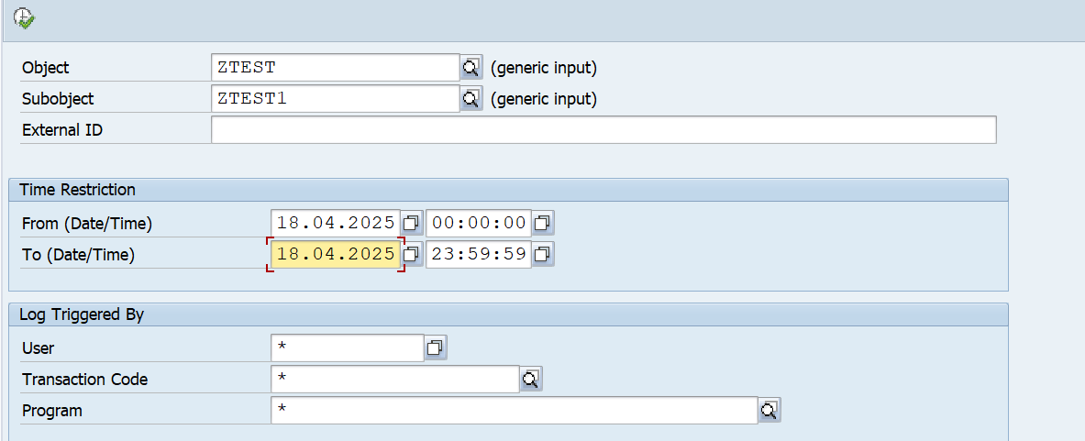

Give the object name and sub-object name that we have created previously.

And run it.

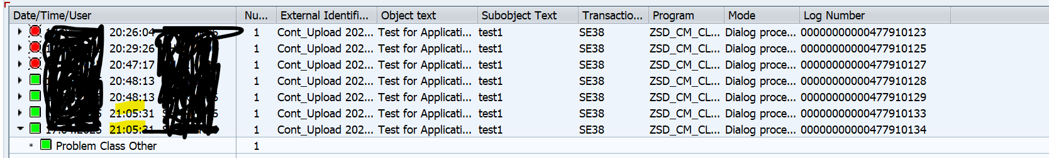

We can see all the entries of 18.04.2024 with time. like this, we can track the logs of any application if we know the object and subobject, and we can see the message.