SUPPLEMENTARY FIGURE LEGENDS

Figure S1. Funnel plots of proportion of cases not reaching bacteriological cure following treatment of clinical mastitis according to selective versus blanket treatment protocols. Standard plot (A), contour plot (B), trimmed and filled (C).

Figure S2. Funnel plots of proportion of cases not reaching clinical cure following treatment of clinical mastitis according to selective versus blanket treatment protocols. Standard plot (A), contour plot (B), trimmed and filled (C).

Figure S3. Funnel plots of ratio of high SCC following treatment of clinical mastitis according to selective versus blanket treatment protocols. Standard plot (A), contour plot (B), trimmed and filled (C).

Figure S4. Funnel plots of difference of milk yield after clinical mastitis following treatment of clinical mastitis according to selective versus blanket treatment protocols. Standard plot (A), contour plot (B), trimmed and filled (C).

Figure S5. Funnel plots of ratio of recurrence of clinical mastitis following treatment of clinical mastitis according to selective versus blanket treatment protocols. Standard plot (A), contour plot (B), trimmed and filled (C).

Figure S6. Funnel plots of difference of days to clinical cure following treatment of clinical mastitis according to selective versus blanket treatment protocols. Standard plot (A), contour plot (B), trimmed and filled (C).

Figure S7. Funnel plots of ratio of new IMI following treatment of clinical mastitis according to selective versus blanket treatment protocols. Standard plot (A), contour plot (B), trimmed and filled (C).

Figure S8. Funnel plots of difference of SCS following treatment of clinical mastitis according to selective versus blanket treatment protocols. Standard plot (A), contour plot (B), trimmed and filled (C).

Figure S9. Funnel plots of ratio of culling rate after clinical mastitis following treatment of clinical mastitis according to selective versus blanket treatment protocols. Standard plot (A), contour plot (B), trimmed and filled (C).
Fig. S1
 | A | 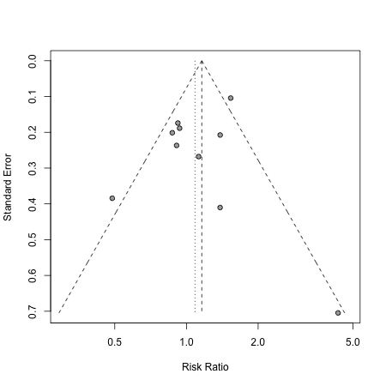
B | 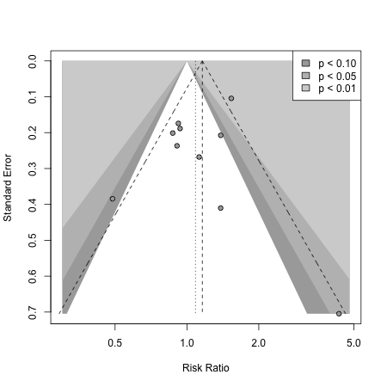 |  | C | 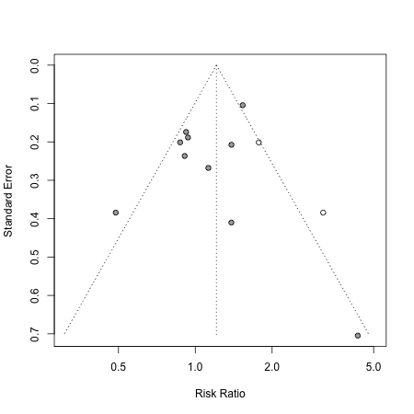

Fig. S2
 | A | 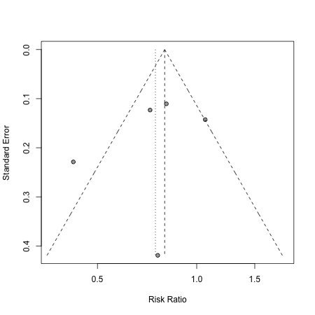
B | 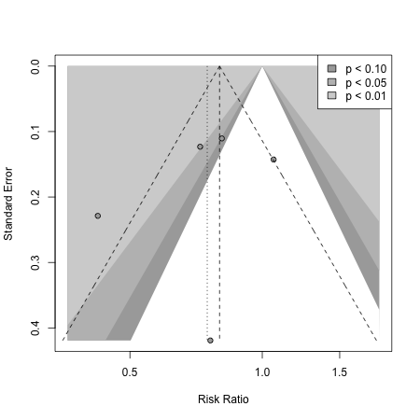 |  | C | 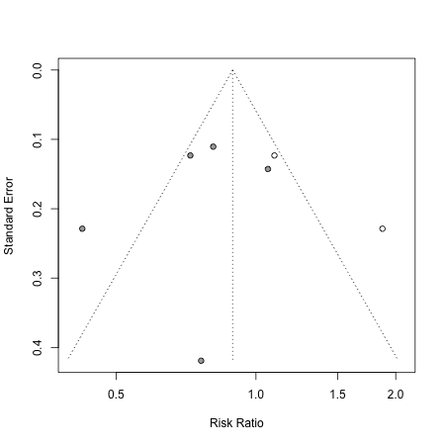
Fig S3
 | A | 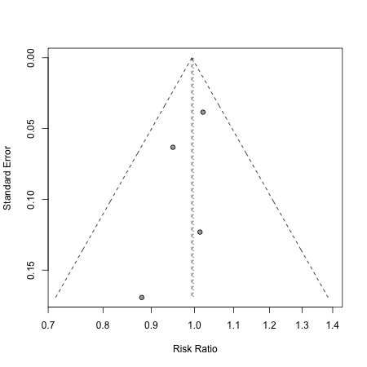
B | 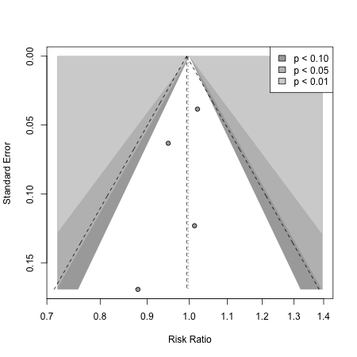 |  | C | 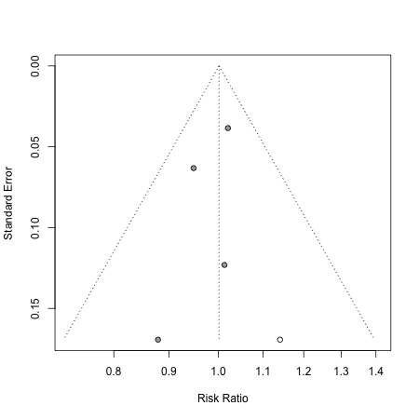

Fig. S4
 | A | 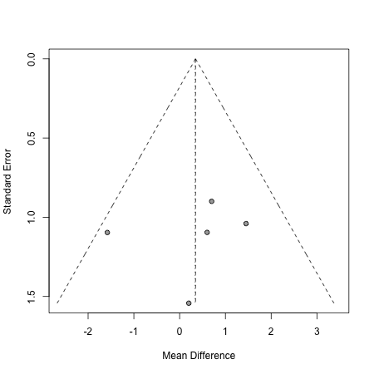
B | 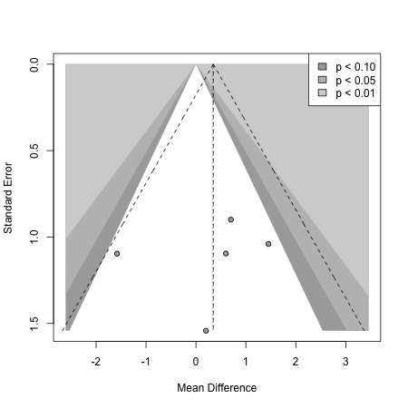 |  | C | 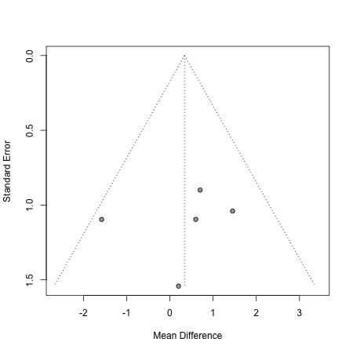
Fig. S5
 | A | 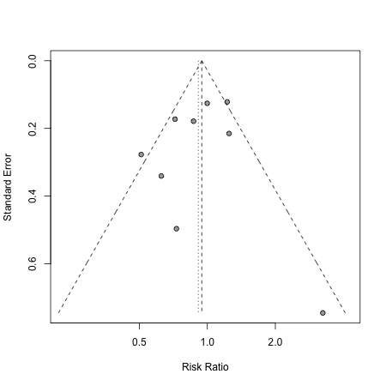
B | 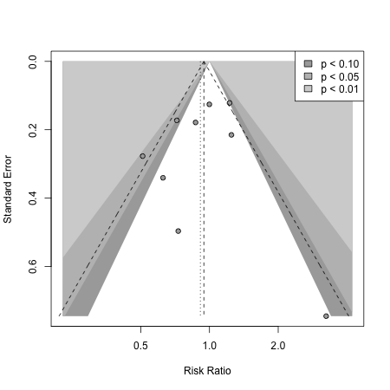 |  | C | 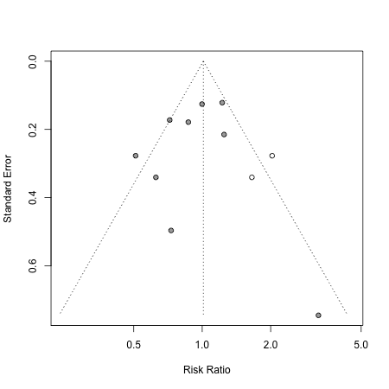

Fig. S6
 | A | 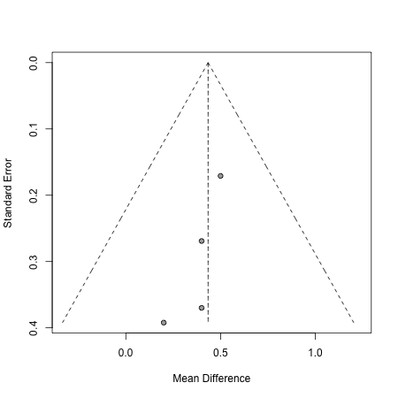
B | 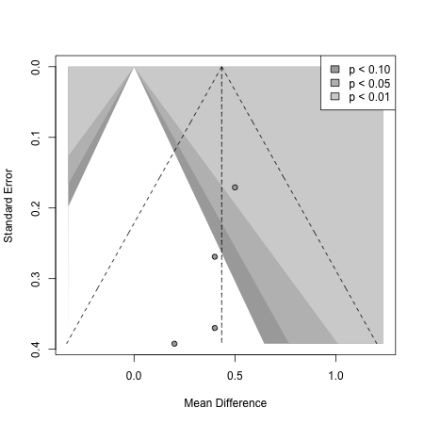 |  | C | 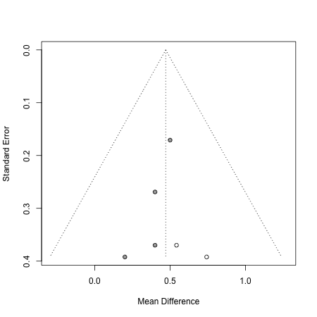

Fig. S7
 | A | 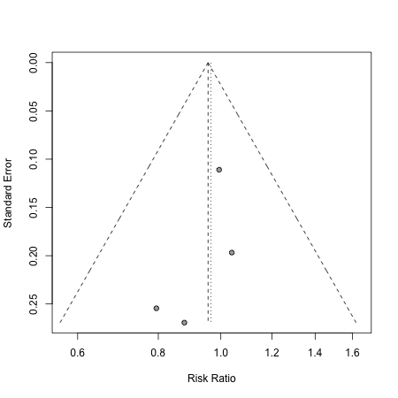
B | 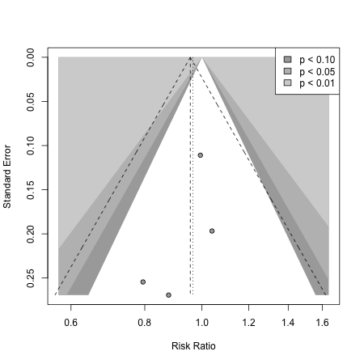 |  | C | 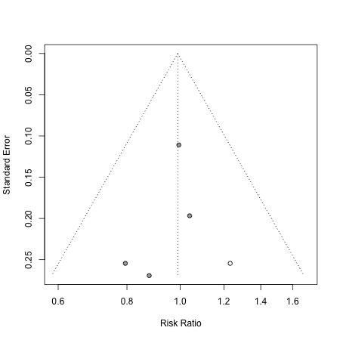

Fig. S8
 | A | 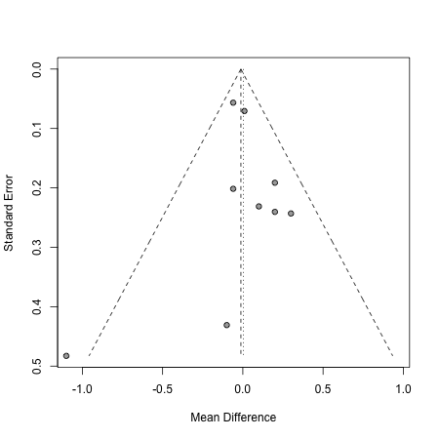
B | 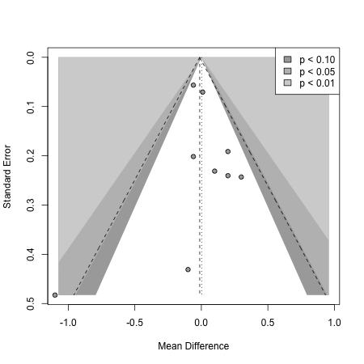 |  | C | 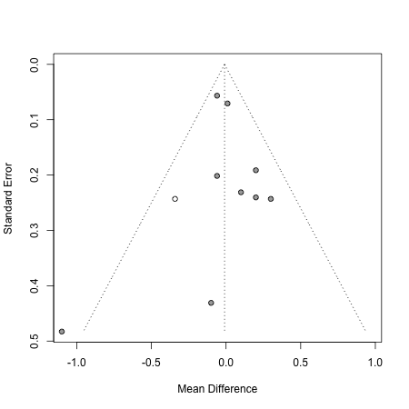

Fig. S9
 | A | 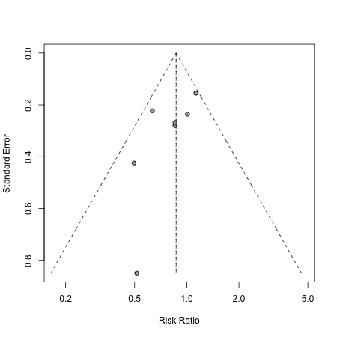
B | 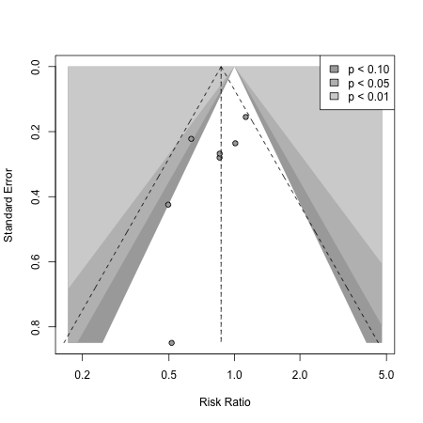 |  | C | 