CREATE TABLE best_10_places (
Place_Name VARCHAR(100),
Activity VARCHAR(100),
Ranking_Position INT,
Closest_City VARCHAR(100)
);

INSERT INTO best_10_places (Place_Name, Activity, Ranking_Position, Closest_City)
VALUES
('Praia do Sepultura', 'snorkeling', 1, 'Florianopolis'),
('Hanauma Bay', 'snorkeling', 2, 'Honolulu'),
('Elliot Island', 'snorkeling', 3, 'Melbourne'),
('Cerro Catedral', 'skiing', 1, 'Bariloche'),
('Camino de Santiago', 'trekking', 1, 'Compostela'),
('Cerro Otto', 'trekking', 2, 'Bariloche'),
('Black Vulcano', 'trekking', 3, 'Honolulu');

CREATE TABLE one_way_ticket (
City_Origin VARCHAR(100),
City_Destination VARCHAR(100),
Ticket_Price DECIMAL(10, 2),
Travel_Time VARCHAR(20),
Transportation VARCHAR(100)
);

INSERT INTO one_way_ticket (City_Origin, City_Destination, Ticket_Price, Travel_Time, Transportation)
VALUES
('Paris', 'Florianopolis', 830.00, '11hr 30 min', 'air'),
('Paris', 'Honolulu', 1564.00, '15hr 20 min', 'air'),
('Paris', 'Melbourne', 2200.00, '18hr 50min', 'air'),
('Paris', 'Bariloche', 970.00, '12hr 20 min', 'air'),
('Madrid', 'Compostela', 80.00, '1hr 10min', 'air');

select * from best_10_places
select * from one_way_ticket

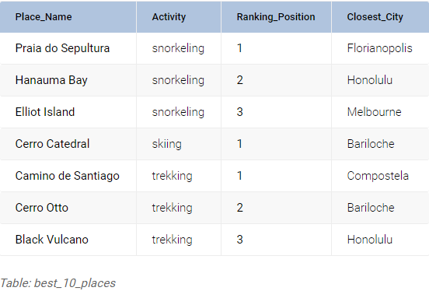

If you want to travel to any of these beautiful places, you’ll need a ticket; We will use Below table to determine how to get from one city to another

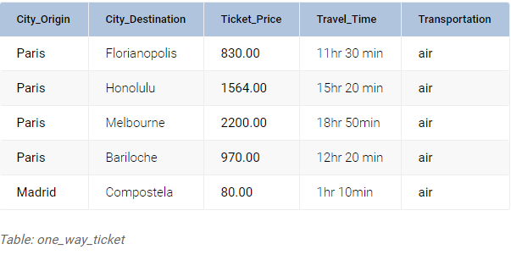

Q1:- Suppose a person in Paris wants to go to the #1 place in the world for snorkeling. What type of transportation goes from Paris to this place?

So Output is

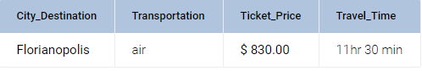

Q2:- Suppose you have a customer who wants to go from Paris to Bariloche. Before buying the ticket, the customer wants to see if there are any places with a cheaper ticket.

Final Output
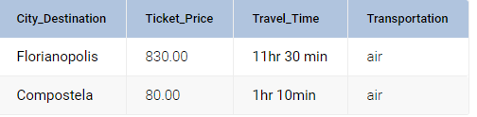
.

Q3 suppose the person who asked about the best place for snorkeling wants to explore other destinations; in fact, they’d like to see the top three snorkeling places.
Final Output
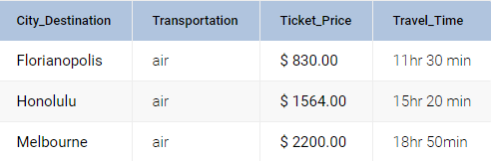

Q5 Suppose the travel agency’s owner wants to show every city along with the ticket cost and the number of “best places” near this city.
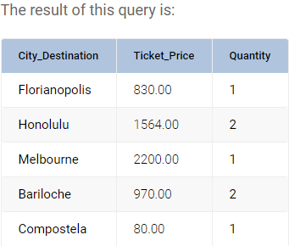

The ALL and ANY operators
This pair of operators works in conjunction with the =, <>, >, >=, < and <= operators,
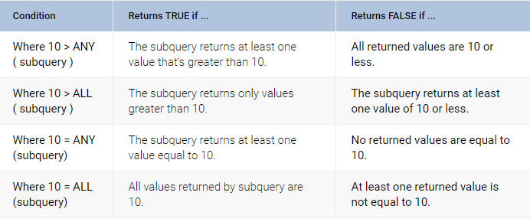

Q7:- Suppose we want to promote all the “world’s best places” you can visit with a ticket under $1,000. Each “best place” in the table best_10_places can have many possible tickets; we are only interested in those places where at least one ticket costs less than $1000.

