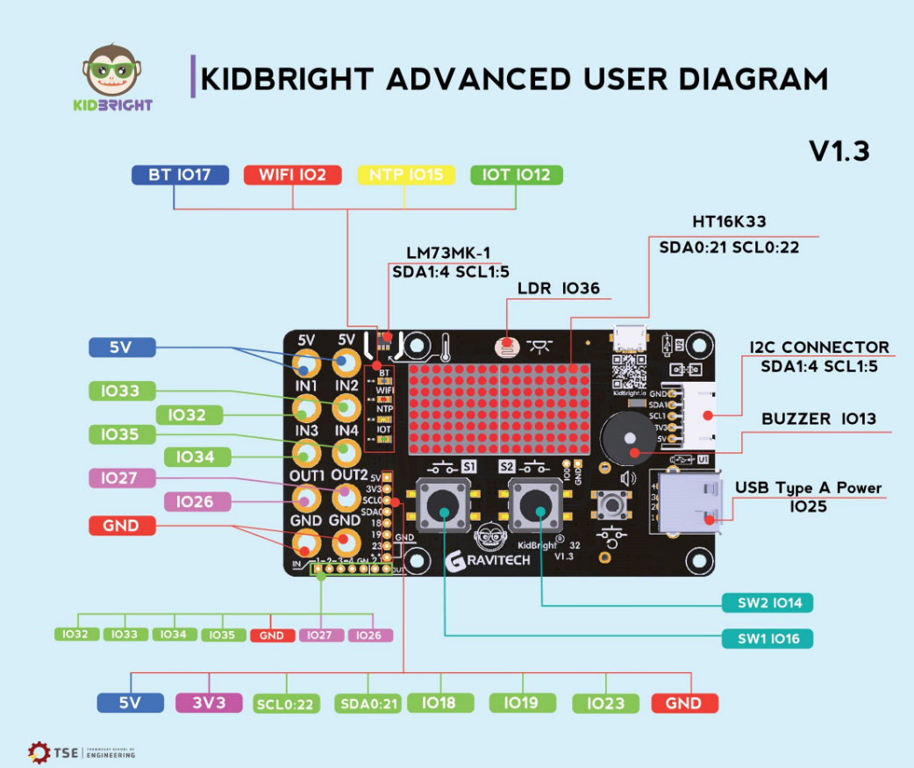

<https://www.instructables.com/id/Pocket-Size-Ultrasonic-Measuring-Tool-With-ESP32/>

<http://quantum.engr.tu.ac.th/smf/index.php?board=8.0>