**Project Report** on

**Programming in Python**



Submitted By:

**RAJ CHETRY(CS23BCAGN009)**

**BCA 4th SEM**

**School of Computing Sciences**

**The Assam Kaziranga University ,Jorhat, Assam**

**Table of Contents**

1.Arithmetic and Quadratic Operation (Project 1)

2.Linear Equation Solver (Project 2)

3.Mathematical Graph (Star Pattern) (Project 3)

4.Function Implementation (Project 4)

5.Tkinter Game: Snake (Project 5)

# Project-1

1. Write a program using python showing implementation of any arithmetic and quadratic operation.

Ans:- This program performs basic arithmetic operations like addition, subtraction, multiplication, division and also solves quadratic equations using the quadratic formula.

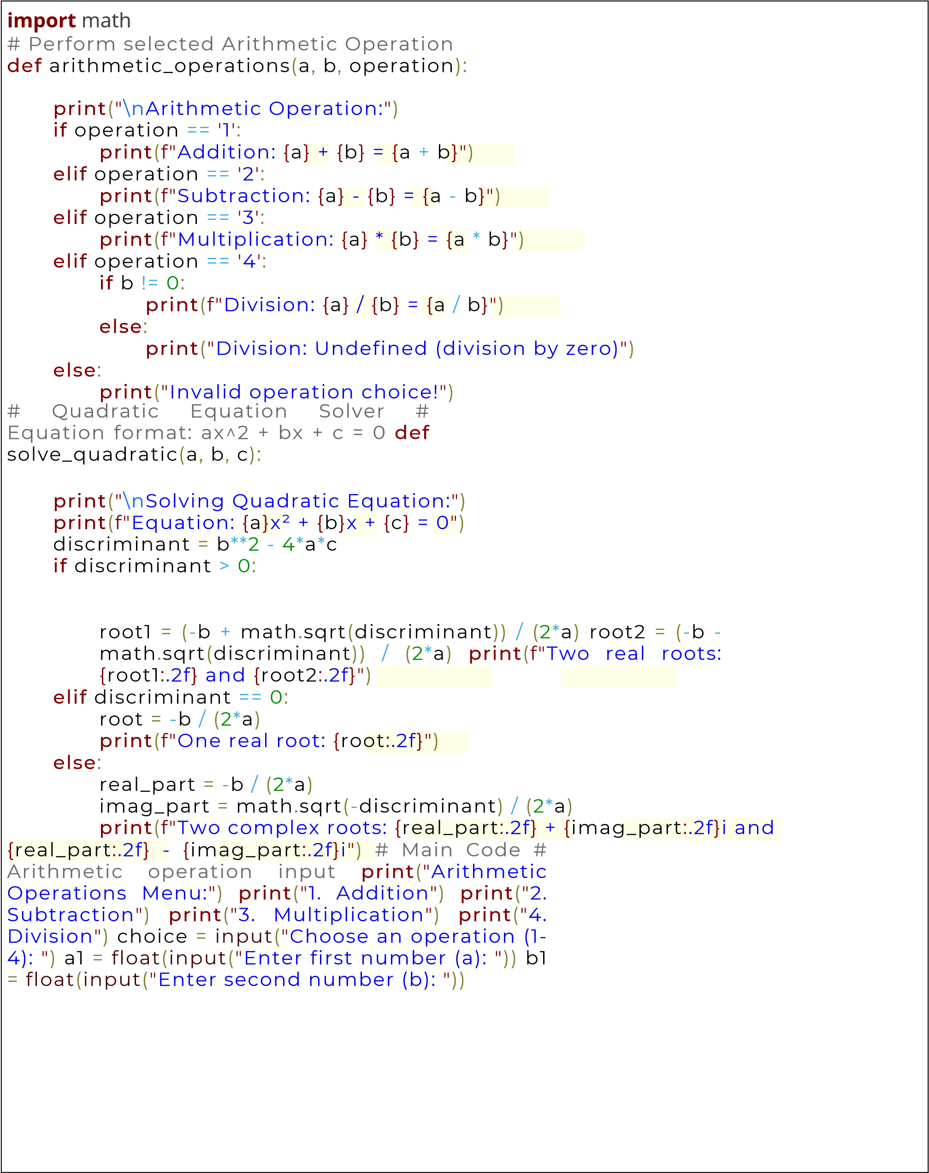

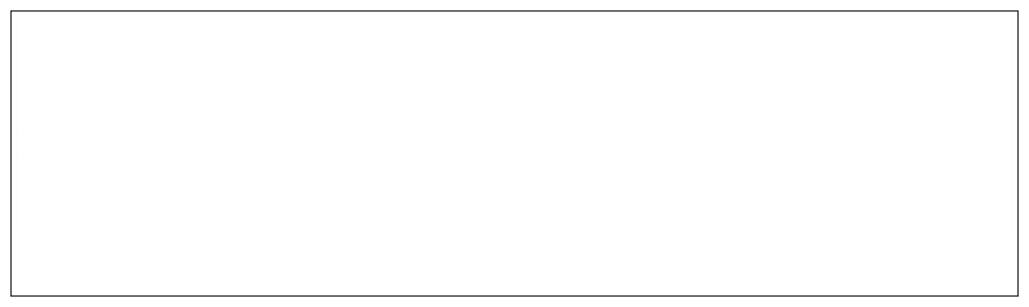

arithmetic_operations

(

a1

,

b1

,

choice

)

#

Quadratic

equation

input

print

(

"

\n

Enter

coefficients

for

quadratic

equation

ax²

+

bx

+

c

=

0:

"

)

a2

=

float

(

input

(

"

Enter coefficient a:

"

))

b2

=

float

(

input

(

"

Enter coefficient b:

"

))

c2

=

float

(

input

(

"

Enter coefficient c:

"

))

solve_quadratic

(

a2

,

b2

,

c2

)

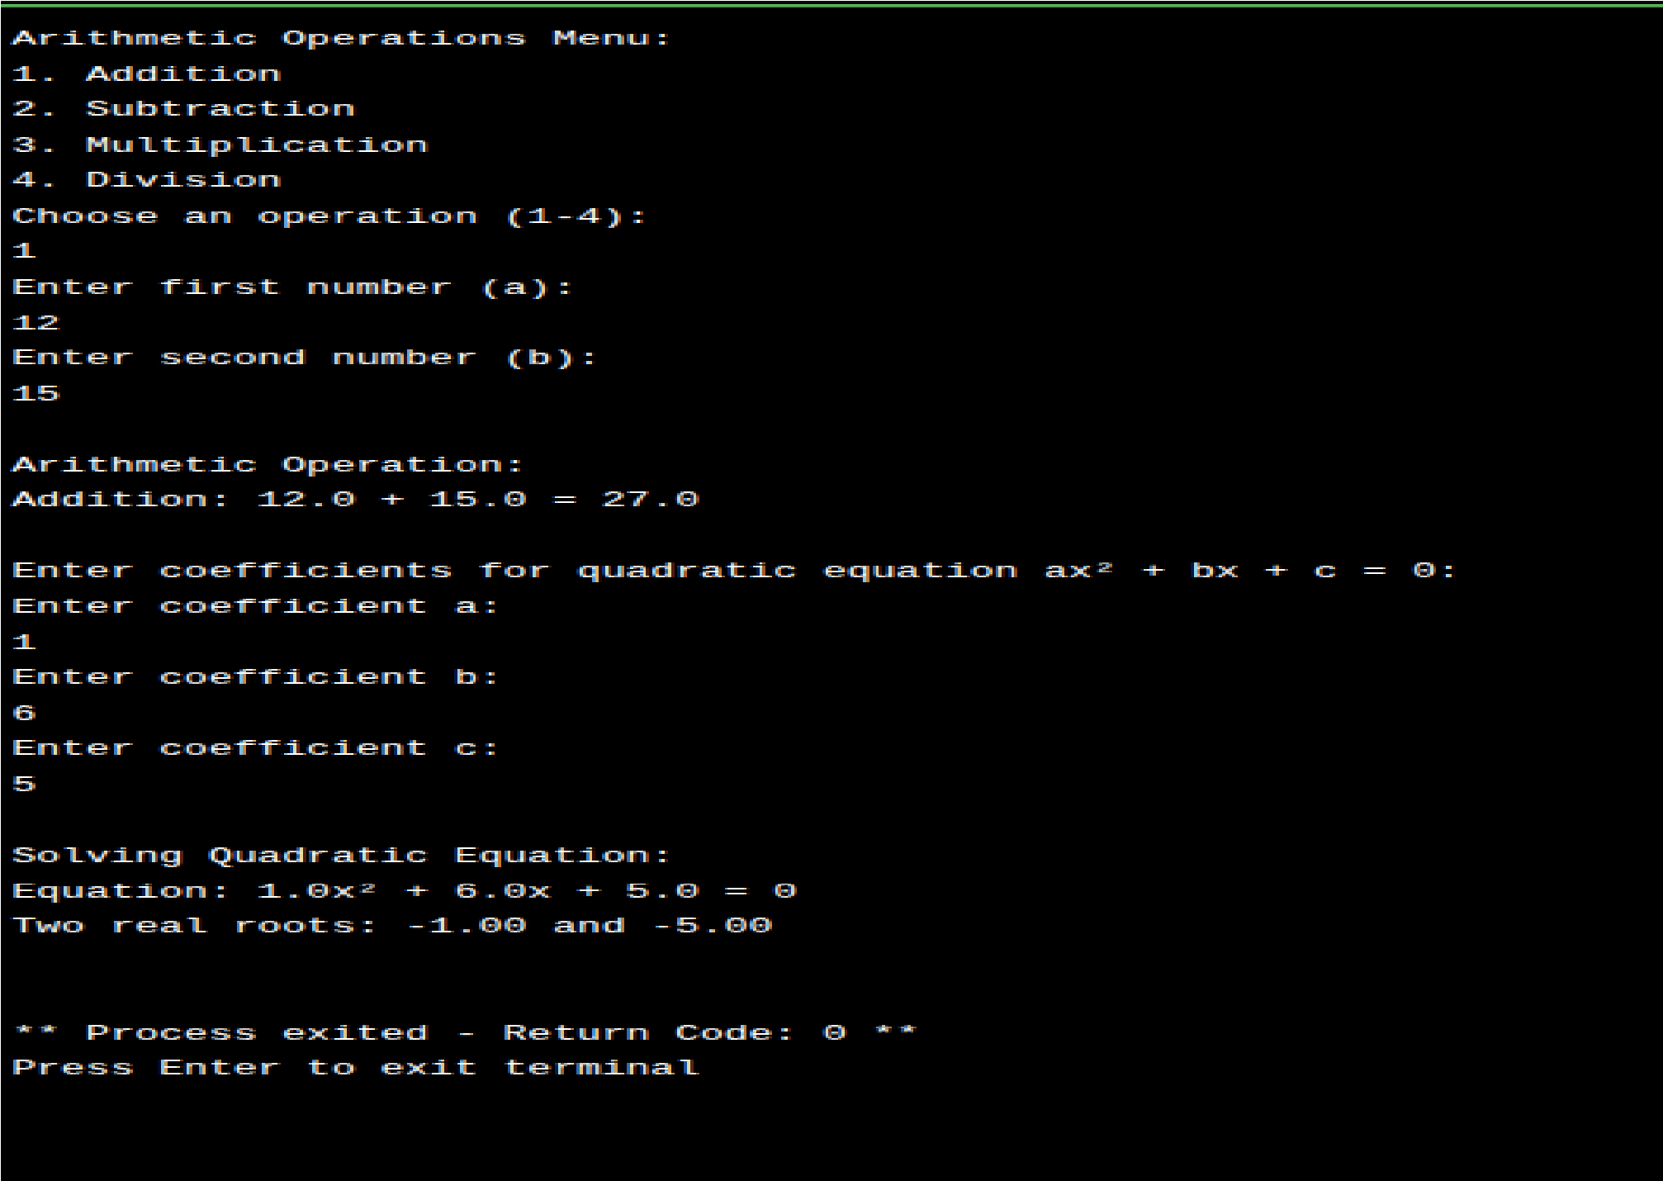

Output:-

# Project-2

2.Write a Python program showing implementation of linear equation.

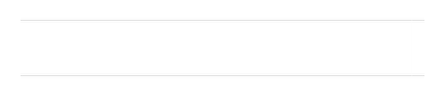Ans:- Solves a system of two linear equations with two variables using **NumPy**. The program uses matrix representation and applies **numpy.linalg.solve** to find the values of x and y that satisfy both equations.

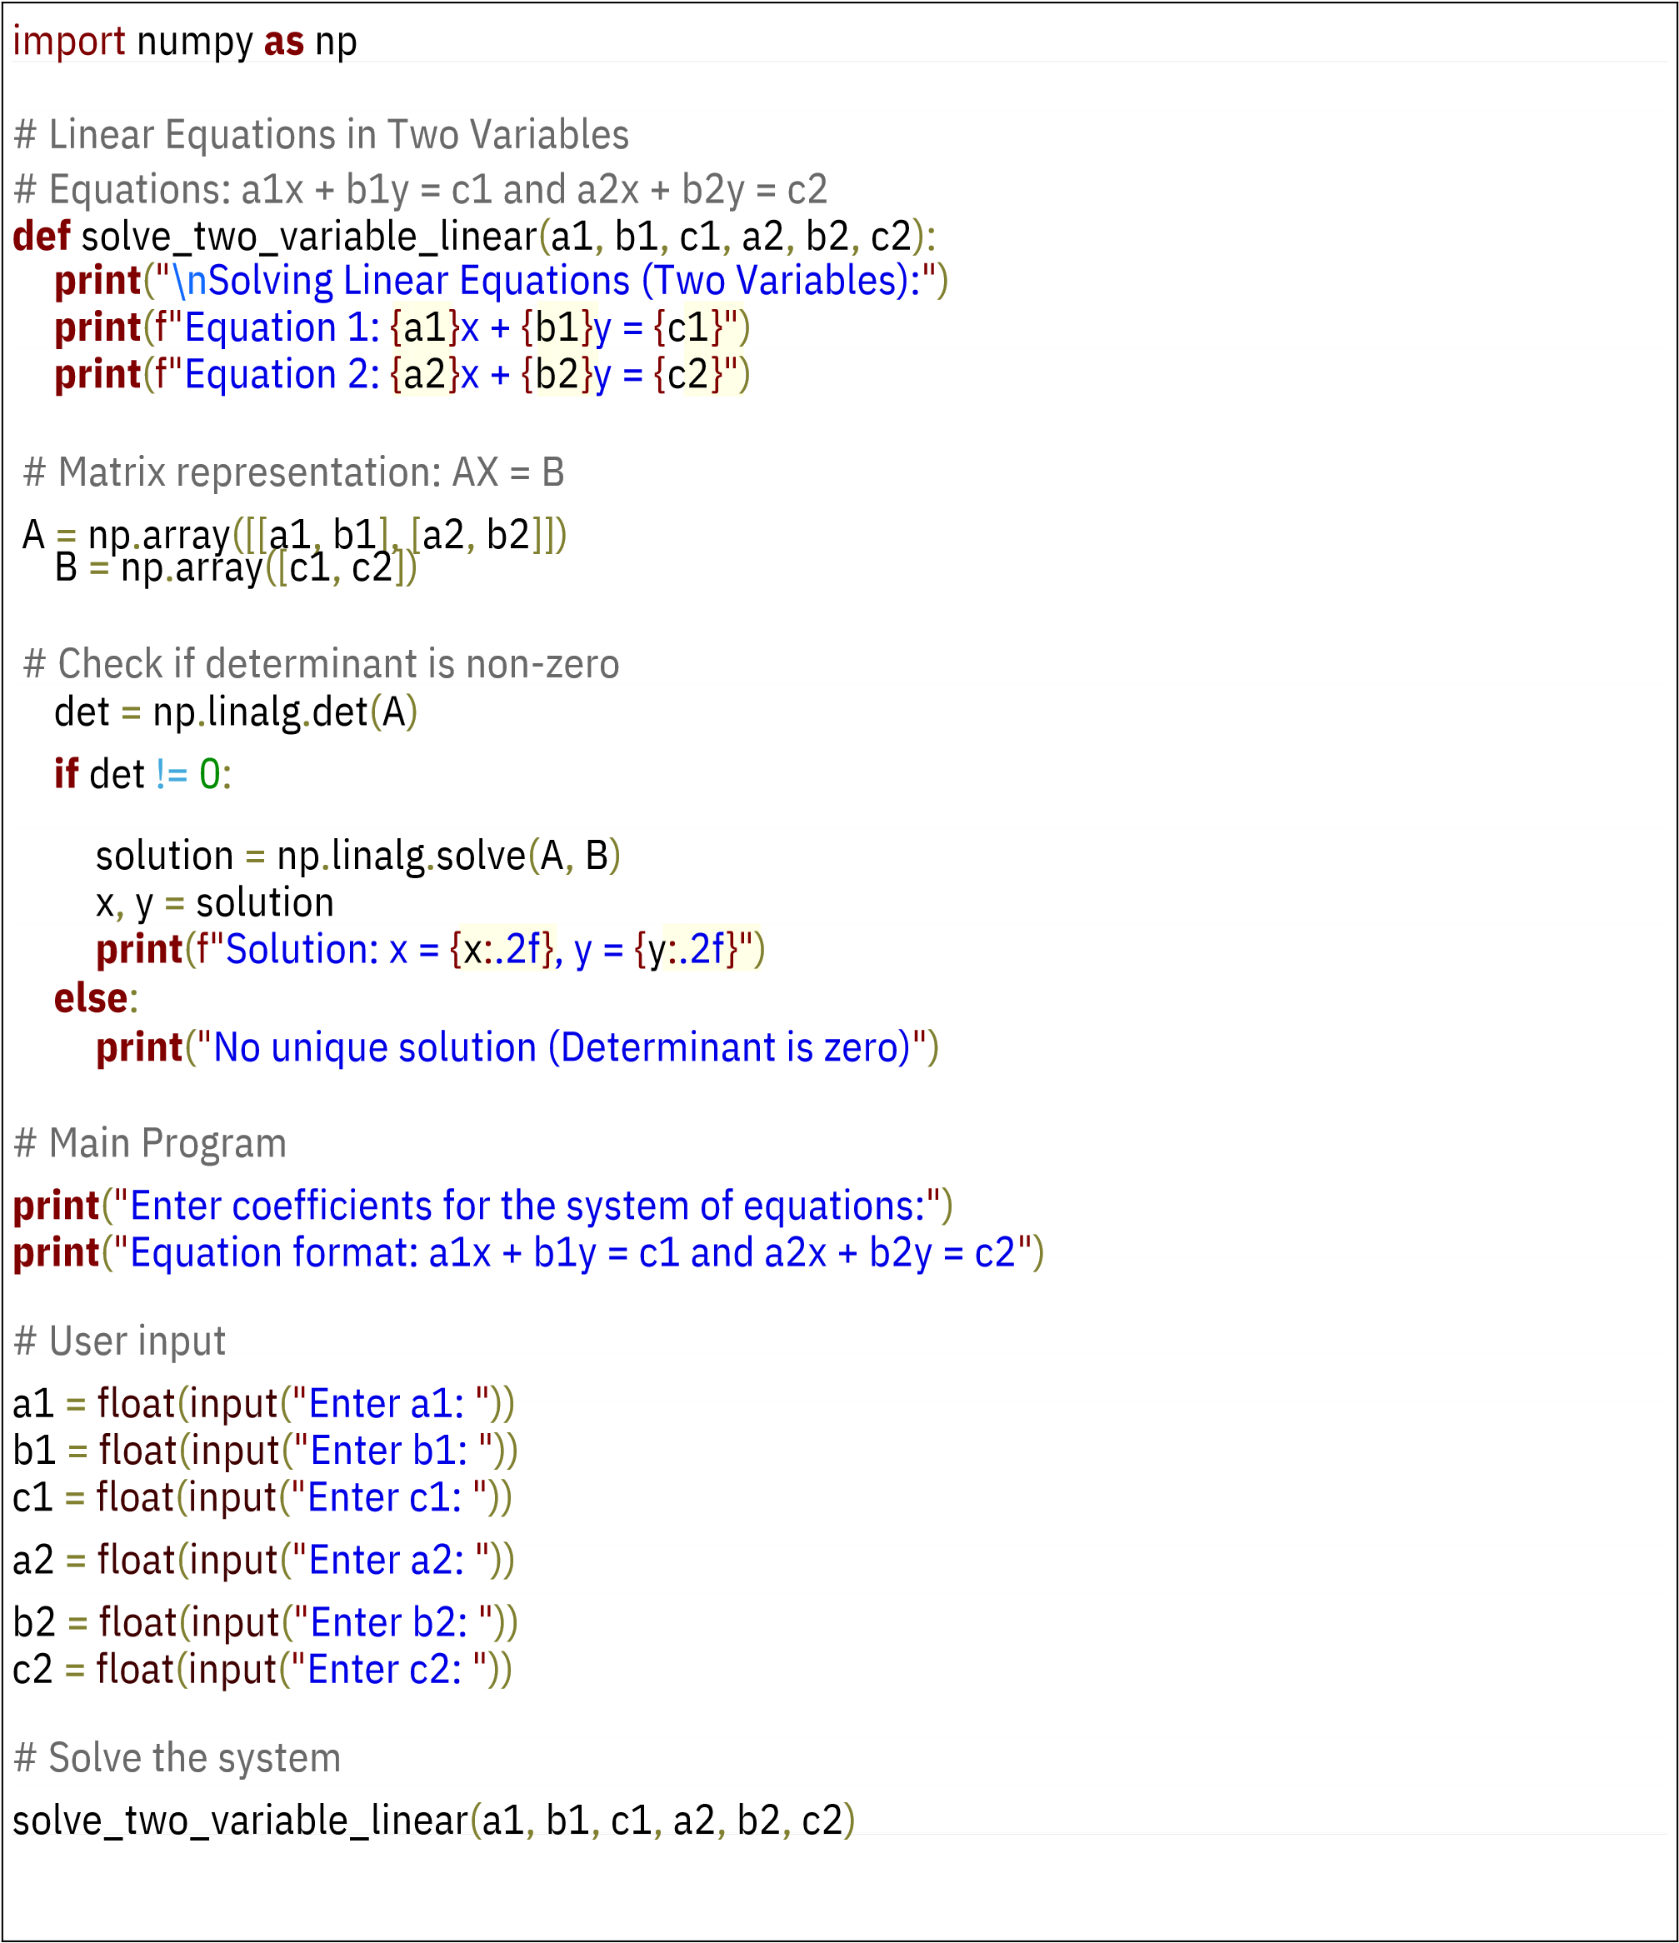

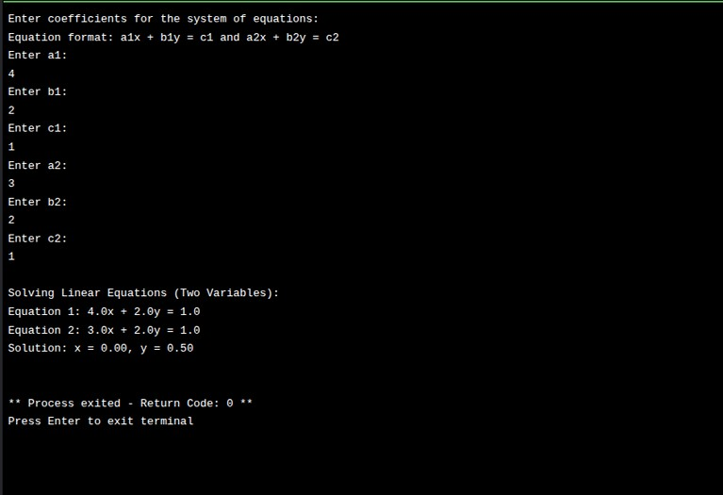

**Output:-**

# Project-3

3. Write a python program using any mathematical function or equation to give graphical representation like star graph.

Ans:- This Python script uses **matplotlib** to generate a star-shaped polar graph. It demonstrates the use of mathematical equations for plotting complex visual patterns. Ideal for learning how to represent equations graphically.

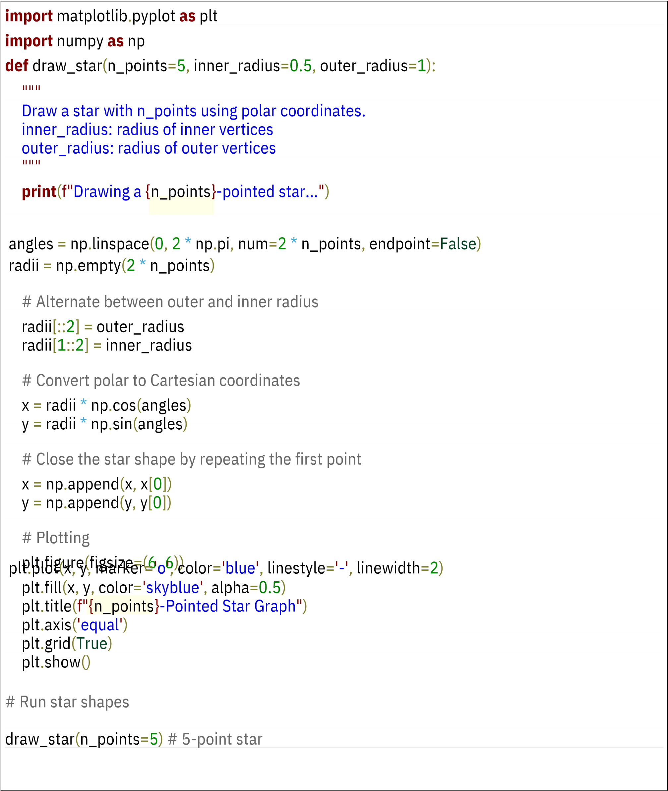



Output:-

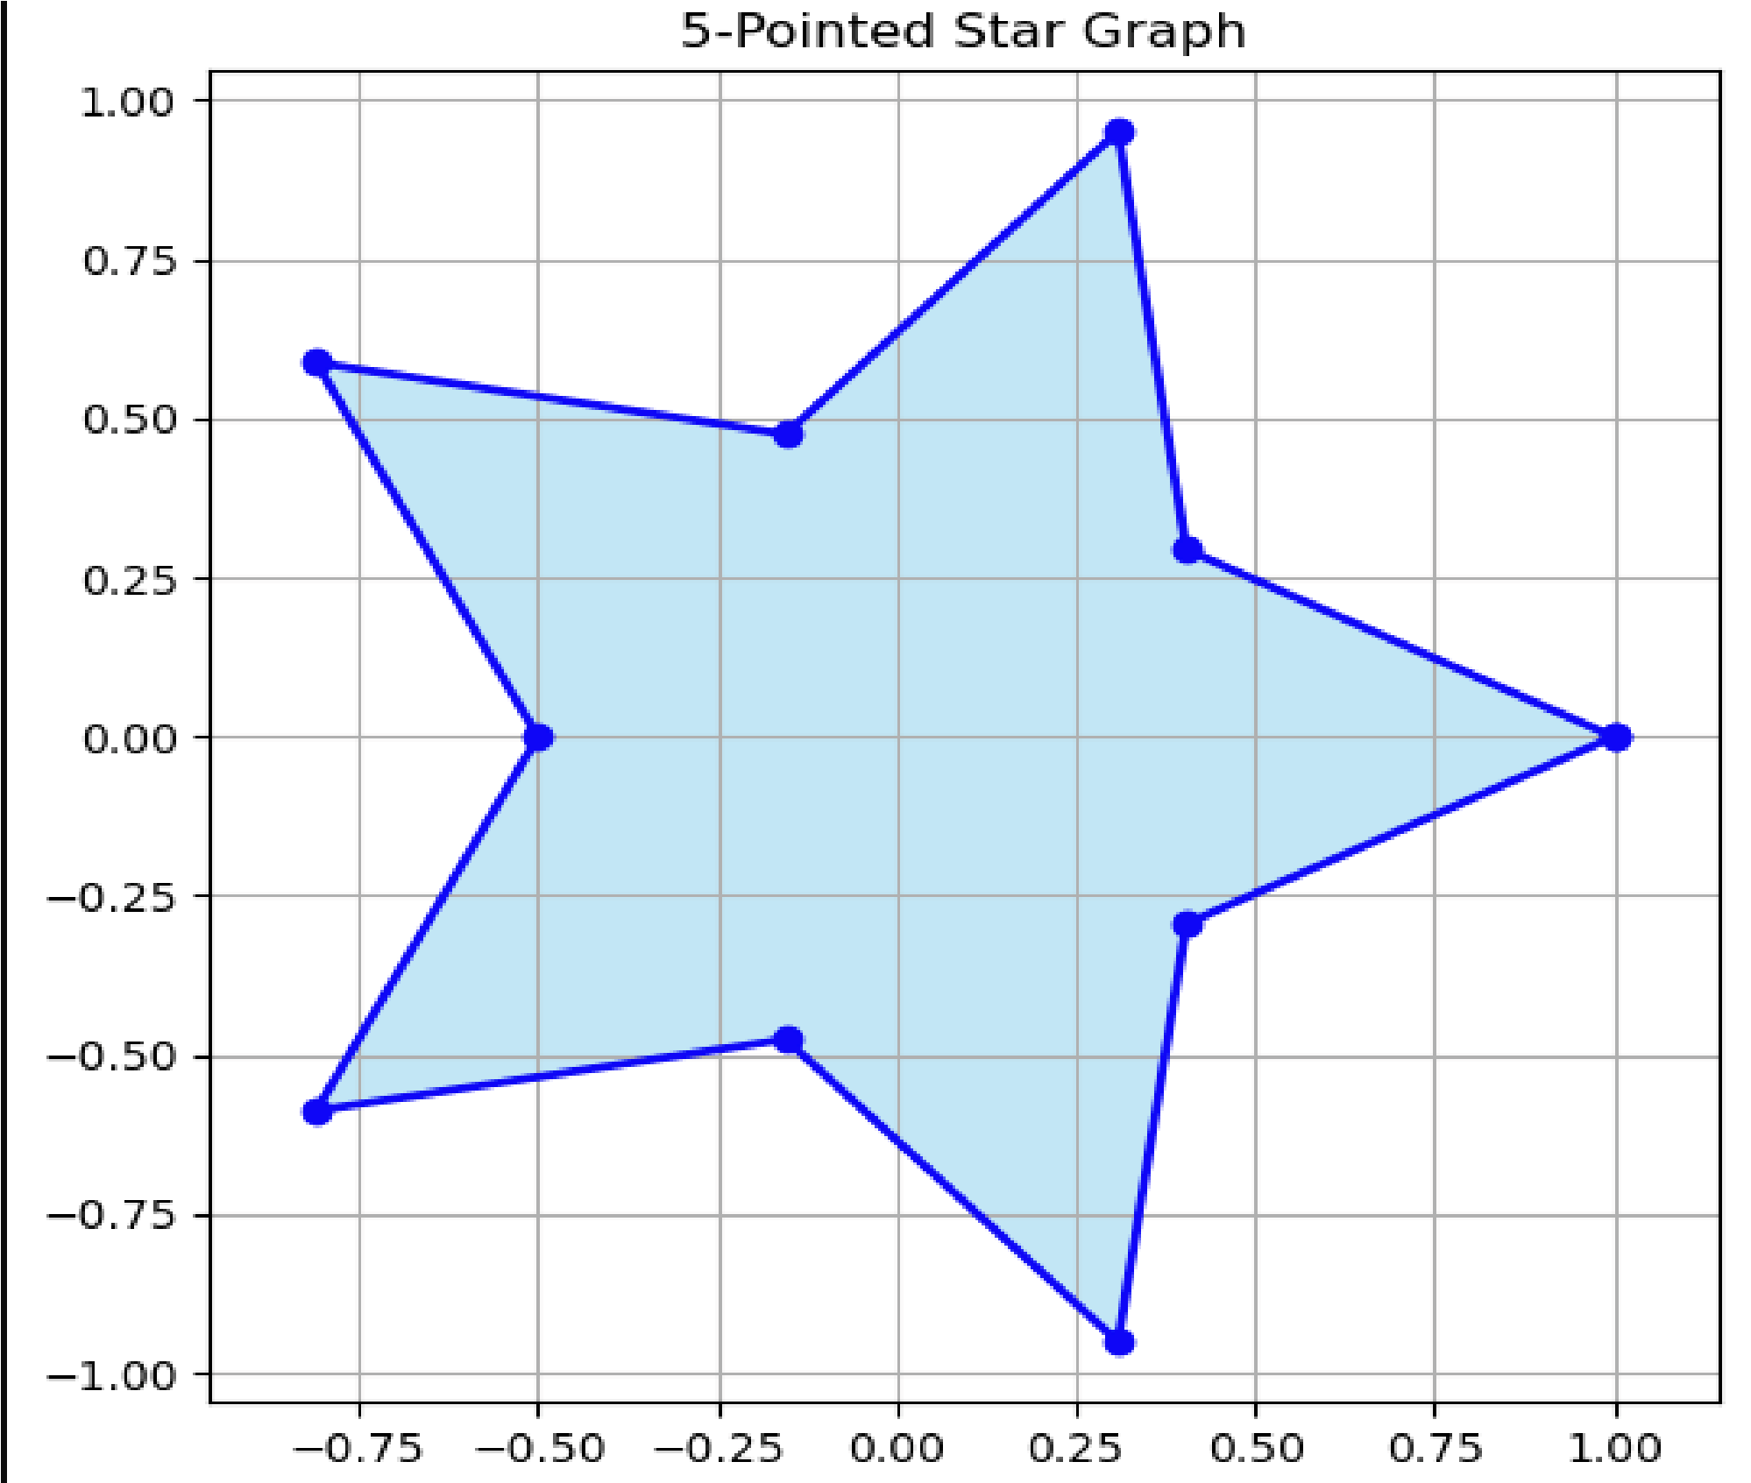

# Project-4

4. Write a python program showing the implementation of a function.

Ans:- This Python program demonstrates the use of simple functions to perform basic tasks:

addition, squaring a number, and checking if a number is even or odd.

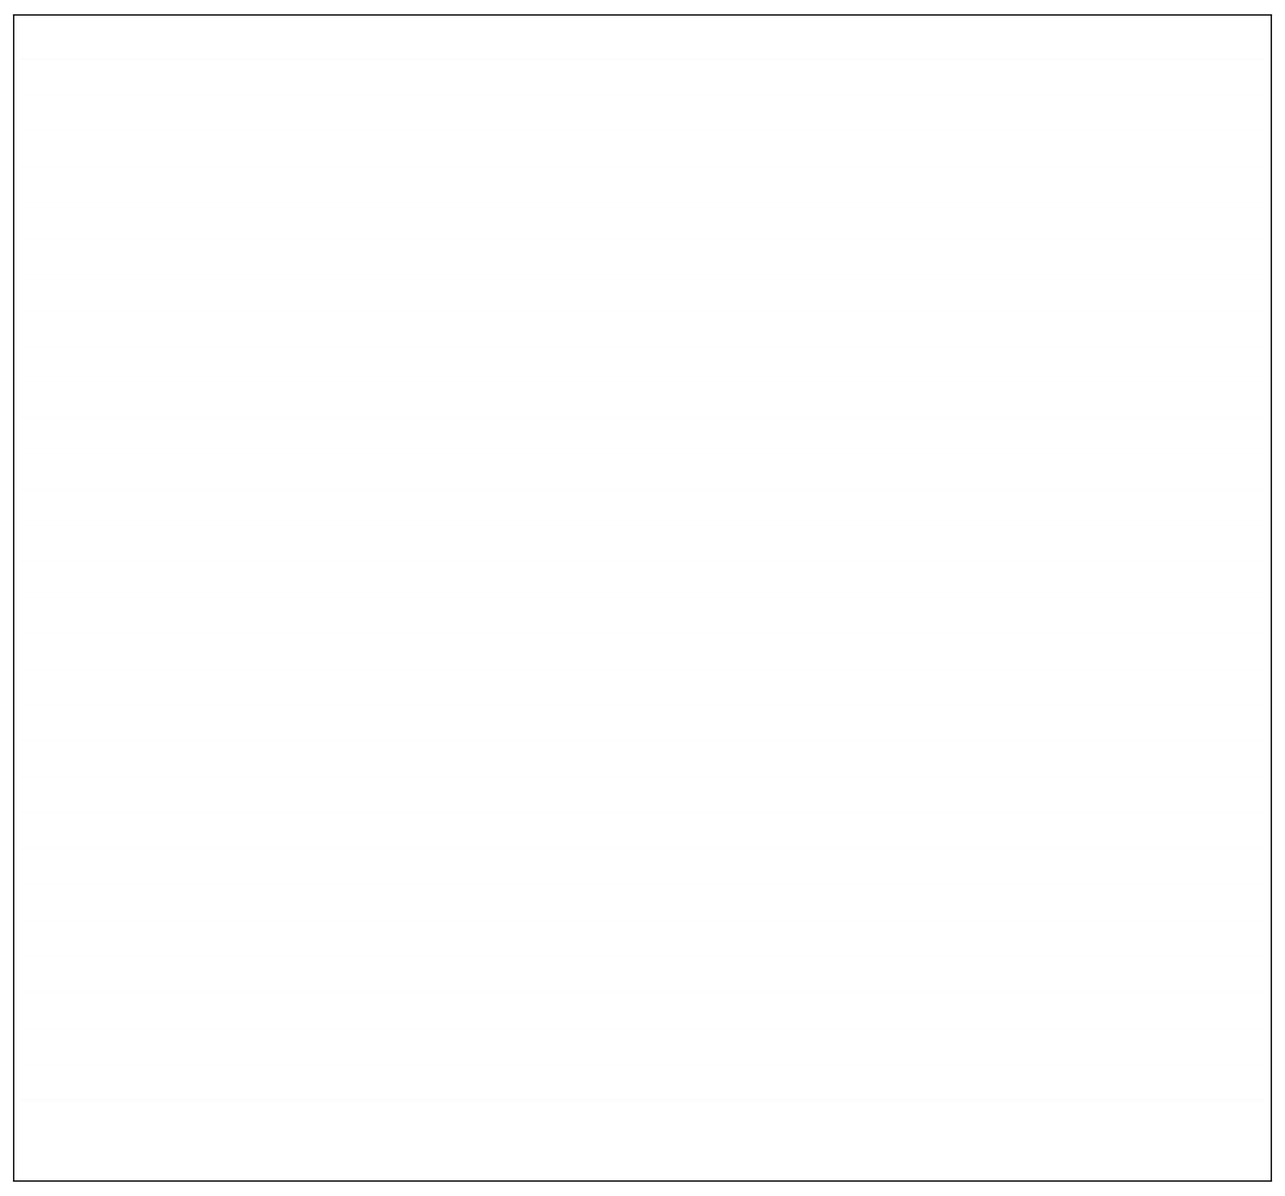

# Function to add two numbers

def

**add**

(

a

,

b):

return a + b

# Function to find the square of a number

def square(n):

return n * n

# Function to check if a number is even or odd

def is_even(n):

return n % 2

=

=

0

# Main Program

print(

"Function Implementation Example:\n"

)

# Using add function with user input

x

=

int(input(

"Enter first number for addition: "

))

y

=

int(input(

"Enter second number for addition: "

))

print(f

"Addition of {x} and {y} is: {add(x, y)}\n"

)

# Using square function with user input

num

=

int(input(

"Enter a number to find its square: "

))

print(f

"Square of {num} is: {square(num)}\n"

)

# Using is_even function with user input

check_num

=

int(input(

"Enter a number to check even or odd: "

))

if is_even(check_num):

print(f

"{check_num} is Even"

)

else:

print(f

"{check_num} is Odd"

)

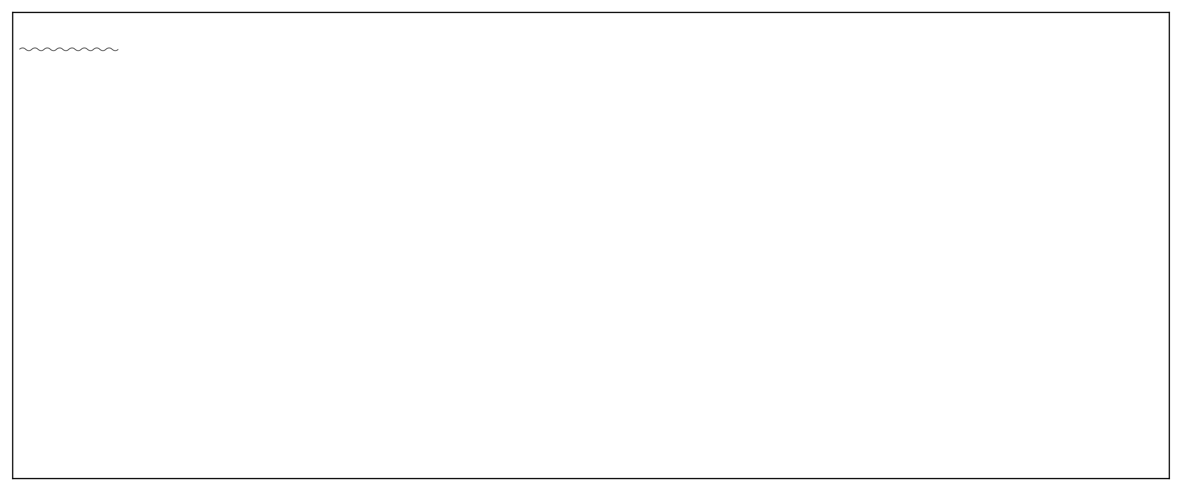

Output:-

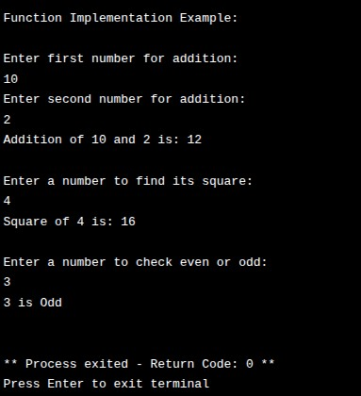

# Project-5

5.Write a python program using tinker make any formatted application according to our ideas ( Tetris,Snake,Card-block).

Ans:- A classic Snake game made using Tkinter. The snake moves with arrow keys, grows on eating food, and the game ends if the snake hits the wall or itself. Real-time movement, score tracking, and collision detection are implemented.

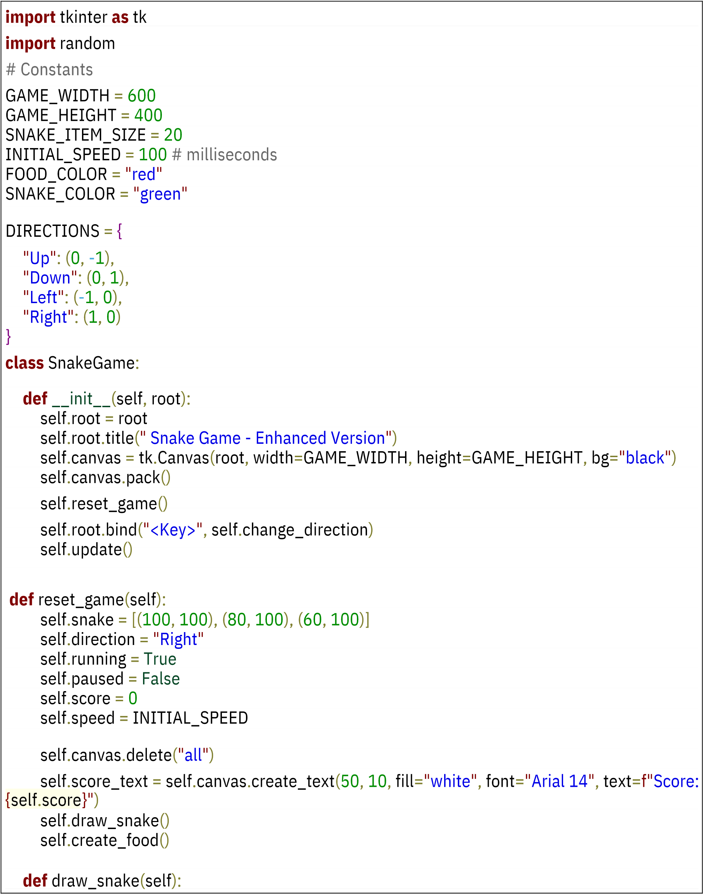

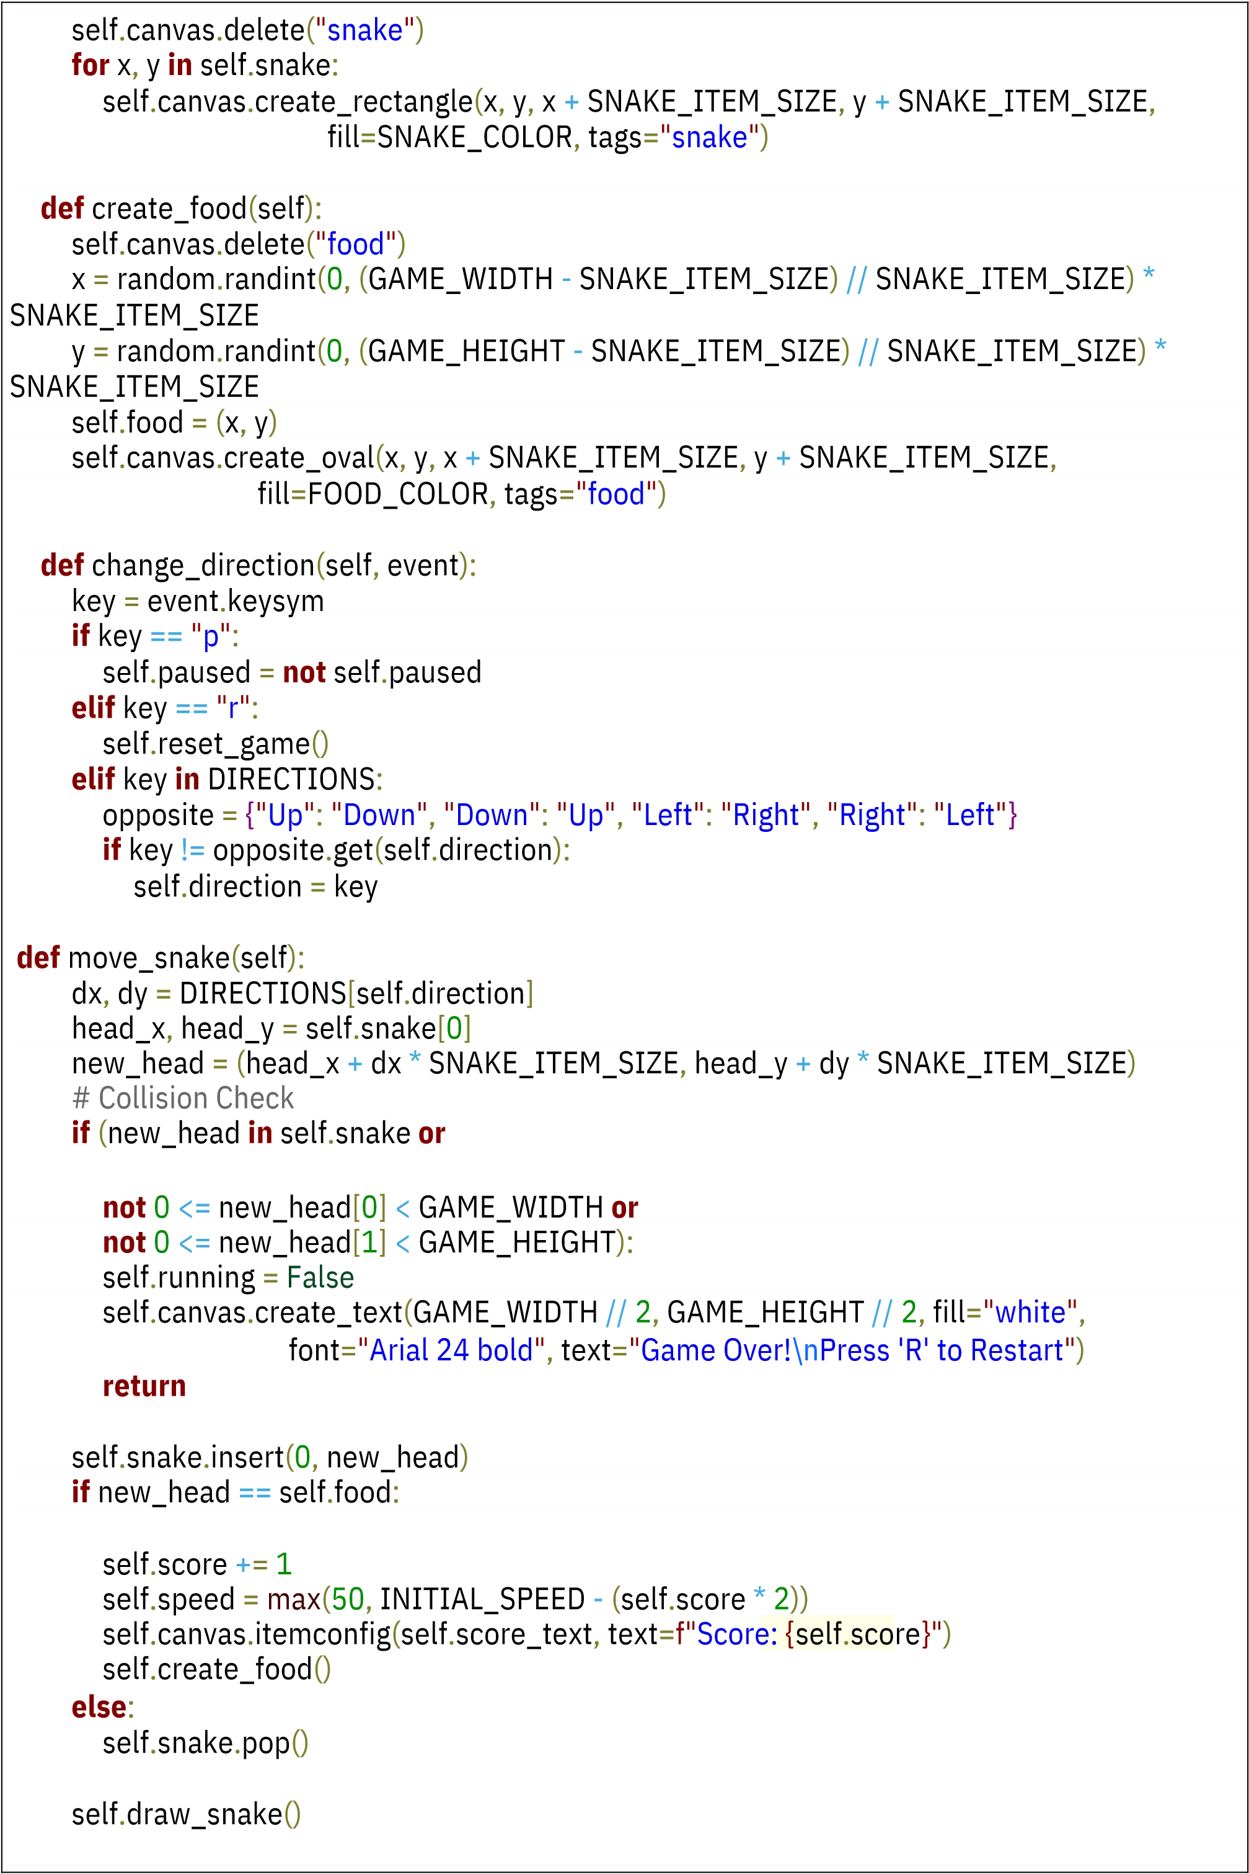

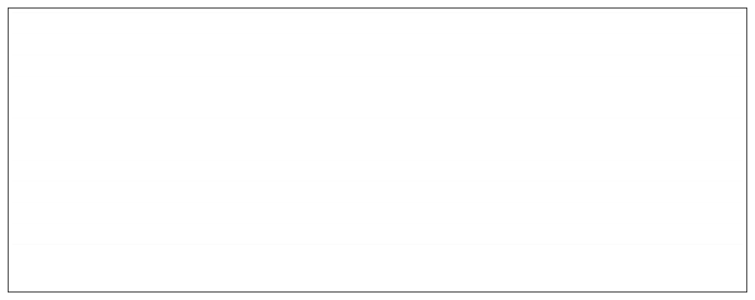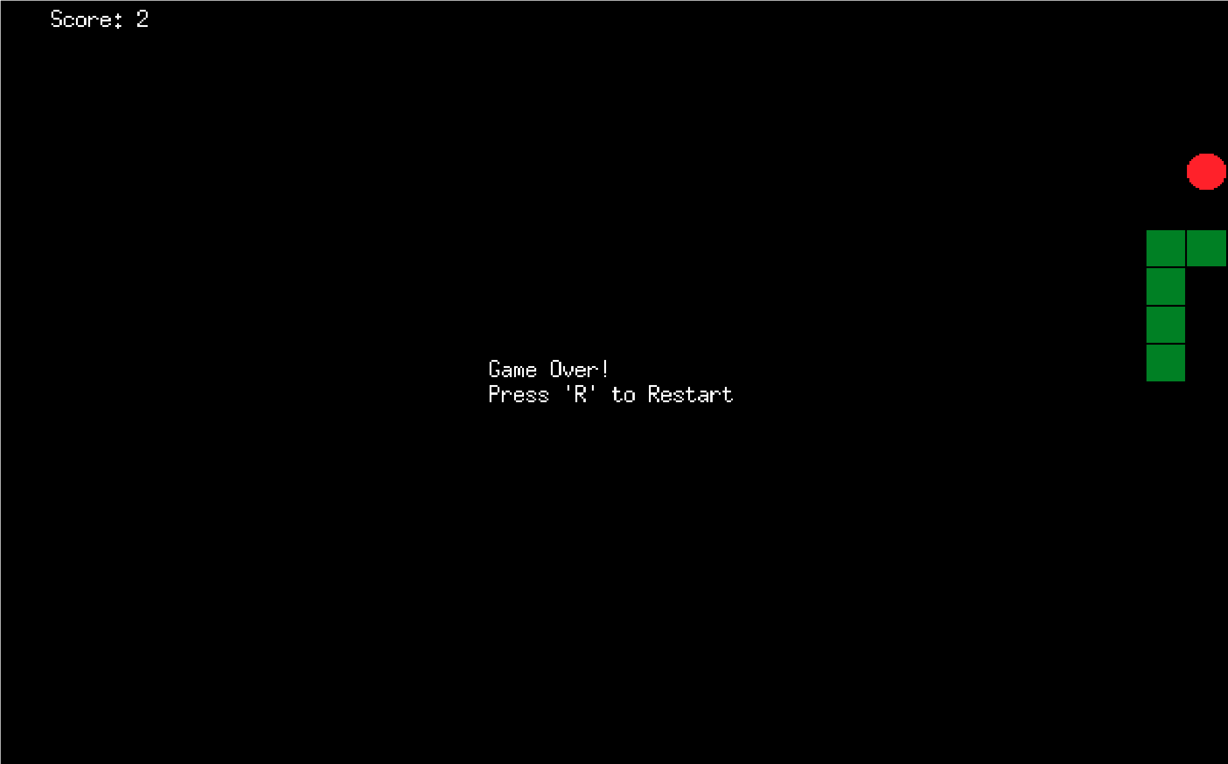

Output:-

**def**

update

(

self

):

**if**

self

.

running

**and**

**not**

self

.

paused

:

self

.

move_snake

()

self

.

root

.

after

(

self

.

speed

,

self

.

update

)

# ------------ Run the Game ------------

**if**

__name__

==

"

__main__

"

:

root

=

tk

.

Tk

()

game

=

SnakeGame

(

root

)

root

.

mainloop

()