**QUESTION NUMBER 1**

fahrenheit=int(input("enter the temperature in fahrenheit"))

celsius=5/9*(fahrenheit-32)

print("the corresponding temperature in celsius is :",celsius)

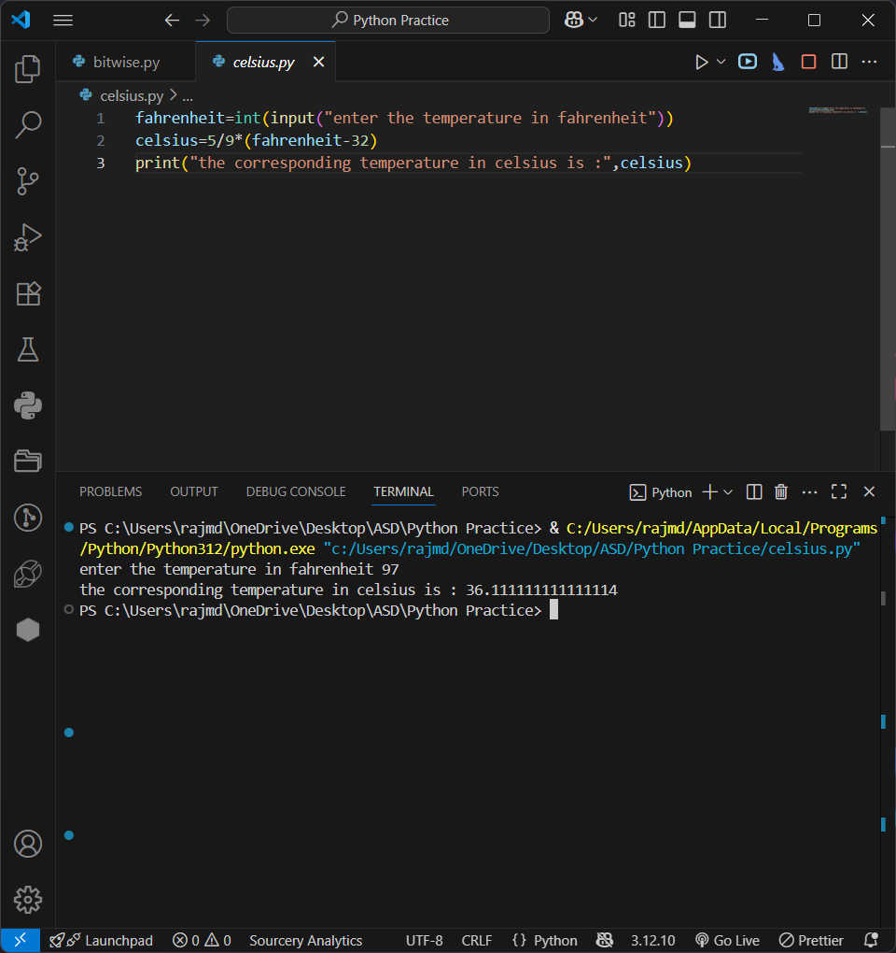

---------------question number 1 output screen

**QUESTION NUMBER 2**

hindi=int(input("Enter the marks obtained in hindi"))

english=int(input("Enter the marks obtained in english"))

maths=int(input("Enter the marks obtained in maths"))

science=int(input("Enter the marks obtained in science"))

bengali=int(input("Enter the marks obtained in bengali"))

total=hindi+english+maths+science+bengali

print("total marks obtained is:",total)

percentage=(total/500)*100

print("total percentage obtained is:",percentage)

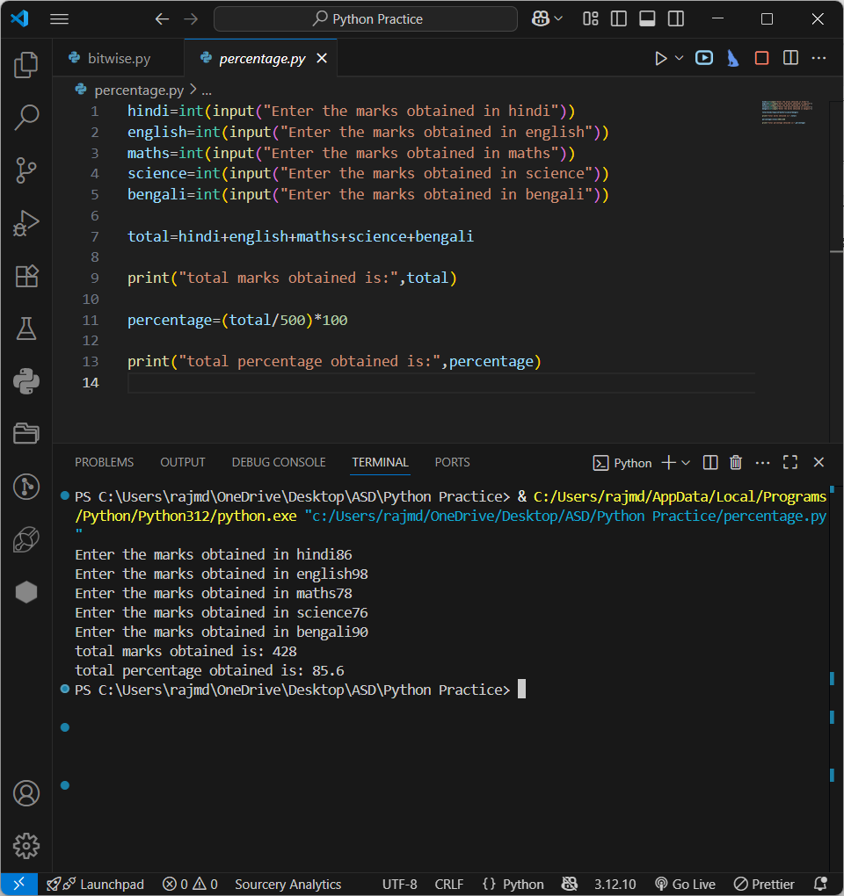

**--------question number 2 output screen----**

**QUESTION NUMBER 3**

length = int(input("enter the length of the rectangle"))

breadth = int(input("enter the breadth of the rectangle"))

area=length*breadth

perimeter=2*(length+breadth)

print("the area of the rectangle is :",area)

print("the perimeter of the rectangle is :",perimeter)

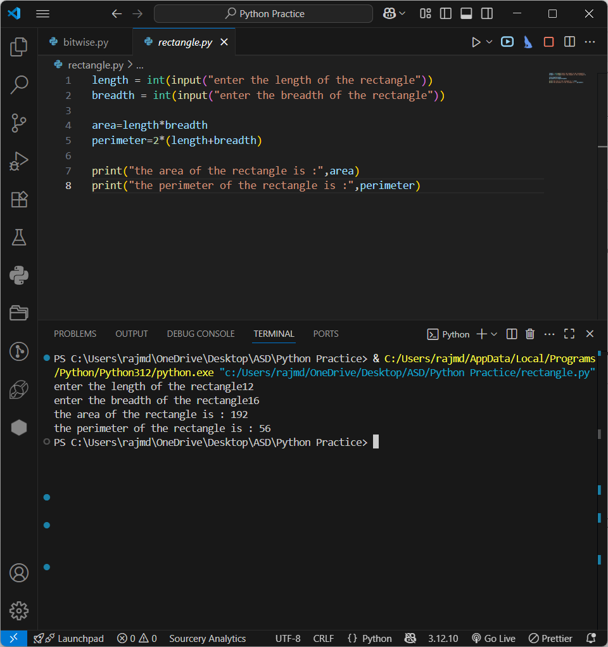

--------------------------Question number 3 output screen-----------

**QUESTION NUMBER 4**

print("working on bitwise operators")

a=5

b=10

print(a|b)

#15

# 0101---->5

# 1010---->10

# 1111---->15

print(a&b)

#0

# 0101---->5

# 1010---->10

# 0000---->0

print(a^b)

#15

# 0101---->5

# 1010---->10

# 1111---->15

print(~a)

#-6

# 0101----->5

# 1010------>-6

print(a<<2)

#20

# 5 = 00000101

# 00000101 << 2 ----> 00010100

# 00010100 = 20

print(a>>2)

#1

# 5 = 00000101

# 00000101 >> 2 ----> 00000001

# 00000001 = 1

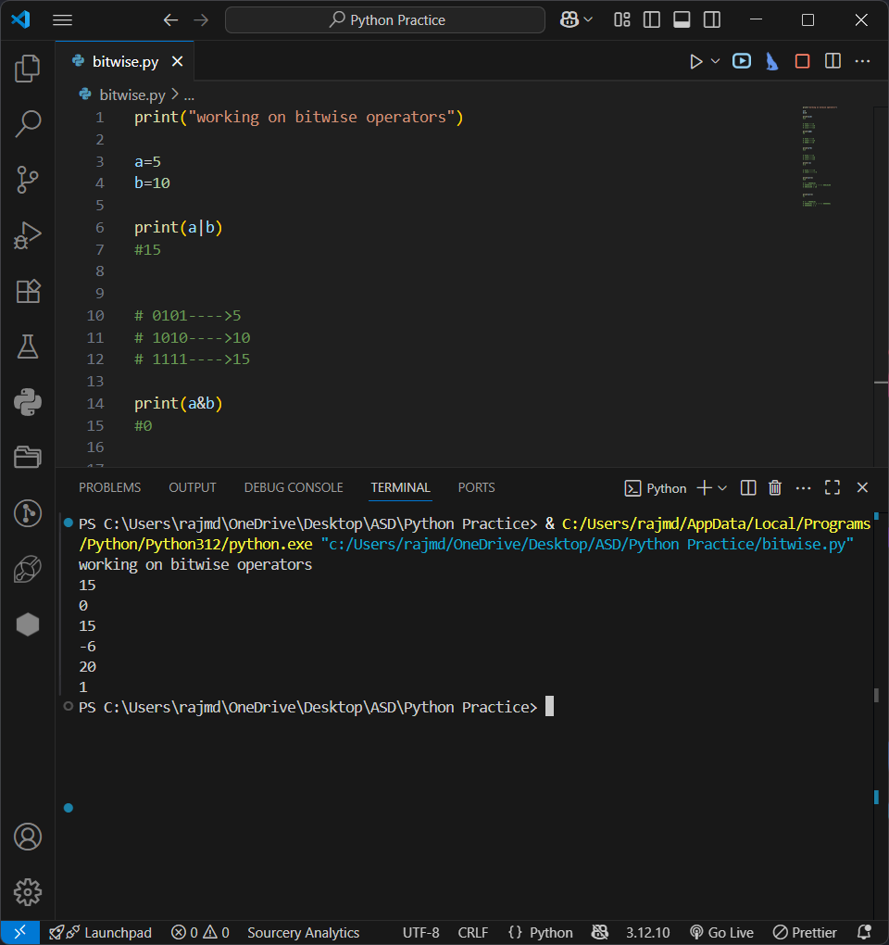

QUESTION NUMBER 4 OUTPUT------