* 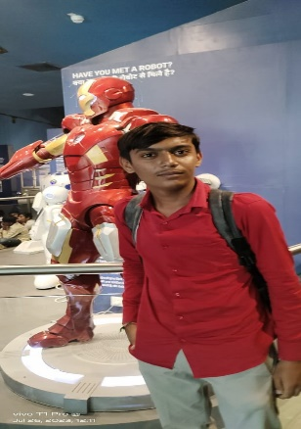Details
* Name : Raj M. Rabadiya
* Current Adress : Ukarada , Paddhri , Rajkot
* Phone : 81605 59131
* Email : [mb816055@gmail.com](mailto:mb816055@gmail.com)

* Objective
* To get best position in my filed and improve my work, increase value your compony.
* Education
* High School: Shree B.M. Patel School (Vakiya)
* Date of Graduation: (Pending)
* Course Highlights:
  + - CCC
    - MS Office
    - Professional Speaking
    - Web Development
    - Sociology
* Certificates
  + - Certified NCC Credit
    - Certified CCC Course
* Work and Related Experience :
* Summer Internship :
  + - Social work
    - Collaborated With staff to provide quality care
    - Developed website and arrangement
* Volunteer Work :
  + - Big brother Big sister
    - Mentored at risk youth
    - Developed and implemented educational programs.
* Aword and Honors
  + - Academic Achievement Award:
    - Academic Panting Award:

* Skills

Soft skills:

1. Responsible
2. Loyal
3. Creative
4. Adventure
5. Accurate

Hard Skills:

1. Cooking
2. Programing
3. Public Speaking