**Ex.No:1**

**Date: Creating a Blog Website UI using Figma**

**Aim:**

To Sign-in and design UI for my Website- Career Guidance using figma.

**1. Getting Started with Figma**

**Step 1: Sign Up or Log In**

- Description: Go to [Figma's website](https://www.figma.com/) and sign up for a new account or log in if you already have one.

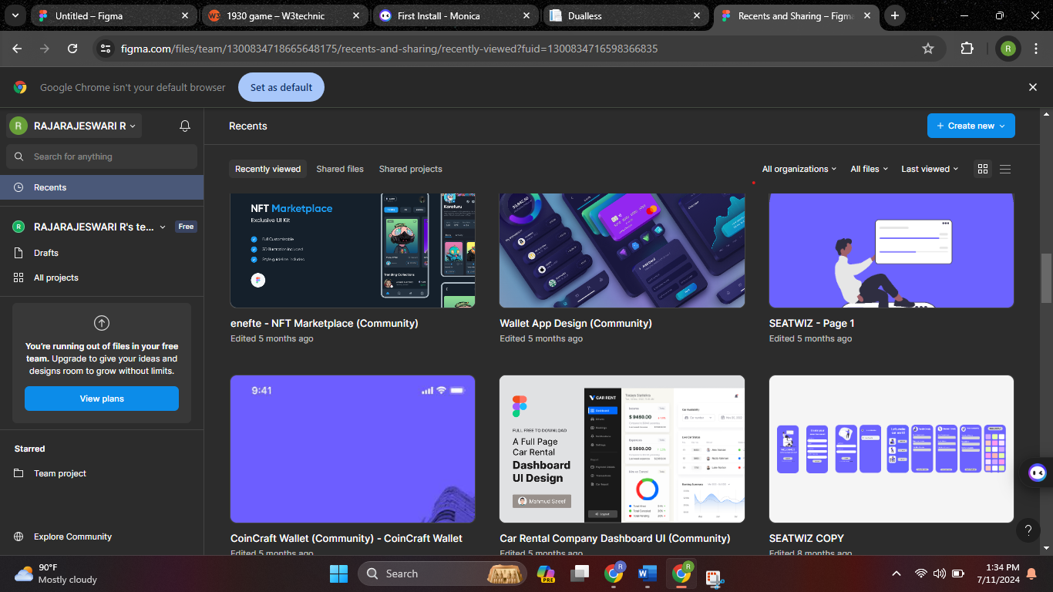

**Step 2: Create a New File**

- Description: After logging in, click on the “New File” button to create a new design file.

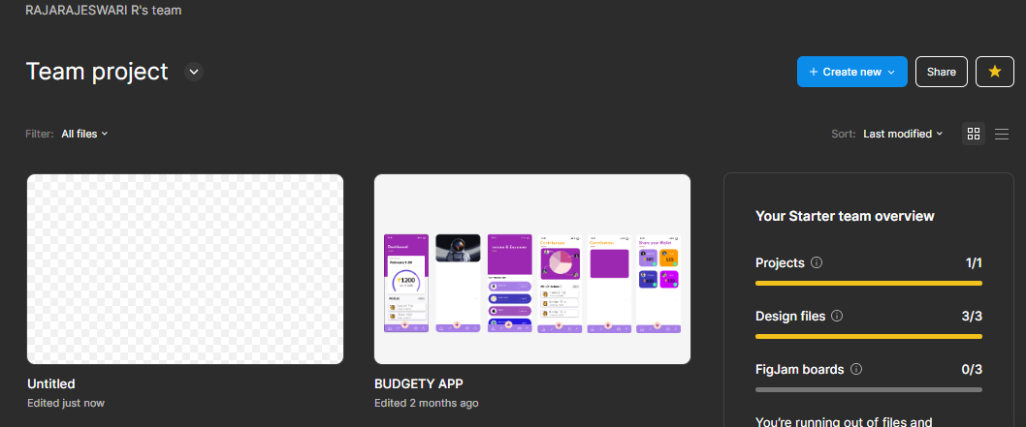

**2. Understanding the Interface**

**Step 3: Figma Workspace Overview**

- Description: Familiarize yourself with the Figma workspace, including the toolbar at the top, layers panel on the left, design panel on the right, and the canvas in the center.

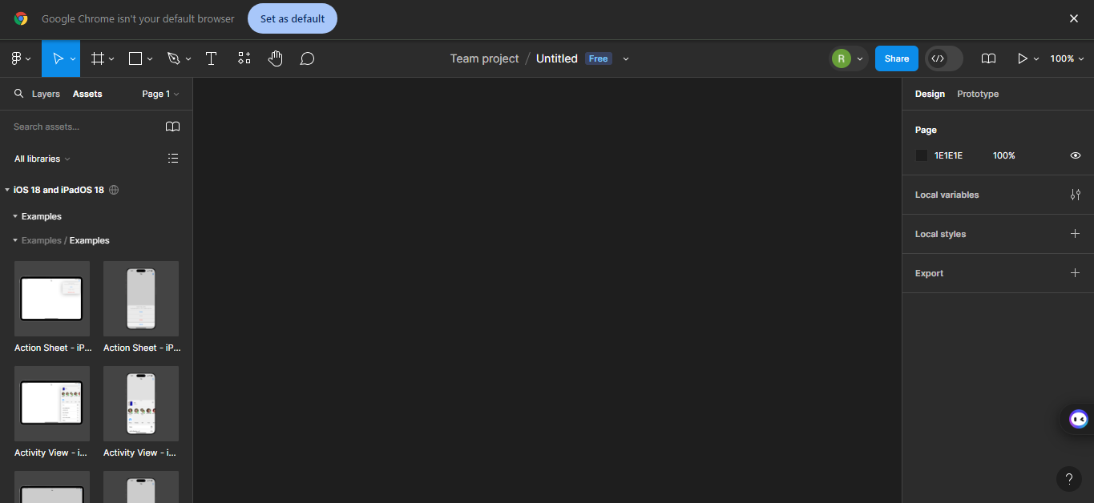

**3. Basic Tools and Features**

**Step 4: Adding Frames**

- Description: Use the Frame tool (F) to create a new frame on the canvas. Frames act like artboards in other design tools.

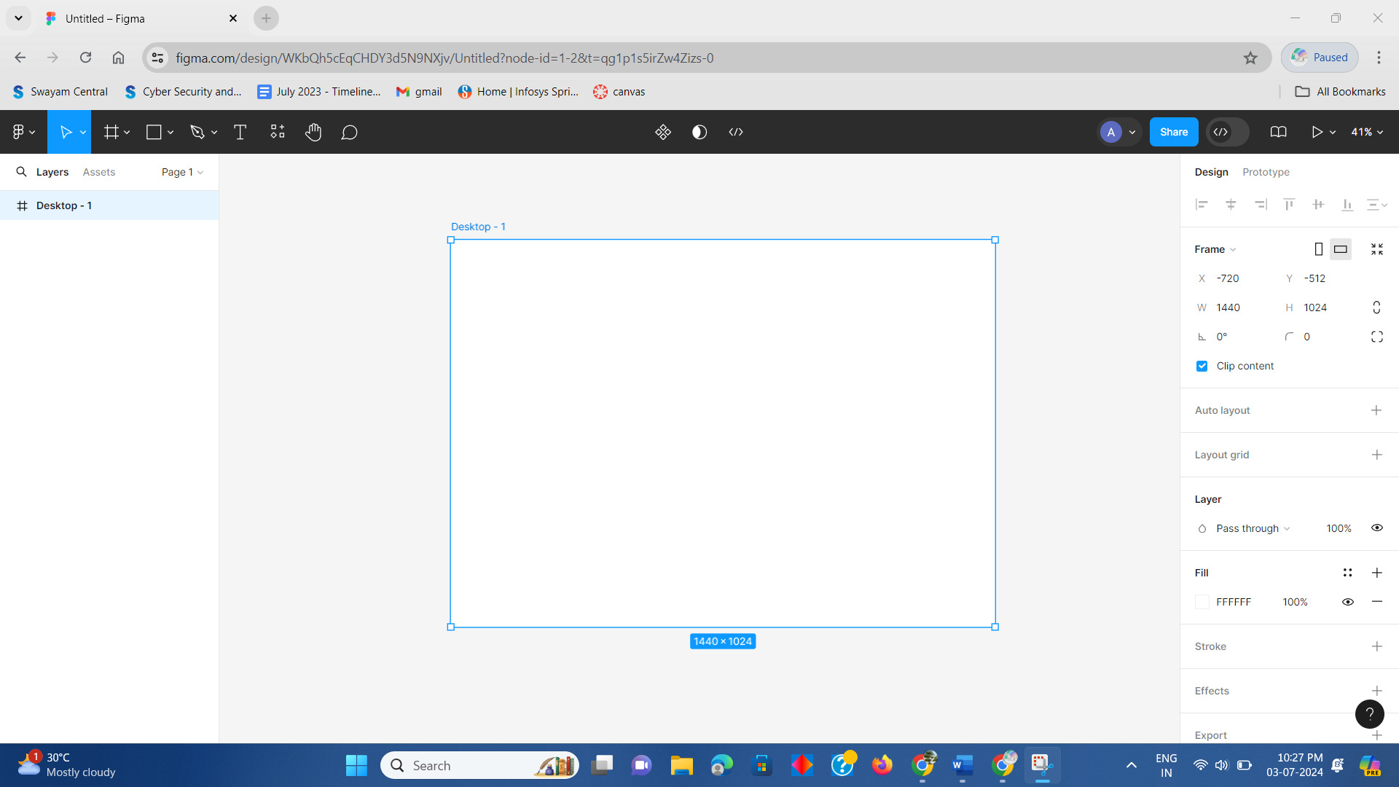

**Step 5: Adding Shapes and Text**

- Description: Use the shape tools (R for Rectangle, O for Oval) and the Text tool (T) to add basic shapes and text to your design.

**4. Working with Components**

**Step 6: Creating Components**

- Description: Select an element or a group of elements, right-click, and choose “Create Component” to make reusable components.

**Step 7: Using Components**

- Description: Drag instances of components from the assets panel to reuse them in your design.

**5. Prototyping**

**Application Title:**

Blog on Projection Mapping

**Application Pages:**

* Blog page
* About Us
* Login page
* Subscribe
* Contact us

**Step 8: Adding Interactions**

- Description: Switch to the Prototype tab, select an element, and drag the connector to another frame to create interactions.

* **Blog Page :**

Guide to become a pro in PROJECTION MAPPING

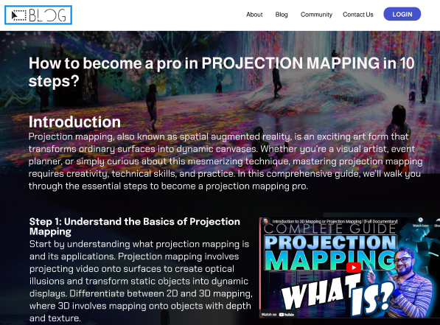

* **Subscribtion Page:**

To Create a New Account by Filling the required details which can make the user access easier.

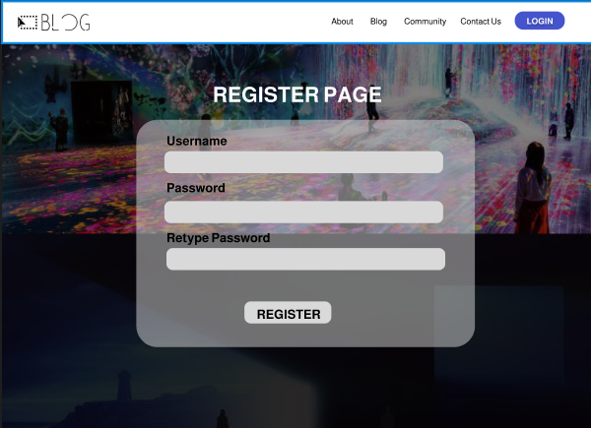

* **Login Page:**

To know about user opinion and choice in various career fields

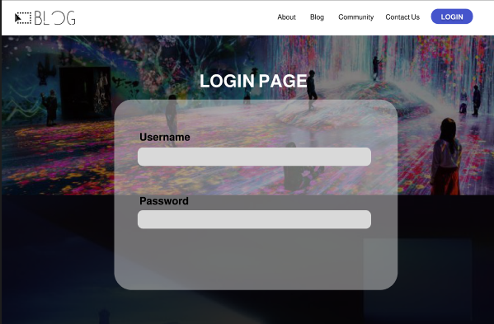

* **Step By Step GUIDE:**

**Provides a 10 step guide to learn PROjection MAPPING**

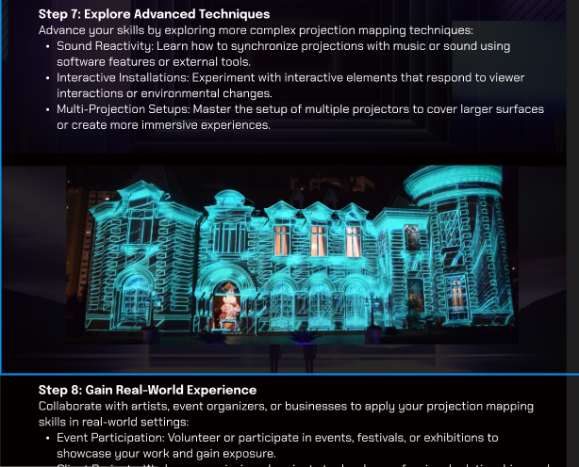

* **Contact Us Page**

Contact the authors directly

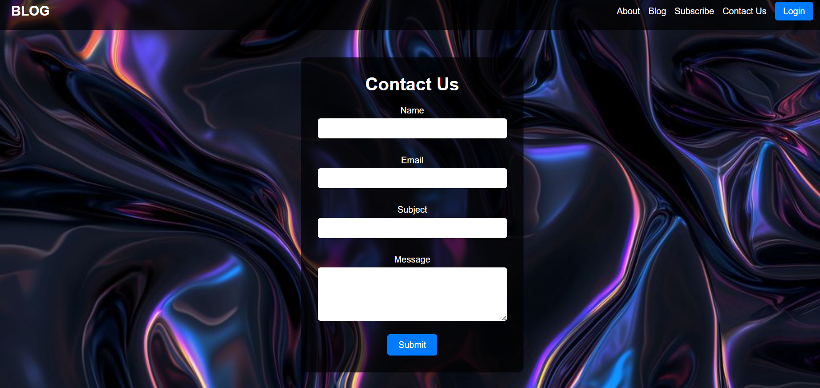

**Step 9: Previewing the Prototype**

- Description: Click the play button in the top-right corner to preview your prototype.

**6. Collaboration and Sharing**

**Step 10: Sharing Your Design**

- Description: Click the Share button in the top-right corner to generate a shareable link or invite team members to collaborate.

**Step 11: Commenting**

- Description: Use the Comment tool to add comments and feedback directly on the design.

**7. Advanced Features**

**Step 12: Using Plugins**

- Description: Explore and install plugins from the Figma Community to extend the functionality of Figma.

**Step 13: Using Auto Layout**

- Description: Select elements and apply Auto Layout to manage responsive design elements.

**8. Finalizing and Exporting**

**Step 14: Exporting Assets**

- Description: Select elements or frames, go to the Export section in the right panel, and export assets in various formats (PNG, SVG, PDF, etc.).

**Result :**

Thus the UI creation for my Website- Career Guidance using Figma has been successfully completed, and the screenshots are attached to the document.