UAV Path Planning using a Large Language Model
From text flight commands to safe grid routes: goal, architecture, methodology, results and a replication guide
Author: Raja
Code: uav_llm_waypoint_planner.ipynb (Google Colab, Python)

Summary
This project tests whether a large language model (LLM) can turn an English flight command into a safe drone route. In our system (Method A) the Gemini model reads the command and extracts the start, the goal and any temporary hazards as JSON. A classical A* planner then computes the route on a 20 × 20 grid that contains fixed no-fly zones. We compare this hybrid with a baseline (Method B) in which the LLM writes the waypoints itself.
Both methods are tested on the same 25 commands with known correct answers: 22 normal commands and 3 unsafe requests that must be rejected. The same route checker judges both. This document explains the goal, architecture, methodology and results, and gives step by step instructions to use and replicate the work in Google Colab.

1. Project Goal

1.1 The problem
Operators describe drone missions in words, for example: "Fly from the helipad to the warehouse and avoid the storm at (10,10)." A path planner, however, needs numbers: a start cell, a goal cell and a list of blocked cells. Classical planners such as A* are excellent at finding routes but cannot read language. LLMs read language well but can make spatial and counting mistakes when they plan routes by themselves.

1.2 Objective
Build and evaluate a hybrid system in which the LLM does what it is good at (understanding the command) and A* does what it is good at (finding a shortest safe route), with a validator that rejects unsafe requests before any route is planned.

1.3 Research questions
- RQ1: How accurately can an LLM extract the start, goal and hazard cells from a text command?
- RQ2: Does LLM + A* produce more valid and safe routes than an LLM that writes the waypoints directly?
- RQ3: Does the system refuse unsafe requests (goal outside the map, start inside a no-fly zone)?

1.4 Scope
In scope | Out of scope (future work)
2D grid map, 20 × 20 cells | Flight simulator or a real drone
Text commands with landmark names, coordinates, corners and hazards | 3D flight, altitude, wind, battery limits
Synthetic map and 25 test commands with known answers | Moving obstacles, multiple drones
Comparison of LLM + A* with an LLM-only baseline | Camera images or vision-language navigation

2. System Architecture
Figure 1 shows the system. The same text command goes to two methods. Method A (our hybrid) parses the command with the LLM, validates it and plans the route with A*. Method B (baseline) asks the LLM to write the waypoints directly. Both outputs are judged by the same route checker, which feeds the metrics.
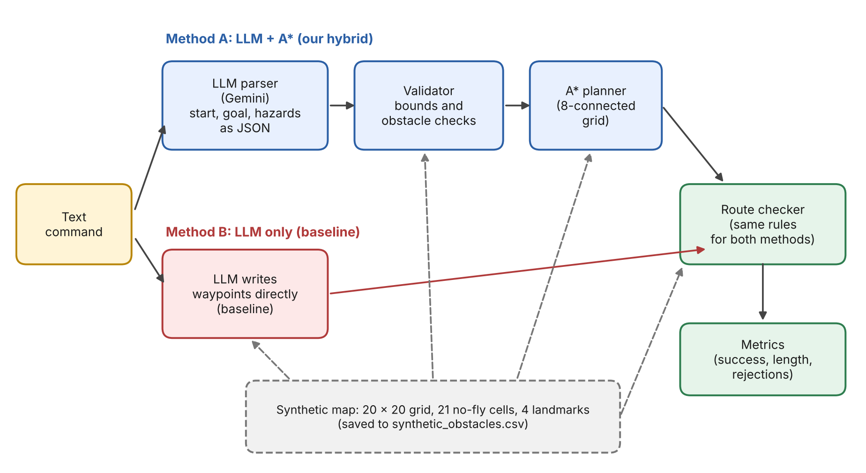
Figure 1. System architecture: Method A (LLM + A*) and Method B (LLM only), judged by the same route checker.

2.1 Components
Component | What it does | Notebook section
Synthetic map | Fixed no-fly zones (21 cells) and 4 named landmarks on a 20 × 20 grid, saved to synthetic_obstacles.csv. | Section 2
LLM parser | Sends the command and a rules prompt to Gemini and receives JSON with start, goal and extra_obstacles. Temperature 0, JSON mode, one retry if the format is bad. No fallback answer is ever invented. | Section 4
Validator | Rejects the request if the start or goal is outside the grid or inside an obstacle. | Section 5
A* planner | Moves in 8 directions (cost 1 straight, 1.414 diagonal), Euclidean heuristic, returns the route and its true length. | Section 3
Route checker | Judges any route against the true obstacles: starts at the start, ends at the goal, stays in the grid, never crosses an obstacle. | Section 3
Baseline | Asks the LLM to output the waypoint list itself, with no A*. | Section 8
Evaluator | Runs the 25 test commands, computes metrics, draws the chart and lists failures. | Sections 7 to 10

2.2 Coordinates and landmarks
The origin (0,0) is the bottom-left cell. x increases to the right and y increases upwards, both from 0 to 19. So the top-left corner is (0,19) and the bottom-right corner is (19,0).
Landmark | Cell | Note
Helipad A | (0,0) | Bottom-left corner
Warehouse North | (19,19) | Top-right corner
Hospital West | (1,18) | Near the top-left corner
Substation East | (18,1) | Near the bottom-right corner

2.3 Data flow example
Command: "Fly from Helipad A to Warehouse North. Avoid a storm cloud at (10,10)."
Expected LLM output:
{"start": [0, 0], "goal": [19, 19], "extra_obstacles": [[10, 10]]}

The validator finds nothing wrong, then A* plans a route of 23 cells with a length of 28.63 grid units around the no-fly zones and the storm cell (see Figure 2).

3. Methodology

3.1 Data: a synthetic map
The map is our own synthetic data, built so that every correct answer is known. It has 21 no-fly cells in four groups.
Group | Cells | Location
Building | 6 | x = 4 to 5, y = 4 to 6
Military zone (1) | 4 | x = 12 to 13, y = 10 to 11
Tower wall | 7 | x = 8, y = 1 to 7
Military zone (2) | 4 | x = 15 to 16, y = 14 to 15

Role of UAVBench. UAVBench is a public benchmark of text scenarios and multiple-choice questions for UAV reasoning. It does not contain map coordinates, so it is not used to create obstacles in this project. We reviewed it as related work and borrowed the idea of testing LLMs on structured flight scenarios. Any earlier experiment that treated UAVBench table columns as x and y coordinates is invalid and must not be reported.

3.2 LLM parsing
- The prompt describes the grid, the coordinate convention, the landmarks and the required JSON format (full text in Appendix B).
- The LLM must not list the permanent no-fly zones; the planner already knows them.
- Areas and lines of hazards must be expanded into every grid cell they cover.
- Coordinates must be copied exactly as written, even if they are wrong, so that the validator can catch unsafe requests instead of the LLM silently fixing them.
- Settings: temperature 0 and JSON response mode. If the answer has a bad format or the API call fails, the code retries once with the error message. If it still fails, the case is recorded as a failure.

3.3 Validation
After parsing, a deterministic validator rejects the request if the start or goal lies outside the 20 × 20 grid, or inside a no-fly cell or a temporary hazard. Hazard cells outside the grid are ignored. This step is plain code, so it is not affected by LLM mistakes.

3.4 Route planning with A*
A* searches the grid with 8-direction moves. A straight move costs 1 and a diagonal move costs 1.414. The priority is f = g + h, where g is the true cost so far and h is the straight-line distance to the goal. Keeping g separate from h makes the returned path length the real length and the route optimal. (An earlier version of the code added h into the stored cost at every step; this gave slightly longer routes on about 3% of random maps and was corrected.)

3.5 Baseline (Method B)
The LLM receives the same map information (grid, landmarks and the list of no-fly cells) and must output the whole waypoint list itself. Waypoints may be sparse; a straight segment between two waypoints is valid only if it crosses no obstacle. For unsafe requests the baseline should return an empty list.

3.6 Test set
The test set has 25 commands, each with a hand-written correct start, goal and hazard list (Appendix A). Before any LLM is called, the code confirms that every normal command has at least one safe route.
Category | Count | Case IDs
Landmark names only | 6 | 1, 2, 3, 4, 8, 20
Landmark names + hazards | 5 | 7, 9, 13, 15, 18
Coordinates only | 3 | 10, 11, 16
Coordinates + hazards (including 2 × 2 area and line) | 6 | 5, 6, 12, 14, 17, 19
Corner words (top-left, bottom-right, ...) | 2 | 21, 22
Unsafe requests that must be rejected | 3 | 23, 24, 25

3.7 Metrics
Metric | Definition
Success (normal command) | The route starts at the correct start, ends at the correct goal, stays in the grid and crosses no true obstacle (no-fly cells plus the correct hazards).
Success (unsafe request) | The system rejects the request or, for the baseline, returns an empty route.
Overall success % | Successes divided by all 25 cases.
Exact parse % | Method A only. Start, goal and hazard cells extracted by the LLM exactly equal the expected values.
Mean length ÷ optimal | For successful normal cases: route length divided by the A* length on the true obstacles. 1.00 is optimal; 1.10 means 10% longer than necessary.
Failures | Any case that is not a success, including bad JSON and failed API calls.

3.8 Fair comparison
Both methods use the same model, the same temperature (0), the same test commands and the same route checker with the true obstacles. A failed API call is never replaced by a hidden default answer, so the LLM cannot look correct by accident.

4. Results
How to complete this section
The numbers must come from a real run of the notebook. Run Sections 7 to 10, then copy the values from the Section 9 summary table and the Section 10 failure table into the yellow cells below. No result values have been filled in here because none were produced yet when this document was generated.

4.1 Experimental setup
Item | Value
LLM model | [fill: MODEL_NAME used in the run]
Date of the run | [fill: date]
Temperature | 0
Test commands | 25 (22 normal, 3 unsafe requests)
API calls | 50 (25 per method), plus retries if any
Run time of Section 8 | [fill: minutes] (about 5 minutes expected)

4.2 Summary of results
Metric | LLM + A* (Method A) | LLM only (Method B) | Where to find it
Overall success % | [fill] | [fill] | Section 9 table
Normal commands success % (22) | [fill] | [fill] | Section 9 table
Unsafe requests rejected % (3) | [fill] | [fill] | Section 9 table
Mean length ÷ optimal | [fill] | [fill] | Section 9 table
Exact parse % | [fill] | not applicable | Section 9 table
Failed API / format cases | [fill] | [fill] | Section 10 table

The bar chart from Section 9 can be pasted below this table.

4.3 Example route
Figure 2 shows the route that A* computes for the command in Section 2.3. It is a deterministic illustration of the planning step: the start, goal and storm cell are entered as the expected LLM output, and the route does not depend on any LLM result.
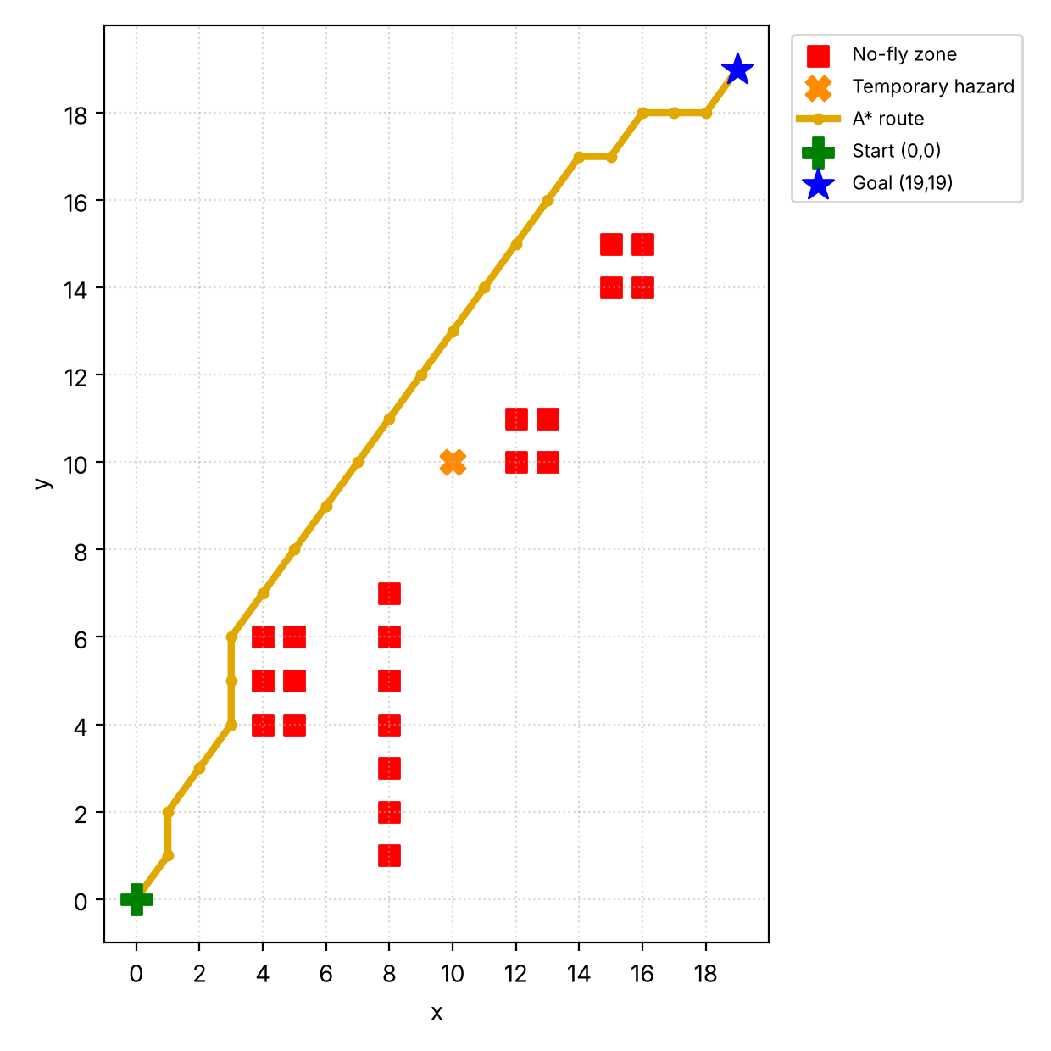
Figure 2. A* route from (0,0) to (19,19) around the no-fly zones (red) and a temporary storm cell at (10,10) (orange).

4.4 Failure analysis
Copy three or four failures from the Section 10 table. Failures are useful findings, for example confusing left and right, forgetting some cells of an area hazard, or inventing a hazard.
Case | Command | What went wrong | Likely reason
[fill] | [fill] | [fill] | [fill]
[fill] | [fill] | [fill] | [fill]
[fill] | [fill] | [fill] | [fill]

4.5 How to read the results
- With 25 cases, one case equals 4 percentage points overall and 33 points in the 3-case unsafe group. A gap of one or two cases is indicative, not statistically significant.
- If Method A has a higher success rate than Method B, the results support using the LLM only for language understanding and leaving route search to A*. If not, report that honestly and use the failure table to explain why.
- If exact parse % is lower than success %, some parsing mistakes did not hurt the route (for example an extra hazard far from the path). A missing hazard cell is more dangerous because the route can cross it.
- Mean length ÷ optimal is 1.00 for A* when the parse is correct. Values above 1.00 come from invented extra hazards or from LLM-written routes that are longer than necessary.

5. How to Use the System

5.1 Requirements
- A Google account and a browser (Google Colab runs the code; no GPU is needed).
- A Gemini API key from Google AI Studio.
- The notebook file uav_llm_waypoint_planner.ipynb.

5.2 Run the live demo
- Open colab.research.google.com, choose File, Upload notebook and select the notebook file.
- Click the key icon on the left, then Add new secret. Name it GEMINI_API_KEY, paste your key as the value and turn on Notebook access.
- Run Sections 1 to 6 one cell at a time with the play button, waiting for each cell to finish. Do not use Run all if you only want the demo, because it also starts the 5-minute experiment.
- Add a new code cell with + Code, type a command and run it:
demo("Fly from Helipad A to Warehouse North. Avoid a storm cloud at (10,10).")

- Read the output: the outcome, what the LLM extracted, the route length and the map (red = no-fly zones, orange = temporary hazards, gold line = route).

5.3 Example commands
Command | Expected behaviour
Fly from Helipad A to Warehouse North. Avoid a storm cloud at (10,10). | Route that avoids cell (10,10)
Go from (0,10) to (19,10) and avoid a bird flock at (7,10), (8,10) and (9,10). | Route that goes around the flock
Fly from the bottom-left corner to the top-right corner. | Route from (0,0) to (19,19)
Fly from Helipad A to (25,3). | Rejected: goal outside the grid
Start at (4,5) and fly to (19,19). | Rejected: start inside a no-fly zone

5.4 What the outcomes mean
Outcome | Meaning
route | The command was valid and A* found a safe route.
reject | The validator stopped an unsafe request; the reason is printed.
parse_error | The LLM did not return valid JSON, even after one retry.
no_route | The request was valid but the hazards leave no safe path.

5.5 Customising
- Map: edit the add_obstacles(...) lines in Section 2 and run Sections 2 to 6 again.
- Landmarks: edit the LANDMARKS dictionary in Section 2. The parser prompt reads it automatically.
- Model: change MODEL_NAME in Section 1 (only one place).
- If you change the map, landmarks or grid size, update the expected answers in the test set (Section 7); the code stops with an error if a normal test case has no route.

5.6 Troubleshooting
Problem | Cause | Fix
Model not found error | MODEL_NAME is wrong or unavailable to your key | In Section 1 remove the # from the three list_models lines, run it and copy a listed name into MODEL_NAME.
GEMINI_API_KEY error | Secret missing, misspelled or Notebook access is off | Create the secret again with the exact name and turn on Notebook access.
Many format/API error rows | Rate limit: too many calls too fast | Set SLEEP_BETWEEN_CALLS to 6 or 7 in Section 1, run Section 1 again, then re-run Section 8.
parse_error in the demo | Invalid JSON twice in a row | Run the command again or write it more simply.
Section 8 is too slow | 4 second wait before each call | Lower SLEEP_BETWEEN_CALLS to 2 if your quota allows.

6. How to Replicate the Results

6.1 Steps
- Upload the notebook to Colab and add the GEMINI_API_KEY secret (Section 5.2, steps 1 and 2).
- Run Section 1 and confirm that no error appears. Fix MODEL_NAME if needed, and write the model name down.
- Run Sections 2 to 5. Confirm the line A* self-test: 23 waypoints, length 28.63 | valid: (True, 'ok').
- Run Section 7. Confirm the line 25 test cases ready (22 normal, 3 must-reject).
- Run Section 8. It makes about 50 API calls with a 4 second pause and takes about 5 minutes. Wait for Saved results.csv.
- Run Sections 9 and 10 to produce the summary table, the bar chart and the failure table.
- Download results.csv from the Files panel (folder icon) and record the model name and the date.
- Optional: run Section 8 a second time to see how much the LLM results change between runs.

6.2 Settings
Setting | Value | Where
GRID_SIZE | 20 | Section 1
MODEL_NAME | [fill: record yours] | Section 1
Temperature | 0 | call_llm in Section 4
JSON response mode | On | call_llm in Section 4
SLEEP_BETWEEN_CALLS | 4 seconds | Section 1
MAX_RETRIES | 1 | Section 1

6.3 What is and is not reproducible
- Exactly reproducible: the synthetic map, the A* planner, the route checker, the test set and the metric calculations. The self-test above gives the same numbers on every run.
- May vary: the LLM answers. Even at temperature 0, outputs can change slightly between runs, model versions and dates, so a replication may differ by a case or two. Always report the model name, the date and the results.csv file.

6.4 Output file: results.csv
Column | Meaning
id, kind | Test case number; ok for a normal command, reject for an unsafe request
method | LLM + A* or LLM only (baseline)
command | The text command given to the LLM
success | True if the case met the success rule in Section 3.7
parse_exact | Method A only: True if start, goal and hazards were extracted exactly
length_ratio | Route length divided by the optimal length (successful normal cases only)
detail | Reason for success or failure
llm_output | What the LLM produced (parsed JSON or waypoints), for failure analysis

7. Limitations and Future Work

7.1 Limitations
- The map is a small synthetic 2D grid, not real terrain; there is no 3D flight, wind, battery model or moving obstacle.
- The test set has only 25 commands written by us in a consistent style. Real operators write more varied commands.
- Only one LLM is tested, and LLM outputs can vary between runs.
- A* allows diagonal moves between two diagonally touching obstacle cells, which a real drone might not be allowed to do.
- The routes were not flown in a simulator or on a real drone.

7.2 Future work
- Test the same pipeline in a simulator such as AirSim with Unreal Engine.
- Use real maps and terrain (for example OpenStreetMap buildings and elevation data) and 3D routes.
- Add dynamic obstacles, multiple drones and energy limits.
- Collect commands written by different people and compare several LLMs.
- Evaluate on public instruction-to-trajectory datasets such as OpenUAV.

References
- UAVBench: An Open Benchmark Dataset for Autonomous and Agentic AI UAV Systems via LLM-Generated Flight Scenarios. arXiv:2511.11252, 2025. Code and data: github.com/maferrag/UAVBench.
- Towards Realistic UAV Vision-Language Navigation: Platform, Benchmark, and Methodology (OpenUAV). arXiv:2410.07087, ICLR 2025.
- Hub-Tian. UAVs_Meet_LLMs. GitHub repository, a curated list of papers and datasets on UAVs and LLMs.
- Hart, P. E., Nilsson, N. J., Raphael, B. (1968). A formal basis for the heuristic determination of minimum cost paths. IEEE Transactions on Systems Science and Cybernetics, 4(2), 100-107.

Appendix A. Test Set (25 commands)
Expected answers were written by hand from the rules in the parser prompt. Hazard cells are the cells blocked by temporary hazards in the command.
ID | Type | Command | Start | Goal | Hazard cells
1 | Normal | Fly from Helipad A to Warehouse North. | (0,0) | (19,19) | none
2 | Normal | Go from Helipad A to Hospital West. | (0,0) | (1,18) | none
3 | Normal | Take off at Substation East and land at Hospital West. | (18,1) | (1,18) | none
4 | Normal | Fly from Warehouse North to Substation East. | (19,19) | (18,1) | none
5 | Normal | Fly from (0,0) to (19,19). Avoid a storm cloud at (10,10). | (0,0) | (19,19) | (10,10)
6 | Normal | Start at (2,2) and fly to (17,17). Keep away from a drone swarm at (9,9) and (10,9). | (2,2) | (17,17) | (9,9) (10,9)
7 | Normal | Go from Helipad A to Hospital West, but there is a crane at (3,12). | (0,0) | (1,18) | (3,12)
8 | Normal | Fly from the hospital to the warehouse. | (1,18) | (19,19) | none
9 | Normal | Depart from the substation and head to the helipad. Avoid heavy rain at (9,5) and (9,6). | (18,1) | (0,0) | (9,5) (9,6)
10 | Normal | Fly from (0,19) to (19,0). | (0,19) | (19,0) | none
11 | Normal | Start at x=3, y=3 and end at x=16, y=17. | (3,3) | (16,17) | none
12 | Normal | Fly from (1,1) to (18,18) avoiding a 2x2 storm cell whose lower-left corner is at (10,12). | (1,1) | (18,18) | (10,12) (11,12) (10,13) (11,13)
13 | Normal | Fly from Helipad A to Warehouse North avoiding a vertical wall of debris from (10,3) to (10,6). | (0,0) | (19,19) | (10,3) (10,4) (10,5) (10,6)
14 | Normal | Go from (0,10) to (19,10) and avoid a bird flock at (7,10), (8,10) and (9,10). | (0,10) | (19,10) | (7,10) (8,10) (9,10)
15 | Normal | Route from Hospital West to Substation East, avoiding fog patches at (6,9) and (14,6). | (1,18) | (18,1) | (6,9) (14,6)
16 | Normal | Fly from (0,0) to (19,19). | (0,0) | (19,19) | none
17 | Normal | Move from (2,15) to (17,3). Avoid a balloon at (8,9). | (2,15) | (17,3) | (8,9)
18 | Normal | Fly from Helipad A to Substation East. There is a temporary restriction at (9,0) and (9,1). | (0,0) | (18,1) | (9,0) (9,1)
19 | Normal | Fly from (5,0) to (5,19). Avoid the storm at (5,10). | (5,0) | (5,19) | (5,10)
20 | Normal | Fly from Hospital West to Warehouse North with no extra restrictions. | (1,18) | (19,19) | none
21 | Normal | Start at the top-left corner and fly to the bottom-right corner. | (0,19) | (19,0) | none
22 | Normal | Fly from the bottom-left corner to the top-right corner. Avoid a thunderstorm at (12,12). | (0,0) | (19,19) | (12,12)
23 | Reject | Fly from Helipad A to (25,3). | (0,0) | (25,3) | none
24 | Reject | Start at (4,5) and fly to (19,19). | (4,5) | (19,19) | none
25 | Reject | Fly from (0,0) to (19,19). Avoid a storm at (19,19). | (0,0) | (19,19) | (19,19)

Appendix B. Prompts
Placeholders in double underscores are filled by the code: the grid size, the landmark list, the no-fly cells and the command.

B.1 Parser prompt (Method A)
You are the language-understanding module of a UAV route planner.
Grid: __N__ x __N__ cells. x goes right (0..__M__), y goes up (0..__M__). (0,0) is the bottom-left corner, so top-left is (0,__M__), top-right is (__M__,__M__), bottom-right is (__M__,0).
Named landmarks: __LANDMARKS__
The planner already knows the permanent no-fly zones. Do NOT list them.
Read the command and extract:
- "start": [x, y]
- "goal": [x, y]
- "extra_obstacles": every grid cell blocked by a temporary hazard mentioned in the command. If a hazard covers an area or a line, list every cell it covers. If none are mentioned, use [].
Copy coordinates exactly as written in the command, even if they look wrong or fall outside the grid. Do not fix or guess.
Return ONLY a JSON object: {"start": [x, y], "goal": [x, y], "extra_obstacles": [[x, y], ...]}

Command: "__COMMAND__"

B.2 Baseline prompt (Method B)
You are a UAV route planner on a __N__ x __N__ grid. x goes right (0..__M__), y goes up (0..__M__). (0,0) is the bottom-left corner, so top-left is (0,__M__), top-right is (__M__,__M__), bottom-right is (__M__,0).
Named landmarks: __LANDMARKS__
Permanent no-fly cells (never enter or cross them): __STATIC__
The command may add temporary obstacles; avoid those too.
Plan the whole route yourself. Return waypoints from the start to the goal. The straight segment between two consecutive waypoints must not cross any obstacle cell.
If the start or goal is outside the grid or inside an obstacle, return an empty list.
Return ONLY a JSON object: {"waypoints": [[x, y], ...]}

Command: "__COMMAND__"

