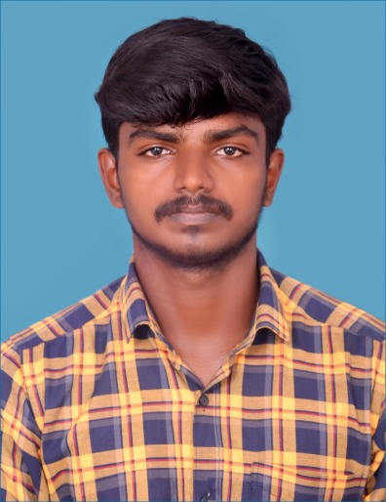

**RAJA S**

B.E – COMPUTER SCIENCE

CONTACT ME

+91-8248983002

Nanguneri,

Tirunelveli.

sraja12062000@gmail.com

EDUCATION

|  |  |  |
| --- | --- | --- |
| **COURSE / DEGREE** | **SCHOOL / UNIVERSITY** | **YEAR** |
| BE / CSE | PET ENGINEERING COLLEGE , VALLIOOR | 2021-2024 |
| DIPLOMA | S.A. RAJAS POLYTECNIC COLLEGE , VADAKKANKULAM | 2017-2019 |
| HSC | GOVT HR.SEC SCHOOL , DALAPATHISAMUDRAM | 2017 |

OBJECTIVES

TECHNICAL SKILLS

* HTML
* CSS
* JAVA SCRIPT
* BOOTSTRAP

ACHEIVEMENTS

* Won 2nd prize in web designing competition in national level symposium.

CERTIFICATE COURSES

* Web development
* Computer hardware
* Type writing in junior

Self-motivated and adaptable developer with applicable database knowledge and coding skills. Organized programmer looking for an opportunity to grow as a developer and support an ambitious startup technology company. Collaborative communicator with relationship building skills.

EXTRA CURRICULAR ACTIVITIES\

Creating some websites with the use of w3 school.

PROJECTS

**PacMAN game(Mini Project):**

Suessessfully created a PacMan game using the javascript with help of game library and the search alogorithm.

LANGUAGES KNOWN

* Tamil
* English

PERSONAL STRENGTH

If I do a task, I will not leave it unfinished.

DATE:

PLACE: SIGNATURE

(RAJA . S)