Azure Databricks Vs Databricks Solution on AWS Overview
Azure Databricks is a cloud-based platform that unifies data engineering, analytics, and AI, enabling organizations to build and scale data-driven solutions efficiently. It combines the power of Databricks with Microsoft Azure’s cloud services, making it easier to manage big data and machine learning workloads securely and at scale.
🌐 What Azure Databricks Is
- Unified Analytics Platform: Azure Databricks integrates data engineering, data science, machine learning, and analytics into one collaborative environment.
- Lakehouse Architecture: It supports the data lakehouse model, combining the flexibility of data lakes with the performance of data warehouses.
- Managed Service: Microsoft and Databricks jointly developed it, and Azure manages the infrastructure, scaling, and security for you.
⚙️ Key Features
- Data Engineering: Build ETL (Extract, Transform, Load) pipelines to process large volumes of data.
- Data Science & ML: Train and deploy machine learning models directly within the platform.
- Analytics: Query and analyze data using SQL, Python, R, or Scala.
- Collaboration: Teams can share notebooks, dashboards, and workflows in a single workspace.
- AI Integration: Uses generative AI to understand the semantics of your data, optimize performance, and even assist with natural language queries.
🔑 Components
- Workspaces: Collaborative environments where teams access notebooks, jobs, and data assets.
- Databricks Units (DBUs): The billing metric for usage, based on compute and workload type.
- Unity Catalog: Centralized governance for managing user access and data permissions across workspaces.

📊 Common Use Cases
- Enterprise Data Lakehouse: Store and manage structured + unstructured data in one place.
- ETL & Data Engineering: Automate ingestion and transformation of raw data.
- Machine Learning: Build predictive models for customer behavior, fraud detection, or recommendation systems.
- Business Intelligence: Enable analysts to query and visualize data for decision-making.
🚀 Benefits:
Azure Databricks is especially valuable for organizations dealing with large-scale data and needing AI-driven insights. It reduces complexity by integrating multiple tools into one platform, while Azure ensures enterprise-grade scalability and security.
Azure Databricks simplifies the complexities of big data and AI workflows by providing a fully managed, scalable, and secure platform. It eliminates the need for managing infrastructure, allowing teams to focus on deriving insights and building data-driven applications.

🔍 Comparison Overview
Azure Databricks is best for unified big data + AI workflows, AWS Glue is focused on ETL/data integration, and Google BigQuery is optimized for fast, serverless analytics. Each shines in different scenarios depending on whether your priority is machine learning, data pipelines, or large-scale SQL analytics.

Platform | Core Strengths | Typical Use Cases | Limitations
Azure Databricks | Unified analytics + AI, lakehouse architecture, collaborative notebooks | End-to-end data engineering, ML pipelines, real-time streaming, IoT analytics | More complex setup than pure SQL warehouses; higher learning curve
AWS Glue | Serverless ETL, schema discovery, integration with AWS ecosystem | Data migration, ETL workflows, preparing data for Redshift or Athena | Limited ML/AI capabilities; less suited for advanced analytics
Google BigQuery | Serverless data warehouse, blazing-fast SQL queries, scalability | BI dashboards, ad-hoc analytics, querying petabyte-scale structured data | Not designed for complex ML pipelines; limited flexibility compared to Databricks

⚙️ Key Differences
- Data Processing Approach
  - Azure Databricks: Built on Apache Spark, supports batch + streaming, ML, and advanced analytics.
  - AWS Glue: Primarily ETL-focused, automates schema discovery and data preparation.
  - BigQuery: SQL-first, optimized for querying structured data at scale.
- Machine Learning & AI
  - Databricks: Full ML lifecycle support (training, deployment, monitoring).
  - Glue: Minimal ML features; relies on AWS SageMaker for ML tasks.
  - BigQuery: Offers ML extensions (BigQuery ML), but limited compared to Databricks.
- Ease of Use
  - Databricks: Flexible but requires more expertise.
  - Glue: Easier for ETL developers; integrates tightly with AWS services.
  - BigQuery: Very user-friendly for analysts’ familiar with SQL.
- Cost Model
  - Databricks: Pay per Databricks Unit (DBU) + Azure compute/storage.
  - Glue: Pay per data processing unit (DPU) per hour.
  - BigQuery: Pay per query (bytes processed) or flat-rate subscription.
🚀 When to Choose Each
- Azure Databricks → If you need end-to-end data + AI workflows with flexibility across structured/unstructured data.
- AWS Glue → If your main goal is ETL pipelines within AWS, preparing data for analytics.
- Google BigQuery → If you want fast, serverless SQL analytics for BI dashboards and reporting.
Here’s a clear visual flowchart to help you decide between Azure Databricks, AWS Glue, and Google BigQuery based on your project goals.
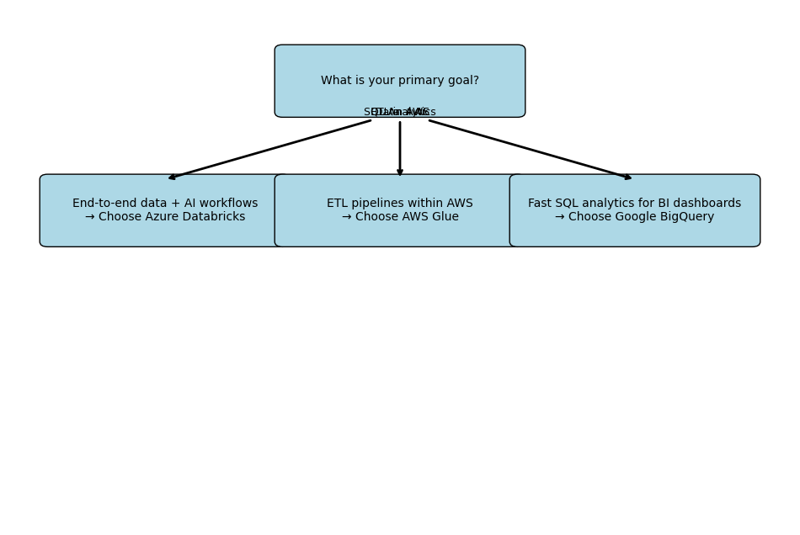
- Azure Databricks → Best for organizations needing a flexible lakehouse that supports machine learning, streaming, and advanced analytics.
- AWS Glue → Ideal if you’re already in the AWS ecosystem and need automated ETL pipelines to prepare data for Redshift or Athena.
- Google BigQuery → Perfect for analysts who want serverless, lightning-fast SQL queries for dashboards and reporting.
🔗 Key Azure Integrations
Azure Databricks integrates deeply with core Azure services like Power BI, Azure Data Lake Storage, Azure Synapse Analytics, Azure Machine Learning, Azure SQL Database, and Microsoft Purview, as well as third-party tools through Partner Connect.
- Power BI → Direct connection for interactive dashboards and business intelligence
- Azure Data Lake Storage Gen2 → Scalable storage for structured and unstructured data
- Azure Synapse Analytics → Seamless integration for advanced analytics and reporting
- Azure Machine Learning → Build, train, and deploy ML models using Databricks data pipelines
- Azure SQL Database & Azure Cosmos DB → Ingest and query relational and NoSQL data
- Microsoft Purview → Data governance, cataloging, and compliance management
- Azure Event Hubs & IoT Hub → Real-time streaming data ingestion for IoT and telemetry
🌐 Third-Party & Partner Connect
Azure Databricks also supports validated integrations with external tools via Partner Connect:
- Data ingestion & ETL: Fivetran, Informatica, Talend
- BI & visualization: Tableau, Qlik
- ML & AI frameworks: TensorFlow, PyTorch, MLflow
- Security & monitoring: Immuta, Alation, Datadog

📊 Why These Integrations Matter
- End-to-End Workflows: You can ingest raw data (Event Hubs), store it (Data Lake), process it (Databricks), analyze it (Synapse/Power BI), and govern it (Purview) — all within Azure.
- Flexibility: Supports both Microsoft-native and third-party ecosystems, reducing vendor lock-in.
- Scalability: Handles everything from small BI dashboards to petabyte-scale ML workloads.
👉 In short: Azure Databricks is the glue that connects Azure’s data, AI, and analytics ecosystem together.

🔑 Key Differences Between Azure Databricks and Databricks On AWS
The main difference is that Azure Databricks is a first-party service deeply integrated into the Azure ecosystem, while AWS Databricks is a partner solution running on AWS infrastructure with less native integration. Both deliver the same Databricks core platform, but the surrounding services, security, and ease of use differ.
Aspect | Azure Databricks | Databricks On AWS
Integration | Native Azure service with tight integration into Azure Data Lake Storage, Synapse Analytics, Power BI, Purview, and Azure ML | Runs on AWS but integrates mainly with S3, Redshift, Glue, SageMaker, and QuickSight
Identity & Security | Uses Azure Active Directory (AAD) for authentication, RBAC, and compliance; seamless with Azure security policies | Relies on AWS IAM for identity and access management; integrates with AWS security tools
Deployment & Management | Managed directly in the Azure portal; feels like a native Azure service with simplified setup | Provisioned via AWS Marketplace or Databricks console; requires more manual configuration
Ecosystem Fit | Best for organizations already invested in Azure cloud and Microsoft tools (Office 365, Power BI, etc.) | Best for organizations heavily using AWS services like Redshift, Glue, and SageMaker
Pricing Model | Billed in Databricks Units (DBUs) + Azure compute/storage; integrated into Azure billing | Billed in DBUs + AWS compute/storage; managed separately from AWS billing
Data Sources | Optimized for Azure-native storage (ADLS, Blob Storage, SQL DB, Cosmos DB) | Optimized for AWS-native storage (S3, DynamoDB, RDS)
⚙️ What Stays the Same
- Core Databricks Platform: Both offer the same Spark-based engine, notebooks, MLflow, Delta Lake, and collaborative workspace.
- Lakehouse Architecture: Both support structured + unstructured data in a unified lakehouse.
- Partner Connect: Both integrate with third-party tools like Tableau, Fivetran, Informatica, and ML frameworks.

🔗 Azure Databricks Integrated Services (with AWS Equivalents)
Azure Service (with Databricks) | Purpose | AWS Equivalent
Azure Data Lake Storage (ADLS Gen2) | Scalable data lake storage for structured & unstructured data | Amazon S3
Azure Synapse Analytics | Data warehouse + analytics integration | Amazon Redshift
Power BI | Business intelligence & visualization | Amazon QuickSight
Azure Machine Learning | ML model training, deployment, and monitoring | Amazon SageMaker
Azure SQL Database | Managed relational database | Amazon RDS (Relational Database Service)
Azure Cosmos DB | Globally distributed NoSQL database | Amazon DynamoDB
Azure Event Hubs | Real-time event streaming ingestion | Amazon Kinesis Data Streams
Azure IoT Hub | IoT device connectivity and telemetry ingestion | AWS IoT Core
Microsoft Purview | Data governance, cataloging, compliance | AWS Glue Data Catalog
Azure Blob Storage | Object storage for raw data, backups | Amazon S3 (same as ADLS equivalent)
Azure Key Vault | Secrets and credential management | AWS Secrets Manager / AWS KMS
Azure Active Directory (AAD) | Identity and access management | AWS IAM

👉 In short: Azure Databricks feels more “native” inside Azure, while AWS Databricks is more of a bolt-on partner solution.
⚙️ What This Means
- Core Databricks Platform is the same across both clouds (Spark engine, Delta Lake, MLflow, notebooks).
- The surrounding services differ: Azure Databricks plugs natively into Microsoft’s ecosystem, while AWS Databricks connects to AWS-native services.
- If your team is already invested in Azure tools like Power BI or Synapse, Azure Databricks feels seamless. If you’re AWS-heavy with S3, Redshift, and SageMaker, AWS Databricks is the natural fit.
👉 In short: Azure Databricks integrates with Azure-native services, while AWS Databricks integrates with AWS-native services that serve the same purpose.

🔹 What is Azure Databricks?
- Definition: A first-party service jointly developed by Microsoft and Databricks, fully integrated into the Azure ecosystem.
- Deployment: Managed directly through the Azure Portal like any other Azure service.
- Identity & Security: Uses Azure Active Directory (AAD) for authentication, RBAC, and compliance.
- Integrations: Connects seamlessly with Azure services such as:
  - Azure Data Lake Storage (ADLS) for big data storage
  - Azure Synapse Analytics for data warehousing
  - Power BI for visualization
  - Azure Machine Learning for ML lifecycle management
  - Microsoft Purview for governance
- Billing: Costs are integrated into your Azure subscription, using Databricks Units (DBUs) + Azure compute/storage.
👉 In short: Azure Databricks feels like a native Azure service, tightly woven into Microsoft’s cloud ecosystem.

🔹 What is Databricks on AWS?
- Definition: A partner solution offered by Databricks that runs on AWS infrastructure.
- Deployment: Provisioned via the AWS Marketplace or Databricks console, not directly inside AWS native services.
- Identity & Security: Uses AWS IAM for authentication and access control.
- Integrations: Connects with AWS-native services such as:
  - Amazon S3 for storage
  - Amazon Redshift for analytics
  - Amazon QuickSight for visualization
  - Amazon SageMaker for ML model deployment
  - AWS Glue Data Catalog for governance
- Billing: Managed separately through Databricks + AWS compute/storage billing.
👉 In short: Databricks on AWS is the same Databricks platform, but it plugs into AWS services instead of Azure ones.
⚙️ What Stays the Same
- Core Databricks Platform: Apache Spark engine, Delta Lake, MLflow, collaborative notebooks, and the lakehouse architecture are identical across both clouds.
- Use Cases: Big data processing, ETL pipelines, machine learning, streaming analytics, and BI dashboards.
🚀 Key Difference
- Azure Databricks → Feels like a native Azure service with deep Microsoft integration.
- AWS Databricks → A partner-managed solution that integrates with AWS services but is less “native.”
👉 Think of it this way: Databricks is the same engine everywhere, but the surrounding ecosystem changes depending on whether you’re in Azure or AWS.

Choosing between Azure Databricks and Databricks on AWS depends less on Databricks itself (since the core platform is identical) and more on which cloud ecosystem your organization is invested in. Here’s a structured way to decide:
🧭 Decision Framework
1. Cloud Ecosystem Fit
- If your company already uses Azure services (Power BI, Synapse, ADLS, Azure ML, Purview), then Azure Databricks is the natural choice.
- If your company is heavily invested in AWS services (S3, Redshift, SageMaker, QuickSight, Glue), then Databricks on AWS fits better.
2. Identity & Security
- Azure Databricks → Uses Azure Active Directory (AAD) for authentication and RBAC.
- AWS Databricks → Uses AWS IAM for identity and access control. 👉 Choose based on which identity system your enterprise already relies on.
3. Data Sources
- Azure Databricks integrates natively with ADLS, Blob Storage, SQL DB, Cosmos DB.
- AWS Databricks integrates with S3, RDS, DynamoDB. 👉 If most of your data lives in Azure storage, go Azure; if it’s in AWS storage, go AWS.
4. Analytics & BI
- Azure Databricks → Best paired with Power BI.
- AWS Databricks → Best paired with QuickSight. 👉 Consider where your analysts are most comfortable.
5. Machine Learning
- Azure Databricks → Works seamlessly with Azure Machine Learning.
- AWS Databricks → Works seamlessly with Amazon SageMaker. 👉 If ML is a big part of your workflow, choose the cloud where your ML team already has expertise.
6. Governance & Compliance
- Azure Databricks → Integrated with Microsoft Purview for governance.
- AWS Databricks → Integrated with AWS Glue Data Catalog. 👉 If compliance and governance are critical, pick the cloud that aligns with your regulatory requirements.

🚀 Quick Rule of Thumb
- Go with Azure Databricks if your enterprise is Microsoft-centric (Office 365, Power BI, Azure AD).
- Go with AWS Databricks if your enterprise is AWS-centric (S3, Redshift, SageMaker, IAM).
- If you’re multi-cloud, choose based on where your data primarily resides — moving petabytes of data across clouds is costly.
👉 In short: Databricks is the same engine everywhere, but the surrounding ecosystem decides which version is right for you.
Thank you……….

