# **DAY-2 TASK**

# **Differences between Document and Window Objects**

**DOCUMENT OBJECT:**

Document object represent a page which loaded in the browser. We can access the HTML page element by accessing the document object. Document object is accessed in browser by **“document”.**

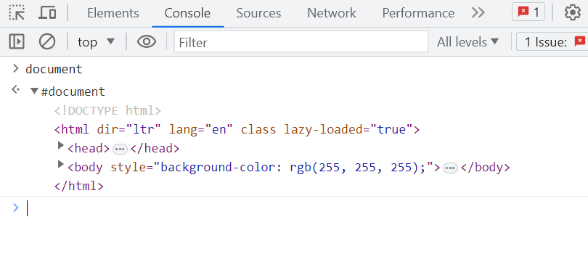

Document object has some properties and methods helps to access the HTML elements in the browser page.

**DOCUMENT OBJECT=> PROPERTY:**

**doctype:** It returns the document’s doctype.

**head:**  It returns the head tag element of the document. Header tag holds title, link of another page, meta information.

**title:** It returns the title tag element of the document. Title tag holds the title of the document.

**URL:** It returns the complete URL of document page of the browser.

**links:** It returns the element <area> and <a> which has “href” attribute.

**image:** It returns the collection of element<img> on the browser document page.

**domain:** It returns the document server’s domain name.

**body:** It returns the content with in the body tag of the HTML script, that show on the document page of the browser.

**anchors:** It returns the element<a> which has a” name” attribute.

**DOCUMENT OBJECT=>METHODS:**

**createAttribute():** It helps to create a new attribute node in specified name and returns the attribute object.

**createComment():** It used to create the comment node with some text .

**createElement():** It helps to create HTML elements

**open():** It helps to collect the output by open the output stream.

**close():** It used to close the output stream.

**write():** It used to add some content or script in the document page of the browser.

**importNode():** It returns the copied node to the document. Which was copied from another document to current document.

**hasFocus():** It helps to indicate whether the document or element has focus or not by returning the “Boolean value”.

**WINDOW OBJECT:**

Window object represent the browser frame which display the content of the web page. Whenever the window opens on the screen to shows the content of the document in the web page. Window object is access in the browser by **“window”**

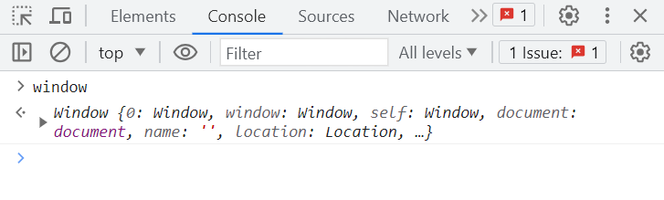

Window object has some properties and methods helps to access the elements in the browser page.

**WINDOW OBJECT=>PROPERTY:**

**console:** It returns a reference to the console object. To access the browser to debugging by the console object

**Length:** It represent the number of frames in the current browser window

**Location:** It contains the URL of the current window of the browser web page.

**innerHeight:** It is used to get the content area height of the browser web page.

**innerWidth:** It is used to get the content area width of the browser web page.

**Document:** It returns a reference to the document object of that browser window

**Name:** It contain the name of the referenced window

**outerWidth:** It is used to get the width of the window which is outside of the browser.

**outerHeight:** It is used to get the height of the window which is outside of the browser.

**WINDOW OBJECT=>METHODS:**

**alert():** It is used to show the alert notification, this give some informations to the user.

**clearInterval():** It is used to clear the interval which has set by the setTimeout() function.

**clearTimeout():** It is used to clear the timeout which has set by the setTimeout() function.  

**open(): It is used to open the new window on browser with specific name or URL.**

**close():** It is used to close the certain browser window which was previously opened

**focus():** It is used to focus on an element in the window

**prompt():**  It is used to show a dialog with an message prompting the user to input text

**stop():** It is used to stop the window from loading in the current browser.

**DIFFERENCE BETWEEN DOCUMENT & WINDOW OBJECT**

|  |  |
| --- | --- |
| **DOCUMENT OBJECT** | **WINDOW OBJECT** |
| * Represent the HTML page which loaded in the browser.      * It loaded inside the window tab * It is an object of the window property * Can access the document from a window by using the **“window.document”** or **“document”** | * Represent the browser frame which shows the content of the window web page. * It is an object that is loaded in the browser * It is an object of the browser page * Can access the window by using the **“window.window”** or **“window”.** |