**Exercise 1: Implementing the Singleton Pattern**

public class Main {

    public static void main(String[] args) {

        // First instance

        Logger logger1 = Logger.getInstance();

        logger1.log("This is the first log message.");

        // Second instance

        Logger logger2 = Logger.getInstance();

        logger2.log("This is the second log message.");

        // Verify if both instances are same

        if(logger1 == logger2) {

            System.out.println("Both logger instances are the same (Singleton works).");

        } else {

            System.out.println("Different instances (Singleton failed).");

        }

    }

}

public class Logger {

    // Private static instance

    private static Logger instance;

    // Private constructor

    private Logger() {

        System.out.println("Logger Initialized.");

    }

    // Public method to get the instance

    public static Logger getInstance() {

        if (instance == null) {

            instance = new Logger();

        }

        return instance;

    }

    // Example logging method

    public void log(String message) {

        System.out.println("Log: " + message);

    }

}

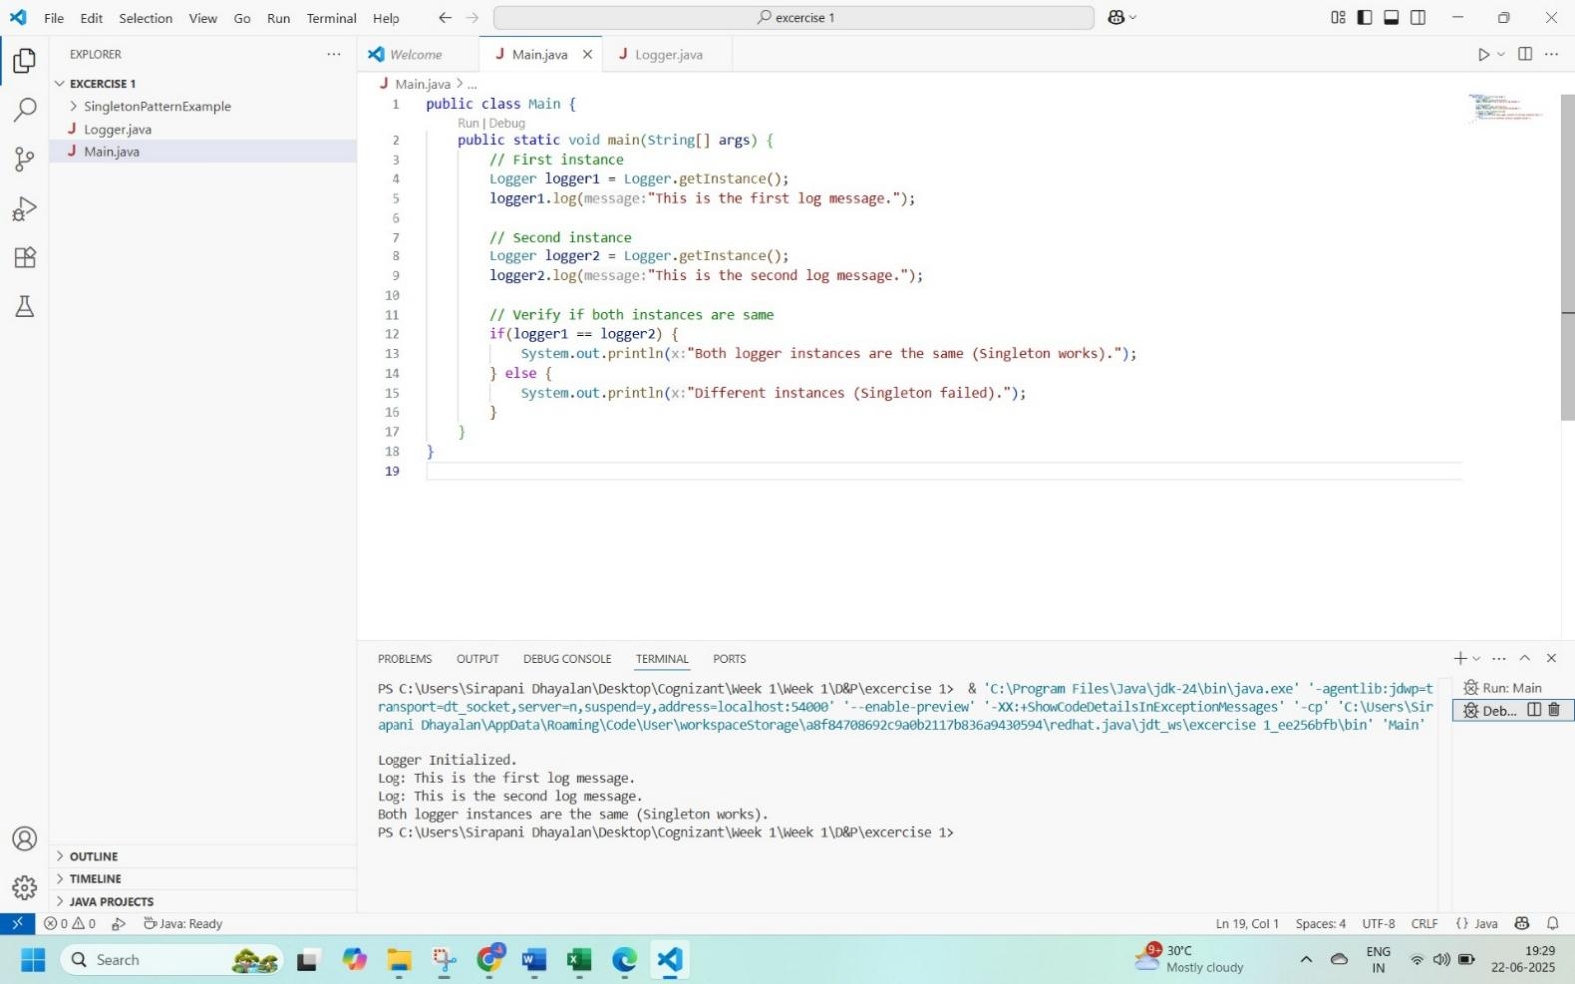

**Exercise 2: Implementing the Factory Method Pattern**

public interface Document {

    void open();

}

public abstract class DocumentFactory {

    public abstract Document createDocument();

}

public class ExcelDocument implements Document {

    public void open() {

        System.out.println("Opening Excel Document.");

    }

}

public class ExcelFactory extends DocumentFactory {

    public Document createDocument() {

        return new ExcelDocument();

    }

}

public class Main {

    public static void main(String[] args) {

        DocumentFactory wordFactory = new WordFactory();

        Document word = wordFactory.createDocument();

        word.open();

        DocumentFactory pdfFactory = new PdfFactory();

        Document pdf = pdfFactory.createDocument();

        pdf.open();

        DocumentFactory excelFactory = new ExcelFactory();

        Document excel = excelFactory.createDocument();

        excel.open();

    }

}

public class PdfDocument implements Document {

    public void open() {

        System.out.println("Opening PDF Document.");

    }

}

public class PdfFactory extends DocumentFactory {

    public Document createDocument() {

        return new PdfDocument();

    }

}

public class WordDocument implements Document {

    public void open() {

        System.out.println("Opening Word Document.");

    }

}

public class WordFactory extends DocumentFactory {

    public Document createDocument() {

        return new WordDocument();

    }

}

