SIMATS ENGINEERING
ASSESSMENT TOOL 2
COURSE NAME: Artificial Intelligence COURSE CODE: CSA17
COURSE OUTCOME COVERED
CO1: Apply AI basics such as intelligent agents and uninformed search methods to solve problems effectively.( BL3)
Assessment Tool Weightage: 35%
QUESTIONS: 1 Duration : 1 Hour Total Marks:10
Annexure A
Constraint-Based Problem Solving
Code of Conduct:
I _____M.Raja Manohar Reddy /192325062 (Name / Reg No) certify that this submission is my original work and that I have adhered to the guidelines specified for this assessment.
I understand that any violation of academic integrity rules will result in disciplinary action. Signature of the student: M.Raja Manohar Reddy

1. Problem Statement
A hospital must assign three doctors, D1, D2 and D3, to three shifts: Morning, Afternoon and Night. Each doctor must receive exactly one shift, and each shift must have exactly one doctor. The schedule must also respect the restrictions listed below. The task is to apply Backtracking Search, show intermediate assignments and constraint checks, and report one complete valid schedule.
- C1 – D1 cannot work the Night shift.
- C2 – D2 must work before D3. The shift order is Morning < Afternoon < Night, so D2's shift index must be smaller than D3's.
- C3 – Only one doctor can work each shift; no two doctors may receive the same shift.
- C4 – D3 cannot work the Morning shift.
- C5 – Every doctor must be assigned exactly one shift.

2. Problem Formulation
Element | Description
Variables | D1, D2 and D3; each variable represents the shift given to that doctor.
Domain | {Morning, Afternoon, Night} for each doctor before applying restrictions.
Initial state | No doctor has been assigned a shift.
Goal state | A complete assignment of all three doctors satisfying C1–C5.
Search method | Backtracking Search: assign one variable at a time, check constraints, and undo a choice if it fails.

3. Constraint Analysis and Prioritization
Unary constraints restrict one doctor's choices and can be checked as soon as that doctor is assigned. The ordering constraint compares D2 and D3, while the uniqueness and completeness constraints apply to the whole schedule. Checking constraints early prevents the search from exploring branches that cannot lead to a solution.
Constraint | Formal rule | Type | When it is checked
C1 | D1 ≠ Night | Unary | When D1 is assigned
C2 | position(D2) < position(D3) | Binary | When D2 and D3 are both assigned
C3 | D1, D2 and D3 have distinct shifts | Global / all-different | Whenever a shift is chosen
C4 | D3 ≠ Morning | Unary | When D3 is assigned
C5 | Each variable has exactly one value | Completeness | At the end of a candidate schedule
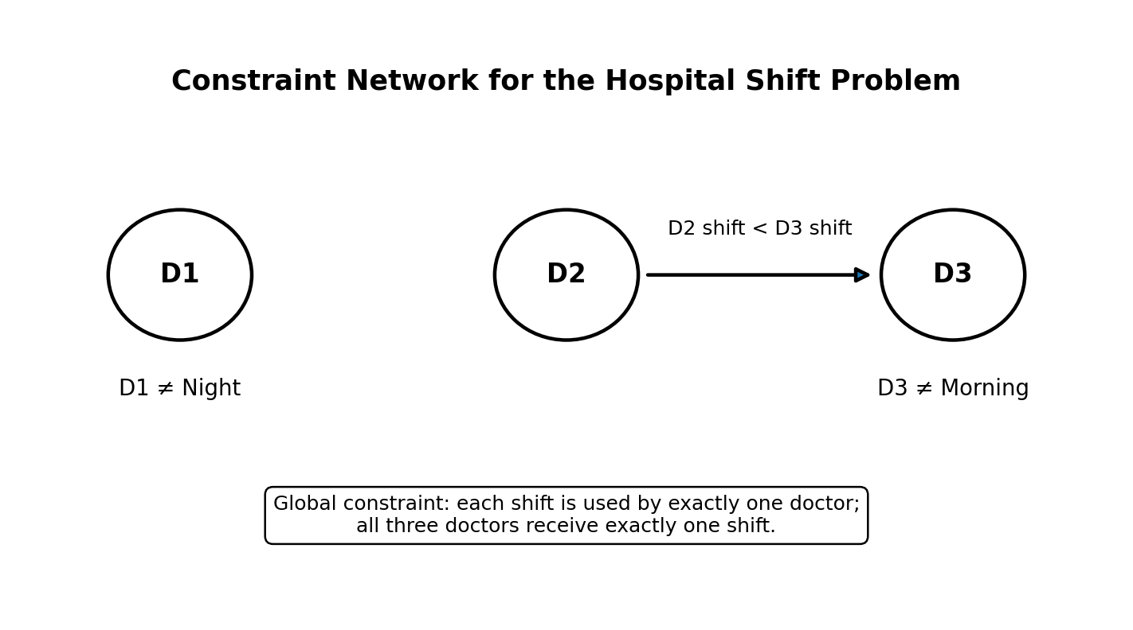
Figure 1. Constraint network showing the ordering relation and doctor-specific restrictions.

4. Backtracking Search Procedure
The algorithm selects a doctor, tries a shift from the domain, and checks whether the partial assignment is consistent. If it is consistent, the algorithm continues to the next doctor. If it violates a constraint, the shift is rejected and another value is tried. If no value works, the algorithm returns to the previous doctor and changes that assignment. This undo-and-try-again process is called backtracking.
- Step 1: Start with an empty assignment.
- Step 2: Select the next unassigned doctor in the order D1, D2, D3.
- Step 3: Try Morning, then Afternoon, then Night.
- Step 4: Check every constraint that can be evaluated at that point.
- Step 5: Keep a consistent value; reject a conflicting value.
- Step 6: Continue until all doctors are assigned or backtrack if a dead end is reached.
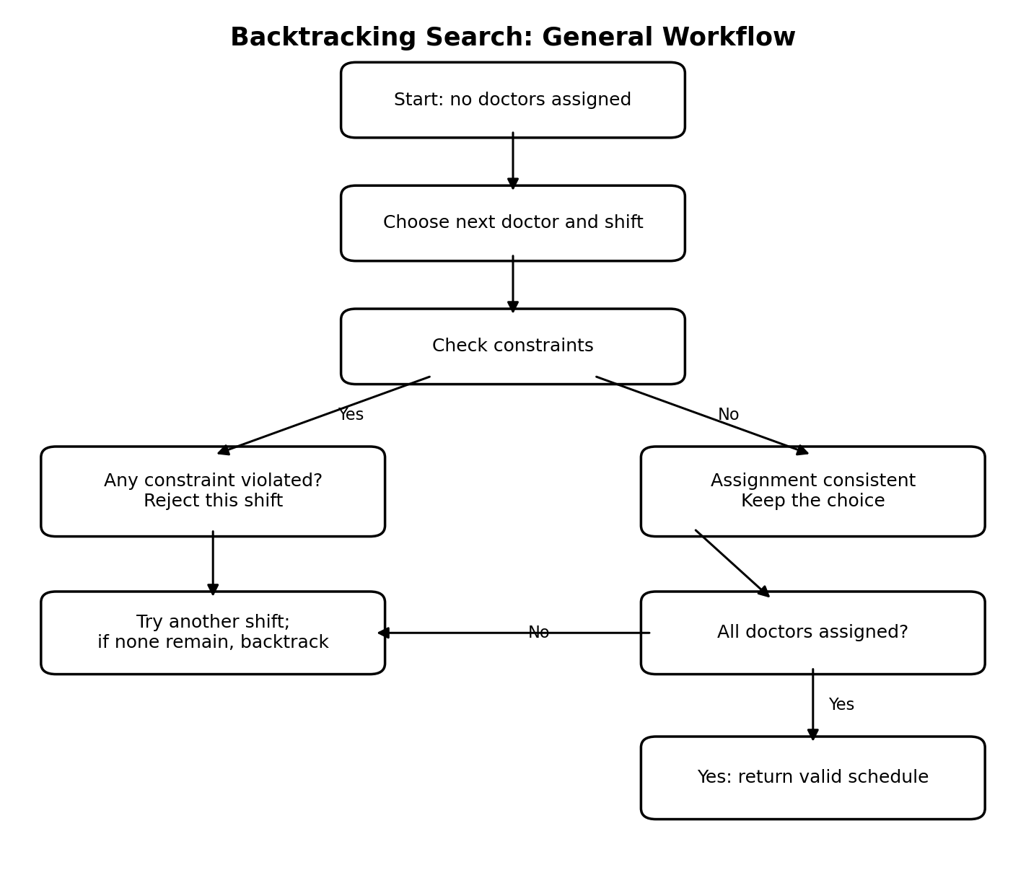
Figure 2. General flow of Backtracking Search.

5. Intermediate Steps and Constraint Checks
For a clear trace, the variable order is D1 → D2 → D3 and the value order is Morning → Afternoon → Night. The trace below shows the first branch that reaches a solution.
Step | Candidate assignment | Constraint check | Decision
1 | D1 = Morning | C1 passes because D1 is not assigned Night. No shift conflict exists yet. | Accept temporarily.
2 | D2 = Morning | C3 fails: Morning is already assigned to D1, so two doctors would share a shift. | Reject; try next value for D2.
3 | D2 = Afternoon | Afternoon is unused, so C3 passes. C2 is not fully checkable until D3 is assigned. | Accept temporarily.
4 | D3 = Morning | C4 fails because D3 cannot work Morning. C3 also fails because Morning is already used by D1. | Reject; try next value for D3.
5 | D3 = Afternoon | C3 fails because Afternoon is already assigned to D2. | Reject; try next value for D3.
6 | D3 = Night | C3 passes because Night is unused; C4 passes because D3 is not on Morning; C2 passes because Afternoon is before Night. | Accept.
7 | D1=Morning, D2=Afternoon, D3=Night | All three doctors are assigned exactly once and C1–C5 are satisfied. | Stop: valid solution found.
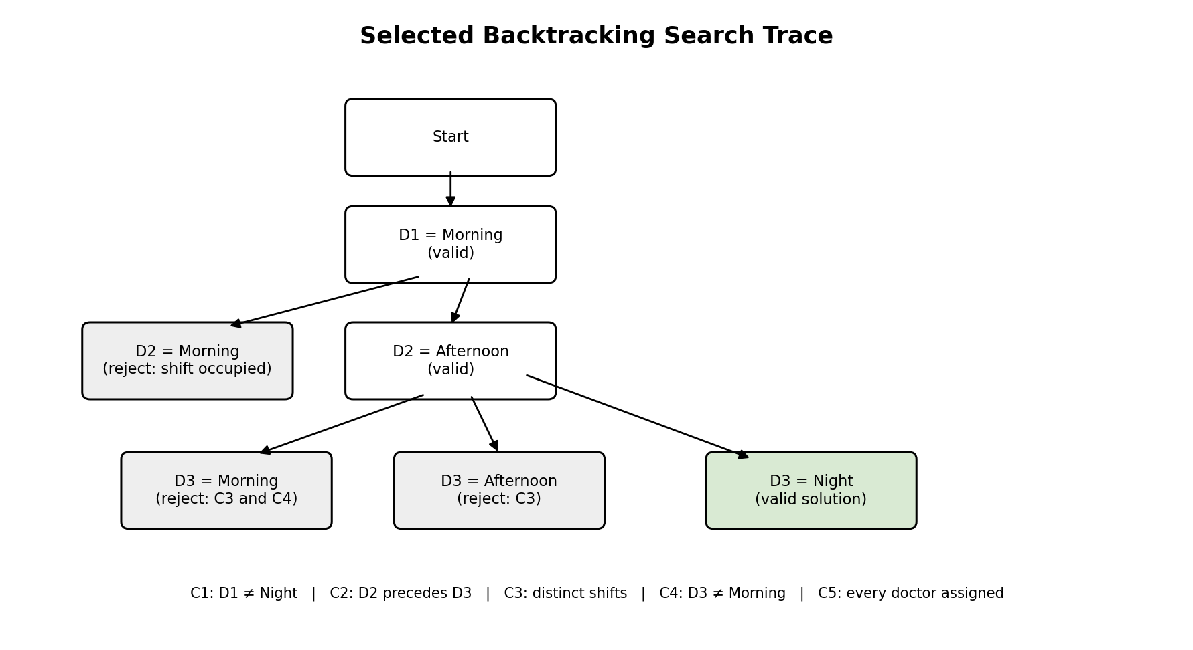
Figure 3. Selected search path, including rejected choices and the valid branch.

6. Final Valid Schedule
Shift order | Shift | Assigned doctor
1 | Morning | D1
2 | Afternoon | D2
3 | Night | D3
FINAL ASSIGNMENT: D1 → MORNING, D2 → AFTERNOON, D3 → NIGHT

7. Verification of All Constraints
Constraint | Evidence from final schedule | Status
C1: D1 cannot work Night | D1 is assigned Morning. | Satisfied
C2: D2 must work before D3 | D2 works Afternoon and D3 works Night; Afternoon precedes Night. | Satisfied
C3: One doctor per shift | Morning, Afternoon and Night are assigned to different doctors. | Satisfied
C4: D3 cannot work Morning | D3 is assigned Night. | Satisfied
C5: Every doctor exactly one shift | D1, D2 and D3 each appear exactly once in the schedule. | Satisfied

8. Why Backtracking Search Is Suitable
This problem is a Constraint Satisfaction Problem (CSP) because it contains variables, domains and rules that restrict valid combinations. Backtracking is suitable because it builds a solution incrementally instead of checking every complete permutation first. When D2 = Morning conflicts with D1 = Morning, that choice is rejected immediately. Likewise, invalid choices for D3 are removed as soon as C3 or C4 is violated. This early checking saves unnecessary work and makes the reasoning easy to explain and verify.
There are only 3! = 6 possible one-to-one assignments before applying the special restrictions. Backtracking checks candidates incrementally and stops once it finds a valid assignment. The purpose here is not only to produce a schedule, but also to show how constraints guide the search.

9. Result and Conclusion
Backtracking Search was applied to the hospital doctor-shift assignment problem. After rejecting assignments that violated the one-doctor-per-shift rule or the restriction on D3, the search found the schedule D1–Morning, D2–Afternoon and D3–Night. The final schedule satisfies all five constraints and demonstrates how AI search can solve a small constraint-based planning problem systematically.

