SIMATS ENGINEERING
ASSESSMENT TOOL 1

COURSE NAME: Artificial Intelligence COURSE CODE: CSA17

COURSE OUTCOME COVERED

CO1: Apply AI basics such as intelligent agents and uninformed search methods to solve problems effectively. (BL3)

Assessment Tool Weightage: 35%

QUESTIONS: 5 Duration : 1 Hour
Total Marks:50

Annexure A

Analytical Problem Solving

Code of Conduct:

I M.Raja Manohar Reddy /192325062 (Name / Reg No) certify that this submission is my original work and that I have adhered to the guidelines specified for this assessment.
I understand that any violation of academic integrity rules will result in disciplinary action.

Signature of the student: M.Raja Manohar Reddy

Annexure A

Analytical Problem Solving

- Solve the Water Jug problem: you are given 2 jugs, a 4-gallon one and 3-gallon one. Neither has any measuring maker on it. There is a pump that can be used to fill the jugs with water. How can you get exactly 2 gallons of water into 4-gallon jug? Explicit assumptions: A jug can be filled from the pump, water can be poured out of a jug onto the ground, water can be poured from one jug to another and that there are no other measuring devices available.

- Find out how Mars Rover, analyse and explore the samples on Mars by answering the following questions.
- What are the percept’s for this agent?
- Characterize the operating environment.
- What are the actions the agent can take?
- How can one evaluate the performance of the agent?
- What sort of agent architecture do you think is most suitable for this agent? Why?

- Explore the search space using search strategies and formulate the problem components for the 8-Queens problem using the following information: Place 8 queens on a chessboard such that none of the queen’s attack any of the others. A configuration of 8 queens on the board as shown in the figure below, but this does not represent a solution as the queen in the first column is on the same diagonal as the queen in the last column.

- A customer wants to travel from the one location to another location using OLA Cab booking mobile application. The customer can select the any of the cab type as mini, micro, sedan, shared, prime and so on based on his comfort to reach the destination. Identify what type of problem-solving agent can be used and write the pseudocode for the above problem.

- A logistics company operates a delivery network where packages must be transported between warehouses at minimum cost. Each route between warehouses has an associated travel cost (fuel + time). The company wants to determine the least-cost path from the starting warehouse S to the destination warehouse G using the Uniform Cost Search (UCS) algorithm.

The delivery network is represented as a weighted graph:


1. Water Jug Problem
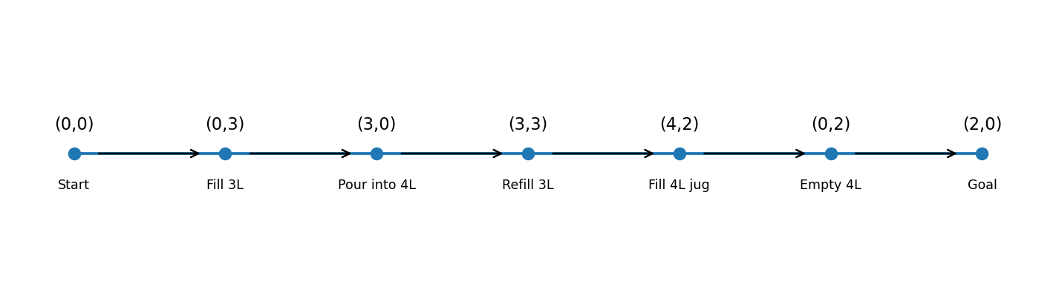
Problem: Given a 4-gallon jug and a 3-gallon jug, obtain exactly 2 gallons in the 4-gallon jug. No measuring marks or other measuring devices are available.
State representation: (x, y), where x is the amount of water in the 4-gallon jug and y is the amount in the 3-gallon jug.
Initial state: (0, 0). Goal state: any state (2, y), where the 4-gallon jug contains exactly 2 gallons.

Procedure
- (0, 0) – Both jugs are empty.
- (0, 3) – Fill the 3-gallon jug.
- (3, 0) – Pour the 3-gallon jug into the 4-gallon jug.
- (3, 3) – Fill the 3-gallon jug again.
- (4, 2) – Pour from the 3-gallon jug into the 4-gallon jug until the 4-gallon jug is full. One gallon remains in the 3-gallon jug.
- (0, 2) – Empty the 4-gallon jug onto the ground.
- (2, 0) – Pour the remaining 2 gallons from the 3-gallon jug into the 4-gallon jug.
Result: The 4-gallon jug contains exactly 2 gallons of water.

2. Mars Rover as an Intelligent Agent
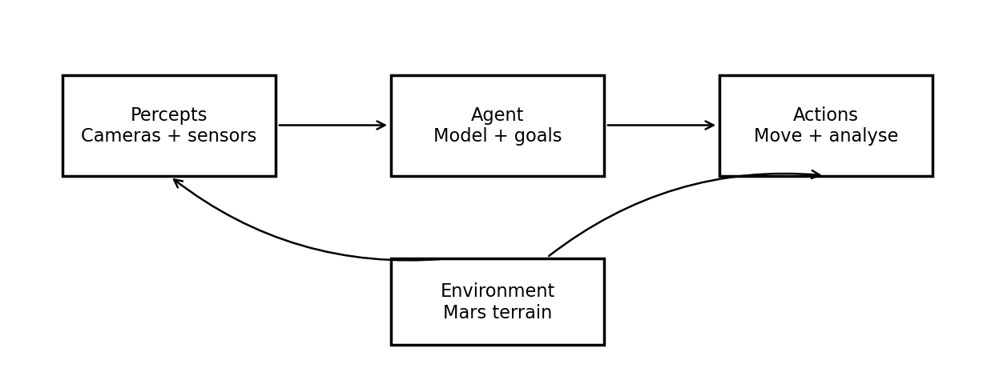
A Mars Rover is an autonomous robotic agent that observes the Martian environment, moves across terrain, performs scientific measurements, and analyses rock or soil samples.

i. Percepts
The rover receives percepts through cameras, spectrometers, temperature sensors, navigation cameras, wheel encoders, hazard-detection sensors, and sample-analysis instruments. These percepts include terrain shape, rocks, slopes, obstacles, soil composition, chemical signatures, temperature, lighting, and the rover’s own position and battery level.

ii. Operating environment
The environment is partially observable, because the rover cannot sense everything around it; stochastic, because movement and measurements may be uncertain; sequential, because each action affects later decisions; dynamic, because conditions such as lighting and terrain hazards can change; continuous, because position and sensor values vary continuously; and single-agent in its immediate task, although it receives instructions from Earth and may coordinate with other systems. Communication delays and limited energy make autonomous decisions important.

iii. Actions
- Move forward, reverse, turn, and adjust speed.
- Capture images and map the surroundings.
- Avoid rocks, steep slopes, and other hazards.
- Use an arm or drill to collect a sample.
- Analyse samples using onboard scientific instruments.
- Transmit data to Earth, conserve power, and enter a safe mode when necessary.

iv. Performance evaluation
Performance can be evaluated by scientific value and accuracy of sample analysis, successful completion of exploration goals, distance and area explored, quality of images and maps, safe navigation without damage, energy efficiency, communication success, and the amount of useful data returned within the mission time.

v. Suitable agent architecture
A model-based, goal-based agent with utility-based decision-making is most suitable. A model-based component maintains an internal map and estimates the rover’s state when the environment is only partly observable. Goal-based planning selects actions that achieve objectives such as reaching a rock or analysing a sample. A utility component compares trade-offs among scientific value, risk, time, and battery use. A learning component can further improve navigation and sample selection from experience.

3. Eight-Queens Problem
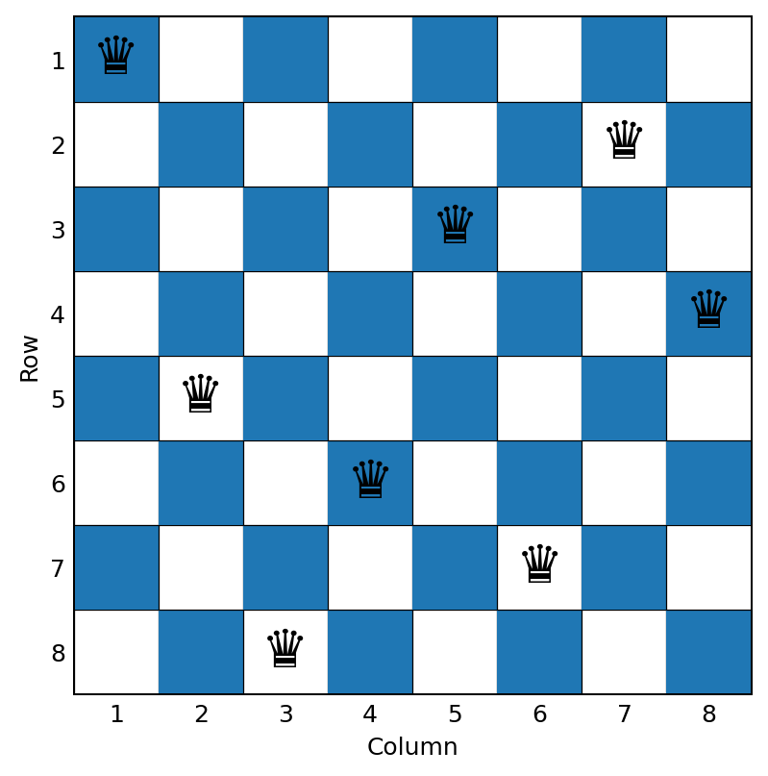
Problem: Place eight queens on an 8 × 8 chessboard so that no two queens attack each other. Queens attack along rows, columns, and diagonals.

Problem formulation
- Initial state: An empty chessboard.
- State: A partial arrangement of queens, normally placing one queen in each of the first k columns.
- Actions: Place a queen in a safe square in the next column.
- Transition model: Add a queen at the selected row and next column.
- Goal test: Eight queens have been placed, with no pair sharing a row, column, or diagonal.
- Path cost: Each placement may be assigned cost 1; all complete solutions then have the same cost of 8.
Constraint representation: Let Q[c] be the row chosen for the queen in column c. A valid solution must satisfy Q[i] ≠ Q[j] and |Q[i] − Q[j]| ≠ |i − j| for every pair of distinct columns i and j.

Search strategy
Backtracking depth-first search is an effective approach. Start in the first column, try each row, and continue only when the new queen does not conflict with any earlier queen. If no safe row exists, backtrack to the previous column and try another row. This systematically explores the search space while pruning invalid partial configurations.
Example of a valid solution (row positions for columns 1–8): [1, 5, 8, 6, 3, 7, 2, 4]. Each column contains one queen, all rows are different, and no two queens share a diagonal.
Result: The problem is solved when a safe placement of all eight queens passes the goal test.

4. OLA Cab Booking as a Problem-Solving Agent
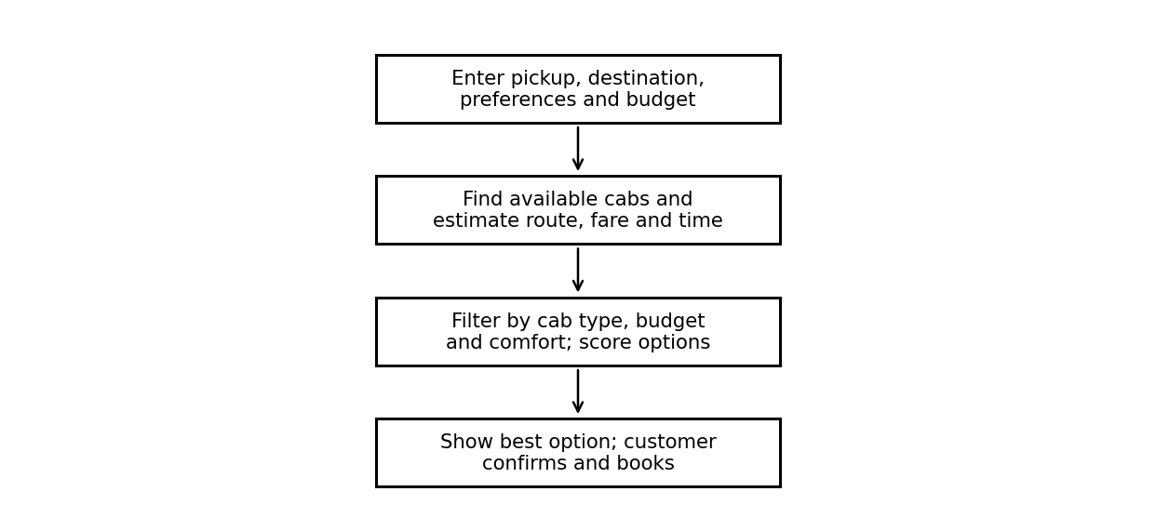
A goal-based problem-solving agent is suitable because the customer has a destination goal and must choose a cab and route that reach it. A utility-based extension is even more practical because it can compare fare, estimated arrival time, comfort, availability, and customer preferences.

Problem formulation
- Initial state: Customer’s current location and booking preferences.
- Goal state: Customer reaches the requested destination.
- Actions: Select a cab type (Mini, Micro, Sedan, Shared, Prime, etc.), request a cab, choose an available route, and confirm the booking.
- State information: Pickup and drop locations, traffic, route distance, fare estimate, cab availability, and estimated arrival time.
- Evaluation: Minimise a cost function based on fare and travel time while respecting comfort and service preferences.

Pseudocode
BEGIN
INPUT pickup_location, destination
INPUT preferred_cab_type, budget, comfort_preference
map_data <- GET_ROAD_NETWORK()
traffic <- GET_CURRENT_TRAFFIC()
available_cabs <- FIND_AVAILABLE_CABS(pickup_location)
IF available_cabs is empty THEN
DISPLAY "No cabs available"
STOP
END IF
options <- empty list
FOR each cab IN available_cabs DO
IF cab matches preferred_cab_type OR no type is preferred THEN
route <- FIND_ROUTE(pickup_location, destination, traffic)
fare <- ESTIMATE_FARE(cab.type, route.distance)
time <- ESTIMATE_TIME(route, traffic)
IF fare <= budget OR budget is not specified THEN
score <- WEIGHTED_SCORE(fare, time, comfort_preference)
ADD (cab, route, fare, time, score) TO options
END IF
END IF
END FOR
IF options is empty THEN
DISPLAY "No suitable cab found; change preferences"
ELSE
best_option <- option with lowest score
DISPLAY best_option cab type, route, fare, and estimated time
IF customer confirms THEN
BOOK(best_option.cab)
DISPLAY "Booking confirmed"
END IF
END IF
END
Result: The agent recommends a suitable available cab and route by balancing the customer’s destination, budget, time, and comfort requirements.

5. Uniform Cost Search (UCS) for the Delivery Network
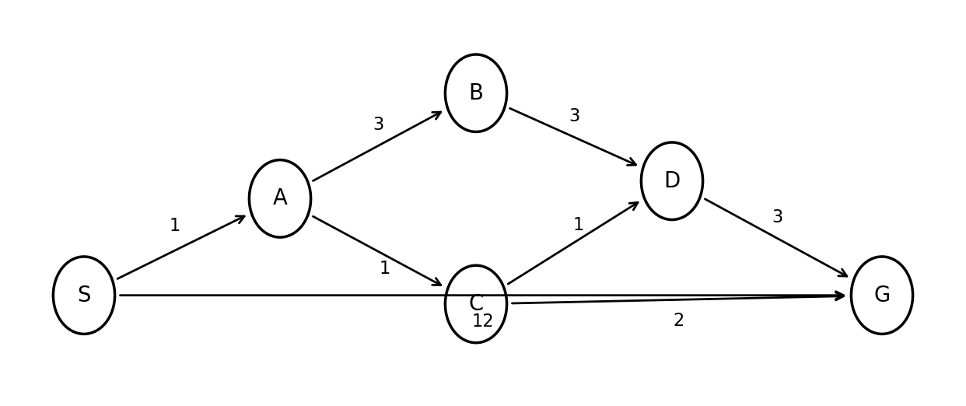
Uniform Cost Search expands the frontier node with the lowest cumulative path cost g(n). It is appropriate when route costs are non-negative and the objective is to find a minimum-cost path.
Directed edges shown in the graph: S→A (1), S→G (12), A→B (3), A→C (1), B→D (3), C→D (1), C→G (2), and D→G (3).

UCS expansion
- Start at S with cost 0. Frontier: A(1), G(12).
- Expand A(1). Add C(2) and B(4). Frontier: C(2), B(4), G(12).
- Expand C(2). Add D(3) and improve G to cost 4 (2 + 2). Frontier: D(3), B(4), G(4).
- Expand D(3). The path through D gives G a cost of 6 (3 + 3), so it does not improve G’s current cost of 4. Frontier: B(4), G(4).
- Expand B(4). The path through B gives D a cost of 7, which is worse than the known cost 3. Frontier: G(4).
- Remove G(4) from the frontier. The goal is reached with the lowest cumulative cost.

Cost comparison
Path | Calculation | Total cost
S → G | 12 | 12
S → A → C → G | 1 + 1 + 2 | 4
S → A → C → D → G | 1 + 1 + 1 + 3 | 6
S → A → B → D → G | 1 + 3 + 3 + 3 | 10
Optimal path: S → A → C → G.
Minimum total cost: 1 + 1 + 2 = 4 cost units.
Interpretation: UCS selects the route with the smallest accumulated travel cost, rather than the route with the fewest edges. Under the given edge weights, travelling through A and C reaches G at total cost 4, which is cheaper than the direct route costing 12.

Conclusion
These problems demonstrate how Artificial Intelligence represents real-world tasks as states, actions, goals, and costs. State-space search solves the Water Jug and Eight-Queens problems; intelligent-agent design guides Mars exploration and cab booking; and Uniform Cost Search identifies the minimum-cost delivery route.

RUBRICS FOR CALCULATION:
Criteria | Weightage | Level 4 (Exemplary) | Level 3 (Proficient) | Level 2 (Developing) | Level 1 (Beginning)
Problem Understanding | 20% | Clearly interprets problem, identifies all parameters and requirements accurately | Understands problem with minor gaps | Partial understanding; misses key elements | Misinterprets or unable to understand problem
Method Selection | 20% | Selects most appropriate method/formula with strong justification | Selects correct method with minor errors | Inappropriate or partially correct method | Unable to select method
Solution Process | 25% | Logical, systematic steps with correct approach throughout | Mostly correct steps with minor mistakes | Disorganized steps; multiple errors | No clear process
Accuracy of Calculation | 20% | All calculations accurate; correct final answer | Minor calculation errors | Frequent errors; incorrect final answer | No valid calculations
Interpretation of Results | 15% | Clearly interprets results with units and engineering relevance | Basic interpretation with minor omissions | Limited or unclear interpretation | No interpretation
Problem Understanding | 20% | Clearly interprets problem, identifies all parameters and requirements accurately | Understands problem with minor gaps | Partial understanding; misses key elements | Misinterprets or unable to understand problem

