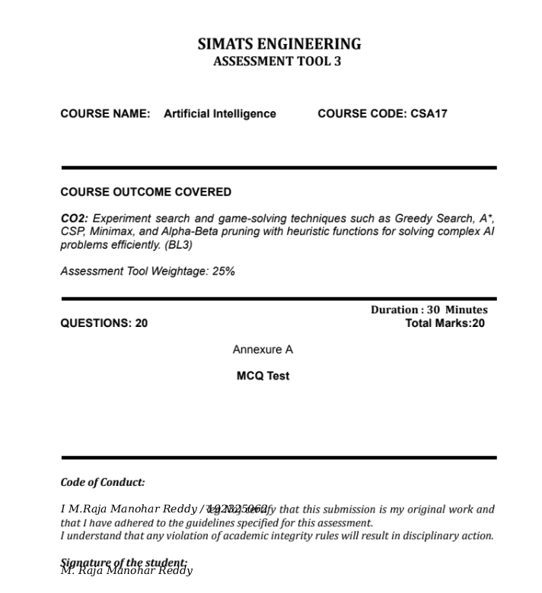

SIMATS ENGINEERING
ASSESSMENT TOOL 3 – MCQ TEST
Course: Artificial Intelligence | Course Code: CSA17
CO2: Search and Game-Solving Techniques
Duration: 30 Minutes | Total Marks: 20 | Questions: 20
Name: M.RAJA MANOHAR REDDY Register No.: 192325062
1. In informed search strategies, some algorithms use only the heuristic value to decide which node to expand next. This approach focuses on selecting the node that appears closest to the goal without considering the cost already incurred.
Which algorithm follows this principle?
A) Breadth First Search
B) Uniform Cost Search
C) Greedy Best-First Search
D) Depth First Search
2. A* search is widely used in pathfinding and graph traversal because it combines the actual cost from the start node and the estimated cost to the goal. This balance allows it to find optimal solutions efficiently when the heuristic is admissible.
What is the evaluation function used in A* search?
A) f(n) = g(n)
B) f(n) = h(n)
C) f(n) = g(n) + h(n)
D) f(n) = g(n) × h(n)
3. Heuristic functions play a crucial role in informed search by guiding the algorithm toward the goal. A good heuristic should not overestimate the actual cost and should improve search efficiency.
What property ensures optimality in A* search?
A) Completeness
B) Admissibility
C) Depth limit
D) Backtracking
4. Local search algorithms operate by starting with an initial solution and iteratively improving it based on a given objective function. These methods are commonly used in optimization problems where the path is not important but the final solution is.
Which of the following is a local search algorithm?
A) A* Search
B) Hill Climbing
C) Breadth First Search
D) Uniform Cost Search
5. In adversarial search, agents compete against each other in a game environment. The decision-making process involves considering both the agent’s moves and the opponent’s possible responses.
Which algorithm is commonly used for such decision-making?
A) Greedy Search
B) Minimax Algorithm
C) Backtracking
D) Uniform Search
6. A delivery robot in a warehouse selects paths based only on the estimated distance to the destination without considering obstacles already encountered. This sometimes leads to suboptimal paths but faster decisions.
Which algorithm is the robot using?
A) A* Search
B) Greedy Best-First Search
C) Uniform Cost Search
D) Depth Limited Search
7. A GPS navigation system calculates routes by combining the distance already travelled and an estimate of the remaining distance to the destination. This helps in finding the shortest path efficiently.
Which algorithm best represents this approach?
A) Depth First Search
B) A* Search
C) Hill Climbing
D) Backtracking
8. A university is scheduling exams for multiple subjects with constraints such as no overlapping exams and limited rooms. The solution must satisfy all constraints while assigning time slots.
This problem is best modeled as:
A) Game Playing Problem
B) Constraint Satisfaction Problem
C) Heuristic Search Problem
D) Optimization Problem
9. An AI-based chess program evaluates all possible moves and anticipates the opponent’s responses before making a decision. It assigns utility values to game states to determine the best move.
Which algorithm is being applied here?
A) Greedy Search
B) Hill Climbing
C) Minimax Algorithm
D) Breadth First Search
10. A robot explores an unknown environment where it does not have prior knowledge of obstacles. It makes decisions step-by-step and updates its knowledge as it moves.
Which type of agent is suitable for this scenario?
A) Offline Agent
B) Online Search Agent
C) Static Agent
D) Deterministic Agent
11. A* search guarantees optimal solutions only when certain conditions are satisfied by the heuristic function. If these conditions are violated, the algorithm may still find a solution but not necessarily the best one.
Why is an admissible heuristic important?
A) It reduces memory usage
B) It ensures optimality
C) It increases branching factor
D) It avoids loops
12. In large game trees, evaluating every node becomes computationally expensive. Alpha-Beta pruning helps eliminate branches that do not affect the final decision, thereby improving efficiency.
What is the primary benefit of Alpha-Beta pruning?
A) Reduces depth of tree
B) Reduces number of nodes evaluated
C) Changes game rules
D) Improves heuristic accuracy
13. Hill Climbing algorithm continuously moves toward better states based on local improvements. However, it may fail to reach the global optimum due to certain limitations in the search space.
What is the main drawback of Hill Climbing?
A) High memory usage
B) Revisiting nodes
C) Getting stuck in local maxima
D) Requires complete tree
14. Constraint Satisfaction Problems involve variables, domains, and constraints. A valid solution must assign values to all variables such that no constraints are violated.
What ensures a valid CSP solution?
A) Heuristic function
B) Path cost
C) Constraint satisfaction
D) Depth-first traversal
15. In adversarial games, evaluation functions are used when it is not feasible to explore the entire game tree. These functions estimate the desirability of a game state.
What is the role of an evaluation function?
A) Generate successors
B) Estimate utility of a state
C) Reduce branching factor
D) Store moves
16. In A* search, the evaluation function is calculated using both the path cost and heuristic value. Suppose a node has a path cost of 7 and a heuristic estimate of 5.
What is the value of f(n)?
A) 12
B) 2
C) 35
D) 7
17. A heuristic function sometimes overestimates the actual cost to reach the goal. This violates the admissibility condition required for optimal solutions in A* search.
What happens in such a case?
A) A* remains optimal
B) A* becomes non-optimal
C) A* becomes BFS
D) A* stops working
18. Consider a search tree with a branching factor of 2 and depth of 4. The total number of nodes generated in a full binary tree can be calculated analytically.
What is the approximate number of nodes?
A) 10
B) 15
C) 31
D) 16
19. In a minimax tree, each node has 3 children and the depth of the tree is 3. The total number of leaf nodes depends on the branching factor raised to the depth.
How many leaf nodes are present?
A) 9
B) 27
C) 6
D) 12
20. Alpha-Beta pruning improves the efficiency of minimax by reducing the number of nodes evaluated. In the best-case scenario, it significantly lowers time complexity.
What is the best-case time complexity?
A) O(b^d)
B) O(b^(d/2))
C) O(d^b)
D) O(log b)

ANSWERS:

1. C – Greedy Best-First Search selects using h(n) only.
2. C – A* uses f(n) = g(n) + h(n).
3. B – An admissible heuristic does not overestimate the true remaining cost.
4. B – Hill Climbing is a local search algorithm.
5. B – Minimax is used for adversarial decision-making.
6. B – Greedy Best-First Search uses estimated distance to the goal.
7. B – A* combines the cost so far and estimated remaining cost.
8. B – Exam scheduling with variables, domains, and constraints is a CSP.
9. C – Minimax evaluates moves and possible opponent responses.
10. B – Online search agents act while learning about the environment.
11. B – Admissibility supports optimality in A* under the required conditions.
12. B – Alpha-Beta pruning reduces the number of nodes evaluated.
13. C – Hill Climbing can get stuck at a local maximum.
14. C – A valid CSP assignment satisfies all constraints.
15. B – An evaluation function estimates the utility of a game state.
16. A – f(n) = 7 + 5 = 12.
17. B – An overestimating heuristic can cause A* to return a non-optimal solution.
18. C – Total nodes = 1 + 2 + 4 + 8 + 16 = 31.
19. B – Leaf nodes = 3^3 = 27.
20. B – Best-case Alpha-Beta complexity is O(b^(d/2)).

RUBRICS FOR CALCULATION
Criteria | Weightage | Level 4  (Exemplary) | Level 3  (Proficient) | Level 2  (Developing) | Level 1  (Beginning)
Conceptual Understanding | 30% | Demonstrates thorough understanding; answers all questions accurately. | Shows good understanding with few errors. | Partial understanding; several incorrect responses. | Lacks understanding; majority of answers incorrect.
Accuracy of Answers | 25% | All answers are correct. | Most answers are correct with minor mistakes. | Some correct answers; frequent errors. | Mostly incorrect answers.
Application of Knowledge | 20% | Correctly applies concepts to problem-based questions. | Applies concepts with minor errors. | Limited ability to apply concepts. | Unable to apply concepts.
Time Management | 15% | Completes quiz well within time efficiently. | Completes on time with minor delays. | Requires extra time or rushes through questions. | Unable to complete within given time.
Question Interpretation | 10% | Interprets all questions correctly and responds appropriately. | Misinterprets a few questions. | Often misinterprets questions. | Unable to understand questions.

Student’s Signature: M. Raja Manohar Reddy

