SIMATS ENGINEERING
ASSESSMENT TOOL 1 – SCENARIO BASED ASSIGNMENT
COURSE NAME: Artificial Intelligence COURSE CODE: CSA17
COURSE OUTCOME: CO2 – Search and game-solving techniques

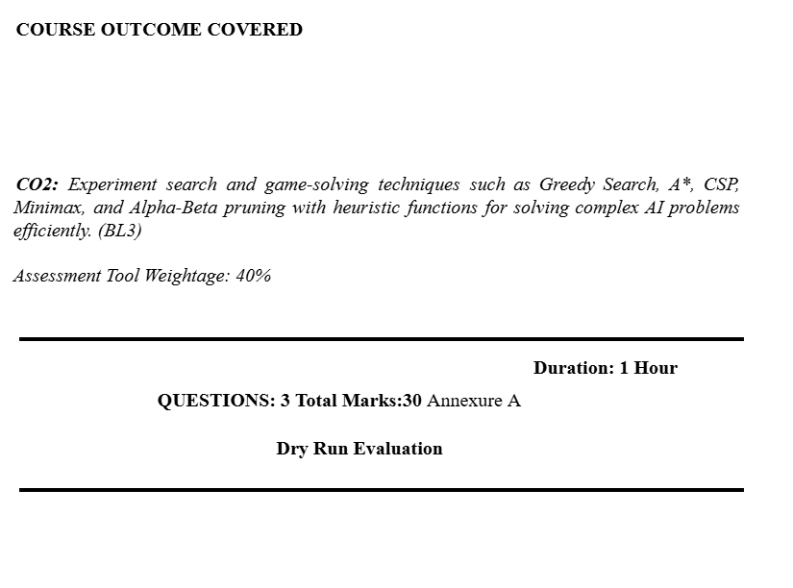
Code of Conduct
I, M. Raja Manohar Reddy (192325062), certify that this submission is my work and that I have adhered to the guidelines specified for this assessment. I understand that any violation of academic integrity rules will result in disciplinary action.
Signature of the student: M. Raja Manohar Reddy

1. Emergency Medicine Delivery Using Greedy Best-First Search and A*

i. Greedy Best-First Search in the scenario
Greedy Best-First Search selects the next node using only the heuristic value h(n), which estimates the straight-line distance from the current location to the destination. The drone therefore chooses the route that appears closest to the medicine delivery point. Its main strength is speed: it can make a quick decision without calculating the full path cost. This is useful when emergency medicines must be delivered urgently. However, it ignores the cost already travelled and the actual terrain or weather cost. A route that looks short may contain flooded roads, strong winds or dangerous conditions. With incomplete real-time information, the drone may choose a blocked or unsafe path. Greedy Best-First Search is not guaranteed to find the lowest-cost or safest route.

ii. How A* handles the situation
A* evaluates each node using f(n) = g(n) + h(n). Here, g(n) is the actual cost from the starting point to the current node, including distance, weather, terrain and delay costs. The heuristic h(n) estimates the remaining cost to the destination. A* balances the cost already incurred with the estimated cost still remaining. It can avoid a route that is geographically short but expensive or risky. If the heuristic is admissible (it never overestimates the true remaining cost) and the path costs are handled correctly, A* can find an optimal route in a static search graph. In this scenario, the graph and costs must be updated when new flood or weather information arrives.

iii. Impact of heuristic accuracy
A heuristic close to the true remaining cost helps both algorithms make better decisions. In Greedy Best-First Search, the heuristic directly controls node selection, so an inaccurate estimate can lead it far from the best route. In A*, the heuristic is combined with g(n), so the actual cost already paid can reduce the effect of a misleading estimate. An overestimated heuristic may cause A* to lose its optimality guarantee. A straight-line distance is generally a lower-bound estimate for distance, but it may be weak when terrain, wind or blocked routes dominate travel time.

iv. Effect of dynamic blocked paths
When a path becomes blocked, the drone's current route may no longer be valid. The system must receive the update, mark the affected edge or location as unavailable, and search for an alternative. Repeated changes can increase computation and cause the drone to replan frequently. A practical system can use incremental replanning, retain useful parts of the previous search, and prioritize fresh sensor and weather information. Safety checks should reject routes that are known to be blocked or exceed permitted risk limits.

v. Recommended algorithm
A* is the more suitable primary algorithm because it considers both the cost already incurred and the estimated remaining cost. The cost function should include travel time, terrain difficulty, weather impact and a strong penalty for unsafe routes. The heuristic should be admissible when an optimality guarantee is required. Since the environment changes, A* should be combined with frequent map updates and fast replanning (or an incremental A* variant). If the deadline is extremely strict, a safe feasible route can be selected first and improved when time permits. Greedy search is faster in some cases, but its lack of cost awareness makes it less reliable for emergency medicine delivery.

2. Smart-City Traffic Signal Optimization

Problem formulation
Let each intersection's signal plan be a decision variable. A plan can specify the green-time duration and phase order for each traffic direction during a control cycle. The objective is to minimize a weighted total cost: J = αW + βF + γC, where W is total vehicle waiting time, F is fuel consumption, C is congestion, and α, β and γ represent the importance assigned to each measure. Constraints include minimum and maximum green times, safe clearance intervals, pedestrian crossing time, and conflict-free signal phases. Traffic flow, queue length and arrival rates are changing inputs. The system is therefore a large, dynamic optimization problem.

Why traditional search is inefficient
The number of possible combinations of signal timings grows rapidly with the number of intersections and possible timing choices. Exhaustively exploring every combination is computationally expensive. In addition, traffic conditions change while the search is running, so a solution may become outdated before it is applied. A centralized search over the entire city can also require substantial memory and communication.

i. Hill Climbing
Hill Climbing begins with a current signal-timing plan and repeatedly examines neighbouring plans. It moves to a neighbour that improves the objective, such as reducing waiting time or congestion. It is simple and can produce improvements quickly. However, it accepts only improving moves, so it can stop at a local optimum even when a better city-wide plan exists. Its result also depends on the starting plan and the definition of neighbouring solutions.

ii. Local maxima, plateaus and ridges
A local optimum occurs when no nearby timing change improves the score, although a better plan exists elsewhere. For example, changing one intersection alone may increase queues temporarily, even though coordinated changes across several intersections would reduce overall congestion. A plateau is a region where many timing plans have nearly the same score, so the algorithm receives little direction. A ridge is a narrow path of improvement that requires coordinated changes to multiple signal timings; changing only one variable at a time may fail to follow it.

iii. Simulated Annealing and Genetic Algorithms
Simulated Annealing sometimes accepts a worse neighbouring solution with a probability controlled by temperature. Early in the search, a higher temperature allows exploration and helps escape local optima. As the temperature decreases, the algorithm becomes more selective and converges toward a good solution. A Genetic Algorithm maintains a population of signal plans. It evaluates their fitness, selects better plans, combines parts of them through crossover, and introduces variation through mutation. This explores several regions of the search space at once. Both methods can find better solutions than basic Hill Climbing, although they require careful parameter tuning and do not guarantee the global optimum within a fixed time.

iv. Recommended approach
A Genetic Algorithm is a suitable approach for coordinating many intersections because a complete candidate can represent a network-wide timing plan, and a population can explore different combinations in parallel. For real-time operation, use a rolling time window, limit the number of generations, and apply only safe plans that satisfy traffic-signal constraints. The system can optimize local groups of connected intersections and coordinate their boundary flows. Simulated Annealing is a simpler alternative when memory and implementation cost must be kept low. In either case, live traffic data and periodic re-optimization are essential.

3. Mars Rover: Online Search in an Unknown Environment

i. Why an online search agent is required
Offline search assumes that the environment and its map are known before the search begins. The Mars rover does not have a complete map of the terrain. It discovers rocks, craters, slopes and safe paths through sensors while moving. An online search agent can choose an action, observe the result, update its knowledge and plan again. This sense–act–learn cycle is appropriate for exploration where the environment is only gradually revealed.

ii. Partial observability and dynamic challenges
The rover's sensors have limited range and may provide incomplete or noisy measurements. A crater may be hidden behind a rock, and the rover may not know the exact slope or surface strength until it approaches. Communication delays and limited power also restrict how much information can be exchanged with operators. The rover must make decisions using an incomplete estimate of the world. Although the terrain may be mostly static, the rover's knowledge changes as new observations arrive; dust, lighting and equipment conditions can also affect sensing and movement.

iii. Building and updating the internal model
The rover maintains an internal map or belief representation of explored and unexplored areas. It records its estimated position, terrain type, obstacles, slopes, hazards and the confidence of sensor readings. After each movement, it compares the expected result with the actual sensor observations. It then updates the map, marks newly observed hazards, revises uncertain areas and recalculates reachable paths. Sensor fusion from cameras, range sensors and other instruments can improve reliability. Uncertain or hazardous cells should be assigned higher movement costs or treated as forbidden.

iv. Comparison with uninformed and informed search
Uninformed search methods such as Breadth-First Search and Uniform-Cost Search do not use goal-directed heuristic information. They may explore many states and can be inefficient over a large terrain map. Informed methods such as A* use a heuristic to guide the search toward a target and can reduce unnecessary exploration when a useful map is available. However, both traditional uninformed and informed methods are commonly described as planning over a known search space. Online search differs because the agent acts while discovering the space and updates its plan from observations. An online rover can still use heuristic guidance locally, but it must account for unknown regions and uncertainty.

v. Most suitable approach
An online, replanning agent is most suitable. It should use sensor-based mapping, conservative movement near uncertain hazards, and heuristic path planning over the currently known map. Before entering an unknown area, it should evaluate risk, energy use and the value of the information it may gain. If new observations reveal an obstacle, it should update the map and replan. Safety constraints, a safe stopping action and communication of uncertain findings are important because a failed movement could damage the rover or prevent mission completion.

4. University Exam Timetabling as a Constraint Satisfaction Problem

CSP formulation
A Constraint Satisfaction Problem consists of variables, domains and constraints. The goal is to assign a value from each variable's domain so that all constraints are satisfied.

i. Variables, domains and constraints
Variables: one variable for each course or examination, such as Exam_CSA17, Exam_Maths and Exam_DBMS. Each variable represents the time slot and hall assigned to that exam. Domains: the available combinations of date, time slot and suitable examination hall. Constraints: (1) Student conflict—two exams attended by the same student cannot occur at the same time. (2) Hall capacity—the number of candidates must not exceed the hall's capacity. (3) Hall availability—a hall cannot host two exams in the same slot. (4) Precedence—if one subject must occur before another, its assigned slot must be earlier. (5) Faculty availability—an exam must be scheduled when required faculty or invigilators are available. (6) Accommodation—students requiring special arrangements must be assigned suitable rooms, facilities and timing. These are hard constraints; preferences such as avoiding consecutive exams can be treated as soft constraints.

ii. Backtracking search
Backtracking assigns a time and hall to one exam at a time. It checks whether the assignment is consistent with all constraints already assigned. If it is valid, the algorithm proceeds to the next exam. If no available value satisfies the constraints, it removes the previous assignment and tries another value. The process continues until a complete valid timetable is found or all possibilities are exhausted. Choosing the most constrained exam first (Minimum Remaining Values) and trying the least constraining value first can reduce unnecessary backtracking.

iii. Constraint propagation and forward checking
After assigning an exam, forward checking removes values from the domains of unassigned exams that would conflict with that assignment. For example, if a course is placed in Hall 1 at 10 AM, Hall 1 at 10 AM is removed from the domains of other exams. If a student has an exam at 10 AM, that time is removed from the domains of the student's other exams. If any unassigned variable has an empty domain, the algorithm detects the conflict immediately and backtracks instead of continuing down an impossible path. Constraint propagation therefore reduces the search space.

iv. Real-world challenges and scalable strategy
Large universities may have thousands of students, many courses, different examination durations, room capacities, faculty schedules and accommodation requirements. Data may also change because of course registration or room availability updates. A scalable strategy is to combine CSP backtracking with variable-ordering heuristics, forward checking or stronger propagation, and a constraint solver for large instances. Hard constraints must never be violated. Soft preferences can be optimized after a feasible timetable is found. The system should also support partial rescheduling when a room or time slot becomes unavailable, rather than rebuilding the entire timetable.

5. Strategic Game AI Using Minimax and Alpha-Beta Pruning

i. Minimax model
Minimax models a competitive, two-player, zero-sum game in which one player tries to maximize the score and the opponent tries to minimize it. The AI is commonly treated as the MAX player and the human opponent as MIN. The algorithm builds a game tree of possible moves. At MAX levels it selects the child with the highest value; at MIN levels it selects the child with the lowest value. The chosen move is the one with the best outcome assuming the opponent also plays optimally.

ii. Computational challenges
If each position has b legal moves and the search explores depth d, the number of nodes can grow approximately as O(b^d). A large branching factor and deeper search therefore create high computation and memory costs. In a real-time strategy game, the state may include units, resources, positions, health and multiple simultaneous threats. The AI may not have enough time to explore the entire tree before it must act. A fixed time limit makes unrestricted exhaustive search impractical.

iii. Alpha-Beta pruning
Alpha-Beta pruning improves Minimax by avoiding branches that cannot affect the final decision. Alpha is the best value MAX can guarantee so far; beta is the best value MIN can guarantee so far. When a branch is found where alpha is greater than or equal to beta, the remaining children of that branch can be pruned because the opponent already has a better alternative elsewhere. For example, if MAX already has an option worth 8, and a MIN branch is shown to have an outcome of 5 or less, MAX will never choose that branch. Further exploration of it is unnecessary. Alpha-Beta returns the same decision as Minimax when applied correctly, but may examine far fewer nodes. With excellent move ordering, its effective search can be substantially deeper; in the best case its complexity is approximately O(b^(d/2)), while the worst case remains O(b^d).

iv. Evaluation function
A practical evaluation function can combine: resource advantage, number and strength of units, territory or map control, objective progress, defensive position, unit health and immediate threats. For example, Eval(s) = w1(ResourceAdvantage) + w2(UnitStrength) + w3(MapControl) + w4(ObjectiveProgress) + w5(DefensiveSafety) − w6(ThreatExposure). The weights represent the relative importance of each factor and should be tuned through testing. The evaluation should reward useful strategic progress while penalizing losses and dangerous positions. It should also avoid double-counting related factors.

v. Balancing optimality and real-time performance
Use depth-limited Minimax with Alpha-Beta pruning, good move ordering and an evaluation function for positions that are not terminal. Iterative deepening searches depth 1, then 2, then 3, and so on; if the time limit is reached, the AI can use the best move from the last completed depth. A transposition table can reuse evaluations of repeated states. The system should reserve time for executing the selected move and should always have a legal fallback action. This provides strong decisions within a strict time budget, although it does not guarantee a globally optimal move when the search is cut off.

