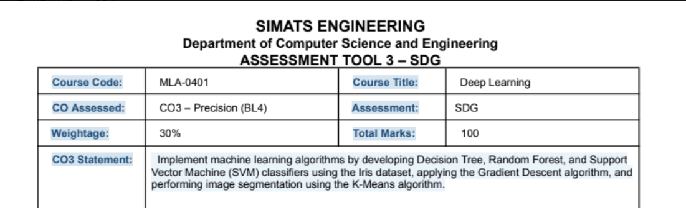
STUDENT DETAILS | INFORMATION
Name | M.RAJA MANOHAR REDDY
Register Number | 192325062
Department / Class | AI&ML
Course / Subject | Artificial Intelligence
Date | 03-11-26

Code of Conduct
I M.RAJA MANOHAAR REDDY /192325062 (Name / Reg No) certify that this submission is my original work and
that I have adhered to the guidelines specified for this assessment. I understand that any violation of
academic integrity rules will result in disciplinary action.
Signature of the Student: M.RAJA MANOHAAR REDDY

1. Aim
To develop a logical agent that recommends whether a household or building should use solar energy based on sunlight availability, electricity demand, and environmental conditions, and to represent its decision-making process using propositional logic.

2. Introduction
Solar energy is a renewable source of electricity that can reduce dependence on conventional power sources and lower environmental impact. However, the amount of electricity generated by a solar panel changes with sunlight intensity and weather conditions. The suitability of solar energy also depends on the amount of electricity required at a particular time.
A logical agent observes the available information, converts it into logical facts, applies a set of rules, and produces a recommendation. In this design, propositional logic is used because each input condition can be represented as a proposition that is either true or false. The agent gives one of three recommendations: use solar energy, use solar energy together with grid electricity, or prefer grid electricity and conserve power.

3. Problem Definition
The agent must evaluate three important factors: (i) sunlight availability, (ii) electricity demand, and (iii) environmental conditions. It should recommend solar usage when sunlight is sufficient and conditions are suitable. If sunlight is moderate or demand is high, it should recommend combining solar power with grid electricity. If sunlight is poor or environmental conditions are unsuitable, it should recommend relying on the grid while reducing unnecessary consumption.
For this logical model, sensor readings are first classified into categories. The categories are illustrative and can be adjusted for a real installation.

4. Propositions Used
Symbol | Proposition | Meaning when TRUE
S | Sufficient sunlight | Sunlight intensity is high enough for useful solar generation.
M | Moderate sunlight | Sunlight is available, but generation may be limited.
D | High electricity demand | Current demand is high.
L | Low electricity demand | Current demand is low or normal.
W | Favourable weather | Weather conditions support solar generation.
U | Unfavourable environmental condition | Heavy cloud, dust, shading, or another condition reduces generation.
B | Battery available | A charged battery or storage system is available.
R1 | Recommend solar | The agent recommends solar as the main source.
R2 | Recommend hybrid | The agent recommends solar together with grid supply.
R3 | Recommend grid / conserve | The agent recommends grid supply and energy conservation.

5. Knowledge Base: Propositional Logic Rules
The knowledge base contains facts derived from sensor readings and rules that describe the agent's decision policy. The symbol ∧ means AND, ∨ means OR, and ¬ means NOT.
Rule | Logical expression | Interpretation
Rule 1 | S ∧ W ∧ L → R1 | If sunlight is sufficient, weather is favourable, and demand is low, recommend solar as the main source.
Rule 2 | S ∧ W ∧ D → R2 | If sunlight and weather are favourable but demand is high, recommend a solar-grid combination.
Rule 3 | M ∧ W → R2 | If sunlight is moderate and weather is favourable, recommend hybrid usage.
Rule 4 | U → R3 | If environmental conditions are unfavourable, prefer grid supply and conservation.
Rule 5 | ¬S ∧ ¬M → R3 | If neither sufficient nor moderate sunlight is available, prefer grid supply and conservation.
Rule 6 | S ∧ W ∧ B → R1 | If sunlight and weather are favourable and storage is available, solar use is recommended, subject to demand management.

The arrow (→) represents implication: whenever the condition on the left is true, the recommendation on the right is derived. Rule 6 is an additional support rule; the agent should still consider high demand under Rule 2.

6. Decision-Making Flow
The agent follows a sequence of sensing, fact generation, logical inference, and recommendation. Sensor values are classified into propositions before the rules are evaluated.
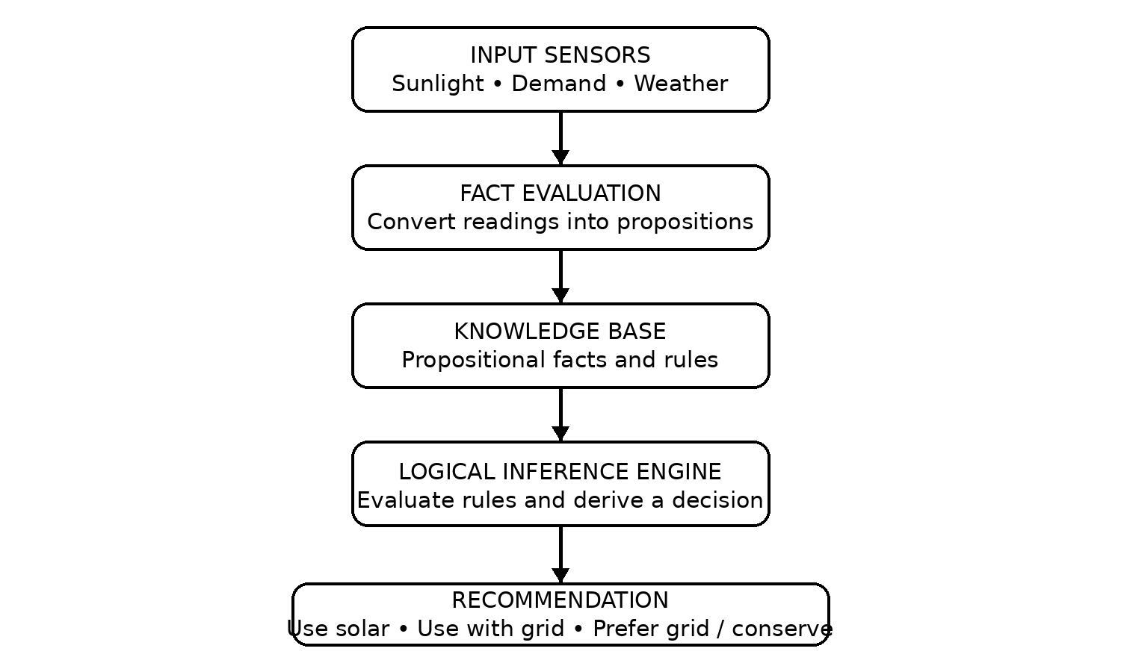
Figure 1: Architecture and decision flow of the solar energy logical agent.

7. Decision Table
Sunlight | Demand | Environment | Agent recommendation
Sufficient | Low / normal | Favourable | Use solar energy as the main source.
Sufficient | High | Favourable | Use solar with grid support.
Moderate | Low or high | Favourable | Use solar with grid support; monitor output.
Poor / unavailable | Any | Any | Prefer grid supply and conserve electricity.
Any | Any | Unfavourable | Prefer grid supply; inspect panels for shade, dust, or weather effects.

Priority is given to an unfavourable environmental condition or unavailable sunlight because these can make solar generation unreliable. A practical controller may also include battery state, inverter limits, and electricity tariffs.

8. Algorithm
- Start the agent.
- Read sunlight intensity, electricity demand, and environmental conditions.
- Classify sunlight as sufficient, moderate, or poor.
- Classify electricity demand as high or low/normal.
- Determine whether environmental conditions are favourable.
- Convert the classifications into propositional facts.
- Evaluate the rules in the knowledge base.
- If sufficient sunlight, favourable weather, and low demand are true, recommend solar as the main source.
- Else, if sunlight is sufficient or moderate and conditions are favourable, recommend solar with grid support when demand is high or generation is limited.
- Otherwise, recommend grid supply and energy conservation.
- Display the recommendation and repeat the process when new sensor readings are received.
- Stop.

9. Pseudocode
INPUT sunlight, demand, environment
IF environment = UNFAVOURABLE THEN
recommendation = "Prefer grid supply and conserve energy"
ELSE IF sunlight = POOR THEN
recommendation = "Prefer grid supply and conserve energy"
ELSE IF sunlight = SUFFICIENT AND demand = LOW THEN
recommendation = "Use solar energy as the main source"
ELSE
recommendation = "Use solar energy with grid support"
END IF
DISPLAY recommendation

10.Program
% Solar Energy Logical Agent
% Decision-making using propositional logic

% Facts: Environmental and energy conditions

sunlight(sufficient).
% sunlight(moderate).
% sunlight(poor).

demand(low).
% demand(high).

weather(favourable).
% weather(unfavourable).

battery(available).
% battery(unavailable).

% Rule 1: Recommend solar energy
recommendation(use_solar) :-
sunlight(sufficient),
weather(favourable),
demand(low).

% Rule 2: Recommend solar with grid support
recommendation(solar_with_grid) :-
sunlight(sufficient),
weather(favourable),
demand(high).

% Rule 3: Moderate sunlight recommendation
recommendation(solar_with_grid) :-
sunlight(moderate),
weather(favourable).

% Rule 4: Unfavourable environmental conditions
recommendation(use_grid_and_conserve) :-
weather(unfavourable).

% Rule 5: Poor sunlight recommendation
recommendation(use_grid_and_conserve) :-
sunlight(poor).

% Display recommendation
run :-
recommendation(X),
write('Solar Energy Recommendation: '),
write(X),
nl.

Output:

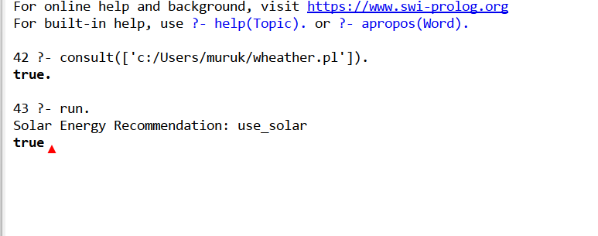
10. Sample Working Examples
Case | Input facts | Logical evaluation | Output
1 | S = TRUE, W = TRUE, L = TRUE | S ∧ W ∧ L is TRUE; Rule 1 fires. | Use solar as the main source.
2 | S = TRUE, W = TRUE, D = TRUE | S ∧ W ∧ D is TRUE; Rule 2 fires. | Use solar with grid support.
3 | M = TRUE, W = TRUE | M ∧ W is TRUE; Rule 3 fires. | Use solar with grid support.
4 | U = TRUE | U is TRUE; Rule 4 fires. | Prefer grid supply and conserve energy.
5 | S = FALSE, M = FALSE | ¬S ∧ ¬M is TRUE; Rule 5 fires. | Prefer grid supply and conserve energy.

11. Advantages
- Simple and understandable: each recommendation is supported by a clearly stated logical rule.
- Explainable decisions: the agent can show which conditions caused a recommendation.
- Low computational cost: propositional rules can be evaluated quickly.
- Adaptable: thresholds for sunlight and demand can be changed to match a particular solar installation.
- Environment-aware: weather, dust, and shading can be considered before recommending solar usage.

12. Limitations and Possible Improvements
Propositional logic treats each proposition as either true or false. Real sunlight, demand, and weather measurements vary continuously, so the system needs thresholds to classify sensor readings. The current rules also do not calculate the exact amount of solar power generated. A more advanced version could use fuzzy logic for uncertain conditions, numerical forecasting for solar output, battery state-of-charge, time-of-day information, panel temperature, and electricity tariff data. Safety constraints and inverter limits should be handled by the actual energy-management controller rather than by this recommendation model alone.

13. Result
A propositional-logic-based solar energy logical agent was designed. It uses sunlight availability, electricity demand, and environmental conditions as input facts. By applying the defined knowledge-base rules, it produces one of three recommendations: use solar as the main source, use solar with grid support, or prefer grid electricity and conserve energy.

14. Conclusion
The proposed logical agent demonstrates how artificial intelligence can support renewable energy decisions through knowledge representation and logical reasoning. Propositional logic provides a clear and explainable method for connecting observed conditions to energy recommendations. The design can serve as a basic model for a smart-home energy management system and can be extended with real sensor data, battery monitoring, and predictive techniques.



