SIMATS ENGINEERING

ASSESSMENT TOOL 1

COURSE NAME: INTERNET PROGRAMMING COURSE CODE: CSA43

COURSE OUTCOME COVERED

CO-1 : Develop well-structured, standards-compliant web pages using HTML/XHTML and XML, and apply Internet protocols and HTTP communication mechanisms for web content delivery. (L2)

Assessment Tool : Application-Based Questions

Weightage: 40%

QUESTIONS: Total Marks: 30

1: Online Symposium Portal
A college is developing an online symposium registration portal. The following HTML structure and HTTP interaction is observed:
<form action="/register" method="POST">
<input type="text" name="name">
<input type="email" name="email">
<button>Submit</button>
</form>
When a student submits the form, the browser sends an HTTP request to the server, and the server responds accordingly.

Questions:

- Identify appropriate HTML5 semantic elements missing in the structure.
- Modify the structure to make it standards-compliant.
- Interpret the HTTP request generated during form submission.
- Analyze the HTTP response cycle from server to browser.
- Suggest improvements for usability and accessibility.

1. Online Symposium Portal

1.1 Identify appropriate HTML5 semantic elements missing in the structure.
The given HTML form allows students to register for a college symposium. However, it does not include semantic elements that clearly describe the structure and purpose of the page.
The following HTML5 semantic elements can improve the page structure:
- <header> – Displays the symposium title or college name.
- <main> – Contains the main registration content.
- <section> – Groups the registration form under a meaningful heading.
- <form> – Collects and submits student details.
- <label> – Provides an accessible name for each input field.
- <footer> – Displays copyright information or contact details.
These elements improve readability, accessibility, search engine understanding, and maintainability.

1.2 Modify the structure to make it standards-compliant.
The corrected HTML5 code is given below.

<!DOCTYPE html>
<html lang="en">
<head>
<meta charset="UTF-8">
<meta name="viewport"
content="width=device-width, initial-scale=1.0">
<title>Online Symposium Registration</title>
</head>
<body>

<header>
<h1>College Online Symposium</h1>
<p>Register to participate in our symposium.</p>
</header>

<main>
<section aria-labelledby="registration-title">
<h2 id="registration-title">Student Registration</h2>

<form action="/register" method="POST">
<label for="name">Full Name:</label>
<input type="text" id="name" name="name"
autocomplete="name" required>

<br><br>

<label for="email">Email Address:</label>
<input type="email" id="email" name="email"
autocomplete="email" required>

<br><br>

<button type="submit">Submit Registration</button>
</form>
</section>
</main>

<footer>
<p>&copy; 2026 College Symposium</p>
</footer>

</body>
</html>
Output:
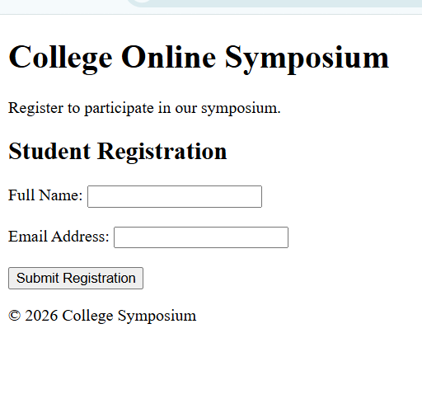

1.3 Interpret the HTTP request generated during form submission.
When a student enters their name and email address and clicks the Submit button, the browser sends an HTTP POST request to the server.
For example, the request may look like this:
POST /register HTTP/1.1
Host: college.example
Content-Type: application/x-www-form-urlencoded

name=Raja+Manohar+Reddy&email=student%40example.com
Interpretation:
- POST specifies the HTTP method used to submit the registration data.
- /register identifies the server endpoint that processes the registration.
- HTTP/1.1 identifies the HTTP protocol version in this example.
- Host specifies the target host.
- Content-Type describes the format of the submitted form data.
- The request body contains the student's name and email address.
The browser typically encodes ordinary form fields as application/x-www-form-urlencoded when using a standard POST form without an overriding enctype.
POST places form data in the request body instead of appending it to the URL. However, POST alone does not encrypt data. HTTPS is required to protect information during transmission.

1.4 Analyze the HTTP response cycle from server to browser.
The HTTP response cycle consists of the following stages.
1. Student submits the form
The browser validates required fields.
2. Browser sends HTTP POST
Registration details are sent to /register over HTTPS.
3. Server processes the request
Validates the data and saves the registration if successful.
4. Server sends an HTTP response
Returns a status code, headers, and possibly a response body.
5. Browser displays the result
Shows confirmation, validation errors, or another appropriate response.
Common response status codes include:
Status code | Meaning | Example
200 OK | Request processed successfully | Registration confirmation returned
201 Created | A new resource was created | Student registration saved
400 Bad Request | Request contains invalid data | Missing or malformed fields
500 Internal Server Error | Server encountered an error | Registration processing failed
A server may also return a 303 See Other redirect after successful POST submission, directing the browser to a confirmation page. The exact response depends on the server implementation.

1.5 Suggest improvements for usability and accessibility.
The portal can be improved in the following ways:
- Use labels: Associate each input with a <label> so screen readers can identify the field.
- Apply HTML5 validation: Use required, type="email", and suitable length constraints.
- Provide clear feedback: Display success messages and understandable error messages.
- Support keyboard navigation: Ensure that users can access every field and button using the keyboard.
- Use HTTPS: Protect personal information while it is transmitted

2: Cross-Browser Compatibility Issue
A company website shows inconsistent layout across browsers. The following HTML snippet is used:
<html>
<head>
<title>Company</title>
</head>
<body>
<div>
<h1>Welcome
<p>About us
</div>
</body>
</html>

Questions:

- Identify improper nesting and missing closing tags.
- Analyze how different browsers may interpret this structure.
- Identify missing semantic elements (e.g., header, section).
- Provide a corrected W3C-compliant HTML structure.
- Suggest techniques to ensure cross-browser compatibility.

2.1 Identify improper nesting and missing closing tags.
The original HTML snippet is:
<html>
<head>
<title>Company</title>
</head>
<body>
<div>
<h1>Welcome
<p>About us
</div>
</body>
</html>
The following problems can be identified:
- The <!DOCTYPE html> declaration is missing.
- The <html> element does not specify the document language.
- The character encoding and viewport declarations are missing.
- The <h1> element has no explicit closing </h1> tag.
- The <p> element has no explicit closing </p> tag.
- The generic <div> provides no semantic meaning.
- The page lacks semantic elements such as <header>, <main>, and <section>.
The missing closing tags are the main structural problem. The heading and paragraph should be explicitly closed to make the markup clear and maintainable.

2.2 Analyze how different browsers may interpret this structure.
Modern browsers use HTML parsing rules and error-recovery mechanisms to process malformed HTML. Therefore, they may automatically insert missing closing tags or reorganize parts of the document into a valid DOM tree.
For example, a browser may infer where the heading ends when it encounters the paragraph element. This can allow the page to display even though the source code is incomplete.
However, relying on automatic error recovery is not recommended because:
- The resulting DOM structure may differ from what the developer intended.
- CSS selectors may apply unexpectedly.
- JavaScript that depends on the document structure may behave incorrectly.
- Different browser engines and versions may handle edge cases differently.
- Assistive technologies may receive a structure that is less meaningful than intended.
Thus, valid HTML should be written explicitly rather than depending on browser error correction.

2.3 Identify missing semantic elements.
The following semantic elements would improve the company webpage:
- <header> – Contains the company name or welcome heading.
- <main> – Contains the primary content of the webpage.
- <section> – Groups the company's introduction or About Us content.
- <footer> – Contains copyright information and contact details.
A <nav> element may also be added if the page contains navigation links.
Semantic elements describe the purpose of the content and improve accessibility and code readability.

2.4 Provide a corrected W3C-compliant HTML structure.

<!DOCTYPE html>
<html lang="en">
<head>
<meta charset="UTF-8">
<meta name="viewport"
content="width=device-width, initial-scale=1.0">
<title>Company Website</title>
</head>
<body>

<header>
<h1>Welcome</h1>
</header>

<main>
<section aria-labelledby="about-heading">
<h2 id="about-heading">About Us</h2>
<p>
We provide reliable services and innovative
solutions to our customers.
</p>
</section>
</main>

<footer>
<p>&copy; 2026 Company. All rights reserved.</p>
</footer>

</body>
</html>
Output:
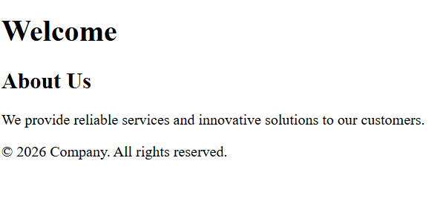

2.5 Suggest techniques to ensure cross-browser compatibility.
The following practices help websites display consistently across browsers.
- Validate HTML: Use the official W3C Markup Validation Service to identify structural errors. Open HTML Validator.
- Use CSS resets or normalization: Reduce inconsistent browser default margins, padding, and element styles.
- Write standard HTML and CSS: Avoid obsolete elements and browser-specific, nonstandard behavior.
- Test multiple browsers: Check the website in Chrome, Firefox, Edge, and Safari where available.
- Use responsive design: Apply flexible layouts, CSS Grid, Flexbox, and media queries.
- Check browser compatibility: Consult MDN Web Docs and MDN Web Docs for feature support.
- Use feature detection: Check whether a required browser feature is available before depending on it.
- Test accessibility: Verify keyboard operation, heading structure, form labels, and color contrast.

3: Form Submission Failure
A web application fails to send form data to the server. The following configuration is observed:
<form action="/submit" method="GET">
<input type="text" name="username">
<input type="password" name="password">
<button type="button">Login</button>
</form>

Questions:

- Identify issues in the form configuration.
- Analyze why the HTTP request is not triggered.
- Interpret the role of GET method in this scenario.
- Propose a corrected implementation.
- Suggest improvements for secure data transmission.

3.1 Identify issues in the form configuration.
The given code is:
<form action="/submit" method="GET">
<input type="text" name="username">
<input type="password" name="password">
<button type="button">Login</button>
</form>
There are three main issues.
Issue 1: Incorrect button type
The button uses type="button". This creates a general-purpose button and does not submit the form automatically. Since no JavaScript event handler is provided, clicking Login does not trigger form submission.
Issue 2: Inappropriate HTTP method for login credentials
The form uses GET. GET sends successful form controls in the URL query string. Passwords should not be transmitted in the URL because URLs may appear in browser history, server logs, analytics, and other records.
Issue 3: Missing validation and accessibility features
The form has no labels, no required attributes, and no clear accessibility structure. It also needs server-side validation and secure transport.

3.2 Analyze why the HTTP request is not triggered.
The main reason is the button type.
The browser handles the button as an ordinary clickable control rather than a form-submission control. Consequently, the browser does not automatically send an HTTP request when the user clicks Login.
The behavior can be summarized as follows:
Button type | Behavior
type="button" | Performs no default form submission
type="submit" | Submits the associated form
type="reset" | Resets the form controls to their initial values
JavaScript could manually submit the form in response to a type="button" click, but no such handler is present in the given code.
Therefore, changing the button to type="submit" is the direct correction.

3.3 Interpret the role of GET method in this scenario.
GET is an HTTP method primarily used to retrieve resources. In an HTML form, it sends the successful form controls as URL query parameters.
For example, if a user enters raja and a password, a GET submission could produce a request resembling:
GET /submit?username=raja&password=example123 HTTP/1.1
Host: college.example
This example illustrates the problem: the password appears in the URL.
GET is appropriate for operations such as:
- Searching for information.
- Filtering a list of products.
- Retrieving records using query parameters.
- Navigating to a results page.
GET is not appropriate for submitting login credentials. A POST request should be used instead, together with HTTPS. POST does not itself provide encryption, and sensitive data must still be protected through secure transport and proper server-side controls.

3.4 Propose a corrected implementation.
The corrected login form is:
<!DOCTYPE html>
<html lang="en">
<head>
<meta charset="UTF-8">
<meta name="viewport"
content="width=device-width, initial-scale=1.0">
<title>Secure Login</title>
</head>
<body>

<main>
<section aria-labelledby="login-heading">
<h1 id="login-heading">Student Login</h1>

<form action="/submit" method="POST">
<label for="username">Username:</label>
<input type="text"
id="username"
name="username"
autocomplete="username"
required>

<br><br>

<label for="password">Password:</label>
<input type="password"
id="password"
name="password"
autocomplete="current-password"
required>

<br><br>

<button type="submit">Login</button>
</form>
</section>
</main>

</body>
</html>
Explanation:

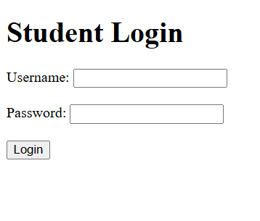

3.5 Suggest improvements for secure data transmission.
The following security measures should be applied:
- Use HTTPS: Encrypt communication between the browser and server using TLS.
- Use POST for login: Avoid putting usernames and passwords in URL query strings.
- Validate on the server: Check input values and authenticate users on the server, regardless of browser validation.
- Hash passwords securely: Store password hashes using a suitable password-hashing algorithm, such as Argon2id, rather than storing plaintext passwords.
- Use secure sessions: Set appropriate session-cookie attributes such as Secure, HttpOnly, and SameSite.
- Prevent brute-force attacks: Apply rate limiting, login-attempt controls, and appropriate monitoring.
- Display safe error messages: Avoid revealing whether a particular username exists.
- Protect against CSRF where applicable: Use appropriate anti-CSRF controls for cookie-authenticated state-changing requests.
- Avoid logging credentials: Ensure that passwords are not recorded in application logs or error reports.
- Use multi-factor authentication where appropriate: Add another verification factor for stronger account protection.
These measures help protect login credentials and reduce the risk of unauthorized access.

Conclusion
The three application-based problems demonstrate the importance of valid HTML structure, semantic elements, HTTP request-response mechanisms, browser compatibility, and secure form handling.
- Question 1: Semantic HTML, accessible registration forms, POST requests, and HTTP responses improve the symposium portal.
- Question 2: Proper nesting, closing tags, HTML validation, and browser testing improve cross-browser compatibility.
- Question 3: Correct submit-button behavior, POST-based login submission, HTTPS, and server-side authentication improve form reliability and security.
Code of Conduct:
I M.Raja Manohar Reddy /192325062(Name / Reg No) certify that this submission is my original work and that I have adhered to the guidelines specified for this assessment. I understand that any violation of academic integrity rules will result in disciplinary action.

Signature of the student:M.Raja Manohar Reddy

RUBRICS FOR CALCULATION:
Criteria | Weig htage | Level 4 – Exemplary | Level 3 – Proficient | Level 2 – Developing | Level 1 – Beginning
Understanding of Concepts | 25% | Demonstrates thorough, accurate understanding of concepts | Good understanding with minor gaps | Basic understanding with some misconception  s | Poor understandin g; major misconceptio  ns
Explanation | 25% | Detailed, well-explained answers with  relevant examples | Clear explanation with adequate  details | Limited explanation; lacks depth | Poor or unclear explanation
Application | 20% | Effectively applies concepts with strong analytical ability | Applies concepts with minor errors | Limited application with weak  analysis | No application or incorrect  analysis
Organization | 15% | Well-structured answers with logical flow and coherence | Organized with minor issues in flow | Basic structure, lacks clarity | Poor organization, incoherent  answers
Accuracy | 10% | Completely accurate and covers all  required points | Mostly accurate with minor  omissions | Partially correct with  missing points | Incorrect answers with  major gaps
Clarity | 5% | Clear, neat, professional presentation | Understandable with minor issues | Limited clarity, readability issues | Poorly written, difficult to  understand

