SIMATS ENGINEERING (SAVEETHA SCHOOL OF ENGINEERING)
Department of Artificial Intelligence and Data Science
ASSESSMENT TOOL 3 – CODING CHALLENGE

Course Code: | DSA03 | Course Title: | Natural Language Processing
CO Assessed: | CO1 – Imitation (L1) | Assessment: | Assessment Tool 3 – Coding Challenge
Weightage: | 30% of CIA
CO5 Statement: | Analyse NLP models, regular expression patterns, finite state automata, morphological processing techniques and to interpret language processing. (BL-3)
Student Name: | M.Raja Manohar Reddy | Reg. No.: | 192325062
Section / Batch: |  | Date: | 10-10-26

Code of Conduct
I M.Raja Manohar Reddy / 192325062 (Name / Reg No) certify that this submission is my original work and that I have adhered to the guidelines specified for this assessment. I understand that any violation of academic integrity rules will result in disciplinary action.
Signature of the Student: M.Raja Manohar Reddy

Instructions
- Develop a complete and modular Python program that meets all the functional requirements specified in the coding challenge using appropriate algorithms, data structures, and programming practices.
- Test the program using multiple valid and invalid test cases, and clearly display the input, processing, and output to verify the correctness of the implementation.
- Follow standard coding practices by using meaningful variable names, proper indentation, comments, exception handling (where applicable), and upload the source code, sample outputs, and README file to the designated GitHub repository.
- Duration: 40 minutes.

Section / Topic | Focus | Q Nos
Regular Expression Pattern Matching | Regular Expressions, Basic Regular Expression Patterns | 1
Finite State Automata Implementation | Finite State Automata, Models and Algorithms | 2
Advanced Regular Expression Search | Regular Expressions, Basic Regular Expression Patterns | 3

Annexure A – Coding Challenge

Section 1: Intelligent Email and Password Validator using Regular Expressions
- Problem Statement:
A software company is developing a user registration system. Before creating an account, the system must validate user credentials based on predefined security policies.

Develop a Python application that validates:
Email Address
Password
Mobile Number

using Regular Expressions.

Validation Rules
Email
Must start with an alphabet.
May contain letters, digits, '.', '_' before '@'.
Domain should contain only alphabets.
Valid extensions: .com, .org, .edu, .net, .in
Password
Minimum 8 characters
At least one uppercase letter
At least one lowercase letter
At least one digit
At least one special character (@,#,$,%,&,!)
Mobile Number
Must contain exactly 10 digits.
First digit should be between 6–9.
Expected Output

Display:

Valid Email / Invalid Email
Strong Password / Weak Password
Valid Mobile Number / Invalid Mobile Number

Program
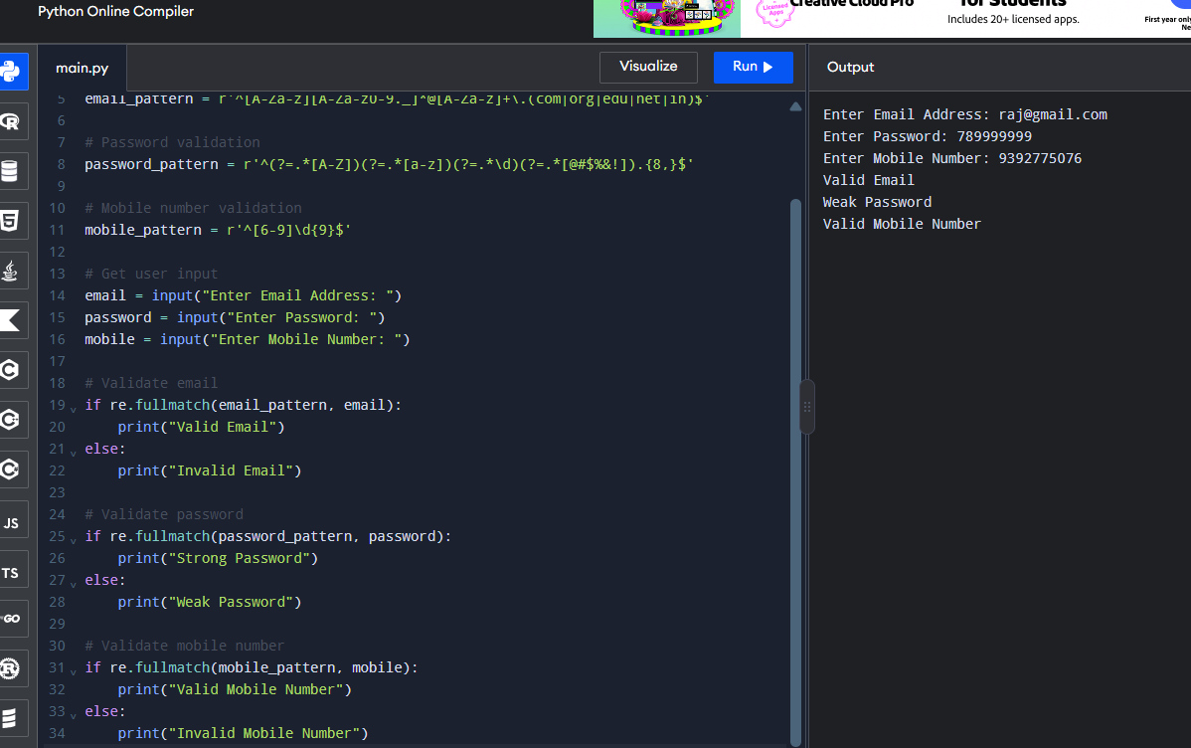

Section 2: Design a Finite State Automata (FSA) Simulator
- Problem Statement

Develop a Python-based Deterministic Finite Automata (DFA) simulator.

The program should:
- Accept the DFA description
    - States
    - Input alphabet
    - Transition table
    - Initial state
    - Final state(s)
- Accept multiple input strings.
- Simulate state transitions.
- Display whether the string is Accepted or Rejected.
Example

Language:
Strings ending with "ab"

Input
abaab

Output
Transition Path:
q0 → q1 → q0 → q1 → q2
Accepted

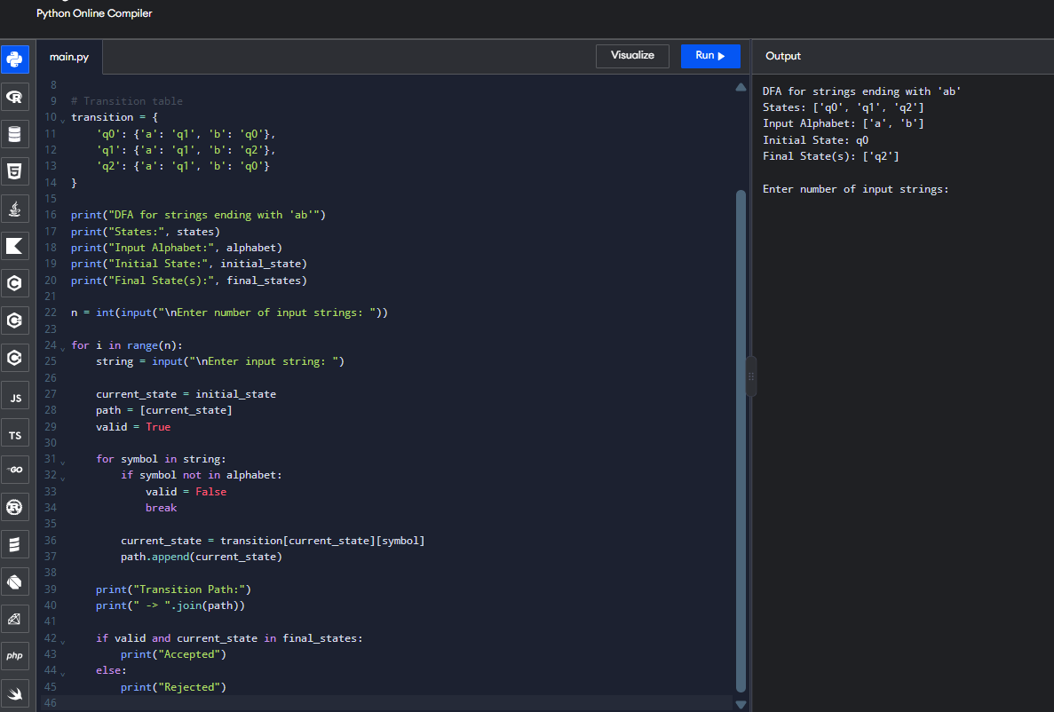

Section 3: Smart Pattern Matching Engine using Regular Expressions
- Problem Statement

Develop a Python-based text search engine that performs pattern matching using Regular Expressions.

The system should support:
Word Search
Prefix Search
Suffix Search
Date Search
Phone Number Search
Hashtag Search
Mention (@username) Search

Example Input
Meeting on 12/09/2026
Call 9876543210
#NLP
@OpenAI
natural language processing

User Menu
1.Search Date
2.Search Phone Number
3.Search Hashtag
4.Search Mention
5.Search Prefix
6.Search Suffix

Expected Output
Display all matching patterns based on user selection.

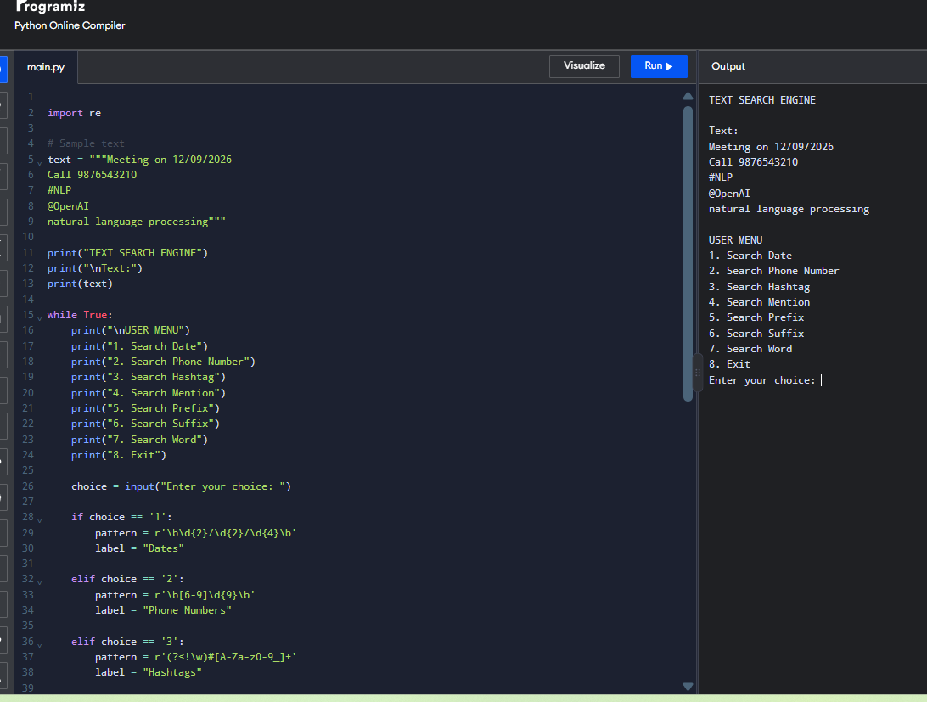

Rubrics for Calculation
Criteria | Weightage | Level 4 – Exemplary | Level 3 – Proficient | Level 2 – Developing | Level 1 – Beginning
Problem Understanding | 20% | Clearly understands problem constraints, edge cases, and competitive requirements | Understands problem with minor gaps in constraints | Partial understanding; misses key constraints | Misinterprets problem or constraints
Algorithm | 25% | Selects optimal algorithm with best time and space complexity for competitive constraints | Uses efficient algorithm with minor scope for improvement | Uses basic/inefficient approach | No clear algorithmic approach
Code Implementation | 20% | Writes correct, efficient, and clean code that passes all constraints | Code works with minor errors or inefficiencies | Partially correct code; fails for some cases | Code does not execute or gives incorrect results
Competitive Performance | 20% | Solves problem within time limits and handles large inputs effectively | Solves within acceptable time with minor delays | Struggles with time limits or larger inputs | Unable to solve within time constraints
Test Case Handling | 15% | Handles all test cases including edge and hidden cases | Handles most test cases | Misses important edge cases | Fails on multiple test cases

Q. No. / Criteria | Problem Understanding | Algorithm | Code Implementation | Competitive Performance | Test Case Handling | Sub. Total | Total %
1
2
3

Faculty In-charge | Course Coordinator | Program Director
Signature: _______________ | Signature: _______________ | Signature: _______________
Date: ___________________ | Date: ___________________ | Date: ___________________

