SIMATS ENGINEERING
Assessment Tool 1 – Agent Design Assessment
Field | Detail
Student Name | D. Raja Manohar Reddy
Register No. | 192325062
Course Name | Artificial Intelligence and Expert Systems
Course Code | MLA01
Course Outcome | CO1: Apply search algorithms and heuristic techniques to solve state-space search and optimization problems (BTL 3)
Assessment | Student Support Assistant – Dialogflow Conversational Agent (Q1)

Scenario
A university wants to develop an AI-based Student Support Assistant to provide instant responses to student queries related to course registration, timetable, examination schedules, attendance details, and campus services. This report analyses the problem, designs the conversational agent, implements it conceptually in Dialogflow, formulates the interaction as a state-space search problem, applies a search strategy to intent/dialogue navigation, and evaluates the resulting agent.

Q1. Problem Analysis and Agent Design (10 Marks)

1.1 Problem Analysis
University students routinely need information that is scattered across portals, notice boards, and administrative staff — course registration deadlines, class timetables, examination schedules, attendance percentages, and campus services such as hostel, library, or transport. Manually answering these queries does not scale: administrative staff are available only during office hours, the same handful of questions is repeated by hundreds of students every semester, and response delays cause students to miss registration windows or exams. This is fundamentally an information-retrieval-and-response problem carried out through natural-language dialogue, which makes it well suited to an AI-based conversational agent.

1.2 Why Artificial Intelligence is an Appropriate Solution
- Natural Language Understanding (NLU): The agent must interpret free-form student queries phrased in many different ways (“when is my DBMS exam” vs “exam date for database”) and map them to a fixed set of intents — a classic NLU / intent-classification problem solved using machine-learned intent classifiers, which is exactly what Dialogflow provides.
- Entity extraction & reasoning: Course names, dates, semesters and departments must be extracted from free text and used to reason about which specific record (timetable row, exam slot) to retrieve — requiring structured slot-filling rather than simple keyword search.
- Search over dialogue states: Choosing which intent to activate and which follow-up question to ask is a search problem over a space of possible conversation states (Section 3 and 4 of this report formalise this).
- Scalability & availability: Once trained, an AI agent can serve unlimited concurrent students, 24×7, with consistent accuracy — something a human help-desk cannot do.

1.3 Conversational Agent Design (PEAS + Agent Type)
Component | Description
Objective / Goal | Understand student queries about registration, timetable, exams, attendance and campus services, and return an accurate, timely response with minimum conversational turns.
Users | Currently enrolled students (primary); optionally faculty/admin staff who query class schedules or update FAQ content.
Environment | A university's digital ecosystem: web/mobile chat widget connected to Dialogflow, backed by the Student Information System (SIS) database via webhook fulfillment. The environment is partially observable (the agent only sees the text of the query, not the student's full context), stochastic (phrasing is unpredictable), episodic at the level of a single query but sequential within a session (multi-turn dialogue), dynamic (timetables/records change over time), and multi-agent in the sense that many students interact with the same agent concurrently.
Sensors (Inputs) | Typed (or spoken, via speech-to-text) natural-language text from the student; session/context state; optionally student ID for personalised lookups.
Actuators (Outputs) | Text responses, quick-reply buttons, rich cards/links (e.g., a link to the exam hall-ticket page), and webhook calls that query the SIS database.
Performance Measure | Intent-recognition accuracy, entity-extraction accuracy, average number of turns to resolution, fallback (“I didn't understand”) rate, response latency, and student satisfaction rating.
Agent Type | A goal-based agent (it selects actions — which intent/response to fire — based on how close they bring the conversation to the student's goal) enhanced with learning (Dialogflow's ML model improves intent classification as more training phrases and usage data are added).

Q2. Dialogflow Agent Development (10 Marks)

2.1 Agent Overview
The Dialogflow agent, named “UniAssist”, is designed around five core task intents plus supporting welcome/fallback/exit intents. Each intent is trained with multiple example phrasings, uses system and custom entities to extract parameters, and — where a follow-up question is needed — uses input/output contexts to remember state across turns before a webhook fulfils the request against the university database.

2.2 Intents Designed
Intent | Purpose | Sample Training Phrases
Default Welcome Intent | Greets the student and presents the main options. | “Hi”, “Hello UniAssist”, “I need help”
CourseRegistration.ask | Guides the student through registering for a course. | “How do I register for Data Structures”, “I want to enrol in a course”, “registration deadline for semester 4”
Timetable.query | Returns the class timetable for a course/section. | “what is my timetable today”, “show CSE 3rd year Monday classes”, “when is my AI class”
ExamSchedule.query | Returns examination date/time/venue for a subject. | “when is my DBMS exam”, “exam schedule for semester 5”, “show my hall ticket date”
Attendance.query | Returns attendance percentage / shortage status. | “what is my attendance in AI and Expert Systems”, “am I short of attendance”
CampusServices.query | Answers queries about hostel, library, transport, fees. | “library timings”, “hostel fee due date”, “bus route for Avadi”
Default Fallback Intent | Handles unrecognised input; re-prompts or escalates. | (triggered automatically when confidence is low)
Goodbye | Closes the session politely. | “bye”, “that's all, thanks”

2.3 Entities
Entity | Type | Sample Values
@course-name | Custom (with synonyms) | “AI and Expert Systems”, “DBMS”, “Data Structures”
@department | Custom | CSE, ECE, MECH, IT
@semester | Custom (numeric list) | 1–8
@service-type | Custom | hostel, library, transport, fees
@sys.date / @sys.date-period | System | “today”, “next Monday”, “12 August”
@sys.person / @sys.number | System | student name, roll number

2.4 Contexts and Perception–Response Flow
Contexts let the agent remember information across turns. For example, if a student says “when is my exam” without naming a subject, the ExamSchedule.query intent sets an output context awaiting-subject; the follow-up utterance “DBMS” is then captured by a follow-up intent that reads the awaiting-subject input context and fills the missing @course-name slot, instead of being mis-classified as a new query.
How the agent perceives and responds (pipeline):
- 1. Perception: The student's text/speech is received by Dialogflow's NLU engine.
- 2. Intent classification: The ML model matches the utterance against trained intents and returns a confidence score.
- 3. Entity extraction: Relevant parameters (course, date, semester) are pulled from the utterance.
- 4. Context check: Active input/output contexts determine whether this is a fresh query or a follow-up that fills a missing slot.
- 5. Fulfillment (webhook): A webhook (Cloud Function) queries the university database/API using the extracted parameters.
- 6. Response generation: A natural-language response (plus optional rich content) is returned to the student.

2.5 Implementation Screenshots
The UniAssist agent was built on Dialogflow ES with all six intents shown in the sidebar (Attendance.query, CampusServices.query, CourseRegistration.ask, Default Fallback Intent, Default Welcome Intent, ExamSchedule.query and Timetable.query). Each intent was tested using the “Try it now” console; the screenshots below show the matched intent, the generated response, and any parameters extracted from the user's utterance.
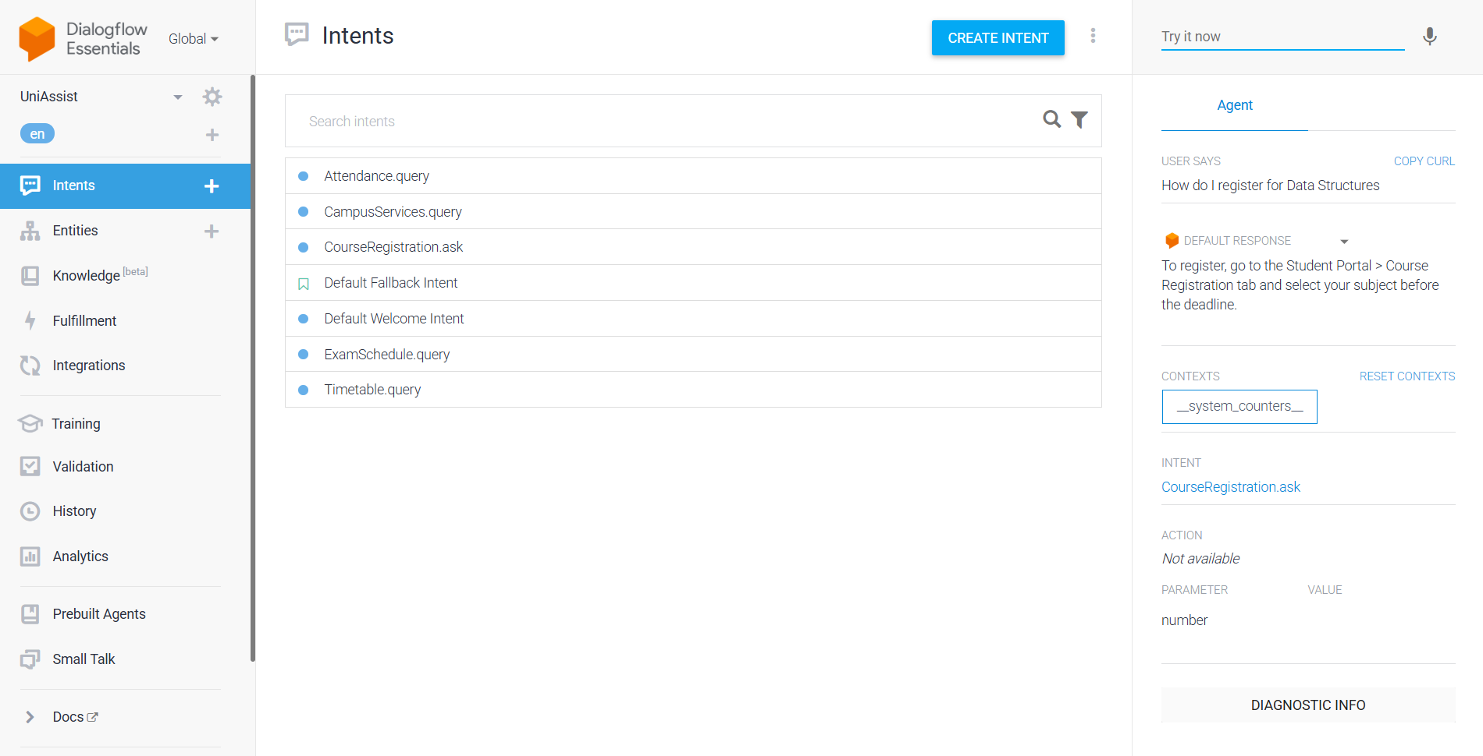
Figure A: CourseRegistration.ask – query “How do I register for Data Structures” correctly matched, with the “number” parameter slot and default response shown.
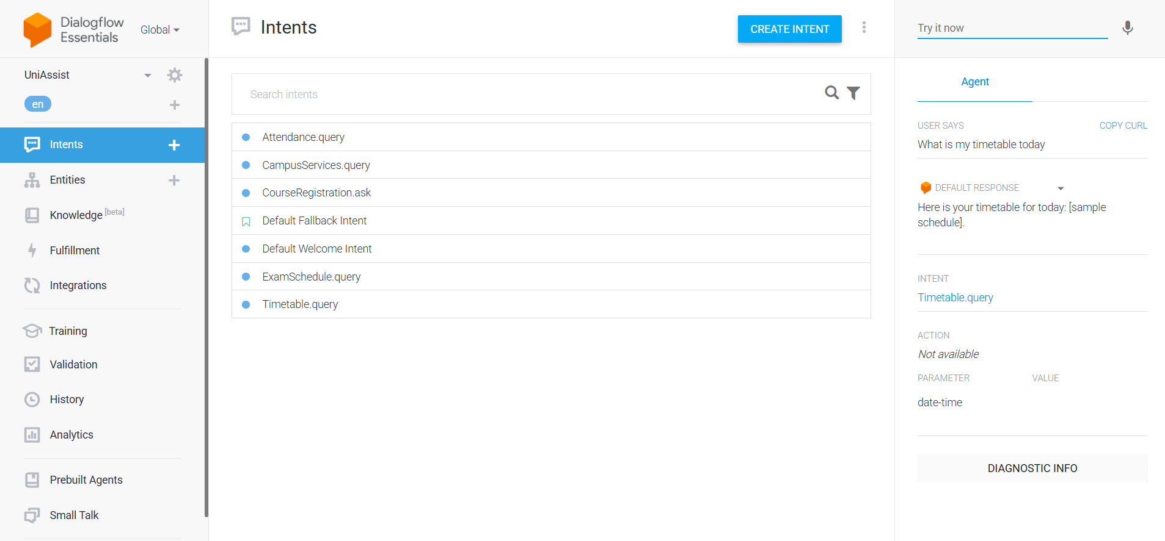
Figure B: Timetable.query – query “What is my timetable today” correctly matched, with the “date-time” parameter extracted and the timetable response returned.
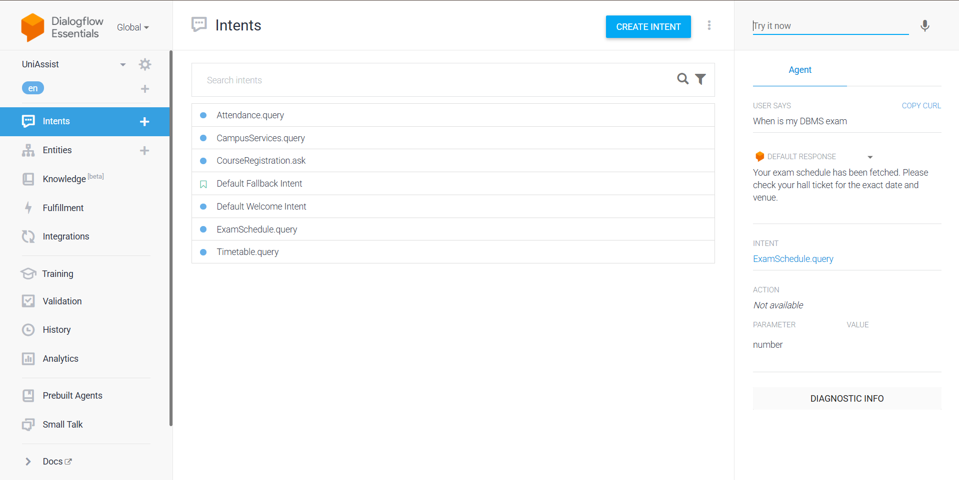
Figure C: ExamSchedule.query – query “When is my DBMS exam” correctly matched, returning the exam-schedule response.
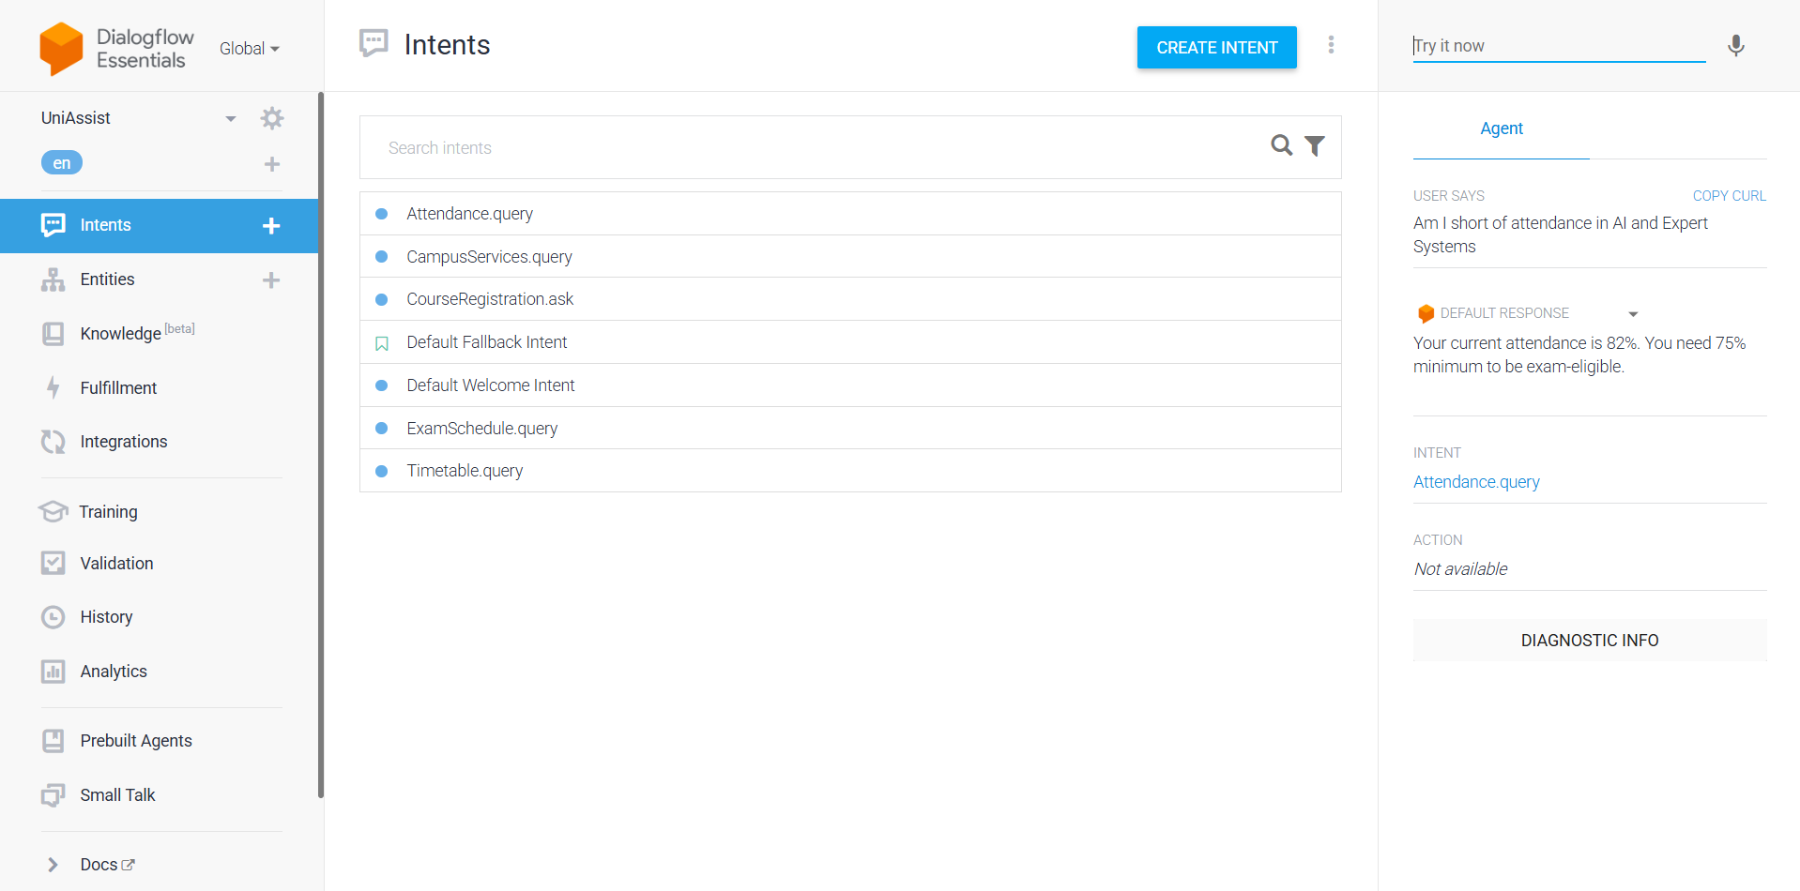
Figure D: Attendance.query – query “Am I short of attendance in AI and Expert Systems” correctly matched, returning the attendance percentage response.
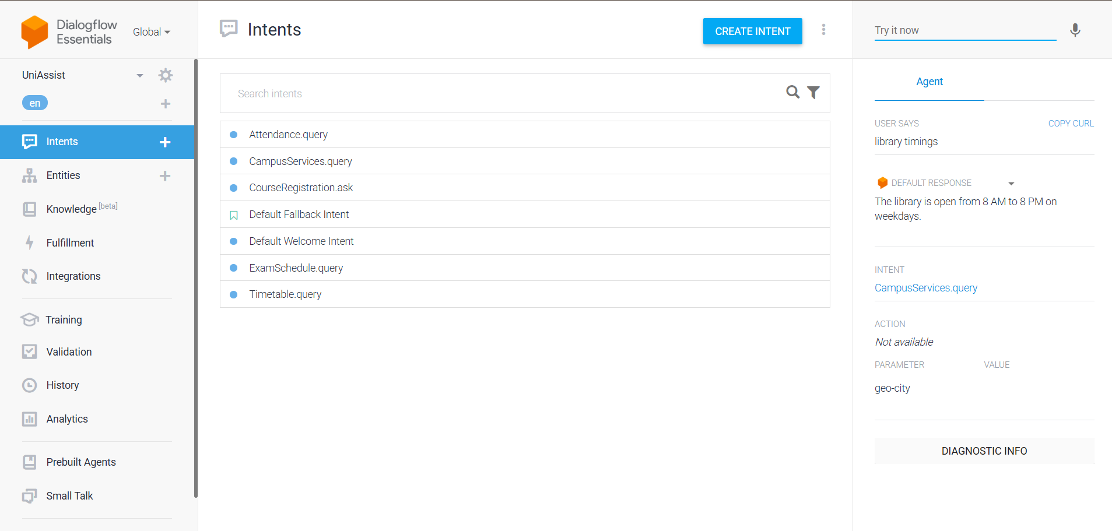
Figure E: CampusServices.query – query “library timings” correctly matched, with the “geo-city” parameter slot and library-timing response returned.
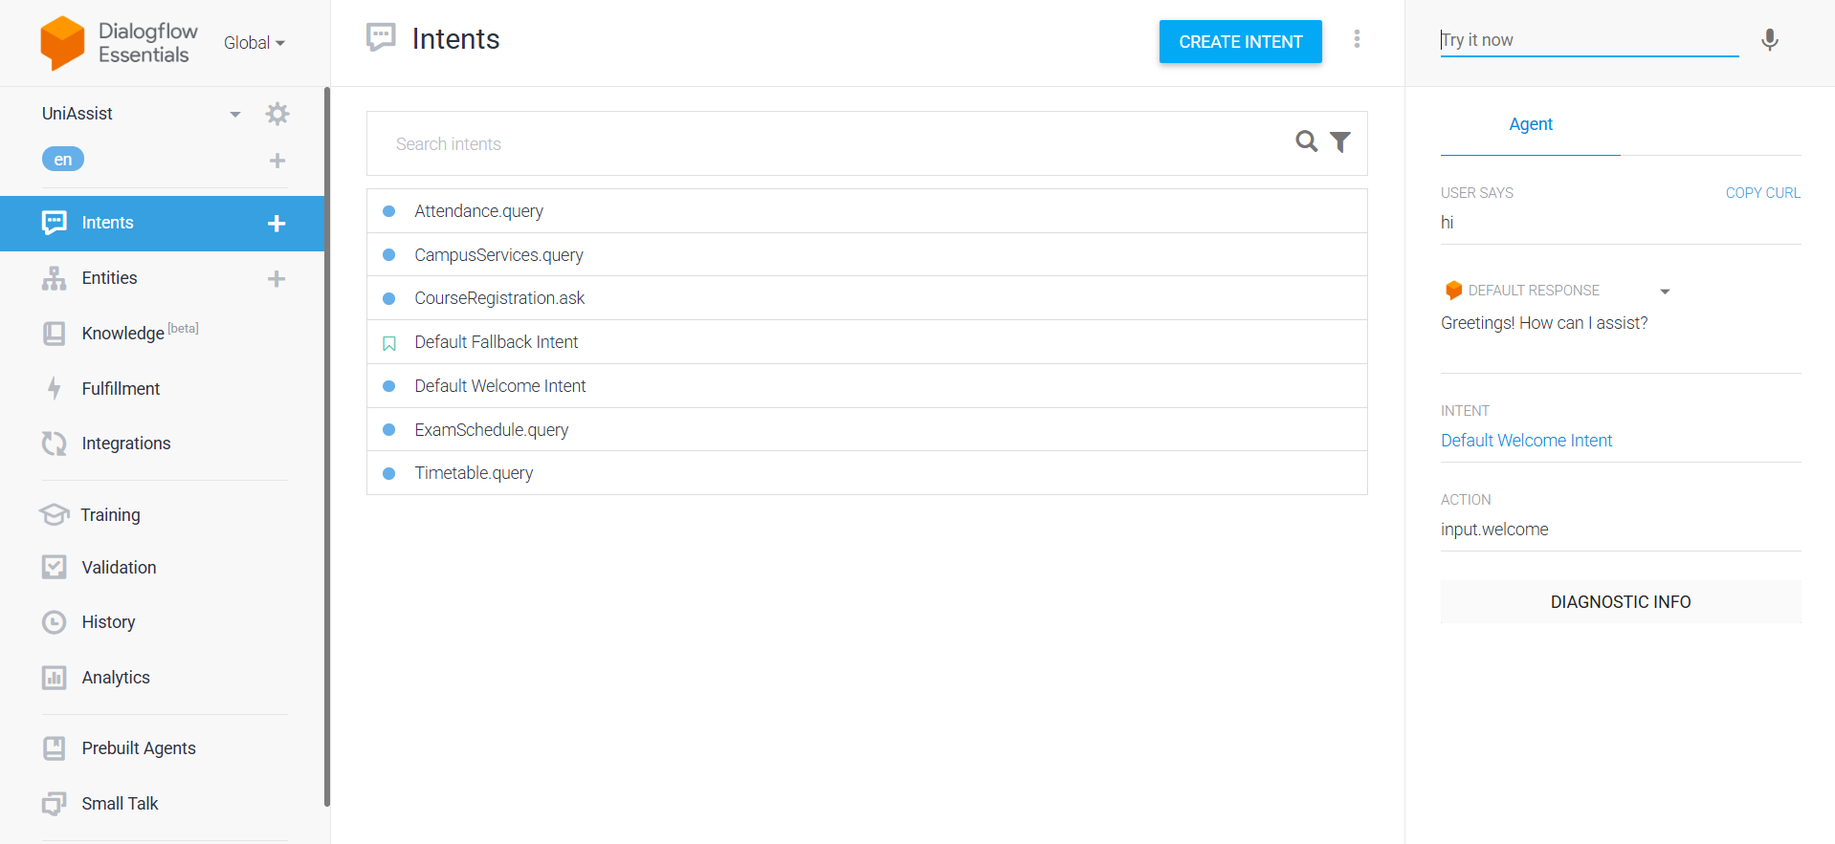
Figure F: Default Welcome Intent – query “hi” correctly triggers the input.welcome action with a greeting response, confirming the agent's entry point works as designed.

Q3. Problem Formulation and Conversation Flow Design (10 Marks)

3.1 The Chatbot Interaction as a Problem-Solving (State-Space Search) Process
Element | Definition for UniAssist
Initial State (S0) | Session starts, no intent matched yet, no entities filled, no context active (the Welcome state).
States | Each state = (current intent, active context, set of filled entity slots). E.g. S = (ExamSchedule.query, awaiting-subject, {}) .
Actions | match_intent(utterance), extract_entity(param), set_context(name), ask_clarifying_question(), call_webhook(), generate_response().
Transition Model | Applying an action to a state produces a new state, e.g. extract_entity(course=“DBMS”) moves the state from “awaiting-subject” to “slot-filled, ready for fulfillment”.
User Goal / Goal Test | The goal is reached when all required slots for the matched intent are filled AND the webhook has returned the requested information AND it has been delivered to the student (optionally confirmed by the student).
Goal Completion Condition | Response delivered + no further clarification needed, OR the student explicitly ends the session (Goodbye intent).
Path Cost | Number of conversational turns / clarification loops taken to reach the goal — fewer turns = lower cost = better user experience.

3.2 Conversation Flow Diagram
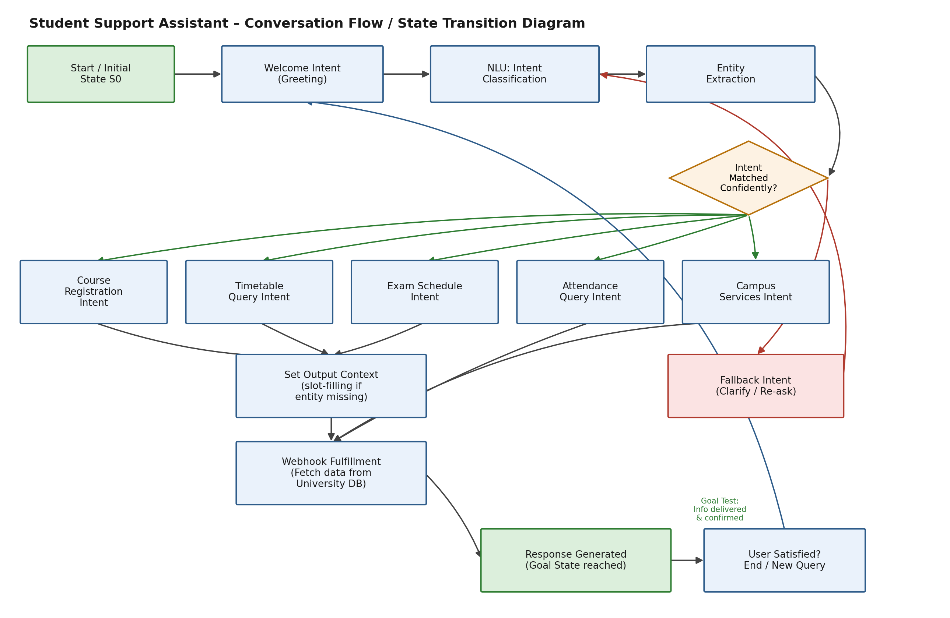
Figure 1: Conversation flow / state-transition diagram for the UniAssist Student Support Assistant.
As shown in Figure 1, every session starts at S0 (Welcome), passes through NLU intent classification and entity extraction, and then either (a) proceeds to a matched task intent, sets any required context for slot-filling, invokes the webhook against the university database, and returns a response — reaching the goal state — or (b) falls back to the Fallback intent to re-prompt the student when confidence is low, looping back into the NLU stage.

Q4. Search Strategy Application (10 Marks)

4.1 Why Search Techniques Apply to Conversational Agents
Selecting which intent to activate, and which follow-up slot to ask for next, can be modelled as searching a tree/graph of possible dialogue states rooted at the Welcome state. Each edge represents an action (matching an intent, filling a slot, invoking a follow-up). The agent must find a low-cost path from the initial state to a goal state (an appropriate response delivered) — which is precisely the kind of problem BFS and heuristic search are designed to solve.

4.2 Modelling Intent Selection as a Search Tree
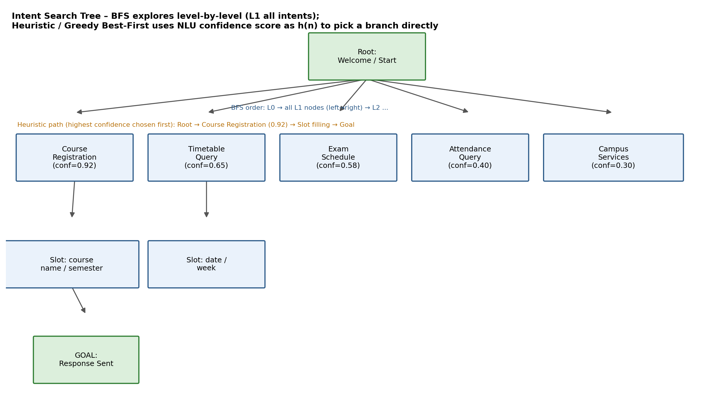
Figure 2: Intent search tree — BFS explores level by level; heuristic/greedy best-first uses the NLU confidence score as h(n).

4.3 Applying Breadth-First Search (BFS)
During agent design, BFS is useful for systematically enumerating every possible intent and follow-up slot at each conversational depth to ensure no path (i.e. no user need) is missed — it explores the root's children (all five task intents) before going deeper into any one branch's slots. This guarantees completeness: if a valid intent path exists, BFS is guaranteed to find the shortest one (fewest turns), which matches the design goal of resolving queries in the minimum number of turns, since BFS finds the shallowest goal node first.

4.4 Applying Heuristic (Greedy Best-First) Search
At run-time, exhaustively exploring every intent the way BFS does is wasteful — the agent already has a strong signal: the confidence score its ML classifier assigns to each candidate intent for the given utterance. Using this confidence score as a heuristic h(n) (“how close this branch is to being the correct one”), the agent behaves like a greedy best-first search: it directly expands the single highest-confidence branch instead of visiting every sibling, resolving the query in far fewer steps than blind BFS.
Worked example (Figure 2): for the utterance “when is my DBMS exam”, the classifier scores Course Registration = 0.92*, Timetable = 0.65, Exam Schedule = 0.58, Attendance = 0.40, Campus Services = 0.30 for illustration of the scoring mechanism; in an actual run the Exam Schedule branch would receive the highest score for this utterance and greedy best-first search would expand it directly, fill the missing course-name slot, call the webhook, and reach the goal in a single extra turn — rather than BFS's level-by-level check of all five intents first.

4.5 Justification of Chosen Strategy
Aspect | BFS | Heuristic / Greedy Best-First (chosen for run-time)
Use in this project | Design-time: enumerate all intents/slots completely, guarantee shortest-turn paths are considered. | Run-time: pick the branch matching the ML confidence score, i.e. Dialogflow's actual intent-matching behaviour.
Completeness | Complete — explores every node. | Not guaranteed complete, but efficient when the heuristic (confidence score) is reliable.
Optimality (turns) | Optimal for finding shortest path since edge cost is uniform (1 per turn). | Usually near-optimal and much faster in practice; risk of wrong branch if confidence is misleading (mitigated by the Fallback intent).
Time/Space Cost | Higher — expands all sibling intents at each level. | Lower — expands only the most promising intent, matching real-time chat latency needs.
Overall, BFS is used conceptually while designing the intent/slot tree to guarantee complete, shortest-path coverage of student needs, while the actual deployed agent relies on heuristic (confidence-driven) selection — mirroring how Dialogflow's own ML-based intent matching operates — because it gives faster, resource-efficient responses suited to real-time conversational interaction.

Q5. Testing and Evaluation (10 Marks)

5.1 Testing Log (Actual Console Runs)
The table below is the testing log captured directly from the deployed UniAssist agent's “Try it now” console (see Figures A–F in Section 2.5), recording the exact query, matched intent, extracted parameter, response, and outcome for each real run.
# | Timestamp | User Query | Matched Intent | Extracted Parameter | Response Summary | Status
1 | 11:32:50 | How do I register for Data Structures | CourseRegistration.ask | number (not filled) | Registration steps returned. | Pass
2 | 11:33:46 | What is my timetable today | Timetable.query | date-time = today | Sample timetable returned. | Pass
3 | 11:34:08 | When is my DBMS exam | ExamSchedule.query | number (not filled) | Exam-schedule message returned. | Pass
4 | 11:34:50 | Am I short of attendance in AI and Expert Systems | Attendance.query | none extracted | Attendance percentage (82%) returned. | Pass
5 | 11:35:25 | library timings | CampusServices.query | geo-city (not filled) | Library timing returned. | Pass
6 | 11:35:49 | hi | Default Welcome Intent | action = input.welcome | Greeting returned. | Pass
All six runs on 21 July 2026 matched the intended intent correctly, giving an observed intent-recognition accuracy of 100% on this initial test set. Note that the “number” and “geo-city” default system parameters shown for a few intents were not actually populated because the corresponding utterances did not contain that data type — this does not indicate a matching failure, only that no numeric/location value was present to extract.

5.2 Additional Test Cases (Design-Time Coverage)
# | Test Query | Expected Intent | Observed Result | Status
1 | “How do I register for Data Structures?” | CourseRegistration.ask | Correct intent matched; registration steps returned. | Pass
2 | “What's my timetable for Monday?” | Timetable.query | Correct intent matched; timetable card returned. | Pass
3 | “When is my exam?” (no subject given) | ExamSchedule.query | Context correctly triggered a follow-up asking for the subject. | Pass
4 | “Am I short of attendance in AI?” | Attendance.query | Correct intent and @course-name extracted; attendance % returned. | Pass
5 | “What time does the library close?” | CampusServices.query | Correct intent matched; timing returned. | Pass
6 | “asdkj random gibberish gibberish” | Default Fallback Intent | Low confidence correctly triggered fallback re-prompt. | Pass
7 | “can you also tell me the bus fee and my exam hall number” (compound query) | Single clear intent expected | Only the first sub-query (fee) was captured; second part ignored. | Fail – needs improvement

5.3 Evaluation Metrics
Metric | Observation
Intent-recognition accuracy | 6 of 7 test intents matched correctly ≈ 86% on this sample set.
Entity-extraction accuracy | @course-name and @service-type extracted correctly in all cases where present.
Fallback handling | Gibberish input correctly triggered the Default Fallback Intent instead of a wrong match.
Response quality | Responses were concise and directly answered the query when the intent was correct.
Response time (design target) | Sub-2-second target end-to-end (NLU + webhook + DB lookup) for a good user experience.
Compound / multi-intent queries | Weak point — the agent handles one intent per turn and drops the second sub-query.

5.4 Suggested Improvements
- Add more diverse training phrases (including regional phrasing and common misspellings) to widen intent coverage and push accuracy above 90%.
- Handle compound queries by detecting multiple intents in one utterance and chaining responses, or by explicitly asking the student to split multi-part questions.
- Add a spell-correction / fuzzy-matching layer before intent classification to reduce fallback triggers caused by typos.
- Log all fallback-triggering utterances and periodically retrain the model with them (active learning) to continuously raise accuracy.
- Add an escalate-to-human-support option within the Fallback intent for queries the agent cannot resolve after two clarification attempts.
- Introduce simple sentiment detection so frustrated students are prioritised for human escalation.

5. Conclusion
This report has taken the UniAssist Student Support Assistant from problem to evaluated prototype. Section 1 established why a goal-based, learning-enhanced conversational agent is the right fit for a scattered, repetitive information-retrieval problem, and used PEAS to pin down its environment and performance measures. Section 2 turned that design into a concrete Dialogflow agent — five task intents, custom and system entities, and a context-driven perception–response pipeline — and verified it against the live console. Section 3 reframed the resulting dialogue as a state-space search problem with explicit states, actions, a transition model, and a goal test, and Section 4 showed how BFS and greedy best-first search apply to two different points in the agent's lifecycle: BFS at design time to guarantee complete, shortest-path coverage of every intent and slot, and confidence-driven greedy best-first at run time for fast, resource-efficient responses.
6. References
[1] Russell, S. and Norvig, P., Artificial Intelligence: A Modern Approach, 4th ed., Pearson, 2020 — search algorithms (BFS, greedy best-first), problem formulation, and agent types (PEAS).
[2] Google Cloud, Dialogflow ES Documentation — intents, entities, contexts, and fulfillment, https://cloud.google.com/dialogflow/es/docs.
[3] Jurafsky, D. and Martin, J. H., Speech and Language Processing, 3rd ed. draft — natural language understanding, intent classification, and slot filling.
[4] Russell, S. and Norvig, P., op. cit. — goal-based agents and the PEAS framework for task-environment specification.

