CPU Scheduler Lab: Design and Implementation of a Browser-Based Scheduling Simulator
<Student Name>
<Student ID / Roll No.>
<Department Name>
<Institute / University Name>
<City, State, Country>
<student-email@example.com>
<Supervisor Name>
<Course: Operating Systems>
<Date: DD Month YYYY>

Abstract?Modern operating systems rely on CPU scheduling, yet students rarely see behavioural differences between scheduling algorithms because the policy is hidden inside kernel code. This paper presents CPU Scheduler Lab, an educational browser-based simulator for a single-core CPU scheduler. It implements six well-known policies?FCFS, SJF, SRTF, Round Robin, non-preemptive priority and preemptive priority?using a pure-Python scheduling engine that is independent of the web framework. A Flask service validates user input and returns JSON, while HTML, CSS, JavaScript and Chart.js visualise a Gantt timeline, per-process metrics, average TAT, WT, RT and CPU utilisation. A five-process workload demonstrates the expected trade-offs; correctness is verified using 57 automated tests and a headless-browser check. The system is a teaching simulator and does not control the running operating-system scheduler.
Index Terms?CPU scheduling, Gantt chart, operating systems education, preemptive priority, simulation, single-core scheduling, SRTF, turnaround time, waiting time.
I. Introduction
A. Background
CPU scheduling determines which ready process receives the processor at any instant [1]. A policy may choose based on arrival order, execution time, priority, or time quantum, and it may be preemptive or non-preemptive [2]. In an educational environment, these differences are usually explained abstractly, which makes it harder for students to see how the schedule changes when the algorithm changes.
B. Motivation and problem statement
The simulator was built to visualise scheduling behaviour without depending on a real OS kernel. The practical problem is to provide a stable browser interface, correct metric calculations, and deterministic execution of six common algorithms on identical inputs. The scheduler itself is simulated and never controls the kernel of the running operating system.
C. Objectives and scope
The project has four objectives: (i) implement six single-core algorithms on the same workload; (ii) calculate CT, TAT, WT, RT, average values and CPU utilisation; (iii) provide an interactive Gantt chart and comparison interface; and (iv) keep scheduling logic separated from the web layer so that the engine is testable as pure code.
The scope is instructional. The implementation uses whole-number time units, ignores dispatcher and context-switch overhead, and handles at most 100 processes. Browser state is not persisted. The simulator is an educational tool rather than a kernel control component.
II. Related Work
Scheduling policies are a standard component of operating-system pedagogy [1]?[3]. Shortest-job-first and priority policies are frequently introduced as alternative heuristics for the same process arrival data. The present work is differentiated by keeping the algorithm implementation as pure Python code and providing the same metric conventions for all six algorithms. The web layer is deliberately tiny: Flask is used for JSON routing and validation [4], the browser uses the Fetch API for request handling [5], and Chart.js is used only for comparison visualisation [6]. The algorithm states themselves are implemented directly rather than approximated by a visual mockup.
III. Proposed Methodology
A. Scheduling conventions
The simulator follows one common convention for all policies: after the primary key, earlier arrival time is preferred, and the final tie-breaker is the smaller process ID. Natural ordering is applied to PIDs, so P2 comes before P10. All arrivals with the same time become available together. If the CPU is idle, an Idle block is inserted and time jumps to the next arrival. Adjacent blocks of the same process are merged in the Gantt output.
B. Algorithm summary
Table I. Six scheduling algorithms implemented in the simulator.
Algorithm | Preemptive? | Primary key | Tie-break
FCFS | No | Arrival time | PID
SJF | No | Burst time | Arrival, PID
SRTF | Yes | Remaining time | Arrival, PID
Round Robin | Yes | Time quantum | Queue order, arrival, PID
Priority | No | Priority number | Arrival, PID
Preemptive Priority | Yes | Priority number | Arrival, PID

Lower priority numbers imply higher priority. For preemptive priority, a new process preempts only when its priority number is strictly smaller. For Round Robin, a process arriving exactly at quantum expiry joins the ready queue before the preempted process is re-added.
C. Metric definitions
The algorithm results are transformed into per-process metrics. Completion time is the end of the last Gantt block. Turnaround, waiting and response times are obtained from CT, first CPU start time, arrival time and burst time.
TAT_i = CT_i ? AT_i (1)
WT_i = TAT_i ? BT_i (2)
RT_i = first_start_i ? AT_i (3)
Average X = (1/n)?X_i, X ? {TAT, WT, RT} (4)
CPU utilisation = (busy / elapsed) ? 100 (5)
Busy time is the sum of non-idle Gantt durations. Elapsed time starts from 0 and ends at the last completion. In non-preemptive algorithms, the response time equals the waiting time because the process runs only once.
IV. System Architecture and Design
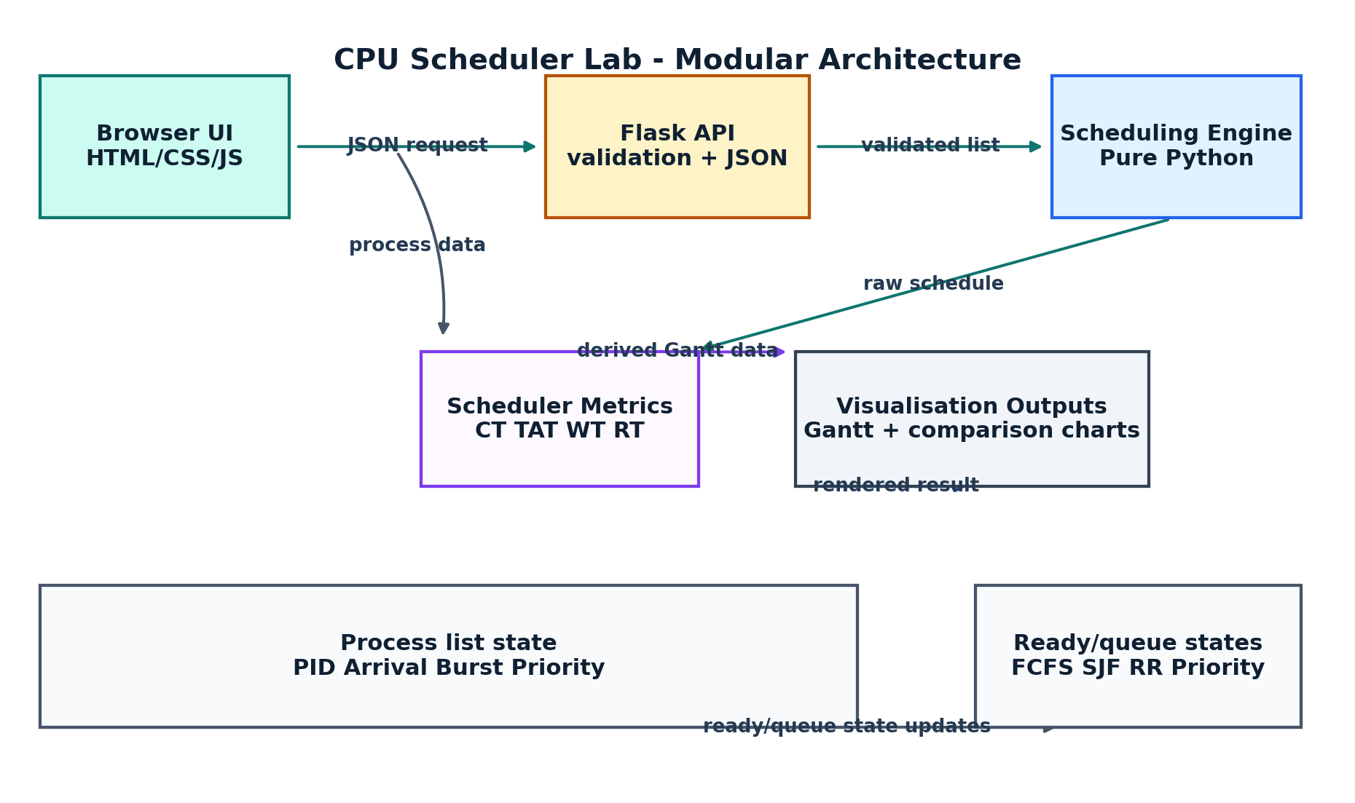
Fig. 1. Modular CPU scheduling architecture.
The system has four loosely coupled layers. The browser layer supports process CRUD and user selection. The Flask layer validates each request and returns either JSON or a 400 error. The scheduling layer is independent of Flask and implements the algorithms in pure Python. Metrics and the timeline are returned in JSON and only then are drawn by the browser.
B. Data flow
Each request is stateless. The browser sends the complete process list and algorithm, the server validates and computes the schedule from scratch, and the visualisation is based only on the returned response. A process ID of "Idle" is reserved, so user input cannot create an ambiguous Gantt block.
C. Validation and error reporting
Arrival, burst and priority are validated as whole numbers. Burst time must be positive and arrival and priority cannot be negative. Duplicate PIDs are rejected case-insensitively, and an unknown algorithm or zero quantum generates a descriptive 400 response rather than an HTML page.
V. Implementation
A. Technologies
The implementation is intentionally compact: Flask for routing, pure Python for scheduling, pytest for algorithm tests, and HTML/CSS/JavaScript for the browser. Chart.js is used for comparison charts. No external database or framework is used.
B. Scheduler engine
The engine keeps a pure Python module for all algorithms. It also exposes a common dispatcher that accepts an algorithm key and returns a deterministic timeline. The module contains functions such as run_algorithm, validate_processes, calculate_metrics, find_best_algorithms and merge_timeline.
C. Preemptive engine
SRTF and preemptive priority share the same _preemptive engine, but use different primary keys. After each timer interval, the engine updates remaining burst, records completion and reselects the next candidate.
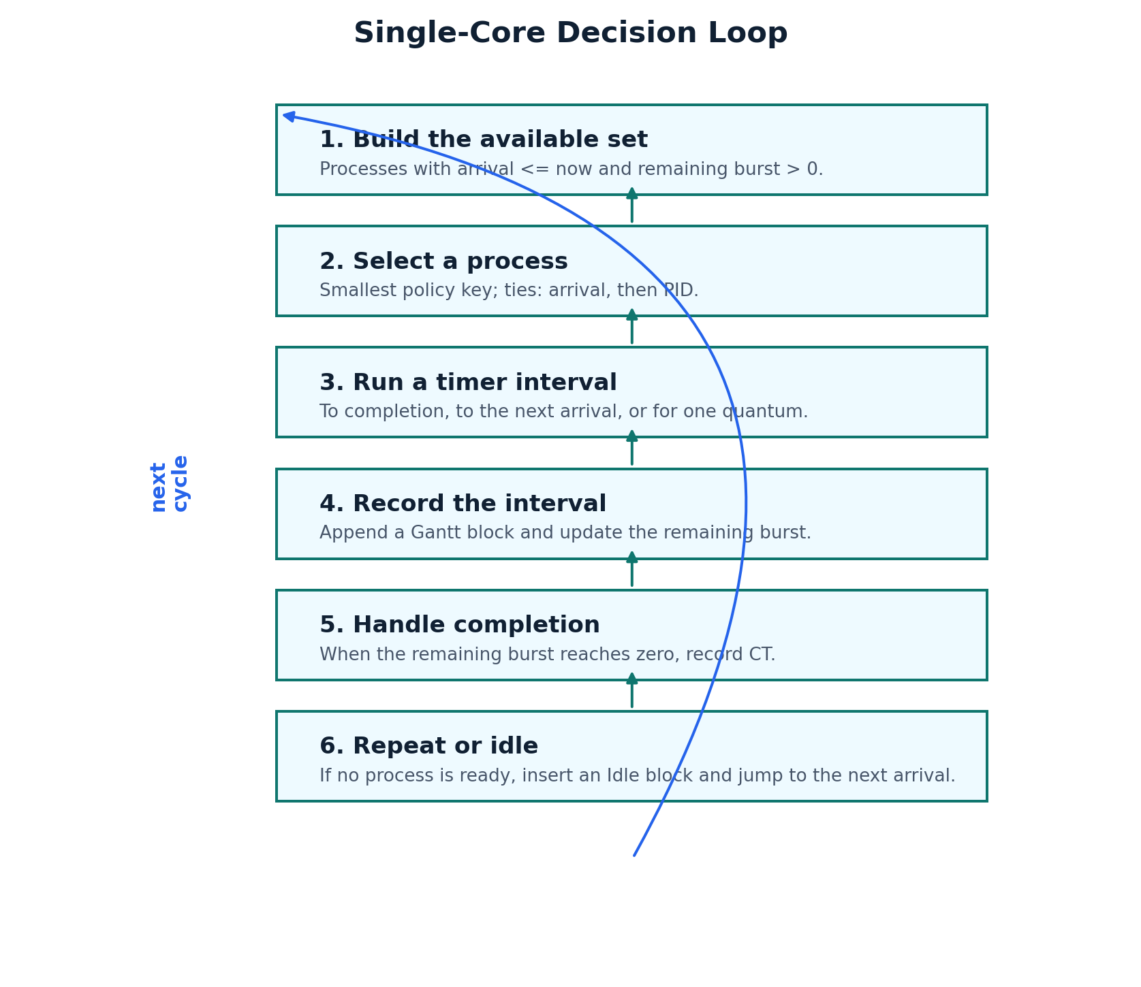
Fig. 2. Repeating decision loop used by preemptive policies.
VI. Results and Discussion
A. Sample workload
Table II. Five-process workload used for the educational example.
PID | Arrival | Burst | Priority
P1 | 0 | 4 | 2
P2 | 1 | 3 | 1
P3 | 2 | 1 | 3
P4 | 3 | 2 | 2
P5 | 4 | 5 | 4

Round Robin uses a quantum of 2. All six algorithms run on the same list. Because the workload has no idle gaps, each algorithm consumes all 15 time units and reports 100% CPU utilisation.
B. Comparative metrics
Table III. Average metrics computed for the sample workload.
Algorithm | Avg TAT | Avg WT | Avg RT | CPU util
FCFS | 6.80 | 3.80 | 3.80 | 100.00%
SJF | 6.20 | 3.20 | 3.20 | 100.00%
SRTF | 6.00 | 3.00 | 2.80 | 100.00%
Round Robin | 7.60 | 4.60 | 2.40 | 100.00%
Priority | 7.00 | 4.00 | 4.00 | 100.00%
Preemptive Priority | 7.00 | 4.00 | 3.40 | 100.00%

SRTF has the best average TAT/WT on this sample because it preempts P1 when the shorter P3 arrives at time 2. Round Robin gives the best response time because its fixed quantum allows new arrivals to receive the CPU earlier. Preemptive priority matches non-preemptive priority on TAT/WT here, but reduces average response time to 3.40.
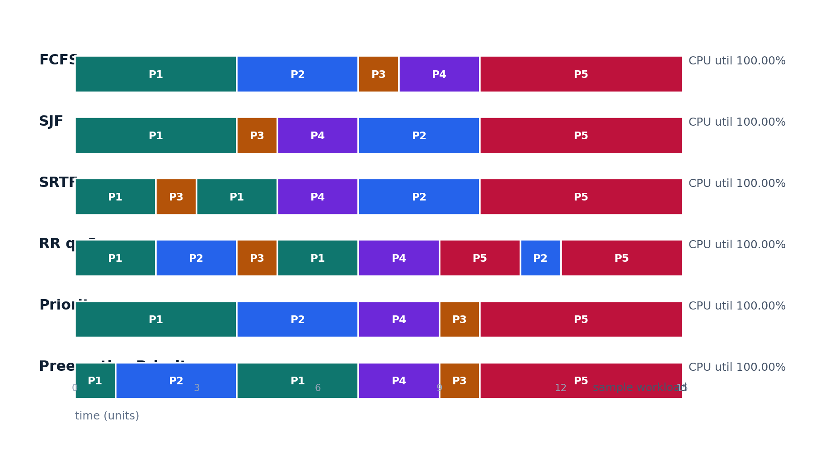
Fig. 3. Gantt schedules for the sample workload.
C. Testing
The implementation has 57 automated tests covering algorithm correctness, edge cases, metrics, and API validation. The browser side was additionally driven in headless Chrome to check six algorithm cards, comparison mode, tooltips, add/edit/delete, error messages and mobile layout. The tests do not interpret the results as real-world performance profiling; they validate educational simulation behaviour.
VII. Limitations
The simulator has several deliberate limitations: it is single-core, it does not model context switches, dispatcher latency, multiprocessor scheduling or I/O bursts; it does not implement aging, and it supports whole-number time units only. The maximum process count is currently 100, and browser state is not persisted. It is therefore not suitable as a replacement for production scheduling or for empirical kernel profiling.
VIII. Conclusion and Future Scope
CPU Scheduler Lab demonstrates the behavioural differences between six well-known scheduling policies on an identical workload, with consistent tie-breaking and correct metric presentation. The browser-only user interface and the pure-Python scheduler allow it to be extended independently of the runtime framework.
Possible future extensions include aging, I/O bursts, multiprocessor scheduling, CSV import/export, larger workloads and additional visualisations. Because the engine is framework-independent, these additions can be layered without changing the existing API contract.
References
[1] A. Silberschatz, P. B. Galvin, and G. Gagne, *Operating System Concepts*, 10th ed. Hoboken, NJ, USA: Wiley, 2018.
[2] A. S. Tanenbaum and H. Bos, *Modern Operating Systems*, 4th ed. Upper Saddle River, NJ, USA: Pearson, 2015.
[3] R. H. Arpaci-Dusseau and R. H. Arpaci-Dusseau, Operating Systems: Three Easy Pieces, 1.00 ed. Madison, WI, USA: Arpaci-Dusseau Books, 2018.
[4] A. Ronacher, "Flask documentation," Flask Project, 2026. [Online]. Available: https://flask.palletsprojects.com/
[5] Mozilla Developer Network, "Using the Fetch API," MDN Web Docs, 2026. [Online]. Available: https://developer.mozilla.org/en-US/docs/Web/API/Fetch_API/Using_Fetch
[6] Chart.js contributors, "Chart.js documentation," version 4.4.x, 2026. [Online]. Available: https://www.chartjs.org/docs/latest/
[7] Python Software Foundation, "pytest documentation," version 8.4.2, 2026. [Online]. Available: https://docs.pytest.org/en/stable/
Appendix A: API endpoint reference (optional)
Available on request.

