Open the springboot application.

* **Adding dependencies.**

Goto the file pom.xml

Goto the <dependencies> in pom.xml

Open the browser and search for maven repository. <https://mvnrepository.com/>

In the search bar, search for ‘**jjwt-api**’ and click on **JJWT :: API,** click on version‘**0.11.5**’.

**<!-- https://mvnrepository.com/artifact/io.jsonwebtoken/jjwt-api -->**

**<dependency>**

**<groupId>io.jsonwebtoken</groupId>**

**<artifactId>jjwt-api</artifactId>**

**<version>0.11.5</version>**

**</dependency>**

Copy the dependency, and paste it in the pom.xml under <dependencies>

Again

in the search bar, search for ‘jjwt-impl’ and click on **JJWT :: impl,** click on version‘**0.11.5**’.

**<!-- https://mvnrepository.com/artifact/io.jsonwebtoken/jjwt-impl -->**

**<dependency>**

**<groupId>io.jsonwebtoken</groupId>**

**<artifactId>jjwt-impl</artifactId>**

**<version>0.11.5</version>**

**<scope>runtime</scope>**

**</dependency>**

Copy the dependency, and paste it in the pom.xml under <dependencies>

Again

in the search bar, search for ‘jjwt-jackson’ and click on **JJWT :: Extensions :: Jackson** **,** click on version‘**0.11.5**’.

**<!-- https://mvnrepository.com/artifact/io.jsonwebtoken/jjwt-jackson -->**

**<dependency>**

**<groupId>io.jsonwebtoken</groupId>**

**<artifactId>jjwt-jackson</artifactId>**

**<version>0.11.5</version>**

**<scope>runtime</scope>**

**</dependency>**

Copy the dependency, and paste it in the pom.xml under <dependencies>

* **Update the project**

Choose the project, Right click on the project, in the popup menu, choose Maven, choose Update Project.

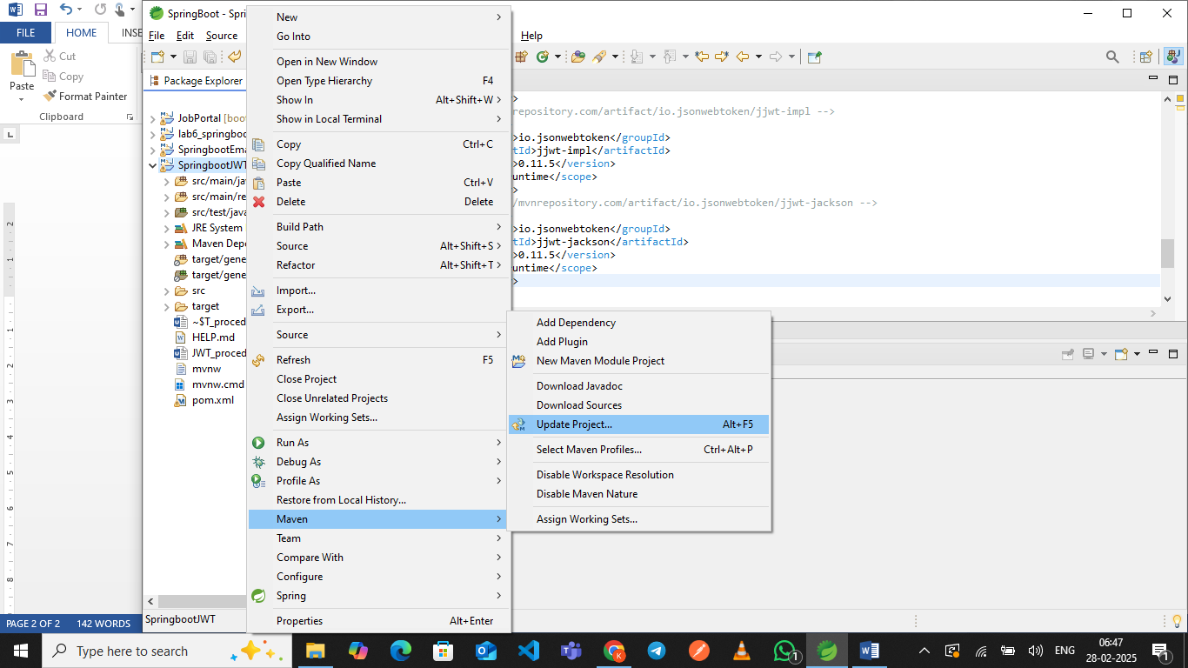

enable Force update of Snapshots/Releases and then click on ‘ok’.

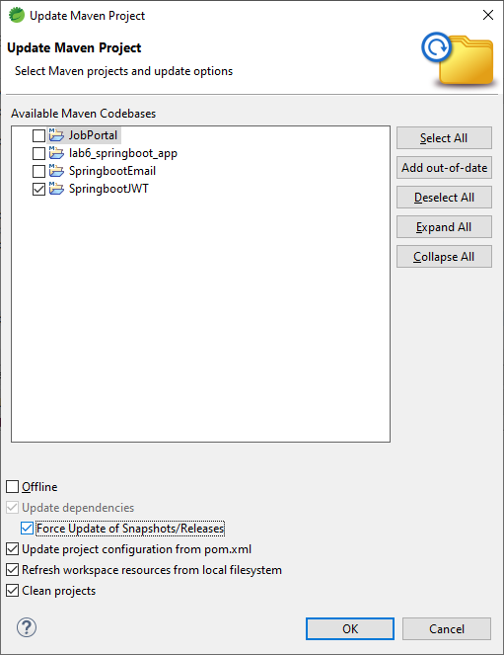

Open the SpringBoot application, in the model package of src/main/java, create a class JWTManager.

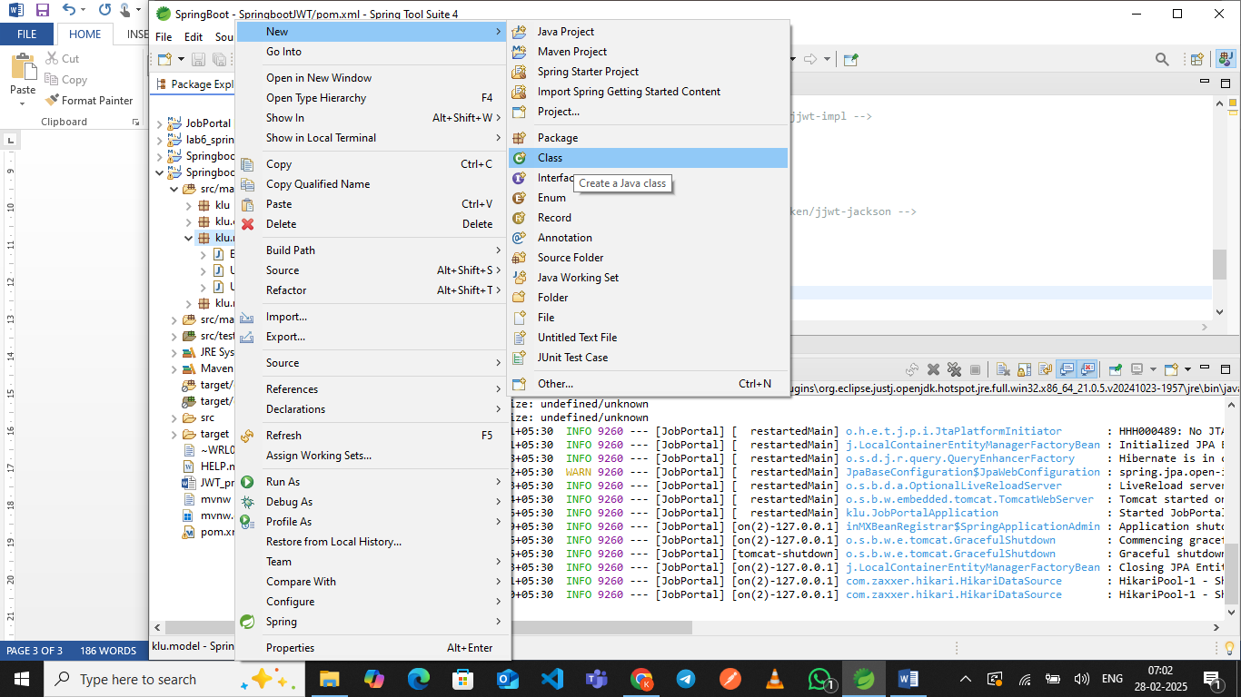

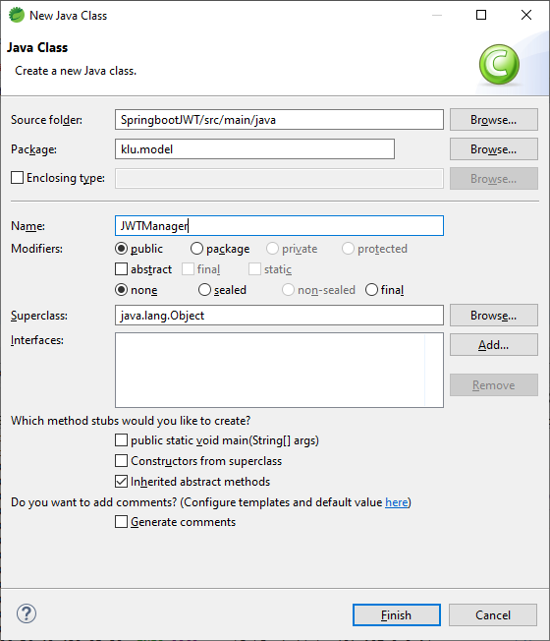

After creating a class, make the class as a service class by adding the annotation @Service.

Define a final string of SEC_KEY.