**CIA-1**

**727721EUIT123**

**RAJASRI-G**

**1)Add to cart**

>cart.java

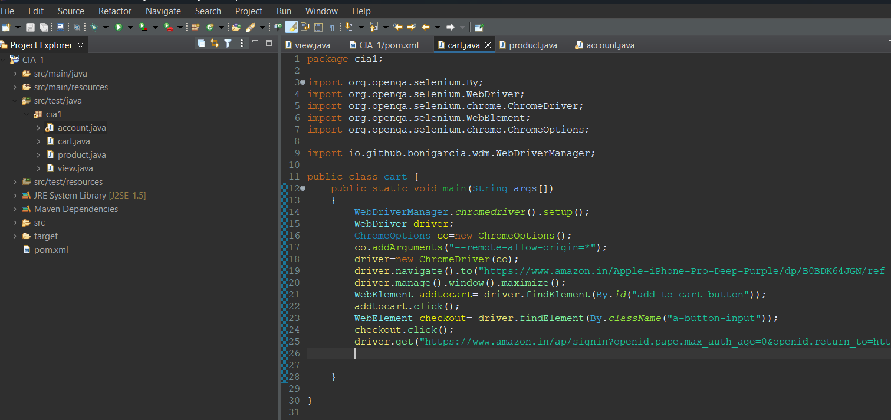

Output:

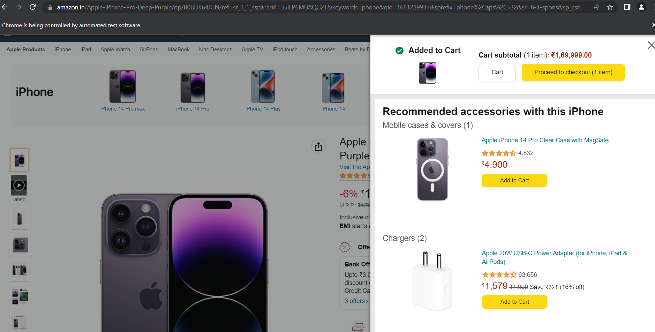

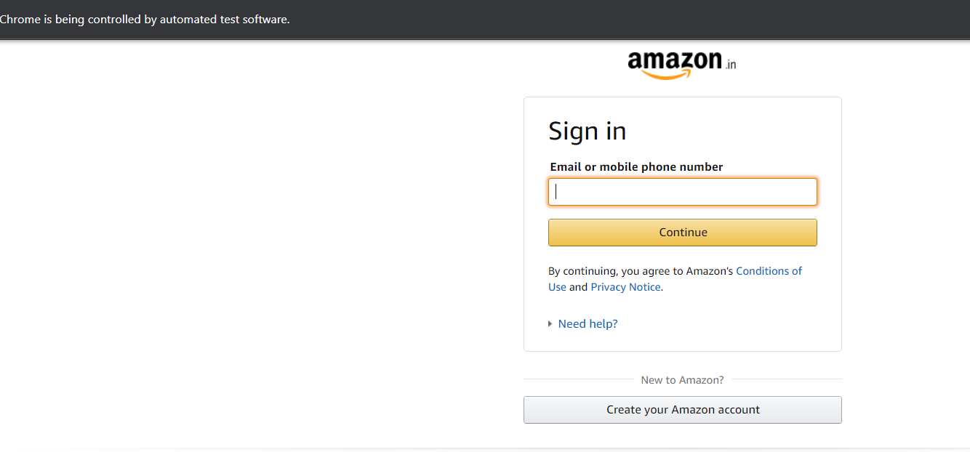

**2)products**

>product.java

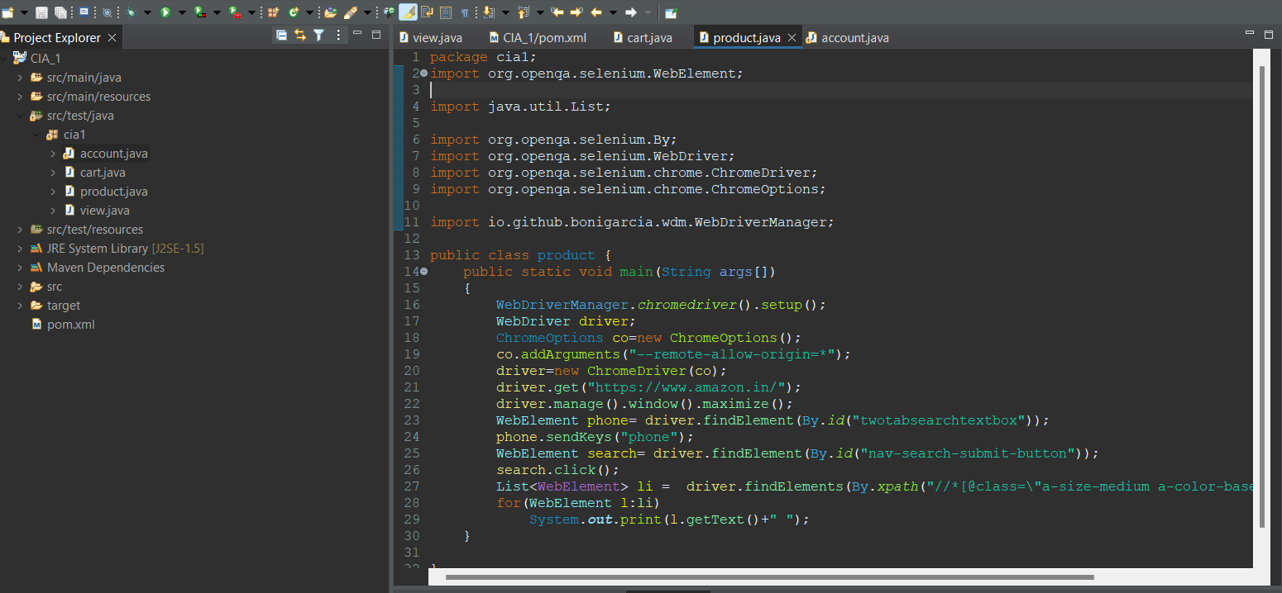

Output:

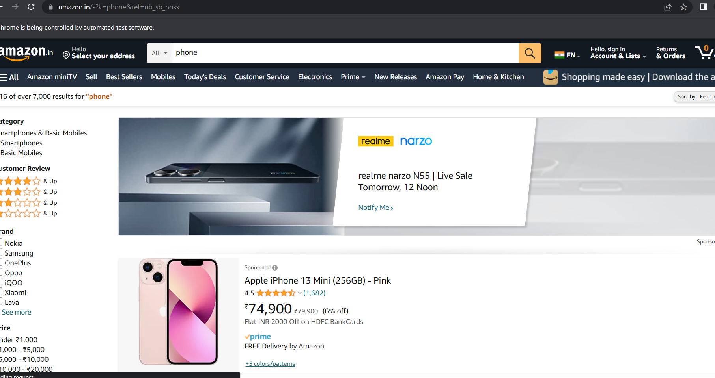

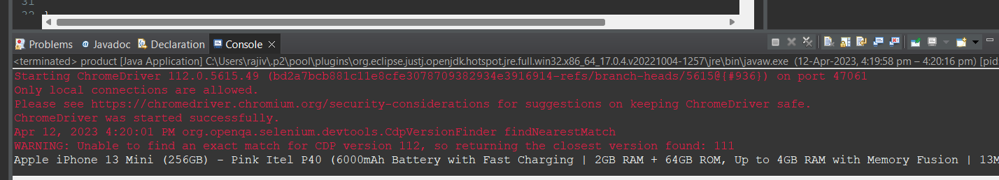

**3)Account details**

>account.java

package cia1;

import java.util.List;

import org.openqa.selenium.By;

import org.openqa.selenium.JavascriptExecutor;

import org.openqa.selenium.Keys;

import org.openqa.selenium.WebDriver;

import org.openqa.selenium.WebElement;

import org.openqa.selenium.chrome.ChromeDriver;

import org.openqa.selenium.chrome.ChromeOptions;

import org.openqa.selenium.support.ui.Select;

import io.github.bonigarcia.wdm.WebDriverManager;

/**

* Hello world!

*

*/

public class account

{

public static void main( String[] args ) throws InterruptedException

{

WebDriverManager.chromedriver().setup();

ChromeOptions co = new ChromeOptions();

co.addArguments(&quot;--remote-allow-origins=*&quot;);

WebDriver driver=new ChromeDriver(co);

driver.get(&quot;https://www.amazon.in/ref=nav_logo&quot;);

driver.manage().window().maximize();

String title=driver.getTitle();

System.out.println(title);

if(title.equals(&quot;Online Shopping site in India: Shop Online for Mobiles, Books, Watches,

Shoes and More - Amazon.in&quot;)) {

System.out.println(&quot;Verified title of the page&quot;);

}else {

System.out.println(&quot;Title not matched&quot;);

}

driver.findElement(By.id(&quot;nav-link-accountList&quot;)).click();

driver.findElement(By.id(&quot;ap_email&quot;)).sendKeys(&quot;feviliya28@gmail.com&quot;);

driver.findElement(By.id(&quot;ap_email&quot;)).sendKeys(Keys.ENTER);

driver.findElement(By.id(&quot;ap_password&quot;)).sendKeys(&quot;Fevi2802*&quot;);

driver.findElement(By.id(&quot;ap_password&quot;)).sendKeys(Keys.ENTER);

Thread.sleep(2000);

String name=driver.findElement(By.id(&quot;nav-link-accountList-nav-line-1&quot;)).getText();

if(name.equals(&quot;Hello, Feviliya&quot;)) {

System.out.println(&quot;Successfully, signed in&quot;);

}else {

System.out.println(&quot;Sign in failed&quot;);

}

System.out.println(&quot;Testing Ended&quot;);

driver.quit();

}

}

Output:

