“Online Signature Verification using Machine Learning Algorithms”
RAJAT SAINI (S0I2UA)

1. Introduction
Secure identity verification remains a core challenge in the digital era. Signatures are still widely used in sectors like banking, legal, and administration, but manual verification is often unreliable and vulnerable to forgery. This project aims to automate the process using machine learning to enhance accuracy, reduce human error, and improve trust in signature-based systems.
Motivation
Even with modern biometrics, handwritten signatures retain legal importance. Forged signatures can lead to fraud and legal issues. A machine learning approach offers a scalable and objective way to improve security and efficiency in systems relying on signature verification.

2. Introduction to Algorithms
This project used three supervised machine learning models—Random Forest, KNN, and SVM—chosen for their strengths in classification and suitability for biometric tasks like signature verification.
2.1 Random Forest
Random Forest builds multiple decision trees and predicts based on majority voting, offering strong performance on both linear and non-linear data with good resistance to overfitting.
- Pros: High accuracy, robust to overfitting, handles high-dimensional data.
- Cons: Slower for real-time use, less interpretable.
2.2 K-Nearest Neighbors (KNN)
KNN classifies samples based on the labels of their nearest neighbors and works well for smaller datasets due to its simplicity and non-parametric nature.
- Pros: Simple, effective for non-linear patterns, no assumptions about data.
- Cons: Slow during inference, sensitive to dimensionality.
2.3 Support Vector Machine (SVM)
SVM finds an optimal separating hyperplane; with an RBF kernel, it effectively captures non-linear patterns and performs well in high-dimensional spaces.
- Pros: Accurate, generalizes well, suitable for complex data.
- Cons: Sensitive to parameter settings, slower on large datasets.

3. Datasets Overview
Five datasets provided by my professor were used for training and testing, each containing genuine and forged signatures with varying features and structures.
- MCYT Dataset
- Samples: 20000 train / 1000 test
- Features: X, Y, P, al, az
- Largest dataset; uses all five features. Data was aggregated per SigID by computing feature means.
- SVC Dataset
- Samples: 5120 train / 320 test
- Features: X, Y, P, al, az
- Notes: Fully structured and clean; used directly after label mapping and scaling.
- Chinese Dataset
- Samples: 4124 train / 285 test
- Features: X, Y, P
- Notes: Compact and clean dataset. Orientation features were unavailable.
- Dutch Dataset
- Samples: 7056 train / 502 test
- Features: X, Y, P
- Notes: No orientation data. Emphasizes pressure and spatial patterns.
- German Dataset
- Samples: 1778 train / 151 test
- Features: X, Y, P
- Notes: Smallest test set; used to test robustness with fewer features.
- Common Preprocessing Steps
- signatureOrigin mapped to binary labels (1 = Genuine, 0 = Forged)
- Columns stripped of whitespace
- MinMaxScaler applied for normalization
- Datasets split into clean training and testing CSV files

4. Methodology
This project developed and assessed machine learning models for online signature verification through preprocessing, training, evaluation, and visualization.
4.1 Preprocessing
All datasets (provided in CSV format with training and testing files) underwent the following steps:
- Label Mapping: A Label column was added by mapping "Genuine" to 1 and "Forged" to 0.
- Feature Selection: Valid features (X, Y, P, and when available al, az) were retained by removing any with missing values.
- MCYT Aggregation: Since MCYT data included multiple points per signature, it was aggregated by averaging feature values per SigID.
- Normalization: All features were scaled to the [0, 1] range using MinMaxScaler to ensure model stability and performance.
4.2 Model Training & Evaluation
Three classification models were applied to each dataset:
- Random Forest (RF): Ensemble of decision trees, effective with high-dimensional, tabular data.
- K-Nearest Neighbors (KNN): Distance-based model that classifies based on nearest training samples.
- Support Vector Machine (SVM): Kernel-based method optimized for high-dimensional classification.
Each model was trained on the scaled training data and evaluated on the test set in a uniform loop.
4.3 Evaluation Metrics
To assess performance, the following metrics were calculated from the confusion matrix:
- Accuracy: Correct predictions out of total samples.
- Precision: TP / (TP + FP), i.e., correct genuine predictions.
- F1 Score: 2 × (Precision × Recall) / (Precision + Recall), balancing precision and recall.
- FAR: Rate of incorrectly accepted forged signatures.
- FRR: Rate of incorrectly rejected genuine signatures.
- EER: Average of FAR and FRR, commonly used in biometric evaluations.
4.4 Visualizations: To interpret the results:
- Confusion Matrix Heatmaps were plotted per model and dataset.
- PCA Scatter Plots were used to visualize class separation by reducing feature space to 2D.
This ensured a consistent, repeatable evaluation pipeline across all signature datasets.
5. Results
To evaluate the performance of each machine learning algorithm on the five signature datasets, we calculated six key metrics: Accuracy, Precision, F1 Score, FAR (False Acceptance Rate), FRR (False Rejection Rate), and EER (Equal Error Rate). Additionally, confusion matrices and PCA visualizations were generated for each dataset. The results are summarized below:

5.1 MCYT Dataset
Model | Accuracy | Precision | F1 Score | FAR | FRR | EER
Random Forest | 93.00% | 0.8772 | 0.9346 | 0.1400 | 0.0000 | 0.0700
K-Nearest Neighbors | 89.10% | 0.8535 | 0.8965 | 0.1620 | 0.0560 | 0.1090
Support Vector Machine | 85.50% | 0.8257 | 0.8612 | 0.1900 | 0.1000 | 0.1450
Highlight: Random Forest achieved the best performance across all metrics, especially with a perfect FRR of 0.0000, indicating no genuine signatures were wrongly rejected.
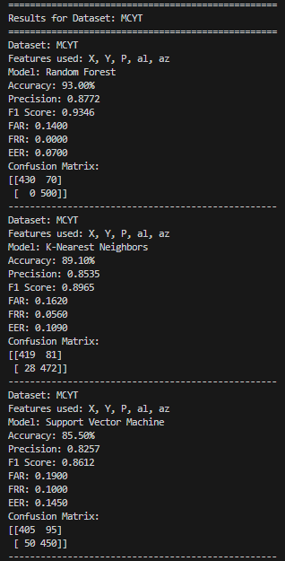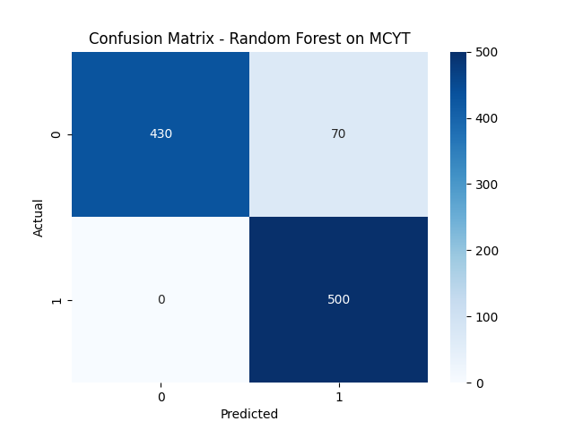
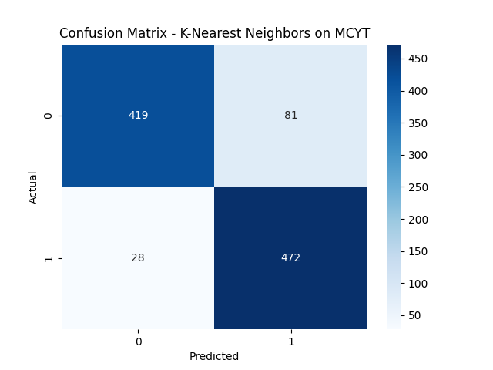
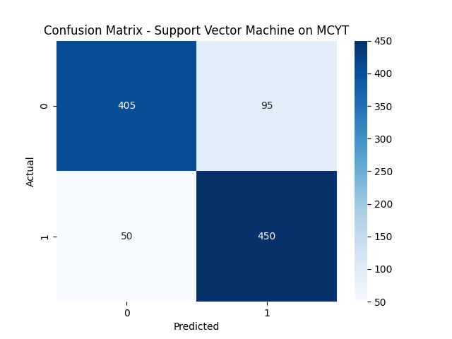
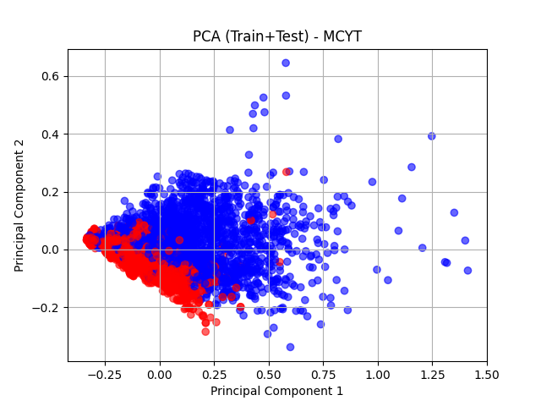

5.2 SVC Dataset
Model | Accuracy | Precision | F1 Score | FAR | FRR | EER
Random Forest | 80.00% | 0.8038 | 0.7987 | 0.1938 | 0.2062 | 0.2000
K-Nearest Neighbors | 77.19% | 0.7574 | 0.7781 | 0.2562 | 0.2000 | 0.2281
Support Vector Machine | 76.56% | 0.7576 | 0.7692 | 0.2500 | 0.2188 | 0.2344
Highlight: Random Forest was again the top performer with balanced results, although all models struggled to lower both FAR and FRR simultaneously.

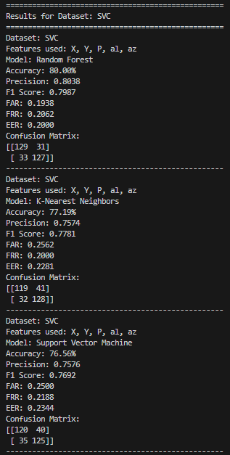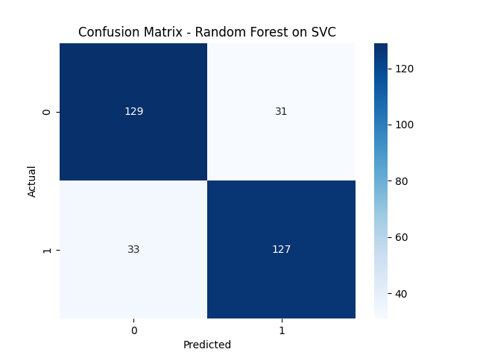
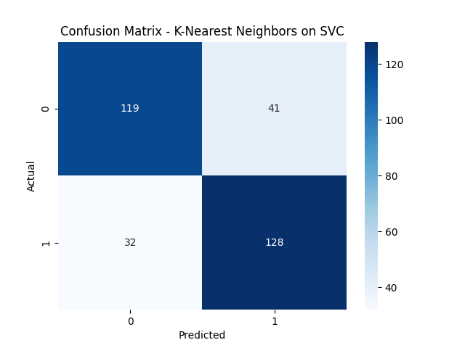
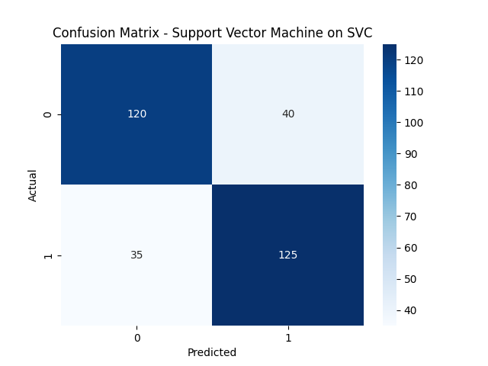
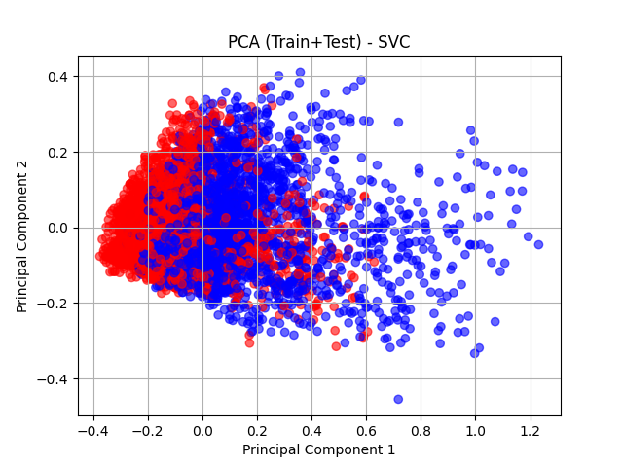
5.3 Chinese Dataset
Model | Accuracy | Precision | F1 Score | FAR | FRR | EER
Random Forest | 86.67% | 0.9041 | 0.7765 | 0.0372 | 0.3196 | 0.1784
K-Nearest Neighbors | 82.81% | 0.7857 | 0.7293 | 0.0957 | 0.3196 | 0.2077
Support Vector Machine | 85.61% | 0.9242 | 0.7485 | 0.0266 | 0.3711 | 0.1989
Highlight: Random Forest had the highest accuracy and well-balanced precision, though SVM achieved the best precision (0.9242) at the cost of high FRR.

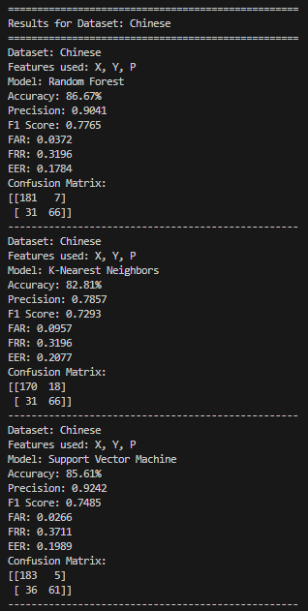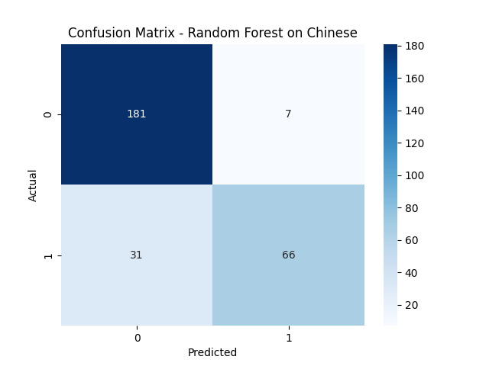
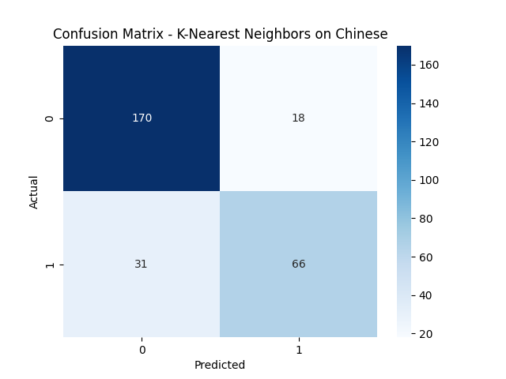
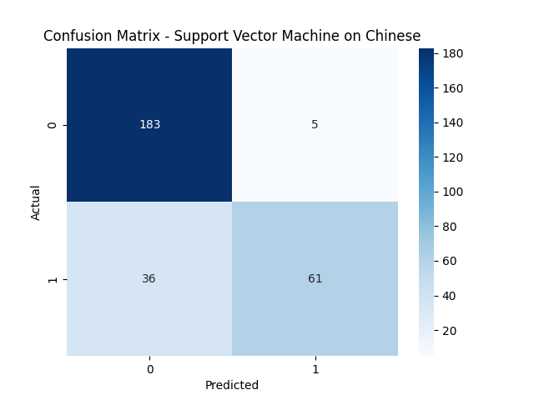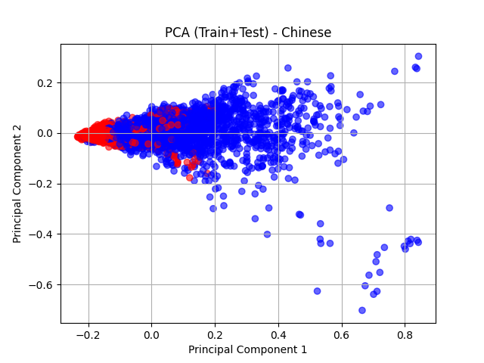
5.4 Dutch Dataset
Model | Accuracy | Precision | F1 Score | FAR | FRR | EER
Random Forest | 85.86% | 0.8507 | 0.8948 | 0.2912 | 0.0563 | 0.1737
K-Nearest Neighbors | 83.67% | 0.8400 | 0.8776 | 0.3077 | 0.0813 | 0.1945
Support Vector Machine | 85.26% | 0.8379 | 0.8918 | 0.3242 | 0.0469 | 0.1855
Highlight: Random Forest and SVM were closely matched, but Random Forest had better F1 and overall balance.
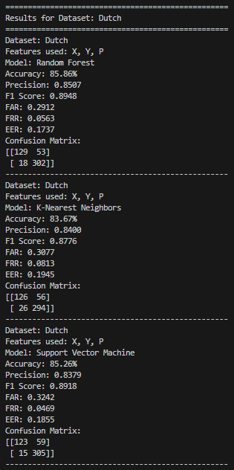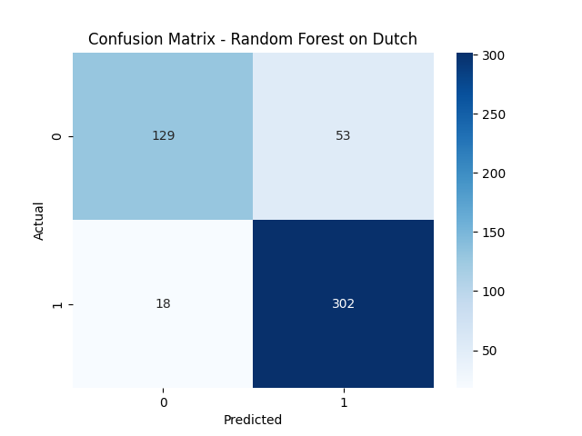
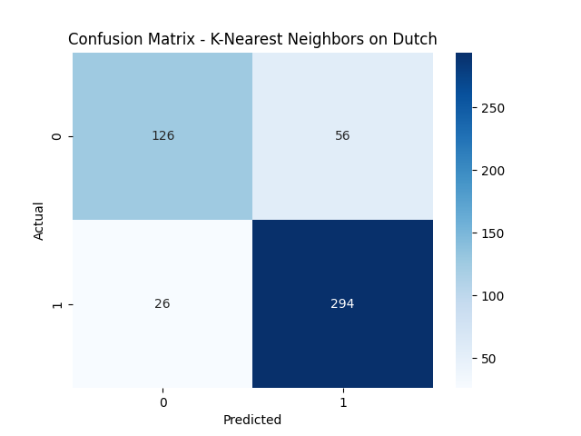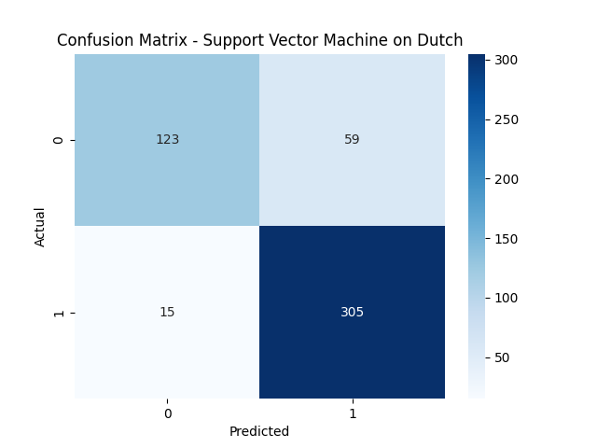
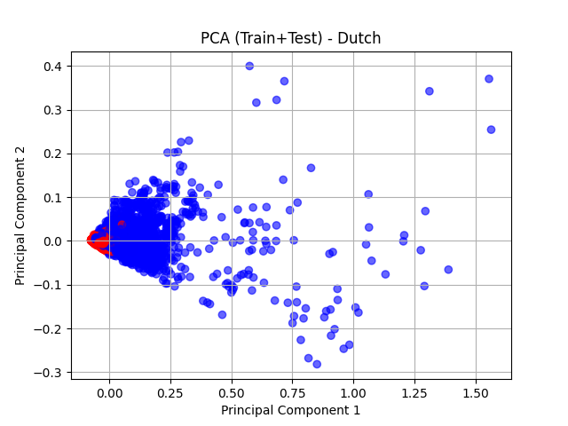

5.5 German Dataset
Model | Accuracy | Precision | F1 Score | FAR | FRR | EER
Random Forest | 76.16% | 0.7523 | 0.8200 | 0.4500 | 0.0989 | 0.2745
K-Nearest Neighbors | 72.85% | 0.7404 | 0.7897 | 0.4500 | 0.1538 | 0.3019
Support Vector Machine | 72.85% | 0.7193 | 0.8000 | 0.5333 | 0.0989 | 0.3161
Highlight: Overall accuracy and precision were lower for this dataset. Random Forest again came out on top, but high FAR across all models suggests room for feature engineering or data augmentation.

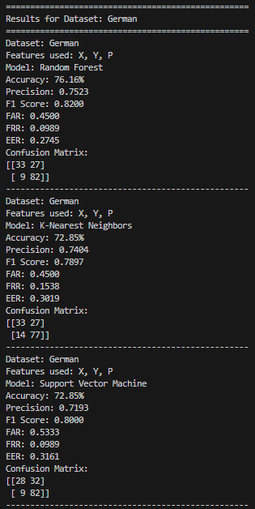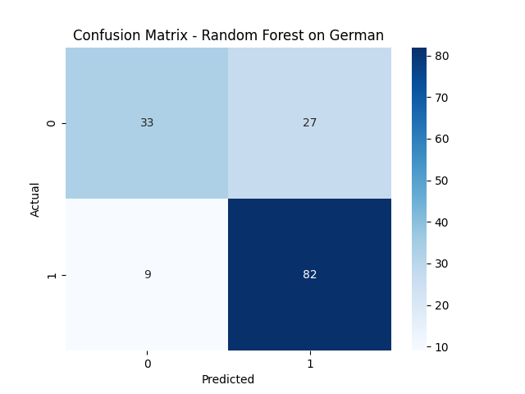
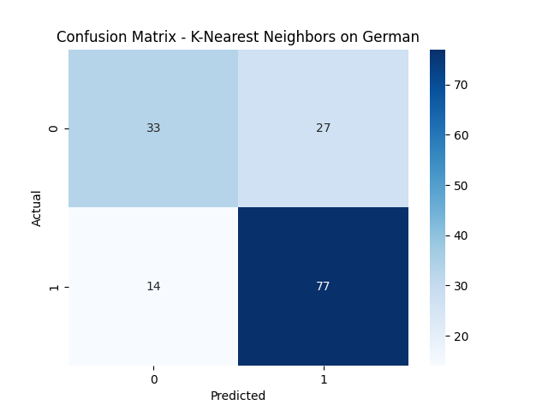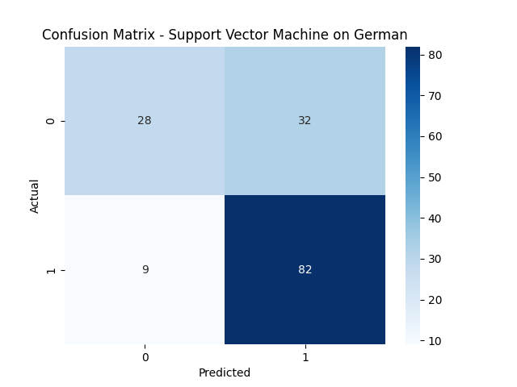
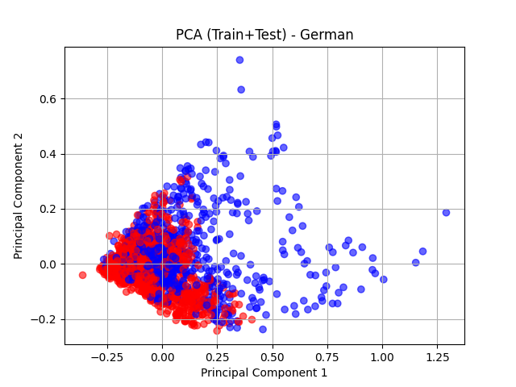
5.6 Trends & Observations
- Top Performer: Random Forest consistently outperformed KNN and SVM across most datasets, showing better accuracy and a balanced FAR/FRR.
- Model Characteristics:
  - SVM often achieved higher precision but had higher FRR, rejecting genuine samples more frequently.
  - KNN offered consistent results but suffered from a higher FAR.
- Dataset Difficulty:
  - MCYT was the most accurate and predictable.
  - German was the most challenging, with the lowest accuracy and highest error rates.
- Feature Influence:
  - Datasets like MCYT and SVC included additional features (al, az) which likely improved model discrimination.
5.7 Visual Analysis
Each model-dataset result included:
- Confusion Matrix Heatmaps – to visually assess prediction errors and correct classifications.
- PCA Scatter Plots – to show how well genuine and forged signatures were separated in reduced-dimensional space after scaling.

6. Conclusion and Future Work
This project successfully explored the use of machine learning algorithms for the task of online signature verification, a critical biometric authentication challenge. By evaluating three widely used classifiers—Random Forest, K-Nearest Neighbors (KNN), and Support Vector Machine (SVM)—across five distinct datasets (MCYT, SVC, Chinese, Dutch, German), I developed a robust pipeline that included data preprocessing, feature normalization, model training, performance evaluation, and visual analysis using PCA and confusion matrix heatmaps.
The models were assessed using multiple metrics: Accuracy, Precision, F1 Score, FAR (False Acceptance Rate), FRR (False Rejection Rate), and EER (Equal Error Rate). Among the models tested, Random Forest consistently outperformed others across most datasets. It delivered the highest accuracy on the MCYT dataset (93%) and achieved a perfect FRR of 0.0000, meaning no genuine signature was misclassified as forged. This superior performance can be attributed to its ensemble structure, which reduces overfitting and better captures feature interactions.
KNN and SVM showed reliable performance as well, with SVM achieving the highest precision in certain datasets, indicating its effectiveness in minimizing false positives. However, both struggled with balancing FAR and FRR, especially on more challenging datasets like German and SVC.

Future Work
To enhance this system further:
- Time-Series Feature Engineering – Incorporate features like velocity or acceleration and use DTW to better capture writing dynamics.
- Real-Time Verification – Adapt the system for live signature input to enable deployment in real-world authentication.
- Deep Learning Models – Explore CNNs or RNNs to automatically learn complex temporal patterns in signature data.
This work lays the groundwork for more advanced, scalable, and accurate signature verification systems in digital environments.

