**Report**

|  |  |
| --- | --- |
| Date | 27 june 2025 |
| Team ID |  |
| Project Name | Predicting Plant Growth Stages with Environmental and Management Data Using Power BI |
| Maximum Marks | 5 Marks |

**PLANT GROWTH MILESTONE : FACTORS AND INSIGHT**

**✅ Summary:**

This dashboard visualizes how temperature, humidity, fertilizer, and soil type impact plant growth milestones. It emphasizes the importance of organic fertilizers, optimal temperature ranges, and frequent watering—especially in clay and loam soils—for better plant development.

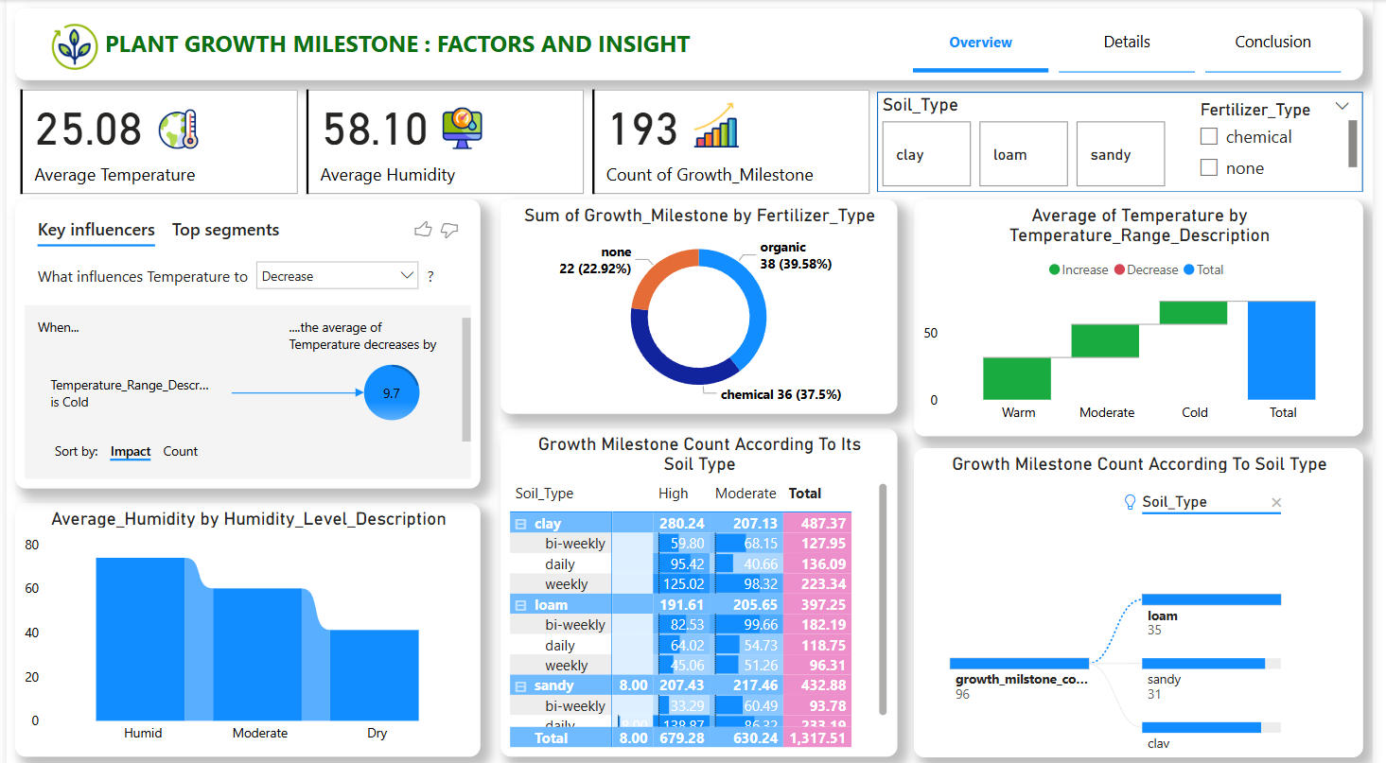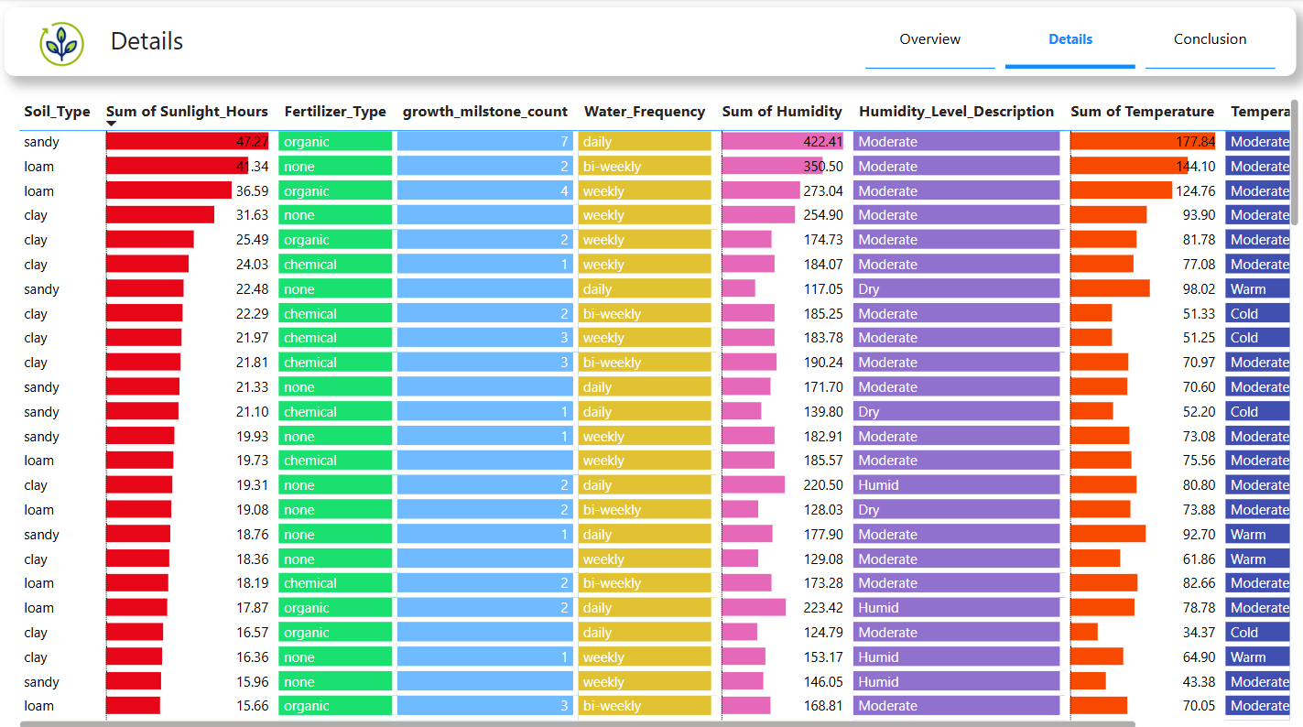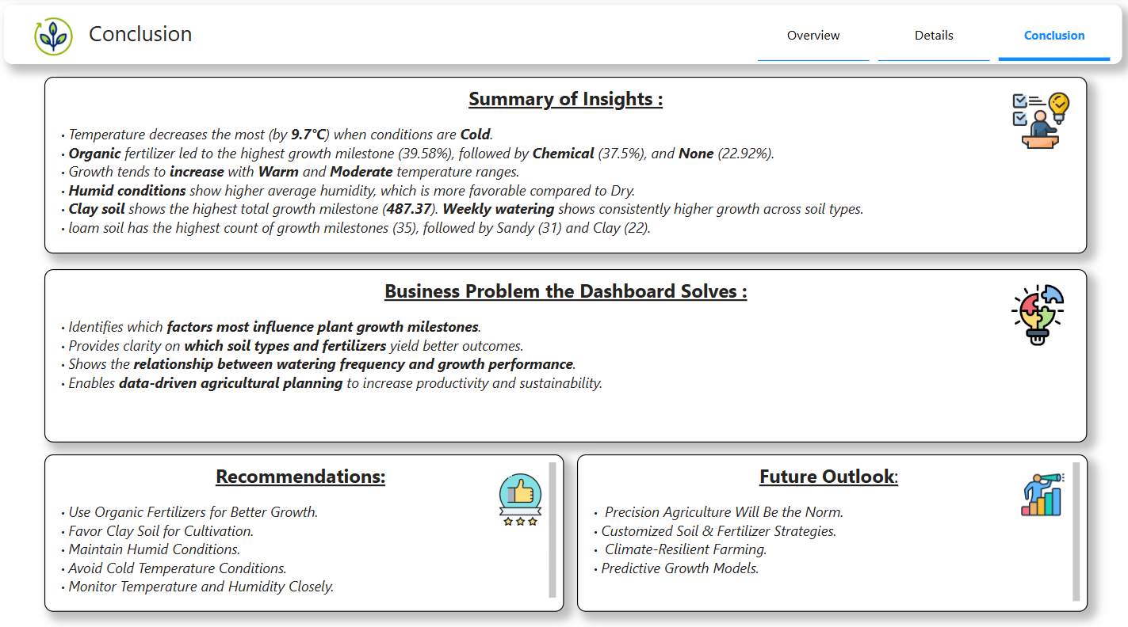

📊 **Key Metrics (Top Section):**

* Average Temperature: 25.08°C
* Average Humidity: 58.10%
* Count of Growth Milestones: 193 recorded instances

**🔍 Key Insights:**

1. Temperature Influencers (Top Left):

When the temperature is categorized as 'Cold', the average temperature drops by 9.7°C—highlighting a strong influence.

2. Fertilizer Effect (Center):

Organic fertilizer accounts for the most growth milestones (39.58%), followed by chemical (37.5%), and none (22.92%).

3. Humidity Trends (Bottom Left):

Humidity level impacts:

Highest average humidity under "Humid"

Moderate in "Moderate"

Lowest in "Dry"

4. Temperature by Range (Top Right):

Temperature is increasing from cold to warm zones.

Warm has the highest positive temperature impact.

5. Soil Type & Growth Milestones (Bottom Middle and Right):

Clay soil has the highest total growth milestone count (487.37), followed by loam and sandy.

Weekly watering supports higher growth across most soil types.

6. Bar Chart (Bottom Right):

Loam shows 35 growth counts, sandy 31, and clay 32 — possibly from a filtered or sliced view.