An Internship Report
Of

Secure Hybrid Data center Network Architecture & Multi-Tier Cloud Segmentation

Submitted
To

School of Computer Science and Engineering
IILM University, Greater Noida, U.P.

In partial fulfilment of the requirement of degree of
B.Tech Computer Science and Engineering (Specialization: Cyber Security)

By

Roll Number of Student: 2410030901
Name of Student: RAJ CHITTORIYA
Batch: 2026-27

AICTE–EduSkills Virtual Internship Program 2026
Domain: Ethical Hacking | Duration: March 2026 – June 2026

CANDIDATE'S DECLARATION
I, Raj Chittoriya, Roll Number 2410030901, Section 3CSE15, student of B.Tech Computer Science and Engineering (Specialization: Cyber Security) at IILM University, Greater Noida, do hereby declare that the internship report titled “Secure Hybrid Data center Network Architecture & Multi-Tier Cloud Segmentation” has been completed by me under the AICTE – EduSkills Virtual Internship Program 2026 (Domain: Ethical Hacking), to fulfil the requirement for the award of the degree of Bachelor of Technology in Computer Science and Engineering. All references used in the preparation of this report have been duly acknowledged and I have not used, as such, any material from any other source without proper citation.
I further affirm that this report is my own original work carried out during the period March 2026 to June 2026 and has not been submitted, in part or in full, to any other institute for the award of any other degree or diploma. I shall be solely responsible for any kind of copyright violation in this regard.

Signature: ____________________
Student Name: Raj Chittoriya
Roll No.: 2410030901
Date: ____________________

ACKNOWLEDGEMENT
I am using this opportunity to express my gratitude to everyone who supported me throughout the AICTE–EduSkills Virtual Internship Program 2026 in the domain of Ethical Hacking. I am thankful for their aspiring guidance, invaluable constructive criticism and friendly advice extended to me during the course of this internship and while preparing this report.
I sincerely thank AICTE and the EduSkills Foundation for providing this opportunity, and Mr. Abhinav Raghav, Instructor, Cisco Networking Academy, IILM University, for his continuous guidance and mentorship throughout the internship. I am also grateful to the School of Computer Science and Engineering, IILM University, Greater Noida, for the resources, encouragement and academic support extended to me.
I express my sincere gratitude to my parents for their constant blessings and support.

Signature: ____________________
Student Name: Raj Chittoriya
Roll No.: 2410030901

INTERNSHIP COMPLETION CERTIFICATE
The following certificates were awarded to the student upon successful completion of the associated courses under the AICTE–EduSkills Virtual Internship Program 2026, delivered in partnership with Cisco Networking Academy. Scanned copies of the original certificates are attached immediately after this page as documentary proof of completion.
Certificate Title | Issuer / Provider | Completion Date | Certificate ID
Cybersecurity Essentials | Cisco Networking Academy, IILM University | 20 June 2026 | cb63b578-677e-48ec-8a42-fb5e7c87b7c9
Getting Started with Cisco Packet Tracer | Cisco Networking Academy, IILM University | 16 June 2026 | 2dbfb49c-4cdb-4563-92f0-272a202b0839
Exploring Networking with Cisco Packet Tracer | Cisco Networking Academy, IILM University | 16 June 2026 | 6818ce3e-d501-4163-b212-915bd83d4789

Instructor: Mr. Abhinav Raghav, Instructor, Cisco Networking Academy, IILM University.
Course Timeline: 15 May 2026 to 19 June 2026.

TABLE OF CONTENTS
Chapter No. | Chapter Name | Page No.
 | Cover Page | —
1. | Candidate's Declaration | i
2. | Acknowledgement | ii
3. | Internship Completion Certificate | iii
4. | Project Description | 1
 | 4.1 Introduction | 1
 | 4.2 Organization Profile
 | 4.3 Problem Statement
 | 4.4 Project Objectives
 | 4.5 Scope of the Project
 | 4.6 Technologies and Tools Used
 | 4.7 System Architecture
 | 4.7.1 High-Level Architecture
 | 4.7.2 VPC Design and IP Addressing Plan
 | 4.7.3 Hybrid Connectivity
 | 4.7.4 IAM Architecture
 | 4.7.5 Kubernetes Security Architecture
 | 4.7.6 Zero Trust Security Model
 | 4.7.7 STRIDE Threat Model
 | 4.7.8 Critical Attack Scenario and Mitigation
 | 4.8 Methodology
 | 4.8.1 Internship Learning Flow
 | 4.8.2 Automated Security Verification Engine
 | 4.8.3 Security Test Cases and Results
 | 4.8.4 Implementation vs Simulation
 | 4.9 Expected Outcomes
 | 4.10 Certificates of Completion and Other Proof
5. | Bibliography / References

4. PROJECT DESCRIPTION
4.1 Introduction
This report presents the work carried out by Raj Chittoriya, a student of B.Tech Computer Science and Engineering (Specialization: Cyber Security) at IILM University, Greater Noida, during the AICTE–EduSkills Virtual Internship Program 2026 in the domain of Ethical Hacking. The internship was undertaken over the period March 2026 to June 2026. The key academic and internship details of the student are summarised in Table 4.1 below.
Table 4.1: Basic / Academic Details
Field | Confirmed Detail
Name | Raj Chittoriya
Roll Number | 2410030901
Section | 3CSE15
Degree | B.Tech Computer Science and Engineering
Specialization | Cyber Security
University | IILM University, Greater Noida
AICTE Student ID | STU68779351287a11752666961
Internship Domain | Ethical Hacking
Program | AICTE–EduSkills Virtual Internship Program 2026
Duration | March 2026 – June 2026

The internship curriculum covered the following major focus areas:
- Ethical Hacking
- Security Fundamentals
- Social Engineering
- Malware
- Network Essentials
- Kali Linux
- Basic Web Application Vulnerability Assessment
- Basic Web Application Penetration Testing
- Capstone Project
- Assessment
4.2 Organization Profile
The internship was conducted under the AICTE–EduSkills Virtual Internship Program 2026, a collaborative initiative of the All India Council for Technical Education (AICTE) and the EduSkills Foundation, aimed at providing structured, industry-aligned virtual internship opportunities to engineering students across India. The Ethical Hacking track of the program was delivered in partnership with Cisco Networking Academy, under the mentorship of Mr. Abhinav Raghav, Instructor, Cisco Networking Academy, IILM University.
The internship was hosted and academically supervised by the School of Computer Science and Engineering, IILM University, Greater Noida, Uttar Pradesh, which provided the institutional framework, evaluation and certification support for the program.
4.3 Problem Statement
Modern organizations increasingly operate hybrid infrastructures, where some applications and services run in a private, on-premises datacenter while others are hosted on public cloud platforms. This hybrid model introduces several security challenges that formed the basis of the capstone project undertaken during this internship:
- Secure connectivity must be established and maintained between the public cloud and the private datacenter.
- Student, faculty and research workloads need to be logically and securely isolated from one another.
- Databases must be protected from direct public exposure over the internet.
- A compromised application or workload must not be able to move laterally across the infrastructure.
- Identity and access privileges must be tightly restricted to what is strictly necessary.
- Kubernetes workloads require isolation at the namespace and network level.
- Security-relevant events across the environment must be continuously monitored and logged.
4.4 Project Objectives
The overall objectives of the internship and the associated capstone project were as follows:
- To understand the core concepts of ethical hacking.
- To develop a strong foundation in cybersecurity fundamentals.
- To understand Vulnerability Assessment and Penetration Testing (VAPT).
- To learn networking principles and secure network architecture design.
- To understand Kali Linux in the context of security testing.
- To apply the principles of Zero Trust security architecture.
- To understand AWS VPC, Security Groups, NACLs and Transit Gateway concepts.
- To apply IAM least privilege, Multi-Factor Authentication (MFA) and STS (Security Token Service) credentials.
- To understand Kubernetes security, RBAC and NetworkPolicies.
- To perform threat modelling using the STRIDE methodology.
- To develop an automated engine for security-policy verification.
4.5 Scope of the Project
The capstone project, titled “Secure Hybrid Datacenter Network Architecture & Multi-Tier Cloud Segmentation”, models an enterprise/college-style hybrid environment in which resources are distributed across a private datacenter, the AWS public cloud, distinct user and workload environments, and Kubernetes-orchestrated workloads.
The central objective of the project is to ensure that a compromised user, workload or application cannot automatically gain the ability to move across the entire infrastructure. To achieve this, the architecture combines network segmentation, Zero Trust principles, least-privilege access control, encryption, continuous monitoring and automated security validation.
4.6 Technologies and Tools Used
- Amazon Web Services (AWS): VPC, Security Groups, NACLs, Transit Gateway, IAM, WAF, CloudTrail, VPC Flow Logs
- Kubernetes: Namespaces, RBAC, NetworkPolicies, Pod Security Context
- Cisco ASA (modelled): stateful firewall at the datacenter edge
- IPsec Site-to-Site VPN: IKEv2, AES-256-GCM, SHA-384, Diffie-Hellman Group 20
- TLS 1.3: encryption in transit for public-facing traffic
- Kali Linux: security testing and penetration-testing environment
- Python 3.10: automated security-policy verification engine
- STRIDE Methodology: structured threat modelling framework
4.7 System Architecture
The project's core deliverable is a capstone architecture titled “Secure Hybrid Datacenter Network Architecture & Multi-Tier Cloud Segmentation”, built around the themes of Zero Trust Architecture, AWS multi-VPC isolation, IAM least privilege, Kubernetes micro-segmentation and threat mitigation.
4.7.1 High-Level Architecture
Figure 4.1 illustrates the high-level architecture connecting the public internet, the segmented AWS VPCs, and the private datacenter.
PUBLIC INTERNET
|
AWS WAF
|
TLS 1.3
|
+--------------+--------------+
| | |
Student VPC Teaching VPC Research VPC
10.100.0.0/16 10.101.0.0/16 10.102.0.0/16
| | |
+--------------+--------------+
|
AWS Transit Gateway
|
Dual IPsec VPN
|
Datacenter Firewall
|
Private Datacenter
172.16.0.0/16
Figure 4.1: High-Level Hybrid Architecture
A dedicated Security and Monitoring Hub (CIDR 10.103.0.0/16) hosts the SIEM / centralized logging platform and an MFA-gated bastion host used for controlled administrative access.
4.7.2 VPC Design and IP Addressing Plan
Table 4.2: VPC / Network Address Plan
Network | CIDR Block | Subnets / Components
Student VPC | 10.100.0.0/16 | Public ALB 10.100.1.0/24; Application Pods 10.100.10.0/24; Database 10.100.20.0/24
Teaching VPC | 10.101.0.0/16 | Public ALB 10.101.1.0/24; Application Pods 10.101.10.0/24; Database 10.101.20.0/24
Research VPC | 10.102.0.0/16 | HPC Compute 10.102.10.0/24; Data Vault 10.102.20.0/24 (intentionally isolated)
Security Hub | 10.103.0.0/16 | SIEM / centralized logging; MFA-gated bastion host
Private Datacenter | 172.16.0.0/16 | LDAP / Active Directory 172.16.10.10; Enterprise Core DB / ERP 172.16.20.50
4.7.3 Hybrid Connectivity
Connectivity between the AWS VPCs and the private datacenter is established through an AWS Transit Gateway paired with a dual IPsec Site-to-Site VPN configuration. The VPN tunnels use IKEv2 for key exchange, AES-256-GCM for encryption, SHA-384 for integrity, and Diffie-Hellman Group 20 for key strength. A Cisco ASA stateful firewall is modelled at the datacenter edge to enforce perimeter security policy.
Two important access restrictions are enforced within this connectivity model:
- Direct access from the Student VPC to the private datacenter is blocked.
- Access from the Teaching application to LDAP is restricted to LDAPS on TCP port 636 only.
At the edge, AWS WAF, TLS 1.3 and rate limiting provide controlled ingress from the public internet, while non-overlapping VPC CIDRs, isolated subnets, Security Groups, NACLs and Transit Gateway route controls enforce internal network segmentation. Databases are never exposed directly to the internet; traffic must always flow Internet → ALB → Application → Database, with direct Internet-to-Database and Web-to-Database access explicitly denied. Only the authorized backend application tier is granted database access.
4.7.4 IAM Architecture
Table 4.3: IAM Roles and Controls
Role | Purpose | Key Controls
Role-StudentWorkload | Access to student assets | Read-only access; administrative actions explicitly denied
Role-Faculty | Access to course content | Hardware MFA required for deletion actions
Role-SecOps-Auditor | Security telemetry review | Read-only access to CloudTrail and VPC Flow Logs; log deletion forbidden
The overall IAM architecture is governed by the principle of least privilege, enforced through Multi-Factor Authentication (MFA), the SecureTransport condition, temporary STS credentials, and explicit Deny statements.
4.7.5 Kubernetes Security Architecture
The Kubernetes environment is organized into four logically isolated namespaces:
- student-workloads
- teaching-workloads
- research-workloads
- security-monitoring
The following controls are enforced across the Kubernetes environment:
- Namespace isolation and Role-Based Access Control (RBAC)
- Default-deny NetworkPolicy with explicit allow rules
- runAsNonRoot=true
- readOnlyRootFilesystem=true
- automountServiceAccountToken=false
A representative application traffic flow within the student-workloads namespace is: student-web → student-api → student-db. Any unauthorized cross-namespace traffic is explicitly denied by default.
4.7.6 Zero Trust Security Model
The central security philosophy underpinning the project is: “Never trust automatically; verify explicitly and enforce least privilege.” This is implemented across four layers:
- Network: default-deny routing and micro-segmentation.
- Compute: non-root execution, read-only filesystem, reduced Linux capabilities.
- Identity: least privilege, MFA, temporary STS credentials, continuous verification.
- Data: AES-256 encryption at rest, and TLS 1.3 / IPsec encryption in transit.
4.7.7 STRIDE Threat Model
The project's major threats were identified and mapped to corresponding security controls using the STRIDE threat-modelling methodology, as summarised in Table 4.4.
Table 4.4: STRIDE Threat – Control Mapping
Threat | Control
Credential Spoofing | MFA + Least Privilege
Rootkit Tampering | Non-root execution + Read-only Filesystem
Audit Repudiation | CloudTrail + VPC Flow Logs + SIEM
Information Disclosure | Private Database + Encryption
DDoS | WAF + Rate Limiting
IAM Privilege Escalation | Explicit Deny + Least Privilege
Lateral Movement | Segmentation + NetworkPolicy
Direct Database Exposure | Private Database + Security Groups/NACLs
4.7.8 Critical Attack Scenario and Mitigation
The most significant validation scenario considered in the project assumes that the student-api Kubernetes pod is compromised through an application vulnerability. Figure 4.2 illustrates the assumed attack path and the point at which each control interrupts it.
Application Vulnerability
↓
student-api compromised
↓
Attempt persistence
↓
Attempt Kubernetes API abuse
↓
Attempt lateral movement
↓
Attempt Research Vault / Teaching DB access
↓
Attempt Datacenter DB access
↓
Attempt IAM privilege escalation
Figure 4.2: Critical Attack Scenario – Assumed Attack Path
The following controls act at each stage of the assumed attack path:
- Read-only filesystem – restricts straightforward malware persistence or file-drop attempts.
- Disabled service-account token – reduces the risk of Kubernetes API abuse.
- NetworkPolicy + Transit Gateway routing – blocks unauthorized lateral movement toward the Research Vault and Teaching Database.
- Datacenter firewall Rule #104 – blocks access to the Enterprise Core DB / ERP host (172.16.20.50).
- IAM Explicit Deny – blocks Security Group modification and privilege-escalation attempts.
The expected result of this scenario is that the blast radius remains contained within the boundary of the compromised student container. It is important to note that this represents a defined security simulation and validation exercise, and not a live production attack.
4.8 Methodology
4.8.1 Internship Learning Flow
The internship followed a structured progression, moving from foundational concepts to the capstone project and final assessment: Ethical Hacking → Security Fundamentals → Social Engineering → Malware → Network Essentials → Kali Linux → Vulnerability Assessment → Penetration Testing → VAPT → Capstone Project → Assessment. This progression ensured that the theoretical and practical knowledge gained at each stage directly informed the design and implementation of the capstone architecture.
4.8.2 Automated Security Verification Engine
To validate the defined security policies without relying solely on manual inspection, a Python 3.10-based automated security verification engine was developed. The engine is executed using the following command:
python tests/run_all_security_tests.py
Its purpose is to automatically validate predefined security policies — such as expected ALLOW/DENY outcomes for specific traffic flows — in place of manual, case-by-case inspection.
4.8.3 Security Test Cases and Results
The verification engine executes ten security test cases covering network, database, Kubernetes and IAM boundaries, summarised in Table 4.5.
Table 4.5: Security Test Cases and Expected Results
# | Test | Expected
1 | Internet → Public HTTPS ALB, Port 443 | ALLOW
2 | Internet → Private Database, 5432/3306 | DENY
3 | Frontend / Web → Backend API | ALLOW
4 | Frontend / Web → Private DB Direct | DENY
5 | Backend API → Database | ALLOW
6 | Student VPC → Research VPC | DENY
7 | Student VPC → Datacenter Core Identity / ERP | DENY
8 | Unauthorized Cross-Namespace Kubernetes Traffic | DENY
9 | Authorized Intra-Namespace Microservice Traffic | ALLOW
10 | Unauthorized IAM / Admin Escalation | DENY
All ten test cases passed (10/10), representing 100% compliance with the defined security test matrix. It should be noted precisely that the defined declarative security model was successfully validated using the automated verification engine; this does not represent a live AWS production environment that was penetration-tested, as the underlying infrastructure was modelled and not physically deployed.
4.8.4 Implementation vs Simulation
This distinction is important to the accurate representation of the project's scope and is summarised below.
Table 4.6: Locally Implemented / Modelled vs Simulated / Conceptual
Locally Implemented / Modelled | Simulated / Conceptual
Declarative AWS VPC configurations; Security Group definitions; IAM policy definitions; Kubernetes namespaces, RBAC, NetworkPolicies and workload manifests; Datacenter firewall definitions; Identity specifications; Interactive and automated Python security verification engines; Evidence/audit logs | Physical Cisco hardware; Live AWS VPC; Live AWS Transit Gateway; Live EKS cluster; Physical enterprise datacenter
Accordingly, the terms “designed”, “modelled”, “simulated” and “validated” are used throughout this report to accurately describe the work, rather than claiming a live production deployment.
4.9 Expected Outcomes
The internship and capstone project were expected to, and did, produce a validated reference architecture demonstrating that a compromised workload can be contained within its own boundary, together with a reusable automated verification engine and a set of transferable cybersecurity skills, summarised below.
Learning Outcomes
Cybersecurity, ethical hacking, security fundamentals and VAPT; threat modelling; networking concepts including CIDR planning, VPC design, segmentation and routing; cloud security concepts including Security Groups, NACLs, Transit Gateway, VPN, IAM, MFA, STS, WAF, CloudTrail and VPC Flow Logs; Kubernetes concepts including namespace isolation, RBAC, NetworkPolicy and container hardening; security architecture principles including Zero Trust, least privilege, defense in depth and lateral-movement prevention; and automation, including Python-based security verification and automated ALLOW/DENY validation.
Individual Contribution
The student undertook the role of Project Lead and Individual Developer, with the following responsibilities:
- Hybrid datacenter and AWS architecture design
- VPC segmentation and CIDR planning
- Security Group / NACL policy modelling
- IAM least-privilege and MFA condition design
- Kubernetes namespaces, RBAC and NetworkPolicies
- IPsec VPN / Transit Gateway modelling
- STRIDE threat modelling
- Development of the Python verification engine and its ten security tests
- Traffic validation and evidence log generation
- Preparation of the README, technical documentation, internship report and presentation
- Organization of certificate evidence and final consistency verification
Future Scope
- Integration of Trivy and Checkov for CI/CD security scanning.
- Integration of Cilium and Falco for runtime monitoring.
- Adoption of AWS Direct Connect with MACsec encryption for dedicated connectivity.
- Continuous, automated security regression testing.

4.10 Certificates of Completion and Other Communication / Proof
Three certificates issued by Cisco Networking Academy, IILM University, were earned during the course of this internship, under the mentorship of Mr. Abhinav Raghav, Instructor. Their details are provided in Table 4.7; scanned copies of the original certificates are attached as documentary proof following this section.
Table 4.7: Certificates Earned
Certificate Title | Completion Date | Certificate ID
Cybersecurity Essentials | 20 June 2026 | cb63b578-677e-48ec-8a42-fb5e7c87b7c9
Getting Started with Cisco Packet Tracer | 16 June 2026 | 2dbfb49c-4cdb-4563-92f0-272a202b0839
Exploring Networking with Cisco Packet Tracer | 16 June 2026 | 6818ce3e-d501-4163-b212-915bd83d4789
Course Timeline: 15 May 2026 – 19 June 2026. All certificates were issued in the name of Raj Chittoriya.
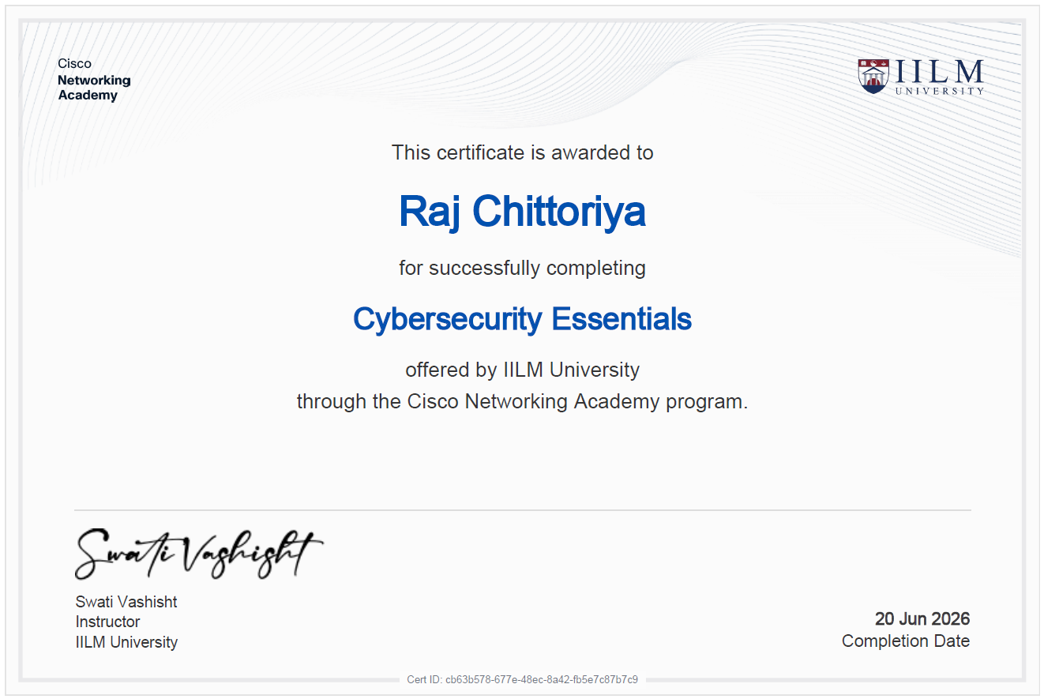

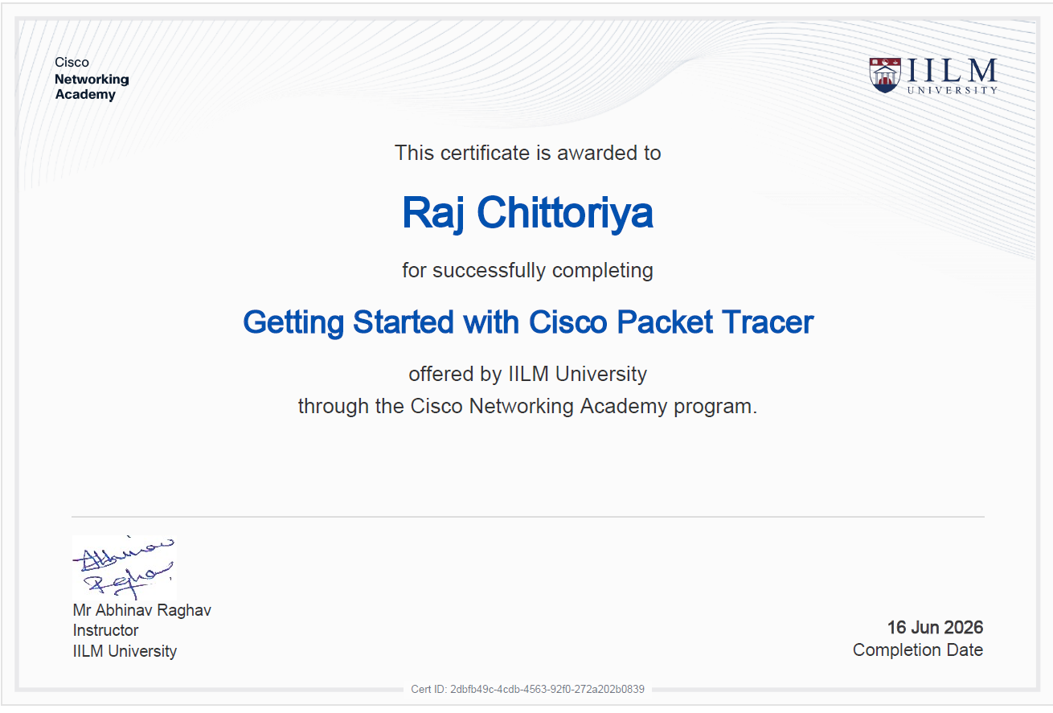

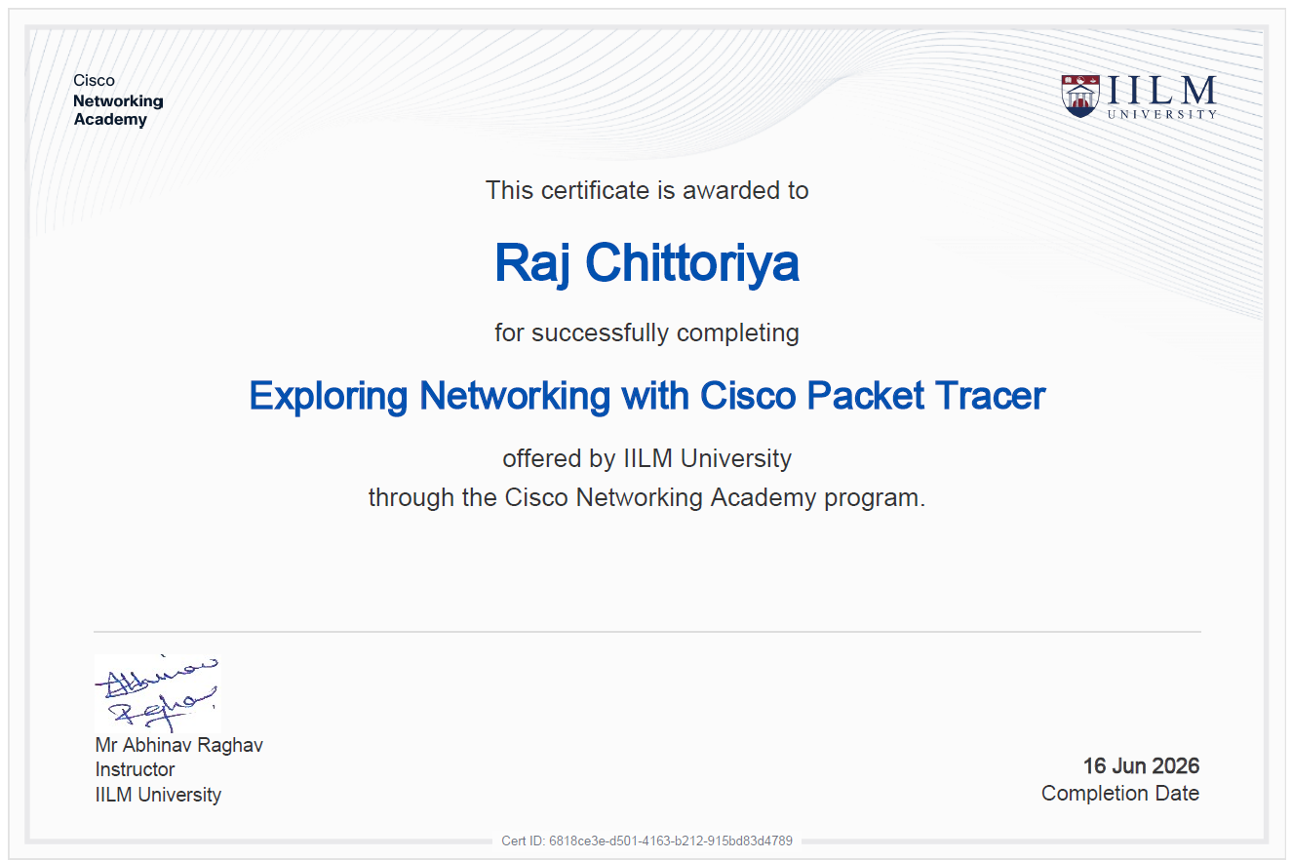

5. BIBLIOGRAPHY / REFERENCES
AICTE–EduSkills Virtual Internship Program, official program portal, 2026.
Cisco Networking Academy, “Cybersecurity Essentials” course materials, IILM University, 2026.
Cisco Networking Academy, “Getting Started with Cisco Packet Tracer” course materials, IILM University, 2026.
Cisco Networking Academy, “Exploring Networking with Cisco Packet Tracer” course materials, IILM University, 2026.
Amazon Web Services, AWS Documentation – VPC, IAM, Transit Gateway and WAF, aws.amazon.com/documentation.
Kubernetes Documentation – RBAC and NetworkPolicy, kubernetes.io/docs.
OWASP Foundation, Web Application Vulnerability Assessment and Penetration Testing references, owasp.org.
Microsoft, STRIDE Threat Modelling Methodology reference documentation.
Python Software Foundation, Python 3.10 Documentation, docs.python.org.
Kali Linux Documentation, kali.org/docs.

