- What qualities should a good Agile tester have?
ANSWER:
- In an Agile team, testers have to collaborate with all other team members and with business stakeholders.
- Agile testers should have skills from traditional testing methods as well as testing skills.
- Otherthan the testing skills, a tester in an Agile team should be very knowledgable:
    - in test automation
    - test-driven development
    - acceptance test-driven development
    - white-box, black-box, and experience-based testing.
Testers in Agile teams should have following qualities:
- Be optimistic and solution-oriented with team members and stakeholders
- Possess critical, quality-oriented, sceptical thinking about the product
- Must also seak information from stakeholders (rather than relying entirely on written specifications)
- Accurately evaluate and report test results, test progress, and product quality
- Work effectively tand need to define testable user stories.
- Collaborate within the team, working in pairs with programmers and other team members
- Respond to change quickly, including changing, adding, or improving test cases
- Plan and organize their own work

A tester in an Agile team have a duty to generate and provide feedback on:
- test status
- test progress
- product quality
- process quality.

- What is Test Driven Development (TDD) and how much does it help add business value?
ANSWER:
- Test-driven development (TDD): It is a method of software development in which unit testing is repeatedly done on source code.
- Here the concept is that : "get something working now and perfect it later."
- After each test, refactoring is done and then the same or a similar test is performed again.
- The process is repeated several times as necessary till each unit is functional as per the required specifications.
- Test-driven development is part of a larger software design paradigms.
- TDD can produce applications of high quality in less time.
- The application of TDD guaratee that all the units in an application have been tested for optimum functionality
- Since tests are conducted from the very beginning of the design cycle, time and money spent in debugging at later stages is minimized.
- It thus adds a lot enhance the business value.
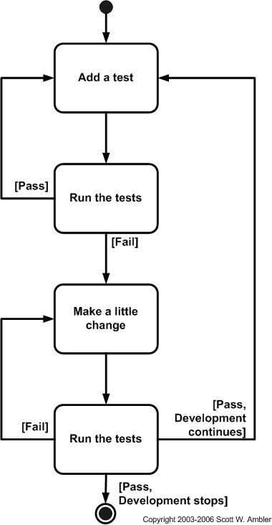
- The Biggest Benefits of Test-Driven Development is Defect Reduction.Functionality that doesn't function provides no business value. TDD allows us to start with high quality, thus providing real value.

Fig: TDD Life Cycle

- What is CI? What is the effect of CI in schedule?
ANSWER:
- Continous Integration involves:
    - Frequent code check-ins
    - Regularly scheduled, automated builds
    - Automated tests
    - Immediate feedback to developers detailing any build errors or failed tests
- Benefits of CI includes:
    - Developers know immediately upon check-in if their code works and if any other application features were broken as a result.
    - Since we are integrating so frequently, there is significantly less back-tracking to discover where things went wrong, so we can spend more time building features.
    - Spending less time debugging and more time adding features.
    - Reduce integration problems allowing you to deliver software more rapidly
    - Software defects can be traced to requirements through issue-tracking software.
    - A CI system can even include automated deployment, with deployment scripts tested every build to ensure no kinks arise when it is time to move code to other environments.
- What is configuration management?
ANSWER:
- Configuration management (CM) refers to a discipline for evaluating, coordinating, approving or disapproving, and implementing changes in artifacts that are used to construct and maintain software systems.
- An artifact may be a piece of hardware or software or documentation.

a) Name some sample tools available for version control?

- CVS :- CVS may very well be where version control systems started. Released initially in 1986, Google still hosts the original Usenet post that announced CVS.
- SVN :- SVN, or Subversion as it is sometimes called, is generally the version control system that has the widest adoption.
- GIT :- Git is considered to be a newer, and faster emerging star when it comes to version control systems. First developed by the creator of Linux kernel, Linus Torvalds.
- Bazaar :- Bazaar is distributed version control system, which also provides a great, friendly user experience. Bazaar is unique that it can be deployed either with a central code base or as a distributed code base.

b) How does version control help in agile projects?
- It is a repository to persist and track version of code and artifacts.
- In agile methodology, several teams work on the same modules of a single project.
- This may lead to code integration without proper communication among the teams. Version control can be used to avoid this problem.
- If in the midst of any project,we can go to an older version will be difficult.
- Version Control helps to go to an older version of a project.
- Describe Automated Testing vs Deployment Automation
ANSWER:
- Automated testing tools are capable of executing tests, reporting outcomes and comparing results with earlier test runs.
- Tests carried out with these tools can be run repeatedly, at any time of day.
- The method or process being used to implement automation is called a test automation framework.
- Automated testing includes:-
- Unit Testing
- Integration testing
- Acceptance testing

- Deployment Automation includes a set of tools to deploy the project automatically.
- It has a push button which deploys the capabilities of the project.
- It reduces the complexity and reduces the cost.

