- List down any 5 differences between Traditional and Modern project management methodologies.
ANSWER:
- A methodology is a model, which project managers employ for the design, planning, implementation and achievement of their project objectives.
- The methodologies used in projects management help to define the scope of the project, time constraints, what resources are available and when the project needs to be delivered.
- Project Management Methodology is a strictly defined combination of logically related practices, methods and processes that determine how best to plan, develop, control and deliver a project throughout the continuous implementation process until successful completion and termination.
- It is a scientifically-proven, systematic and disciplined approach to project design, execution and completion.
- Two types : Traditional & Modern
- Selecting a Project Management methodology can be one of the most difficult parts and can have real impact on the fate of the project.
- Normally the Project Managers' criterion for choosing a methodology for any project is mainly based on :
    - an expert’s opinion,
    - past working experience
    - government rules and regulations
    - organisation
    - senior management
    - stakeholder’s preferences and
    - client location.
- All of these can have positive or negative impact on the underdevelopment projects.
Traditional Project Management Methodologies
- Follows a series of consecutive steps in project management process. More importance is givento the steps and procedures.
- Only after completion and perfection of first phase the next will start
- Document oriented and Document driven.
- Very difficult implement the changes
- each stage should be carried out with atmost care so the chance of error in the following stages can be reduced.
- if an error occurs or the developed system is not exactly the one demanded by the client, then the entire process should be repeated.
- extensive planning is required and is often milestone based.
- example: waterfall model , V Model , iterative model, evolutionary model etc.
Modern Project Management Methodologies
- Doesn’t follows the linear approach in project management process.Give major importance to soft skills like team building and collaboration among team mates.
- There is different types of modern methodologies some even include weekly releases which helps in easily to rectify the problems.
- Works as a team and great communication among them.
- Models like agile doesn’t have great documentaions importance is moved away from the documentation.
- Very flexible to changes.
- here, the entire process is divided into different cycles and reviews are conducted at each stage.
- customer interaction or involvementat each review stage is necessary, which in turn benefits the project and results in customer satisfaction.
- any modifications can be carried out in between.
- example: agile,scrum,cpm,ccpm,lean,xp
- How to choose which Project Management Methodology that the project should adapt and why?
ANSWER:
- Selecting a Project Management methodology can be one of the most difficult parts and can have real impact on the fate of the project.
- Normally the Project Managers' criterion for choosing a methodology for any project is mainly based on
    - an expert’s opinion
    - past working experience
    - government rules and regulations
    - organisation
    - senior management
    - stakeholder’s preferences and
    - client location.
- All of these can have positive or negative impact on the underdevelopment projects.
Choosing a proper methodology based on several criterions is essential because:
- A formal project methodology should lead the work of all team members throughout the life cycle of a project.
- identifying and selecting the correct methodology
    - Avoid mistakes
    - Reduce cost
    - Reduce risk
    - Meet project schedules
- Decisions in which a methodology is chosen or used based on a single criteria can have serious negative impacts on the project especially if the project manager, development teams do not have the knowledge or the pros and cons of the selected methodology.
- No project management methodology is meant to be taken exact.
- It must be customised in the context in which it is being applied in order to increase the rate of adoption and the opportunity for success.

Requirements for Selecting a Methodology
- The essential decisions that a project manager must make when selecting a methodology are:
    - Budget:Budgets play a big role in any project, and the type of methodology to be used is important.
    - Team size: Methodologies are directly proportional to the team size. Use light methodologies for smaller teams and heavy methodologies for larger teams.
    - Technology used: The technology used on a project affects the direction and type of methodology selected. Unfamiliar technology slows progress.
    - Tools and techniques : Some project methodologies require more tools and techniques than others. For example, some projects need databases, visual modeling tools, and project management tools; while others require hardly anything.
    - Project criticality :Any critical project with a "must-deliver" target date needs to have the correct choice of methodology. The project might require additional resources to finish by the required date. If the methodology is too small, the project manager loses control; too large and formal, he or she slows the project down
    - Existing processes : In any company, the maturity and ease of use of existing project processes largely influence the methodology.

- When do you decide if the Project has to be done in Sprints and provide an example.
ANSWER:

- Scrum, the most popular agile framework in software development,
- It is an iterative approach that has at its core the sprint — the scrum term for iteration.
- Scrum teams use inspection throughout an agile project to ensure that the team meets the goals of each part of the process.
- The scrum approach includes assembling the project's requirements and using them to define the project.
- We then plan the necessary sprints, and divide each sprint into its own list of requirements.
- Daily scrum meetings help keep the project on target as do regular inspections and reviews.
- At the end of every sprint, we hold a sprint retrospective to look for ways to improve the next sprint.
- The process looks something like this:
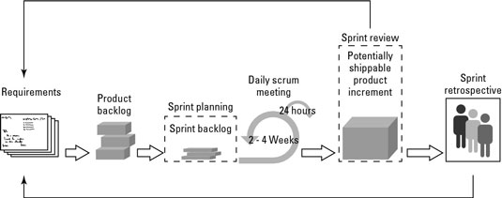
- Within each sprint, the development team builds and tests a functional part of the product until the product owner accepts it and the functionality becomes a potentially shippable product.
- When one sprint finishes, another sprint starts.
- Scrum teams deliver product features in increments at the end of each sprint.
- A product release occurs at the end of a sprint or after several sprints.
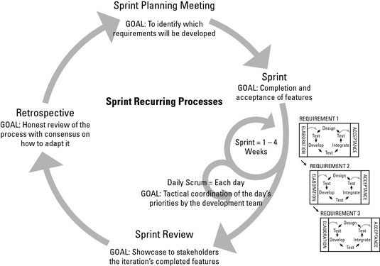
- A core principle of the sprint is its cyclical nature: The sprint, as well as the processes within it, repeats over and over, as shown:We use the tenets of inspection and adaptation on a daily basis as part of a scrum project:
- During a sprint, we conduct constant inspections to assess progress toward the sprint goal, and consequentially, toward the release goal.
- We hold a daily scrum meeting to organize the day by reviewing what the team completed yesterday and what it will work on today.
- Essentially, the scrum team inspects its progress toward the sprint goal.
- At the end of the sprint, we use a retrospective meeting to assess performance and plan necessary adaptations.
AN EXAMPLE:

Consider the case where a school management has decided to operate the day to day functions there with the help of a campus mangement portal.

As we know there are so many tasks like-
Student management
Admission management
Transfer management
Staff management
Fee collection
Transportation Management
Assignments Managements
Exam managements etc...

The school may demand the vendor company to submit the product before the start of a new acadamic year. Suppose the contaract has been signed by the the month of December.So the development team have about 3 months to complete the work.

Then the development can be carried out in phases with each important modules to be delivered first.
Then Student mangement ,Staff management Transfer management will be the modules to be deliverd first.
The rest of the modules are to be completed after the former ones.

