Q.1) What is a story point? How will you use story points to measure size of the following fruits (fruit points) given the planning poker value ½, 1, 2, 3, 5,8,13, 20, 40, 100, infinity.

<Apple,Mango,Banana,Jackfruit,Pineapple,Gooseberry,Avocado,Lime,Pomegranate,Watermelon>

ANSWER:

- A story point is a measure in agile project management and development that determine (or estimate) the difficulty of implementing a given user story.
- In simple terms its a number that tells the team how hard the story is. Hard could be related to complexity, Unknowns and effort.
- The way we do story point estimation gives better estimates than hourly estimates .
- It is more accurate and have less variation.

FRUIT | POINT
APPLE | 2
MANGO | 3
BANANA | 5
JACKFRUIT | 20
PINEAPPLE | 8
GOOSEBERRY | 1/2
LIME | 1
POMERGRANATE | 3
WATERMELON | 13

Q.2) What are the points discussed during the daily standup meeting? What happens if there is a problem a team member identifies during the standup meeting and how the same will be resolved?

ANSWER:

- The daily Scrum meeting or standup meeting is a short everyday meeting in which the participants are mainly the Dev team.
- Usually it is conducted during the start of the working day.
- Each team member who works towards the completion of a given sprint needs to participate.
- During this meeting, each team member should briefly provide the answers of the following three questions:
- What he/she has completed since the last daily Scrum meeting?
- What he/she will be going to complete till the next Scrum meeting?
- What are the impediments that prevent him/her from completing tasks?
- All team members should attend and they should stand during the meeting.
- The daily Scrum meeting should ideally not exceed 15 minutes.
- Issues or concerns raised during the meeting are allowed to be ignored due to the lack of time.
- Issues or concerns are to be recorded by the SM and needs to be handled later after the meeting.
- As the case problem a team member identified during the standup meeting will not be addressed then. SM can arrange another meating specific to the issue addressed later that include the typical member and other related guys.

Q.3) What is the relationship between Epic, User story and Feature? What are themes?

ANSWER:
- FEATURE
    - A feature is a distinct element of functionality which can provide capabilities to the business.
    - A Feature is the ‘What’ that a Stakeholder (the User or Customer) requires from the Product Owner.
    - A user story is a part of the feature.
    - By splitting a feature in smaller stories, the user can give early feedback to the developers to issues quickly.
    - A feature is a collection of stories.
- USER STORY
- A user story is simply something a user wants.
- User stories are more than just text written on an index card.
- These User Stories are very high level definition of the Stakeholder’s requirement by the Product Owner.
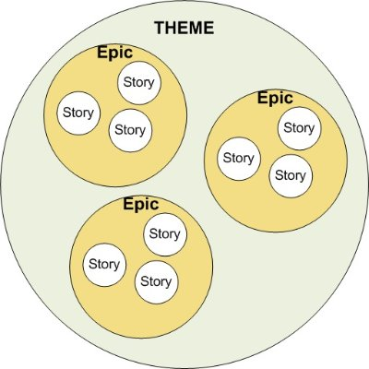
- Each User stories may be further divided into tasks.User stories typically follow a simple format:
“As a [type of user] I [want/can/am able to/need to/etc.] so that [some reason].”
- EPIC
    - An epic is a large user story.
    - They are made up of multiple stories.
    - It include a high level description of the system..
- THEMES
  - Theme is a collection of user stories.
  - These user stories share a common attribute.

Q.4) Provide an example of Feature and user stories for the below .
Epic: Allow the customers to manage their own accounts in the web portal

ANSWER:
Feature
- login feature to get into dashboard
- mailing feature

User stories:
- As a salesperson, I'd like to set my password, so I can log into the system.
- As an administrator, I'd like to send an emails to a salesperson so that i can help them in solving th their query

