- How do you evaluate the performance of a project in agile?

ANSWER:
Unless the traditional model the performance of a projct developed through agile manifesto is not simply evaluated on the basis of quality, cost and effort. Rather, the total performance is based on the folowing:
Here the preference is given more to
- the individals and interactions over processes and tools
  - functional software over comphresive documentation
  - customer collaboration over contract negotiation
  - responding to change over following a plan.
Thus we could say that Agile priciples are greatly associated to the freequent delivery of a working software , that is a result of proper collocation, daily team meatings and timebox review meetings.
As a part these meetings, we calculate several performance metrics for the project:

- Velocity – measures the rate at which team can produce the working software.
    - The Velocity is predicted during Agile Project initiation for the first Release Plan from histoic data
    - . After that the actual Velocity is measured at the end of each Timebox.
    - ActualVelocity is used to predict the Velocity for subsequent Timeboxes in the Release Plan.
- Hit Rate – measures the percentage of work allocated to a Timebox that was actually completed.
- Work remaining on the tasks
- Project Cost – uses 3 values.
        - Cost Performance Index (CPI)
        - Schedule Performance Index (SPI)
        - Earned Business Value (EBV)

CPI
CPI > 1 is an indication that cost incured for the project is less than what expected .
CPI<1 is an indication that the cost has exceeded the expected value.

SPI
SPI > 1 is an indication that the project has finished earlier than expected.
SPI < 1 is an indication that the project has finished late than expedcted.

SPI = CPI = 1 : means that the project development is as according to the plan.

EBV
- In agile methodology CPI and SPI values are not only the necessary criterion to measure the performance.
- Instead we do also consider the business value.It measures the outcomes rather than outputs.
- Customer’s satisfation is a measure that improve this value.
- It accounts for what all features (as demanded by the user) are there in the software produced.
- It is the sum of all the business values for those stories that are complete

- Compare traditional monitoring & control with agile monitoring & control with respect to metrics generation.
ANSWER:
Common measures that could be used to distinguish traditional and agile methods in monitoring and control of project include
- velocity
- delivery time
- business value.
- Hit rate
- colocation
- daily team meetings
- timebox review meetings and so on
Measure | Traditional | Agile
Velocity | Velocity is less .  It takes more time to produce a working software. | Velocity is more.  It takes less time to produce a working software as it is used in sprints.
Delivery Time | Delivery takes time. | Delivery takes time.
Busines Value | It doesnot focus on earned usiness value | It focuses on Earned Business value. Business value is based on customer satisfaction.
Hit rate | Hit rate depends on the overall completion of the delivery | Hit rate depends on the completion of each sprint.
Colocation | Colocation is not necessary in this  method. | Colocation is very much necessary for the effective delivery.
Project performance measurement | No such calculation is performed.Progress is compared with the plan schedule. | CPI,SPI, and EBV are calculated to determine progress
Timebox review meeting | No such reviewing process is done inbetween the development of a project | After delivering of working product at each stage, a reviewing process is done based on customer feedbacks
Daily team meeting | There are no daily meetings during project development. | An everyday short time meeting is conducted to discuss problems,what was done and what is to be done.

- With a total project budget of $ 175,000, and having completed one out of four Iterations, we have this product backlog and these actuals: In our example, after Iteration 1 we should be at 25% complete)
i) Calculate Planned Value ii) Actual % Complete iii) Earned Value
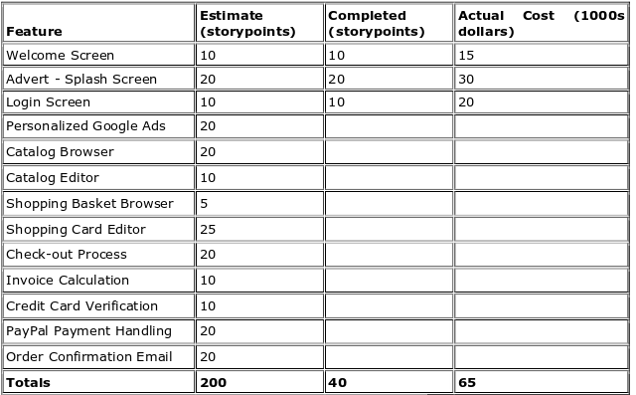

ANSWER:
Given the total number of story points (SP) = 200
Number of iterations or sprints = 4
Total budget incured for entire project = $175000

Expected percentage of completion during first sprint = 25% ie. 50 SP
Expected cost for first sprint(Calculated planed valuue) = 25% of the Total Project cost
= 175000 * (25/100)
= 43750
SP s completed after iteration 1 = 40
Actual Percentage of work completed after first iteration = (40/200)*100
= 20%

Since only 20% of the total work has been completed earned value = (20/100)*175000
= $35000

