- Consider the user story: “As a customer I want to use ATM”. What would be my acceptance criteria (“so that......)”? List all possible acceptance criteria.
ANSWER:
Acceptance Criteria:
- I can withdraw cash as long as there is sufficient amount in my account at any time.
- For every transaction i can get a printed statement
- Without approaching the bank i can do my balance enquiry
- My transaction completely secured.
- I may not only depend on the particular bank where i have account.
- I can get a proper feedback message for each of the opertions performed.

- What are the advanced Scrum Master skills?
ANSWER:
Following could be the skills for Advanced Scrum Master
- multi-team environment
- proper knowledge of agile methodolgy and scrum priciples
- Quality Engineering
- Good interaction and communication skills
- Should have a skill to recognize aswell as avoid agile and scrum anti-patterns
- Motivating as well as success making skill

https://www.google.co.in/search?client=ubuntu&hs=4IY&channel=fs&q=is+there+any+need+to+calculate+earned+value+in+agile+project+methodology%3F&oq=is+there+any+need+to+calculate+earned+value+in+agile+project+methodology%3F&gs_l=serp.3...2169241.2191157.0.2191301.77.73.2.2.2.0.215.9558.0j58j4.62.0....0...1c.1.64.serp..11.40.5884...0j0i67k1j0i10k1j0i22i30k1j33i21k1j30i10k1.gxi82v21xQw
- How do you think you can use Agile practices in large projects? (Given that the team can have no more than 9 people, do you think large projects with large teams can be involved in agile practices?)
ANSWER:

In my opinion Agile practices can be adopted in even larrger projects. Say using the scrum priciples we can handle even large project.

In the case there is large number of teams they can be splited into groups of 9 as multiple scrum team.
Even restricting the team size to 9, it is possible that: a properly skilled scrum master can lead multiple scrums each of which will be separately lead by skilled scrum masters.

Being a large project obviously the project will be having so many features.To get all these perfectly captured in the project, it is very much required that there is proper communication which is one of the governing principle in agile methodology.

- What are the Possible options for tracking project performance in Agile?
ANSWER:

Measuring Sprint Progress : A simple burndown chart is used in Scrum to show a trend of the remaining To Do estimate for all tasks within the sprint (iteration).

Measuring Release Progress : Releases represent the lifeblood of the business. Ability to successfully deliver software to the business is of critical importance . We use a release burndown chart to evaluate the progress of the same.

Internal assessments : The Agility Index Measurements (AIM) scores product development against a number of agility factors to achieve a total. The similarly named Agility Measurement Index, scores developments against five dimensions of product development (duration, risk, novelty, effort, and interaction).

Other techniques are based on measurable goals and one study suggests that velocity can be used as a metric of agility.
There are also agile self-assessments to determine whether a team is using agile practices .

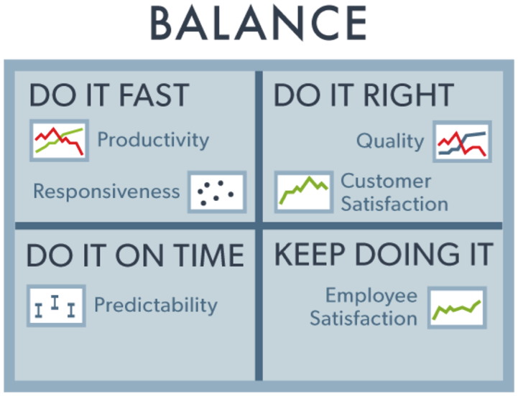
- In Agile, the team always picks up business value user stories in every sprint. Do we still need to know earned value?
ANSWER:
- In my opinion , it is good that we may calculate the earned value even the determining factor for project sucess is CPI, SPI and EBV.
- The reason I would suggest is that, we could make a clear comparison of the planned aswell as earned value.
- Earned Value Management, or EVM, is a popular method of measuring project performance, and an Agile project manager/ScrumMaster should know how to calculate this for better control on a project.

