- When to use (Rapid Application Development) RAD model? When not to use (Rapid Application Development) RAD model?
ANSWER:
- It is a system development approach that employs tools, techniques, and methodologies designed to speed application development.
- RAD model is based on prototyping and rapid cycles of iterative development .
RAD IS USED
- When development time is critical, or when a product is needed now before things change
- When stakeholders are not sure exactly what they want other than some basic requirements
- When Quality is negotiable
- RAD should be used when there is a need to create a system that can be modularized in 2-3 months of time.
- It should be used only if high skilled resources are available in designing developing and modelling the system.
- It is only accounted if the budget is high enough to afford thecost of automated code generating tools.
- It is used in situation to accomodate changing requirements .
- It is used when the developement time is very less.
- It is used when there is a need to reuse the components.
RAD IS NOT USED:
- When stakeholders think they will save a lot of money using RAD .
- When stakeholders are not willing to compromise on Quality.
- When project management will not accept informal project deliverables .
- When the product must support or interface with other critical systems (reliability and performance are not critical)
- When highly skilled resources are unavailable.
- When system to be developed cannot be modularized.
- When budget allocated is very less.
- Define an ER diagram of a software Organization with all the relationship model that was discussed in the classroom.
ANSWER:

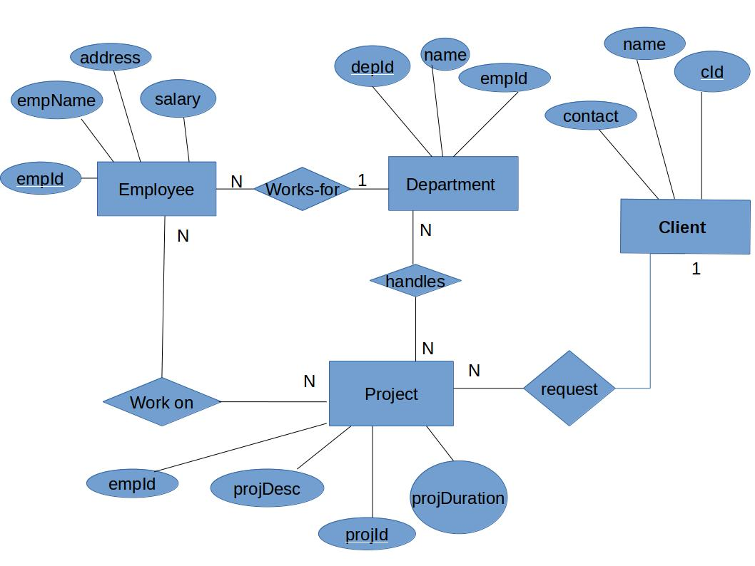
- The above diagram shows relationships among 4 entities namely :
Employee, Department, Client and Project.
- For each of these entities the they are characterized by several attributes as shown abouve.The underlined attribute shows the primary key.
- As multiple employes could relate to single department there we can have a many-to- one relationship.
- Many employees can work on many projects and therefore we have a many-to-many relationship between Employee and Project.
- Similarly Many departments have to work over many project,so there also we can have a many-to-many relationship between Department and Project.
- Since a single client can have his multiple projects with the organization , we can define a one-to- many relationship between Client with Project.
- Describe the Entity Relationships for the following diagram.

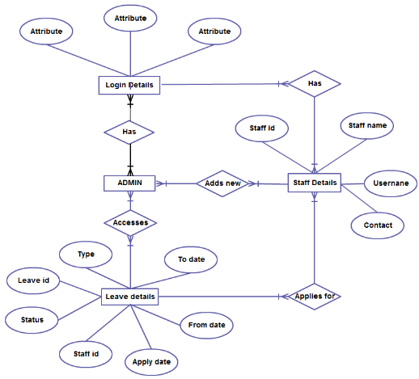

ANSWER:
The diagram above explains about four entities .
- Admin
- Login Details
- Staff Details
- Leave Details

An attribute characterize an entity.In otherwords it could be the properties that the entity possesses. The attributes for the above entities include
- Login Details:- Id,Password and some other private data.
- Staff Details :- Id,name,username and contact
- Leave Details:- Type,todate,fromdate,ld,status,staffid,apply date
- Admin entity :- is not attributed in the question.

RELATIONSHIPS

Entity Admin has a many to many relationship with Login Details.
Entity Admin has a many to many relationship with Leave details
Entity Admin has an adds new relation with staff details.Its a many to many relationship.
Entity staff details has applies new relationship with Leave Details.

