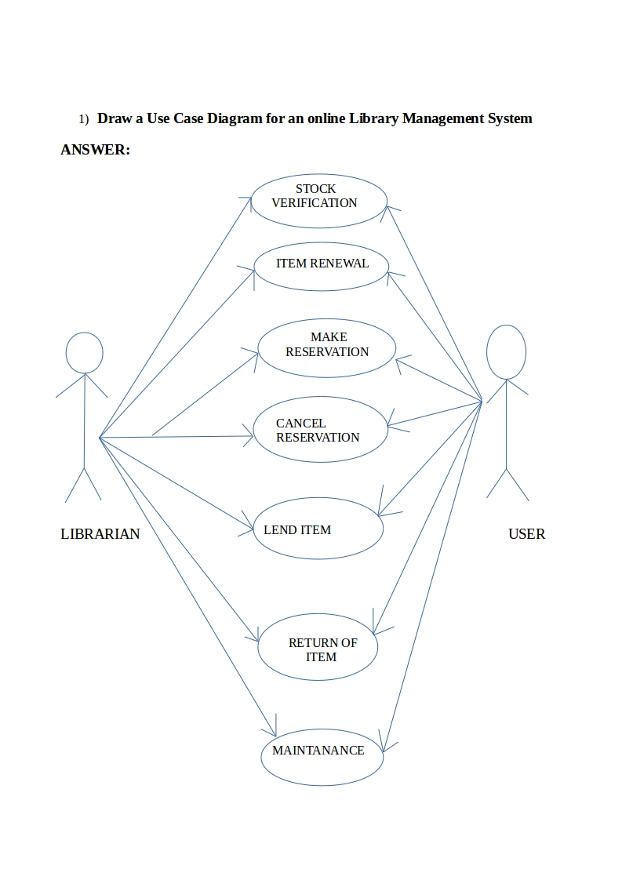

2) List down the best practices from Agile/Scrum methodology

Best practices from agile/Scrum methodology:

- Product Backlog (PBL),which is ordered list of features based on priorities maintained by product owner.
- Sprint Backlog(SBL),owned by developemnt team and created during Sprint planning
- Planning poker to estimate tasks during sprint planning
- Daily scrums or daily standup meetings to point out current issues
- Burn down to monitor sprint progress
- Sprint reviewmeeting to present completed work
- Sprint retrospective to learn from previous sprint
- Release Planning to release product increments
- User stories are written
  - 6 hours per a day is a realistic planning input. Total sprint hour capacity can be calculated as: (number of team members) * (number of sprint days) * 6 hours
- The project velocity is measured
- When a bug is found tests are created
- Acceptance tests are run often and the score is published
- All code must pass all unit test before it can be released

3) Collaboration
a) How does collaboration help agile development?
b) What if the team is distributed and can you achieve the same productivity?
c) What would you do to achieve the productivity for a distributed team?
ANSWER:

Collaboration simply means to work jointly rather than independently to accomplish a task.
- Two of the four values in the agile manifesto highlight the emphasis Agile methodologies place on strong collaboration. "Individuals and interactions over processes and tools" reminds us of the importance of strong and respectful communication. "Customer collaboration over contract negotiation“reminds us that it's more important for a development team to allow for some flexibility to please a customer, seeking a collaborative solution to issues that might arise during product development, rather than to stick to a rigid contract.

  - collaboration in agile development
    - Through collaboration,customer satisfaction can be ensured as they evaluate the product at each level.
    - Modifications can be incorporated at each level.
    - Collaboration has the following advantages:
      - Satisfy the customer through early and continuous delivery
      - Welcome changing requirements
      - Business people and developers work together daily
      - The best way to convey information is face-to-face
      - The team regularly tunes and adjust its behavior

  - case of distributed team
    - Achieving the best results with agile requires a well-connected team. If the team is distributed the productivity tends to decrease
    - The issues in distributed development are:
      - Strategic: Difficult leveraging available resources, best practices are often deemed proprietary, are time consuming and difficult to maintain.
      - Project and process management:Difficulty synchronizing work between distributed sites.
      - Communication:Lack of effective communication mechanisms.
      - Cultural: Conflicting behaviors, processes,and technologies.
      - Technical: Incompatible data formats,schemas, and standards.
      - Security: Ensuring electronic transmissionconfidentiality and privacy.
  - acheiving productivity for distributed team
    - Following are the methods to achieve productivity in a distributed agile team:
      - Optimize Team Size and Team Mix:
          - Finding the right mix of talent at every location is critical when the team is distributed.Effective distributed Agile development is about minimizing the impact of distribution.
      - Distribute Work Evenly:
          - Make sure all team members understand their role and have fairly equal workloads. In a distributed team, if the workload is uneven, you may risk the overall project delivery schedule if you ignore the imbalance. Uneven workloads can also cause bottlenecks
      - Set Up Pair Programming:
          - Pair programming, where two team members sit side by side and work on the same code, is a challenge for distributed teams
      - Enforce and Re-enforce Agile Practices:
          - Agile approaches rely on a set of mutually supporting practices. When one practice doesn’t make sense for one team, the practice should be either abandoned or replaced. With distributed teams, enforcing and reinforcing a practice takes time and effort

      - Use Online Tools for Agile Artifacts:
          - take advantage of Agile process artifacts (white boards, sticky notes, and so on) by moving them from their physical environment to an online tool.
      - Understand Time Differences
      - Understand Cultural Differences
      - Adapt Communication for Remote Teams
      - Arrange Face-to-Face Interactions
      - Plan Frequent Demos and Retrospectives

4) What is Sprint Zero in Agile? Describe the activities that are done in Sprint Zero.
ANSWER:
Sprint Zero is also called as Iteration Zero. Sprint Zero will get ready the things needed for the sprint . Sprint Zero should be used to create the basic skeleton and plumbing for the project so that future sprints can be truly add incremental value in an efficient way - See more at:
Following are the activities done in Sprint:-

- Infrastructure readiness :- Without the infrastructure, team will not be able to progress on anything. So a high dependency on the systems, software, licenses, environments etc.
- Team Readiness :- Creation of the team as per the resourcing plan.
- Training :- Training will make team ready for the development/testing. These trainings are critical to project success.
- Product Backlog/Requirement :- These are the product requirements that team will be building in the coming sprints. Product owner and Technical Architect need to work closely here to prepare the backlog for the team.
- Design/Architecture :- High level architecture management plan that talks about the technical architecture of the future product from the technical architect. Next step will be to convert the architect plan into the architecture solution i.e. the coding platform for the developers.
- Project Management Plan :- Comprehensive project management plan will be the guide for the project team members as far as project processes are concerned.

