**REPORT**

**The Battle of Neighborhoods**

**(Coursera Cases in Germany)**

Name : Rajesh Sriram

Contents

1 Introduction 1

2 Data 2

3 Methodology 2

3.1 Pre- Processing of Datas 2

3.2 Plotting of the Graphs 3

3.3 Additional Task 3

4 Result 4

5 Discussion 7

6 Conclusion 7

# Introduction

As the current Pandemic of the Covid-19 which is affecting the whole world, many people are admiited to the hospital for fighting against the Covid-19 which is a cruicial thing for the surivial of the people. So at the present situation the opening of the restaurant or mall isnt possible and when the situation will come to normality no one know .

So at what matters at present is whether the number of hospital is sufficient for the people.

This Project attempts to compare the Corona Cases in the different city in Germany and with the different type of visualisation it is seen whether the population has the effect on corona virus and an attempt is made to seen whether the intensiv beds in hospitals are sufficient for the people in current situation

The assumption and factor considered for this project is that each hospitals admit the same number of patients

So what the problems aims is to

a) compare the population of the top cities affected in Corona cases

b) using four square compare the no of hospitals in the cities and plot it in the map

c) compare the number of covid cases in the cities

This aims to see whether the population and hospital have any effect on the number of Covid-19 cases in these cities

# Data

a) The number of hospital beds in the individual cities are given in this data set, these are arranged by the numbers of intensive beds in each state, from which the total number of the intensive beds can be determined and the data can be found in :

<https://www.kaggle.com/datasets>

b) Population of the citiy :

Since no table could be found for the population of the city. With the help of the google search the data is created as a column

.

c)Geo-spacial data of the different cities is plotted to get a better understanding of the hospitals in neighborhoods in it and their corresponding locations in the Folium map would make

certain things clear for the Project. This will be achieved using the acquired data and visualize the same using the Folium module

d) Finally the data going to be collected/acquired from the Foursquare API about the various hopsitals in each cities which will be used for predictibg whether the

which will be used for acquiring the information regarding same for all the venues of each neighborhood of the toronto cities

e) The corona cases in each cities is scrapped using the html and the data is found in :

https://www.statista.com/statistics/1105401/coronavirus-covid-19-cases-cities-districts-germany/

# Methodology

## Pre- Processing of Datas

To plot the datas in a presentable format where the graphs can be visualized it is necessary to preprocess the data. If one see ths the link in which the number of hospitals and beds are given it is for all the cities in Germany. To find out the total hospital in the state the cities should be first arranged by the state and then the total beds in each state should be summed to obtain the total number of the beds in the country

Since the second data is only for the total corona cases for the top 10 cities in the Germany. So the first table had to be first arranged state wise and then the second tables a new column is created to add the state in which the corona cases have taken place. Now for both the table the common term is the state which can be seen in the code also. So both the tables are merged usind the pd.merge coomand.

Due to the availability of this command it is possible to merge both the tables without sql command. The other method in which it could be done is that the tables are uploaded in the database and then the sql command is used to obtain the required data which is mentioned in the Coursera Sql Lessons

## Plotting of the Graphs

**Scatter Graph** : Using this graph the data is plotted in scatter. This approach is preffered as one can clearly see the graph and tell whether it has a linear relationship with the population .

Here the Population of the cities is plotted against the Covid Cases. If it is a linear relationship the graph would have a constant slope. This cant be seen directly on observing the graph. The result of this method will be discussed in the upcoming section

**Bar Graph :** This is used for seeing which cities have the higher numbers of the corona cases. As for this case it doesn’t matter whether as the number of cities used for comparison is less. But for a larger dataset bar graph one can quickly visualise who has the highest data. The results will be discussed later

## Additional Task

**Geolocator :** As in other cases, these datasets doesn’t have the longitude and latitude. In such a cases Geolocator plays a huge role. As with just creating a empty list and just appending the cities name, the Geolactor automatically provides the latitude and longitude. With the help of this approach the latitude and longitude is obtained which helps in plotting it in the maps. As for the code it can be seen in the notebook.

**Four Square API Method :** With this the the name of the hospital around the city of Berlin is plotted on the maps. The result is seen that depends on the search terms. As when the search term was made hospital it resulted less amount of query result. But the results changed as soon as the local term of the hospital in the Deutsch Language the Krankenhauser is used

# Result

In this section the screenshot of all the process is included from the beginning

1. Scatter Graph

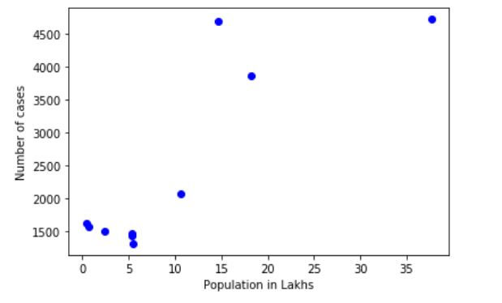

2) Bar Graph

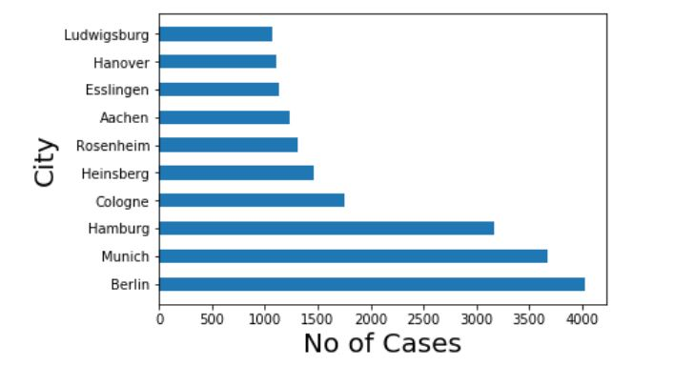

1. Bubble Flow Chart based on the the number of corona cases. The radius increases with the increase in the corona cases

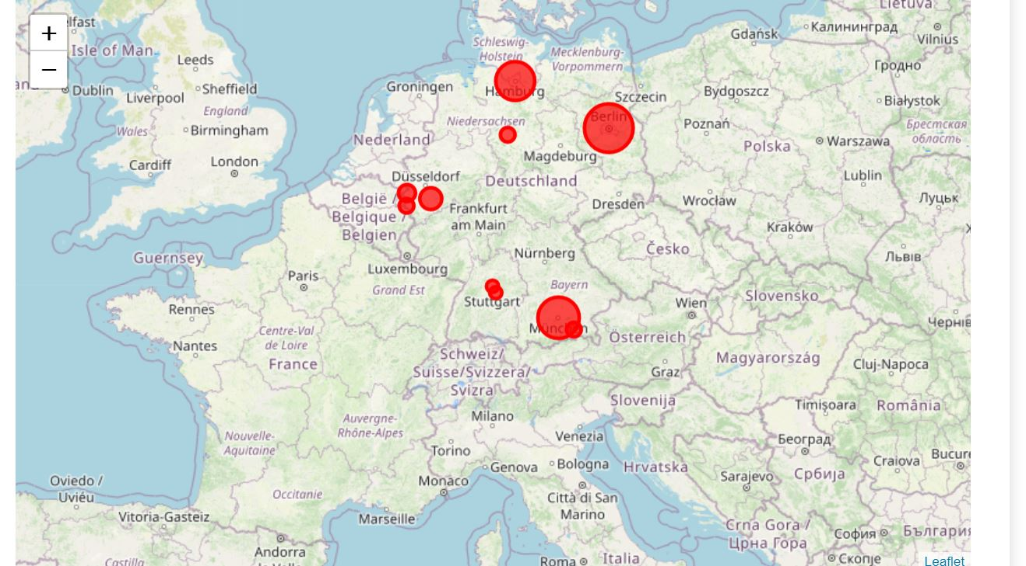

1. Number of Hospitals in Berlin and its location is plotted in the map

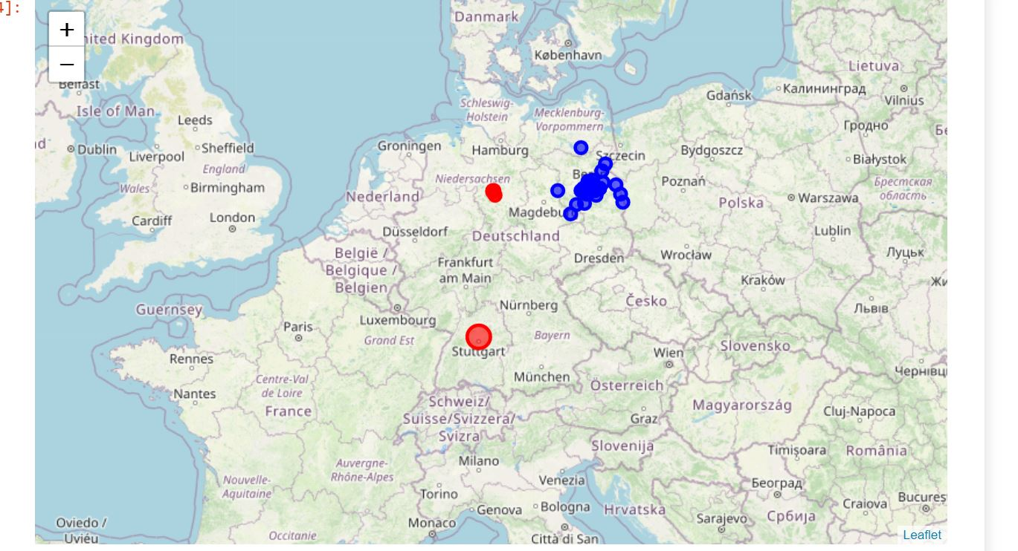

1. Number of intesiv beds in each state of Germany which is obtained after pre processing of the datas

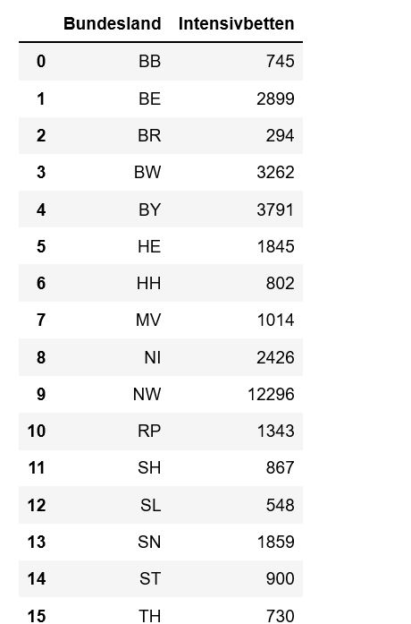

1. By merging the two tables the resulting data are obtained and the result is as follows

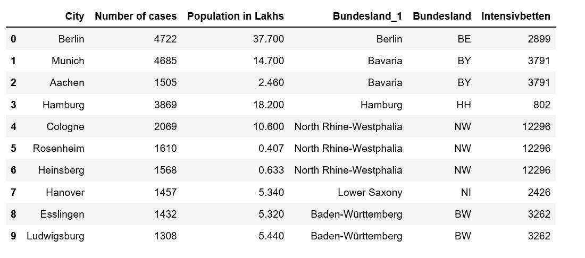

# Discussion

It has been observed that they are total of 35000 intensive beds which are spread throughout the Germany. At present the total number of critical cases is around 4560 . This situation will get worse if the Germany opens the lockdown as the health system cant take the increase in the patient. Due to which the the Government should open slowly . This things waas the same which the government also told in its press meet to increase the lockdown uptil 3rd May

# Conclusion

The Foursquare Api search results not in uniform results, it changes with the language input

In terms of the topic if the Germany follows a strict lockdown then it can control the Corona Virus.