# ACTIVITY RATE MAINTENANCE IN SAGE:

The activity rate maintenance is a setup module in SAGE that must be setup along with customer, vendor and item before the creation of an SRO order in the system.

This setup module will determine the inventory movement – inbound and outbound of the items and the customer or partner rate for each item based on the activity type.

**STEP 1: FILTERS/DEFAULTS TAB**

Check if activities have been defined for a specific combination of delivery type, customer, vendor and item.

1. Select Delivery type:
   1. Shipment
   2. Pickup
2. Select vendor, items and customer information.
3. Based on customer, the Ship to location will be populated.
4. Activity code value is not required.
5. Once all required fields have values, select the ‘Apply Filter’ button. 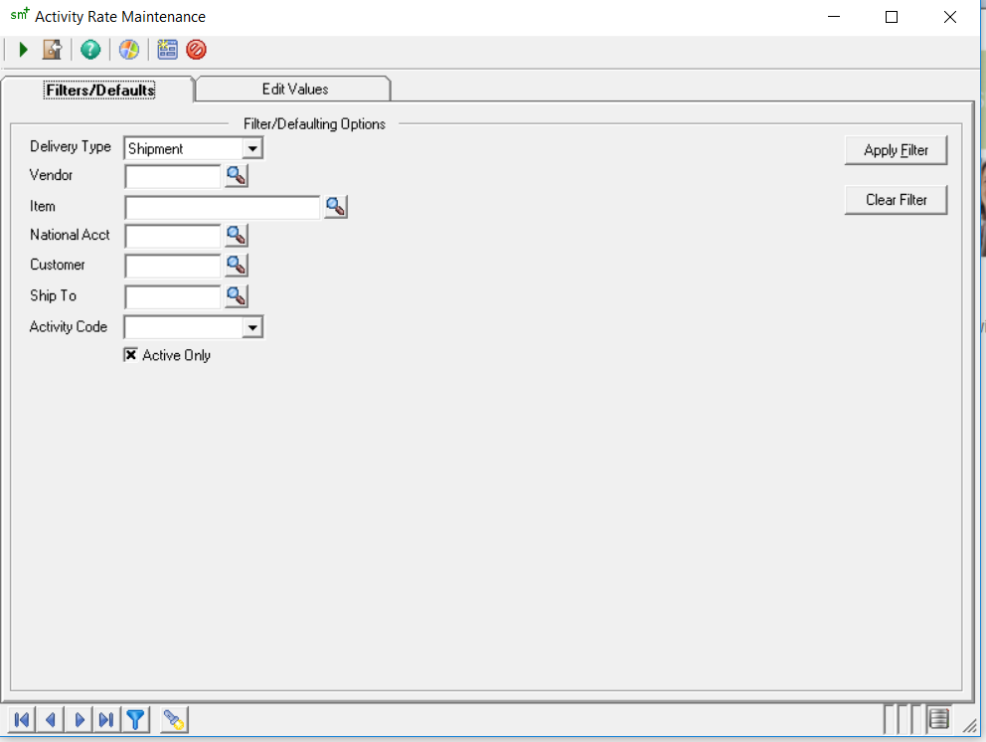

**STEP 2: EDIT VALUES TAB**

The Apply Filter button will open the ‘Edit Values’ tab.

If activities were created for a specific combination of delivery type, vendor, item and customer, it will populate in the activities table as below.

If no activities were created, the table will contain zero activity records.

## List of Fields and functionality:

1. **Delivery Type:** Prepopulated from the Filter/Defaults tab. The value can be edited.

Values are:

* Pickup
* Shipment

1. 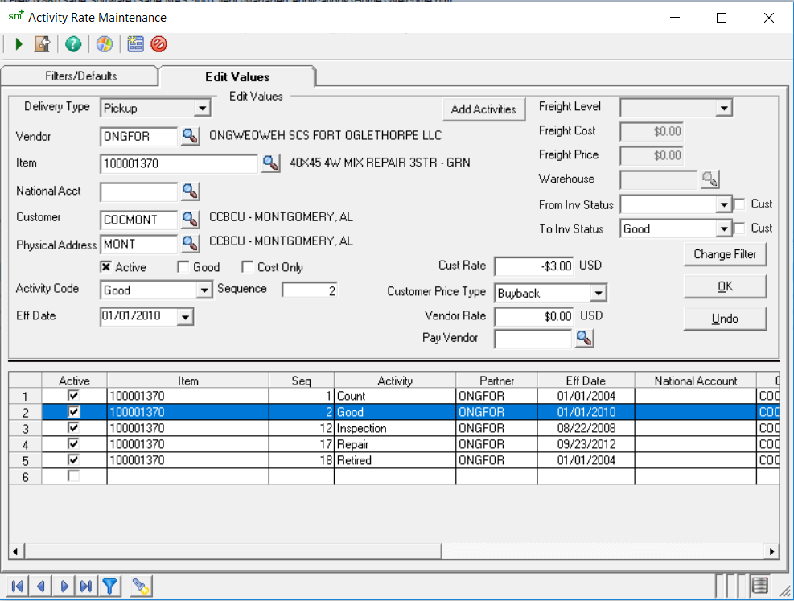**Vendor:** Prepopulated from the Filter/Defaults tab. The value can be edited. Contains the selected vendor code. On entry of a valid vendor code the description is displayed.
2. **Item:** Prepopulated from the Filter/Defaults tab. The value can be edited. Contains the INWA number of the item. On entry of a valid INWA number the item description is displayed.
3. **National Acct:** Must be auto populated based on **‘Customer’** value.
4. **Customer:** Prepopulated from the Filter/Defaults tab. The value can be edited. Contains the customer code. On entry of a valid customer code the customer description is displayed.
5. **Physical Address:** Auto populated based on **‘Customer’** value. Contains the ‘Ship To’ locations of the customer.
6. **Activity Code:** Refer to the Table 1 for the list of Activities. For each activity code set the Cust Rate, Customer Price Type, Vendor Rate, Pay Vendor fields as applicable. To add the activity to the Activity table, select the ‘Ok’ button.
7. **Add Activities button:** Opens a table that provides the user with the option to select multiple activities to be populated in the activities table.
8. **Sequence:** Displays the sequence number for each activity. Should not be an editable field **(Confirm with Vickie)**
9. **Eff Date: (Check with Vickie)**
10. **Checkboxes (Refer to Table 1)**
    1. Active – Displays the active/inactive status of an activity
    2. Good – **Not sure if we need this feature**.
    3. Cost Only – Activities that do not hit the inventory.
11. **Cust Rate:** The customer rate can take positive and negative values. For Shipment, the Cust rate takes a positive value that signifies that the customer pays ONG. For pick up, the Cust rate is negative to signify that ONG pays customer. The Cust Rate value is required if Customer Price Type is BuyBack or Deposit. The cust rate is zero if the delivery type is pickup and the customer price type is not set.
12. **Customer Price Type:** The customer price type includes two values:
    * + BuyBack
      + Deposit

The customer price type is set for specific activity types associated with Delivery type = ‘Pickup’. (In Dynamics 365 it can be a column drop down value that can be set at a line level for an activity).

1. **Customer Price Type = Buyback**

In BuyBack scenario we are purchasing the items from the customer. Hence customer rate must be a non-zero value. It is usually a negative value to signify that ONG pays the customer.

1. **Customer Price Type = Deposit**

For customer type = ‘Deposit’, the customer price type will be negative. In a deposit scenario, ONG will pay the customer for a particular ship to location a deposit amount of -$13.98. Hence, the customer rate must be a non-zero value for customer price type = ‘Deposit’. **(Prompts for Deposit customer)**

1. **Vendor Rate:** The vendor rate can take positive and negative values. For Shipment, the vendor rate takes a positive value that signifies that ONG pays vendor. For Pickup, the vendor rate is negative to signify that vendor pays ONG.
2. **Warehouse:** Select the warehouse that will be used for inbound and outbound of items. For DS and scrap scenarios, the selected warehouse = ‘DS’. If the warehouse does not contain the item, it gives an error message. (In Dynamics we can ensure that we populate only those warehouses that are tied to the items.)
3. **Pay vendor:** This field is used for the scrap by weight – shipment scenario in which a transaction has two AP transactions involved. The Pay vendor field will contain the vendor code.
4. **From Inv Status:** For field value = Good and cust checkbox is not set, the quantity will hit inventory. For field value = Good and cust checkbox is checked, the quantity will not hit inventory.
5. **To Inv Status:** If the field value is scrapped, then inventory is not hit. If the field value is good, and cust checkbox is not checked, inventory is hit.

**Freight: Not used currently by customer (Confirm with Vickie)**

**Table 1: List of Activities**

|  |  |  |  |  |  |  |  |
| --- | --- | --- | --- | --- | --- | --- | --- |
| **List of Activities** | **Cost Only** | **Good** | **From Inv Status** | **Cust** | **To Inv Status** | **Cust** | **Inventory** |
| Add to Inventory |  | Yes |  |  |  |  | Yes |
| Adjustment |  |  |  |  |  |  | Yes/No |
| Block & DKBD Repair |  | Yes |  |  |  |  | Yes |
| Clean | Yes |  |  |  |  |  | No |
| Count |  |  | Good | Y |  |  | No |
| Credit |  | Yes |  |  | Scrapped |  | No |
| Each | Yes |  |  |  |  |  | No |
| Flat Fee | Yes |  |  |  |  |  | No |
| FSC | Yes |  |  |  |  |  | No |
| Good |  |  |  |  | Good |  | Yes |
| Handling Fee |  |  |  |  |  |  | No |
| Heat Treat | Yes |  |  |  |  |  | No |
| Inspection |  | Yes |  |  |  |  | Yes |
| Minor Block Repair |  | Yes |  |  |  |  | Yes |
| OnSite Sort | Yes | Yes |  |  |  |  | No |
| Paint/Stencil | Yes |  |  |  |  |  | No |
| Pounds/Lbs |  | Yes |  |  |  |  | No |
| Repair |  |  |  |  |  |  | Yes |
| Retired |  |  |  |  | Scrapped |  | No |
| Shipment |  |  | Good |  | Unknown | Y | Yes/No - Out of Inventory not into |
| Storage Fee | Yes | Yes |  |  |  |  | No |
| Stringer Repair |  | Yes |  |  |  |  | Yes |
| Swap Charge |  |  |  |  |  |  | No |
| Wash | Yes |  |  |  |  |  | No |
| Weight | Yes |  |  |  |  |  | No |
| Weight/Ton |  |  |  |  |  |  | No |