MLOps (S2-25_AIMLCZG523) Assignment 2
Binary image classification (Cats vs Dogs) for a pet adoption platform
End-to-End MLOps Implementation
Name: RAJ KUMAR M
BITS ID: 2024AD05110 Email: 2024AD05110@wilp.bits-pilani.ac.in
Course: MTech AI & ML
GitHub Repository link:
https://github.com/RAJKUMAR27M/cats-dogs-mlops-assignment2.git
Final Demo video location link: https://drive.google.com/file/d/1_U2VYAa3dZED1Pxb_FuAIr3QS98JCg5u/view?usp=drive_link

Pipeline Architecture Overview
This project implements a complete MLOps pipeline covering model development, experiment tracking (MLflow), packaging (FastAPI + Docker), CI/CD (GitHub Actions), deployment (Docker Compose / Kubernetes), and monitoring (Prometheus).
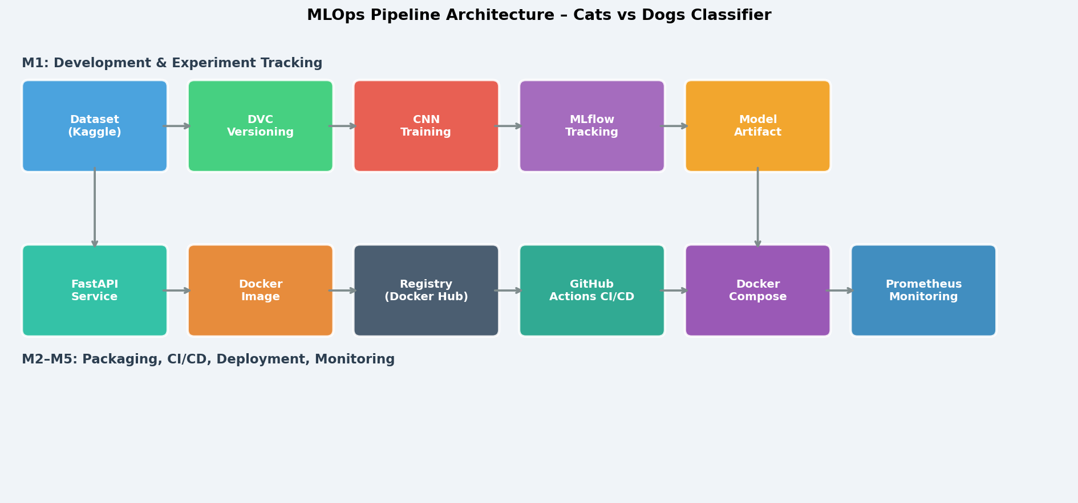
Figure 1: End-to-end MLOps pipeline architecture

M1: Model Development & Experiment Tracking
Build a baseline CNN, track experiments with MLflow, version data/code with Git + DVC.

Data & Code Versioning (Git + DVC)
Git tracks all source code; DVC tracks large data and model artifacts.

Git initialisation
git init
git add .
git commit -m "Initial project structure"
git remote add origin https://github.com/<user>/cats-dogs-mlops.git
git push -u origin main

DVC setup
pip install dvc
dvc init
dvc remote add -d local_remote ../dvc_store
git add .dvc .dvcignore
git commit -m "Initialise DVC"
dvc push

Download dataset
Manual download (recommended):
- Go to https://www.kaggle.com/datasets/bhavikjikadara/dog-and-cat-classification-dataset
- Click the Download button (downloads dog-and-cat-classification-dataset.zip)
- Extract the zip — you should get Cat\ and Dog\ folders
- Place them under data\raw\ so the structure is:
  - data\raw\Cat\*.jpg
  - data\raw\Dog\*.jpg
- Skip the download script below — go directly to Step 4 (preprocess)

dvc add data/raw
git add data/raw.dvc
git commit -m "Track raw data with DVC"

# Only needed if using Kaggle API instead of manual download:
python scripts/download_data.py --output-dir data/raw

Model Building (Custom CNN)
A 4-block CNN with BatchNorm, Dropout, and GlobalAveragePooling is implemented. Input: 224x224 RGB. Output: sigmoid (0 = cat, 1 = dog). Model saved as model.pt.

Training commands
- With real dataset
python src/models/train.py --data-dir data/processed --artifacts-dir artifacts
- Full DVC pipeline (preprocess + train)
dvc repro
- Dry-run (synthetic data, no Kaggle needed)
python src/models/train.py --dry-run

Task 3 – Experiment Tracking with MLflow
MLflow logs: hyperparameters, per-epoch accuracy/loss, test accuracy, confusion matrix PNG, training curves PNG, classification report, and model artifact.

MLflow commands
# Launch MLflow UI
mlflow ui --host 127.0.0.1 --port 5000
→ http://localhost:5000
mlflow experiments list
mlflow runs list --experiment-name cats-dogs-classification

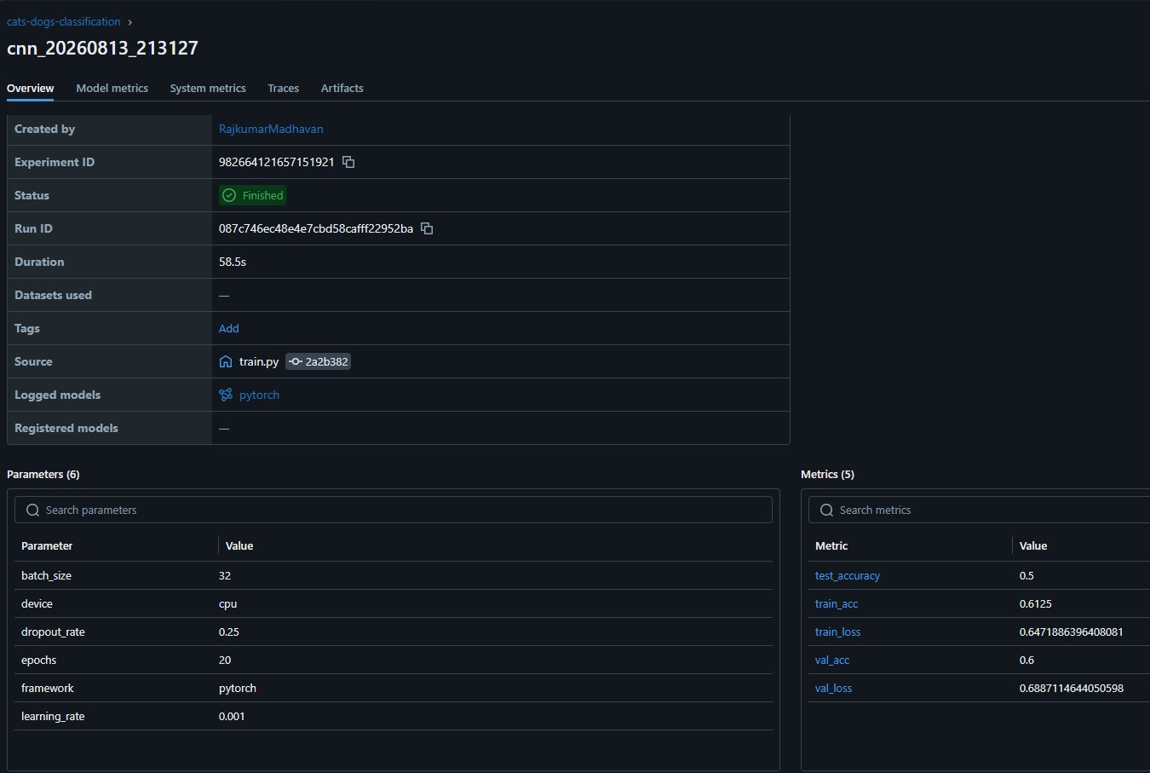

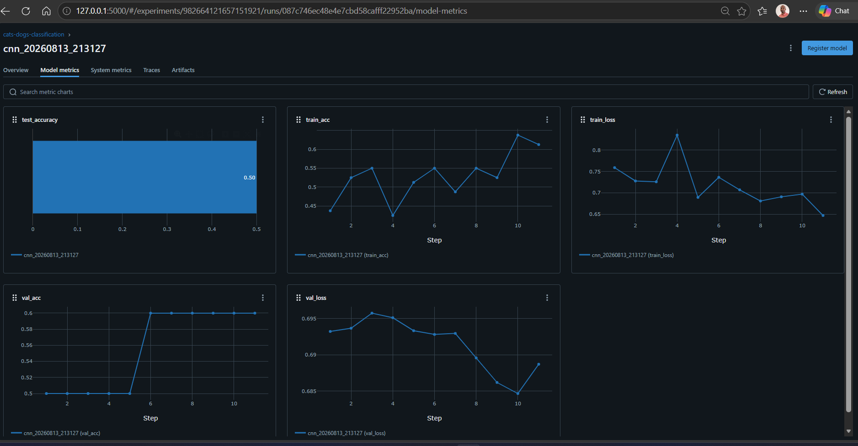

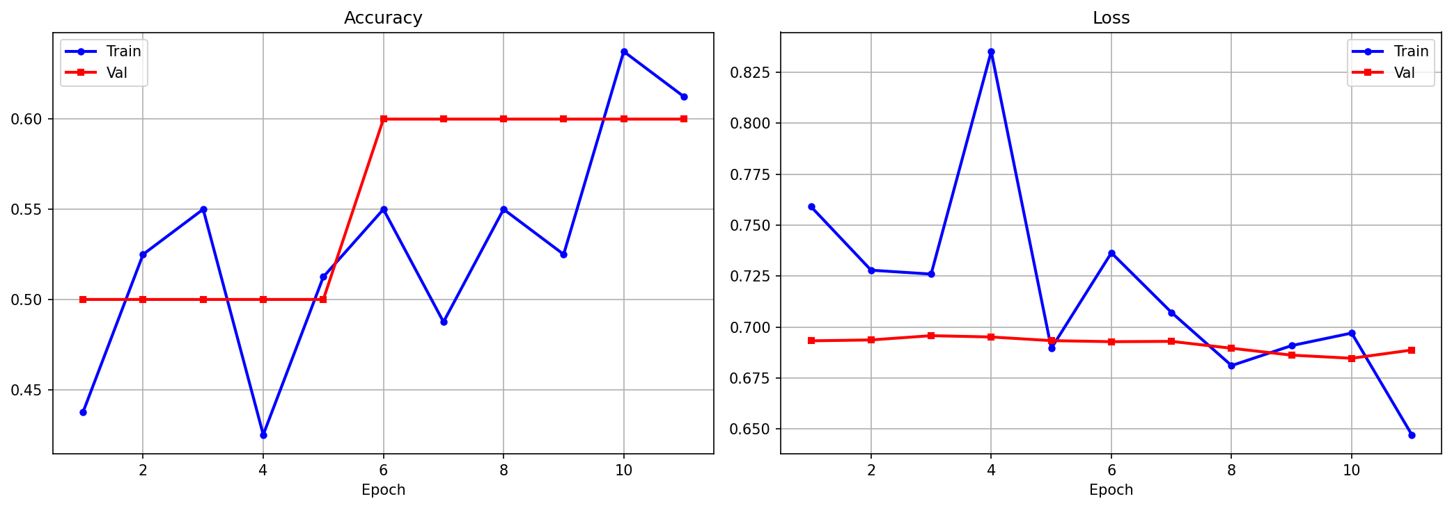
Figure 2: Training and validation accuracy/loss curves
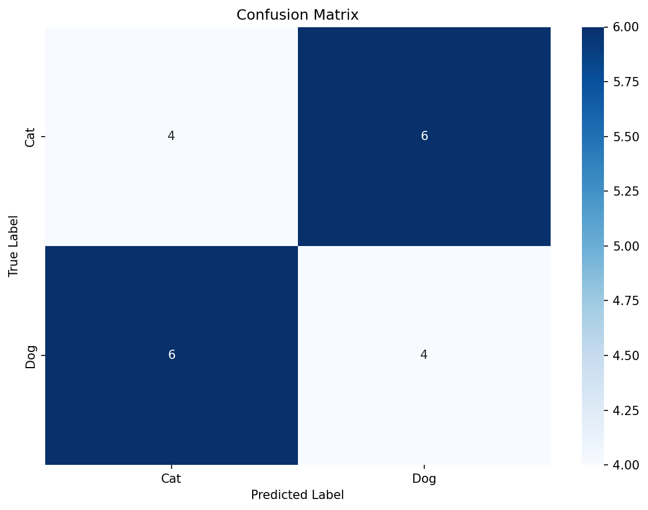
Figure 3: Confusion matrix on the evaluation split

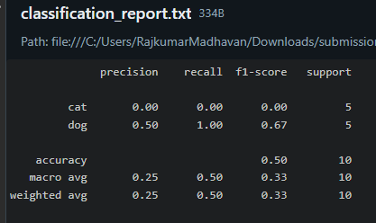

Latest recorded metrics
Metric | Value
test_accuracy | 0.5
train_accuracy | 0.6125
val_accuracy | 0.6

Logged MLflow parameters
Parameter | Value
model_type | custom_cnn
input_size | 224×224
batch_size | 32
epochs | 20
learning_rate | 0.001
dropout_rate | 0.25
optimizer | Adam
loss | BCELoss

M2: Model Packaging & Containerization
Wrap the model as a reproducible Docker-based REST API.

FastAPI Inference Service
Endpoints:
GET /health – service status + model_loaded flag
POST /predict – upload image → label, confidence, probabilities, latency_ms
GET /stats – request count and average latency
GET /metrics – Prometheus metrics

curl test commands
- Health check
curl http://localhost:8000/health
- Predict
curl.exe -X POST http://localhost:8000/predict -F file=@dog.jpg
- Expected response:
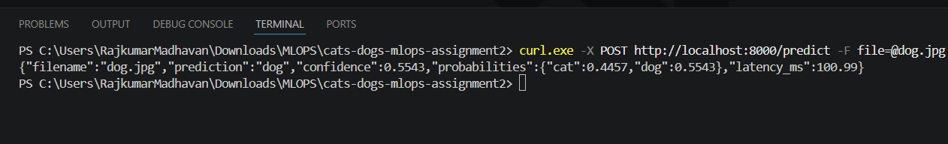
- Prometheus metrics
curl.exe http://localhost:8000/metrics

Task 2 – Environment Specification (requirements.txt)
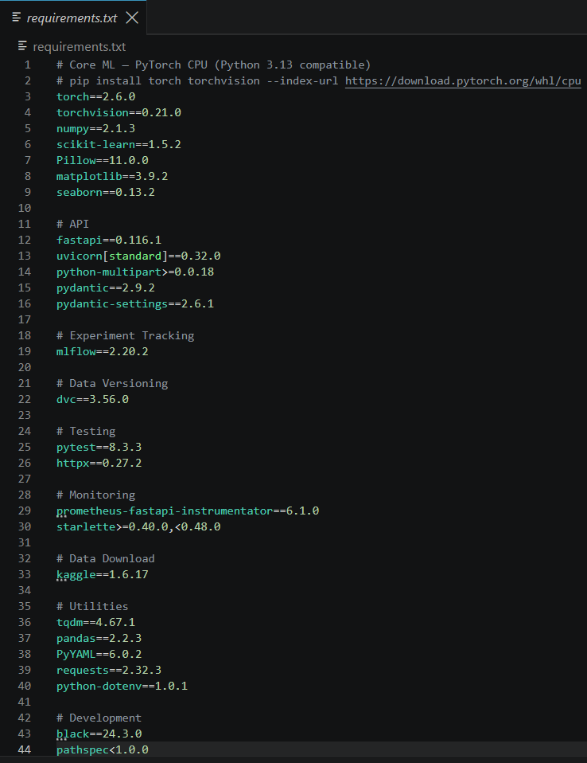
- System Python (preferred — no venv needed)
pip install -r requirements.txt
- Optional: virtual environment (create it INSIDE cats-dogs-mlops)
python -m venv .venv
.venv\Scripts\activate
pip install -r requirements.txt

Containerisation (Docker)

Dockerfile

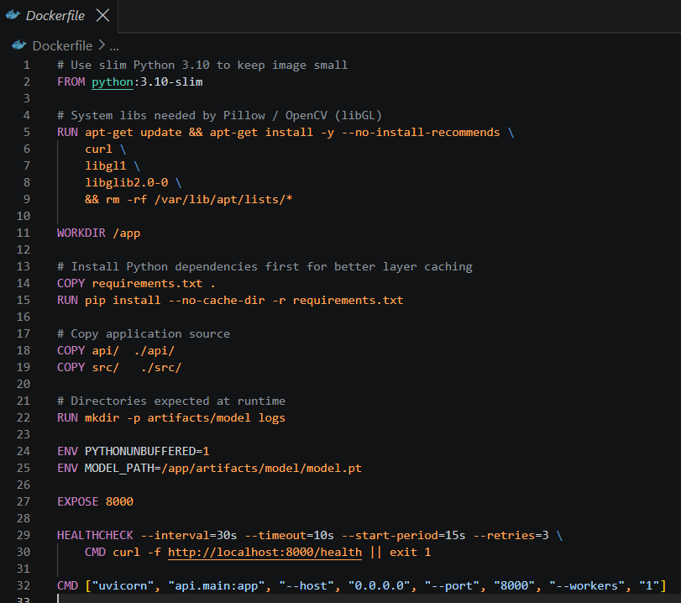Docker build & run
- Build
docker build -t cats-dogs-api:latest .

- Deploy with Docker Compose
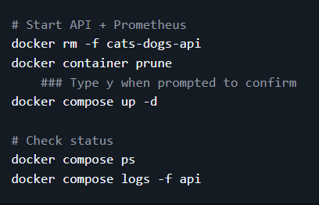
- Verify
curl http://localhost:8000/health
- Stop
docker compose down

M3: CI Pipeline – Build, Test & Image Creation

Automated Testing with pytest
Unit tests cover:
• Preprocessing: load_and_resize_image, normalize_image, preprocess_image
• Inference: Predictor class (label, confidence, edge cases)
• API: /health endpoint structure

Run tests
pytest tests/ -v
With coverage report
pytest tests/ -v --cov=src --cov=api --cov-report=html

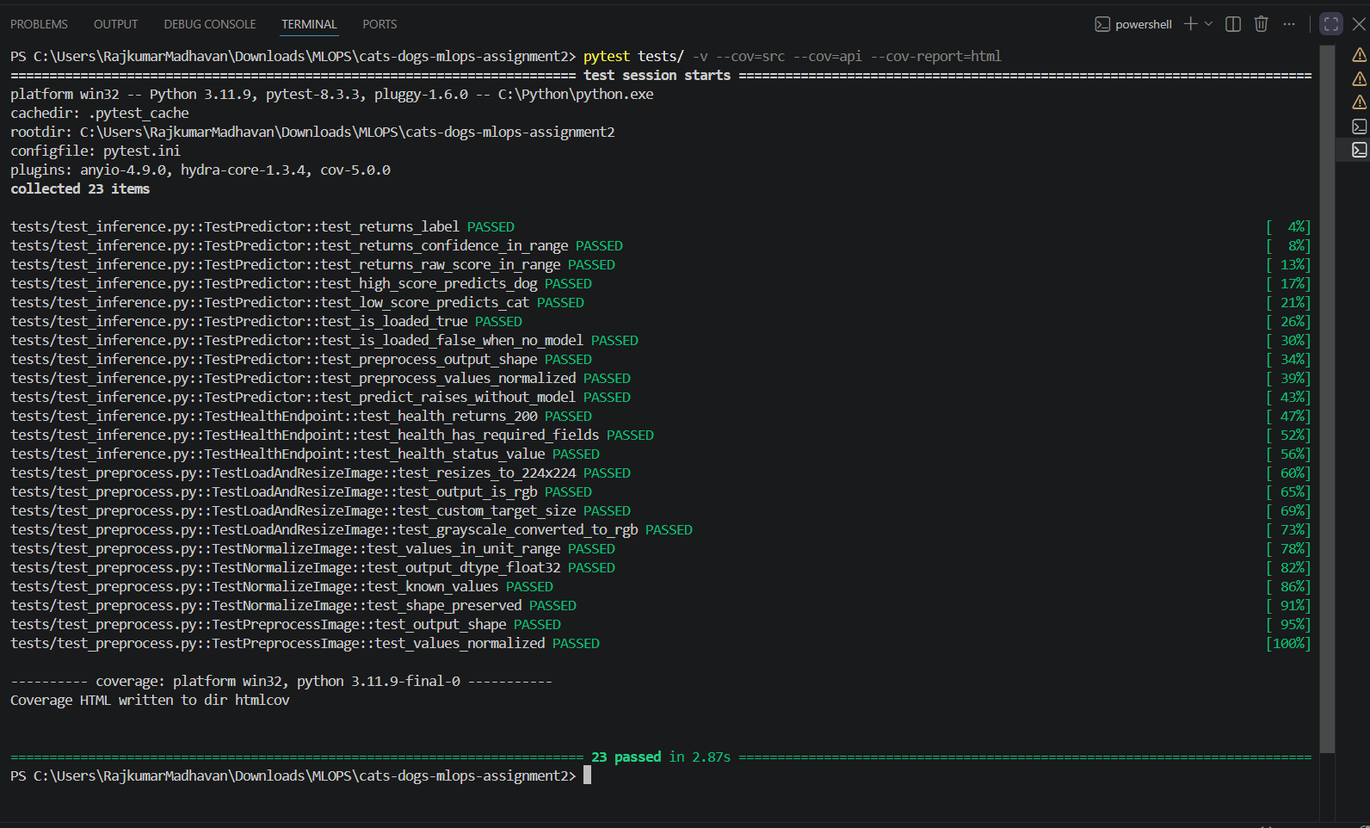

CI with GitHub Actions

CI pipeline steps
1. Checkout repository
2. Set up Python 3.10 with pip cache
3. pip install -r requirements.txt
4. pytest tests/ -v
5. docker/setup-buildx
6. docker/login-action (Docker Hub)
7. docker/build-push-action (push only on main)

Artifact Publishing (Docker Hub)
On every successful push to main the CI workflow tags the image as:
<username>/cats-dogs-api:latest
<username>/cats-dogs-api:main
<username>/cats-dogs-api:main-<sha>
Manual Docker Hub push
docker login -u <username>
docker tag cats-dogs-api:latest <username>/cats-dogs-api:latest
docker push <username>/cats-dogs-api:latest
Pull on another machine
docker pull <username>/cats-dogs-api:latest

M4: CD Pipeline & Deployment

Deployment commands
- Deploy
docker compose up -d
- Check status
docker compose ps
docker compose logs -f api
- Rolling update
docker compose pull && docker compose up -d --remove-orphans

- Kubernetes (optional)
kubectl apply -f k8s/deployment.yaml
kubectl apply -f k8s/service.yaml
kubectl rollout status deployment/cats-dogs-api

CD / GitOps with GitHub Actions

Smoke Tests
After deployment the CD pipeline runs scripts/smoke_test.py which verifies:
1. /health returns HTTP 200 with status='healthy'
2. /predict accepts an image and returns a valid prediction
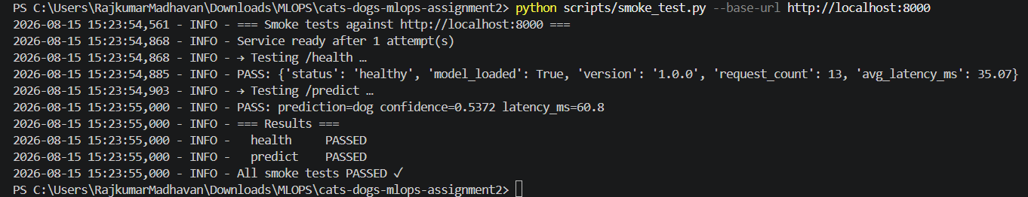
Pipeline fails and rolls back if any smoke test fails.
Post-deploy smoke tests – health check and prediction endpoint (M4

Run smoke tests manually
python scripts/smoke_test.py --base-url http://localhost:8000
- Expected output:


M5: Monitoring, Logs & Final Submission

Request/Response Logging & Metrics
The FastAPI service implements:
• Python logging (api.requests logger) for every prediction (filename, pred, confidence, latency)
• prometheus-fastapi-instrumentator exposing /metrics for Prometheus scraping
• In-app counters: request_count, total_latency
• /stats endpoint for quick dashboard

Prometheus configuration
global:
scrape_interval: 15s
evaluation_interval: 15s
scrape_configs:
- job_name: cats-dogs-api
static_configs:
- targets: ['api:8000']
metrics_path: /metrics
scrape_interval: 10s
- job_name: prometheus
static_configs:
- targets: ['localhost:9090']

Start monitoring stack
docker compose up -d # starts API + Prometheus
# Prometheus UI → http://localhost:9090
# Useful PromQL queries:
# http_requests_total
# http_request_duration_seconds_bucket
# rate(http_requests_total[5m])
curl http://localhost:8000/metrics # raw Prometheus metrics
curl http://localhost:8000/stats # JSON summary

Sample log output
2024-11-01 10:23:45 - api.requests - INFO - PREDICT | file=cat.jpg | pred=cat | conf=0.9234 | latency=42.5ms
2024-11-01 10:23:46 - api.requests - INFO - PREDICT | file=dog.jpg | pred=dog | conf=0.8891 | latency=38.2ms
2024-11-01 10:24:10 - api.requests - INFO - PREDICT | file=test.png | pred=cat | conf=0.7120 | latency=51.0ms

Task 2 – Post-Deployment Performance Tracking
scripts/batch_evaluate.py sends a batch of images (real or synthetic) to the running API, computes accuracy / precision / recall / F1 / P95-latency, and logs them to MLflow.

Run batch evaluation
python scripts/batch_evaluate.py \
--base-url http://localhost:8000 \
--data-dir data/processed \
--output-dir artifacts
# Writes artifacts/post_deployment_metrics.json
# Example output:
# {"num_samples":100,"accuracy":0.87,"precision":0.88,
# "recall":0.86,"f1_score":0.87,"avg_latency_ms":45.2,"p95_latency_ms":78.3}

Complete End-to-End Workflow

Step 1 – Install dependencies
python -m pip install -r requirements.txt

Step 2 – Init Git & DVC
git init && git add . && git commit -m 'init'
dvc init && dvc remote add -d local_remote ../dvc_store

Step 3 – Download dataset
set KAGGLE_USERNAME=xxx && set KAGGLE_KEY=yyy
python scripts/download_data.py --output-dir data/raw

Step 4 – Preprocess & Train (DVC)
dvc repro
# OR: python src/models/train.py --dry-run

Step 5 – View MLflow UI
mlflow ui --host 0.0.0.0 --port 5000

Step 6 – Run tests
pytest tests/ -v

Step 7 – Build Docker image
docker build -t cats-dogs-api:latest .

Step 8 – Deploy
docker compose up -d

Step 9 – Smoke tests
python scripts/smoke_test.py --base-url http://localhost:8000

Step 10 – Monitor
# Prometheus: http://localhost:9090
curl http://localhost:8000/metrics

Step 11 – Batch evaluation
python scripts/batch_evaluate.py --base-url http://localhost:8000

Conclusion
M1: A custom 4-block CNN with BatchNorm and Dropout is trained on 224x224 RGB images. All runs are tracked with MLflow; dataset and model are versioned with DVC.
M2: The trained model is served via FastAPI with /health and /predict endpoints, containerised with Docker, and deployed reproducibly with Docker Compose.
M3: GitHub Actions CI automatically runs pytest, builds the Docker image, and pushes it to Docker Hub on every commit to main.
M4: The CD workflow pulls the new image, deploys with Compose, and runs smoke tests to validate each release. Kubernetes manifests are also provided.
M5: prometheus-fastapi-instrumentator exposes Prometheus metrics; every prediction is logged with filename, class, confidence, and latency. Post-deployment batch evaluation tracks drift over time and logs results to MLflow. The GitHub repository URL and published container image reference should be included in the final submission report alongside the zip archive.

GitHub Repository link:
https://github.com/RAJKUMAR27M/cats-dogs-mlops-assignment2.git
Final Demo video location link: https://drive.google.com/file/d/1_U2VYAa3dZED1Pxb_FuAIr3QS98JCg5u/view?usp=drive_link

