Economics Assignment 1

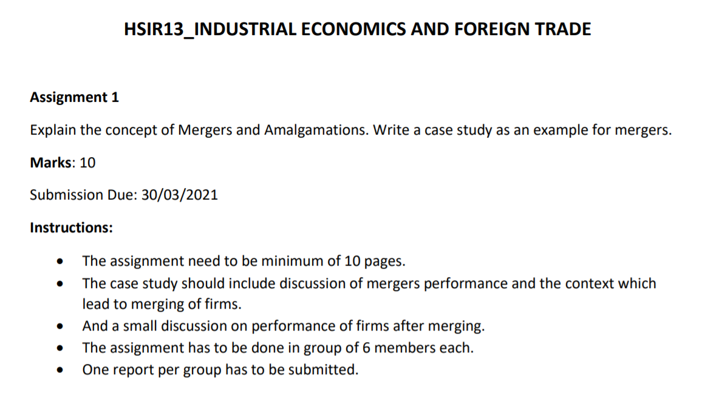

Group Members (2):

1. Rajneesh Pandey - 106119100
2. Satyarth Pandey – 106119112

Merger

Nowadays, the deals of Merger and Amalgamation in India are increasing rapidly due to continuous change of dynamics, increased competition, technology adaption, business expansion and globalization. Therefore, every company opts for the process of merger to reap the benefits of associating with a large company.

Further, merger and amalgamation are often known as a single expression. However, there is significant differences between the two concepts.

The merger is a process wherein two or more companies/entities are combined to form either a new company or an existing company absorbing the other target companies. Basically, it’s a process to consolidate multiple businesses into one business entity.



According to Prof. L.H. Haney, merger is, “*a form of business organization which is established by the outright purchase of the properties of constituents, organizations and the merging or amalgamating of such properties into a single business unit*”.

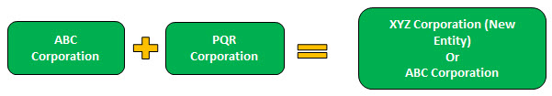

The Merger process may involve two possibilities in the above example:

* A new entity XYZ Corporation will be formed to house the asset and liabilities of existing entities. Hence survival of existing entities ABC Corp and PQR Corp cease to exist.
* ABC Corporation being relatively more robust entity absorbing PQR Corp, hence the resultant entity being the absorbing company, i.e., ABC Corporation.

Amalgamation

Amalgamation is a type of merger process in which two or more companies combine their businesses to form an entirely new entity / company.

Amalgamation is an appropriate arrangement wherein two or more companies operate in the same business; thus, Amalgamation helps in reduction in operational cost due to operational synergy.

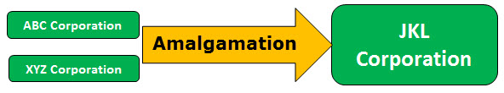

ABC Corp and XYZ Corp will cease to exist after the Amalgamation process resulting in a new entity, JKL Corporation.

Differences between Merger and Amalgamation

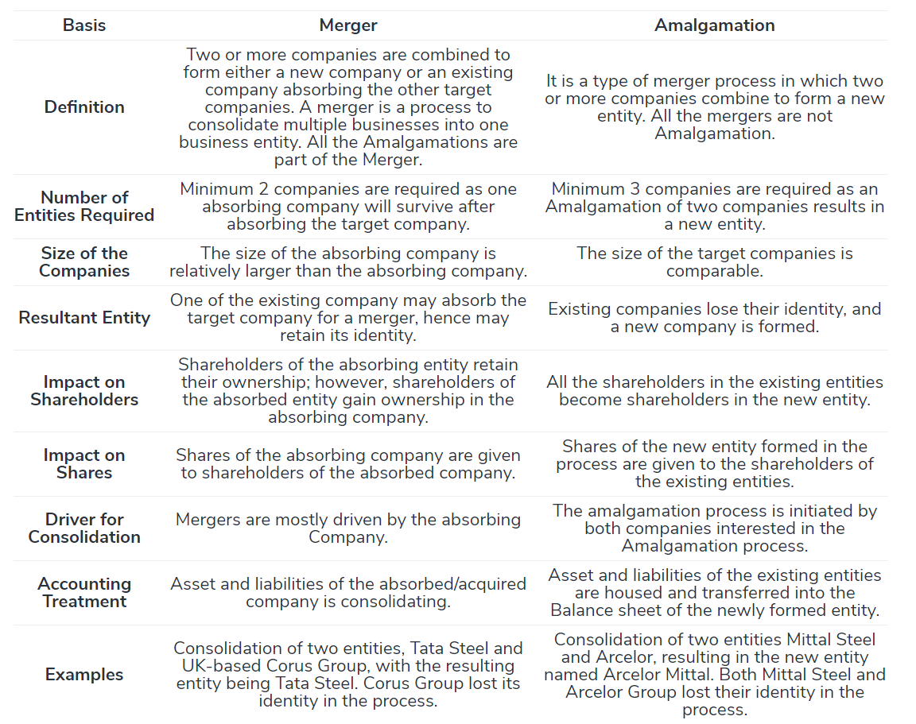

Why Companies prefer Amalgamation and Merger?

Diversification into multiple industries without going through hurdles of starting afresh.

To achieve the Economies of Scale for cost optimization, access to a larger market, effective utilization of resources, etc.

To achieve Operational Synergy by targeting companies in the same industry/similar product lines.

To achieve Growth targets in lesser time.

The advantage in Taxation by combining a loss-making company with a profit-making company, thereby reducing the tax liabilities

Reduced Competition in a specific industry by combining two entities to achieve Effective Financial Planning with a resultant entity having a bigger balance sheet and to utilize financial resources effectively.

Increased Control Over Value Chain in a specific industry by way of forward integration and backward integration.

Case Study on Vodafone-Idea Merger and Amalgamation

*Before* Merger and Amalgamation:

In August 2015, Idea announced the rollout of its 4G services. It was now competing with Airtel and Vodafone – in a non-monopolistic market. The company relaunched its “What an Idea” campaign taking 4G to the rural areas and empowering people through the usage of 4G services.

All is going well for IDEA but all of a sudden in October 2016, Mukesh Ambani announced the launch of the Reliance Jio and disrupted the entire dynamics of the Indian Telecom sector.

Below pie chart shows the market share of different telecom players before the entry of Jio.

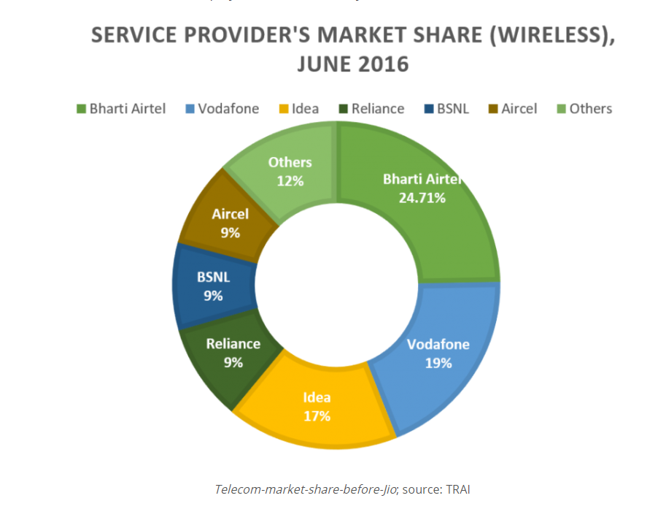

After all, the Indian market is very price sensitive and Jio used it most profitably. Through offering free services for the first few months and then extremely cheap data and voice calls, Jio was able to capture the significant share of the telecom industry.

This is evident from the below pie chart of the post-Jio market share of various telecom players.

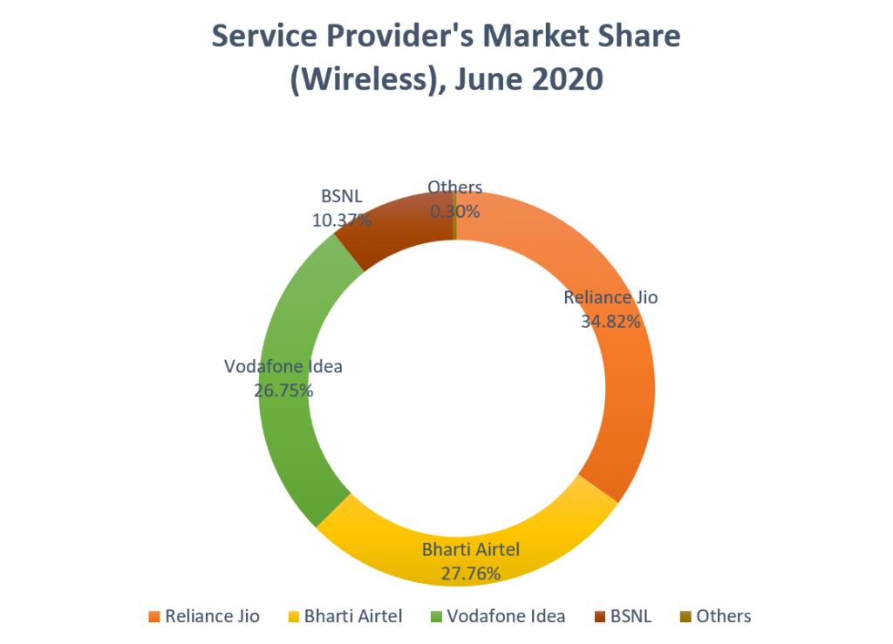

In just four years, Jio gained a significant amount of market share. The small players of the industry went extinct/left the market while the rest were acquired by other telecom players, leaving behind the four major market leaders – Airtel, Jio, Idea, and Vodafone.

As a consequence of Jio’s dominance and competition created by it in the telecom sector, Idea Cellular and Vodafone India joined hands to retail their market share. This merger is a strategic response to Jio’s significant move, as per analysts quoted in various media reports.

On 31 August 2018, Vodafone India merged with Idea Cellular, to form a new entity named Vodafone Idea Limited. Vodafone currently holds a 45.1% stake in the combined entity and Aditya Birla Group holds a 26% stake. Kumar Mangalam Birla heads the merged company as the Chairman. Ravinder Takkar, Ex-CEO of Vodafone Romania is the current CEO of the company.

It was decided that both the brands will continue to operate under their ongoing brand names as they have strong consumer affinity across the metro, urban, rural, and deep interior markets. The merger was also committed to creating a truly ‘Digital India’ by enabling millions of citizens to connect, join the digital revolution, and build a better tomorrow.

But looks like this is yet another long haul, the incessant investments that Jio is raising from around the World, specifically, from the brands like Google and Facebook, almost makes the comeback for other players improbable. It literally went from no market share to almost 35% today.

Vi Rebranding

On 7 September 2020, Vodafone Idea unveiled its new brand identity, 'Vi' which involves the integration of the company's erstwhile separate brands 'Vodafone' and 'Idea' into one unified brand.

As per Vodafone Idea, their new brand name using just the initials of the two companies’ which makes the new logo short & simple and represents the spirit of integration. Also, with their new tagline – Together for Tomorrow, the organization is trying to give a strong message about its future.

As of 31 January 2021, Vi has a subscriber base of 286 million, making it third largest mobile telecommunications network in India and sixth largest mobile telecommunications network in the world.