CSPC 54 : Prolog Assignment-3

Name : Rajneesh Pandey,

Roll no. 106119100,

Class : CSE-B

## Instructions

Implement, DFS, BFS, Best-first search and A* search algorithms in Prolog. Compare the algorithms and justify your results. For A* and Best-first search you may use Straight line distance as the heuristics function.

Try an alternate heuristic function and compare that with the SLD.

Apply the above algorithms to solve the TSP problem

Code :

*/* city with its corresponding index */*

city(1,'City A').

city(2,'City B').

city(3,'City C').

city(4,'City D').

city(5,'City E').

city(6,'City F').

city(7,'City G').

*/* Distance between cities */*

road(1,2,436).    */* From City A to City B the distance is 436 kilometers */*

road(1,7,600).

road(1,3,78).

road(2,4,399).

road(2,5,85).

road(3,7,260).

road(3,6,227).

road(3,4,175).

road(5,7,241).

road(4,6,390).

road(4,5,481).

*/* Heuristic that was used                */*

*/* distance with straight line (assumed) */*

h(1,300).

h(2,250).

h(3,250).

h(4,100).

h(5,80).

h(6,50).

h(7,50).

h(8,200).

*/* highway between cities */*

highway(1,2,'N 163').

highway(1,3,'N 343 e 358').

highway(2,4,'N 163').

highway(4,5,'N 163').

highway(3,4,'N 246').

highway(3,7,'N 246, 364 e 163').

highway(3,6,'N 358 e 364').

highway(5,7,'N 163').

highway(2,5,'N 163').

highway(4,6,'N 358').

find_shortest_path(*Origin*, *Destination*):-

    city(*C1*,*Origin*),

    city(*C2*,*Destination*),

    a_star([[0,*C1*]],*C2*,*ReversePath*),

    reverse(*ReversePath*, *Path*),

    write('The best/shortest Path is: '), print_path(*Path*,*Highways*),

           write('Highway to be traveled will be: '),print_highways(*Highways*),!.

find_shortest_path(**_**,**_**):- write('There was an error with origin or destination city, please type again').

find_all(*Origin*, *Destination*):-

    city(*C1*,*Origin*),

    city(*C2*,*Destination*),

    a_star([[0,*C1*]],*C2*,*ReversePath*),

    reverse(*ReversePath*, *Path*),

    write('A Path was found: '), print_path(*Path*,*Highways*),

    write('Highway to be traveled will be: '),print_highways(*Highways*),fail.

find_all(**_**,**_**):- write('That is all!').

a_star(*Paths*, *Dest*, [*C*,*Dest*|*Path*]):-

    member([*C*,*Dest*|*Path*],*Paths*),

    decide_best(*Paths*, [*C1*|**_**]),

*C1* == *C*.

a_star(*Paths*, *Destination*, *BestPath*):-

    decide_best(*Paths*, *Best*),

    delete(*Paths*, *Best*, *PreviousPaths*),

    expand_border(*Best*, *NewPaths*),

    append(*PreviousPaths*, *NewPaths*, *L*),

    a_star(*L*, *Destination*, *BestPath*).

decide_best([*X*],*X*):-!.

decide_best([[*C1*,*Ci1*|*Y*],[*C2*,*Ci2*|**_**]|*Z*], *Best*):-

    h(*Ci1*, *H1*),

    h(*Ci2*, *H2*),

*H1* +  *C1* =< *H2* +  *C2*,

    decide_best([[*C1*,*Ci1*|*Y*]|*Z*], *Best*).

decide_best([[*C1*,*Ci1*|**_**],[*C2*,*Ci2*|*Y*]|*Z*], *Best*):-

    h(*Ci1*, *H1*),

    h(*Ci2*, *H2*),

*H1*  + *C1* > *H2* +  *C2*,

    decide_best([[*C2*,*Ci2*|*Y*]|*Z*], *Best*).

expand_border([*Cost*,*City*|*Path*],*Paths*):-

    findall([*Cost*,*NewCity*,*City*|*Path*],

        (road(*City*, *NewCity*,**_**),

        not(member(*NewCity*,*Path*))),

*L*),

    change_costs(*L*, *Paths*).

change_costs([],[]):-!.

change_costs([[*Total_Cost*,*Ci1*,*Ci2*|*Path*]|*Y*],[[*NewCost_Total*,*Ci1*,*Ci2*|*Path*]|*Z*]):-

    road(*Ci2*, *Ci1*, *Distance*),

*NewCost_Total* is *Total_Cost* + *Distance*,

    change_costs(*Y*,*Z*).

print_path([*Cost*],[]):- nl, write('The total cost of the path is: '), write(*Cost*), write(' kilometers'),nl.

print_path([*City*,*Cost*],[]):- city(*City*, *Name*), write(*Name*), write(' '), nl, write('The total cost of the path is: '), write(*Cost*), write(' kilometers'),nl.

print_path([*City*,*City2*|*Y*],*Highways*):-

    city(*City*, *Name*),

    highway(*City*,*City2*,*Highway*),

    append([*Highway*],*R*,*Highways*),

    write(*Name*),write(', '),

    print_path([*City2*|*Y*],*R*).

print_highways([*X*]):- write(*X*), nl, nl.

print_highways([*X*|*Y*]):-

    write(*X*),write(' - '),

    print_highways(*Y*).

**INPUT:** find_shortest_path('City A','City E').

**OUTPUT:**

The best/shortest Path is: City A, City B, City E  
The total cost of the path is: 521 kilometers  
Highway to be traveled will be: N 163 - N 163

**Screenshots:**

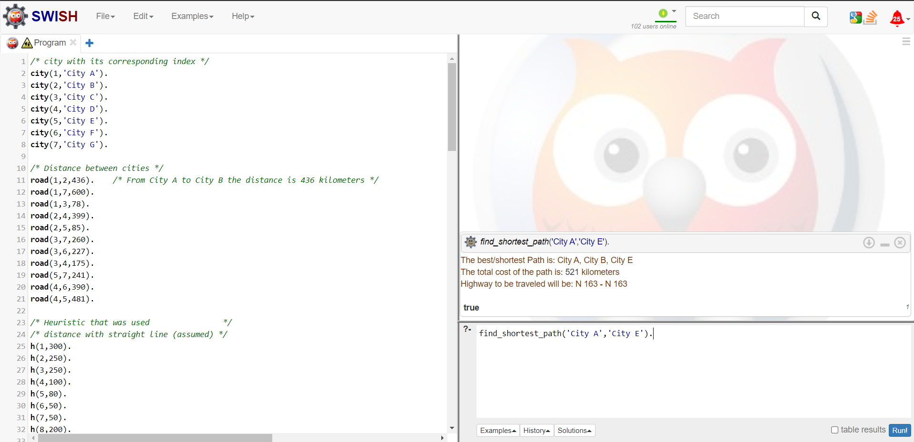

BFS and DFS in Prolog

*%--------------------------------------------------------------%*

*%   Depth-first search by using a stack                        %*

*%   call: depth_first(+[[Start]],+Goal,-Path,-ExploredNodes).  %*

*%--------------------------------------------------------------%*

depth_first([[*Goal*|*Path*]|**_**],*Goal*,[*Goal*|*Path*],0).

depth_first([*Path*|*Queue*],*Goal*,*FinalPath*,*N*) :-

    extend(*Path*,*NewPaths*),

    append(*NewPaths*,*Queue*,*NewQueue*),

    depth_first(*NewQueue*,*Goal*,*FinalPath*,*M*),

*N* is *M*+1.

extend([*Node*|*Path*],*NewPaths*) :-

    findall([*NewNode*,*Node*|*Path*],

            (arc(*Node*,*NewNode*,**_**),

            \+ member(*NewNode*,*Path*)), *% for avoiding loops*

*NewPaths*).

*%--------------------------------------------------------------%*

*%   Breadth-first search                                       %*

*%   call: breadth_first(+[[Start]],+Goal,-Path,-ExploredNodes).%*

*%--------------------------------------------------------------%*

breadth_first([[*Goal*|*Path*]|**_**],*Goal*,[*Goal*|*Path*],0).

breadth_first([*Path*|*Queue*],*Goal*,*FinalPath*,*N*) :-

    extend(*Path*,*NewPaths*),

    append(*Queue*,*NewPaths*,*NewQueue*),

    breadth_first(*NewQueue*,*Goal*,*FinalPath*,*M*),

*N* is *M*+1.