**CHAPTER 1**

**COMPANY PROFILE**

| **Name** | Gieom Business Solutions Pvt Ltd |
| --- | --- |
| **Address** | NAVAMI ARCADE, #18, 4th Floor, 1st Main road, 3rd block, 3rd stage, Basaveshwaranagar, Bangalore, 560079, India |
| **Contact Number** | +91 80 40901243 |
| **Email** | john.santhosh@gieom.com |
| **Website** | https://www.gieom.com |
| **Company Registration Number** | U72200KA2008PTC045605 |
| **Type of the Company** | Private |
| **Nature of the Company** | Banking |
| **Company Logo** |  |
| **Vision** | GIEOM Business Solutions Private Limited is a company that develops software solutions for business process management, compliance management, and risk management |
| **Company Operational Status** | Private |

**CHAPTER 2**

**ABOUT THE COMPANY**

Gieom Business Solutions Pvt Ltd is an Indian software company founded in 2010. It specializes in delivering innovative solutions for business process management, compliance, and risk management across diverse industries. The company's primary focus is on assisting organizations in streamlining their operations, ensuring adherence to regulatory standards, and effectively managing risks.

**2.1 History**

GIEOM Business Solutions Private Limited was founded in 2010 by with a vision to revolutionize business process management, compliance management, and risk management. The company began its journey by developing innovative software solutions aimed at helping organizations streamline their processes, ensure regulatory compliance, and manage risks effectively.

In its early years, GIEOM quickly gained recognition for its customer-centric approach, technological expertise, and commitment to delivering value-driven solutions. The company`s focus on leveraging emerging technologies such as artificial intelligence, machine learning, and analytics set it apart in the market, enabling it to stay ahead of industry trends and meet the evolving needs of its clients.

**2.2 Achievements in Business**

GIEOM Business Solutions Private Limited has achieved remarkable accomplishments in the business world. One of its key feats is being recognized as a leader in providing innovative software solutions for managing business processes, compliance, and risk. Industry experts and organizations have praised the company for its cutting-edge technologies and contributions to improving operational efficiency and regulatory compliance for businesses. Furthermore, GIEOM has successfully expanded its global reach, serving clients across diverse industries such as banking, finance, insurance, and healthcare. This expansion demonstrates GIEOM's ability to deliver tailored solutions that address the specific needs and challenges of different sectors. Additionally, GIEOM has forged strategic partnerships with leading technology providers, allowing it to integrate advanced technologies like artificial intelligence and machine learning into its offerings.

**2.3 Overall turnover**

Gieom Buisness Solutions Private Limited is a platform for banking various courses for KYC.Gieom Buisness Solutions Private Limited headquarters is located in Bangalore , Karnataka. Gieom Buisness Solutions Private Limited generates ₹20,000 in revenue per employee.

**2.4 Number of Employees**

At present there are over 200 employees working in Gieom business solutions Private Limited. Gieom Business Solutions Private Limited have incubation center in India.   
Professional development happens when professionals improve their skills which will enhance their performance and means of achieving it would be from corporate training. They have experience in providing on-site and offshore corporate training programs and have successfully delivered many corporate training programs so far. They work with many organizations to provide corporate training in courses which includes Development. After the training, if the engineers start implementing the topics learnt during training, they provide free guidance to identify the gaps and fine tune the understanding for half day.

**2.5 About the Department**

GIEOM Business Solutions Private Limited, a software company, likely has several teams that work together to ensure smooth operations and deliver high-quality software solutions to their clients.

1. GIEOM Digital Validator helps organizations to automate customer onboarding/Digital KYC process using our ground up developed Artificial Intelligence/Machine Learning components and configurable workflow engine with seamless customer experience, higher accuracy, scalability and faster processing.  
   Digital Validator also supports plug and play APIs for easy integration with any systems for Liveness check, Facial Match, ID Recognition & OCR.
2. Product Development: This team is responsible for designing, developing, and testing software products and services. It includes roles like software developers, engineers, quality assurance testers, and user experience designers.
3. Sales and Marketing: This team focuses on promoting GIEOM's offerings, acquiring new clients, managing customer relationships, and conducting market research to understand customer needs. It includes sales representatives, account managers, marketing specialists, and digital marketers.
4. Customer Support: This team is responsible for providing ongoing assistance and support to GIEOM's clients.
5. The Operations and Administration: This team takes care of the company's daily tasks. This includes managing people, money, laws, and office work. HR staff handle hiring and employee matters. Finance experts deal with money-related tasks. Legal advisors provide counsel on rules and regulations. Administrative assistants help with office duties.
6. Research and Development: Focuses on creating new technologies for GIEOM's products. Analysts study data and trends to find novel ideas. Scientists explore ways to improve current offerings. Researchers investigate cutting-edge concepts to stay ahead in the industry. Their goal: drive innovation and enhancement.
7. Quality Assurance and Compliance: Ensures software meets required standards. Analysts assess product quality and identify issues. Compliance officers verify adherence to regulations. Cybersecurity professionals safeguard systems from threats. Together, they uphold excellence while mitigating risks.

**2.6 Nature of Products**

GIEOM Business Solutions provides software. They simplify work processes, follow rules, and handle risks properly. Their software includes workflow tools to automate tasks and collaborate. Another product ensures policies are tracked and enforced correctly. They offer risk tools to find and reduce operational and money problems. GIEOM's products analyse data and create reports to help make good decisions. They allow businesses to organize operations efficiently. Their software helps achieve goals confidently and stay in control.

**2.7 Nature of Customers**

GIEOM Business Solutions Private Limited aids many types of organizations. Their customers work in banking, finances, insurance, healthcare, telecommunications, government, and other industries. Customers can be small companies or large international corporations.

These customers require software that solves difficult business issues. They need solutions for process management, following rules, and reducing risks. The customers want new technology to make operations smoother, ensure they comply with regulations, and improve risk management practices.

Companies wanting digital change and work better may pick GIEOM. They want tech solutions to grow. GIEOM knows their field and gives valuable products and services, which attracts these firms.

In summary, GIEOM's clients are varied - from different industries. But they all want efficiency, rules followed, risks managed, and new technologies for their business.

GIEOM's customer base may also include companies looking to achieve digital transformation, improve operational efficiency, and drive business growth through technology-enabled solutions. These customers value GIEOM's expertise, industry knowledge, and commitment to delivering value-driven products and services.

Overall, the nature of GIEOM's customers encompasses a diverse range of industries and organizations that prioritize efficiency, compliance, risk management, and technological innovation in their business operations.

**2.8 Introduction to the department where work is carried out**

1. Automation of customer onboarding and Digital KYC processes.
2. Use of AI/ML components for higher accuracy and scalability.
3. Configurable workflow engine for tailored processes.
4. Seamless customer experience with faster processing times

**CHAPTER 3**

**TASK PERFORMED**

During the internship, the work focused on two main areas: Front End Web Development and Optical Character Recognition (OCR) using Tesseract. The trainer carefully selected these tasks to give interns essential industry skills and a deeper understanding of the technology. Each task aimed to provide interns with practical knowledge and hands-on experience relevant to real-world scenarios, ensuring a smooth transition into professional settings.

**3.1 HTML**

**HTML** (HyperText Markup Language) is the most basic building block of the Web. It defines the meaning and structure of web content. Other technologies besides HTML are generally used to describe a web page's appearance/presentation or functionality/ behavior.

"Hypertext" refers to links that connect web pages to one another, either within a single website or between websites. Links are a fundamental aspect of the Web. By uploading content to the Internet and linking it to pages created by other people, you become an active participant in the World Wide Web.

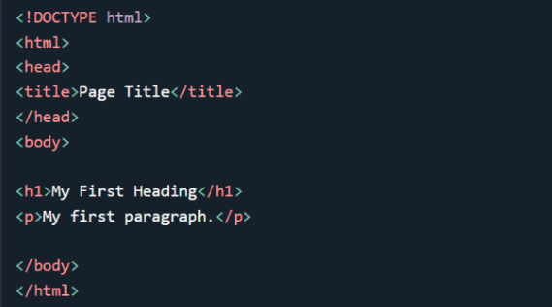

Fig 3.1: A simple html document

Html document explaination The declaration defines that this document is an HTML5 document The element is the root element of an HTML page

The <head> element contains meta information about the HTML page

The <title> element specifies a title for the HTML page (which is shown in the browser's

title bar or in the page's tab)

The <body> element defines the document's body, and is a container for all the visible

contents, such as headings, paragraphs, images, hyperlinks, tables, lists, etc.

The <h1> element defines a large heading

The <p> element defines a paragraph

**3.1.1 HTML Page Structure**

Below is a visualization of an HTML page structure:

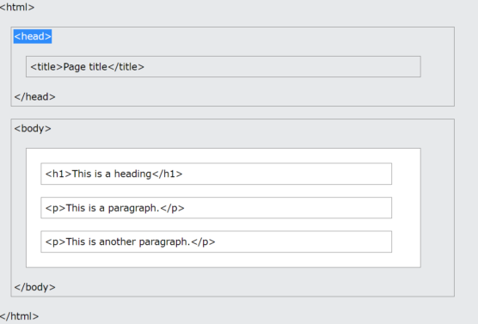

Fig. 3.2: Visualization of HTML page structure

**3.1.2 HTML Element**

An HTML element is defined by a start tag, some content, and an end tag.

The HTML element is everything from the start tag to the end tag:

<tagname> Content </tagname>

Example:

<h1>My First Heading</h1>

<p>My first paragraph.</p>

**3.1.3 HTML Formatting Element**

Formatting elements were designed to display special types of text:

* <b> - Bold text
* <strong> - Important text
* <i> - Italic text
* <em> - Emphasized text
* <mark> - Marked text
* <small> - Smaller text
* <del> - Deleted text
* <ins> - Inserted text
* <sub> - Subscript text
* <sup> - Superscript text

**3.1.4 HTML CSS**

Cascading Style Sheets (CSS) is used to format the layout of a webpage. With

CSS, you can control the color, font, the size of text, the spacing between elements, how

elements are positioned and laid out, what background images or background colors are

to be used, different displays for different devices and screen sizes, and much more.

CSS can be added to HTML documents in 3 ways:

* **Inline** - by using the style attribute inside HTML elements
* **Internal** - by using a <style> element in the <head> section
* **External** - by using a <link> element to link to an external CSS file

**INLINE CSS**

An inline CSS is used to apply a unique style to a single HTML element.

An inline CSS uses the style attribute of an HTML element.

The following example sets the text color of the <h1> element to blue, and the text color

of the <p> element to red:

<h1 style="color:blue;">A Blue Heading</h1>

<p style="color:red;">A red paragraph.</p>

**INTERNAL CSS**

An internal CSS is used to define a style for a single HTML page.

An internal CSS is defined in the <head> section of an HTML page, within

a <style> element.

The following example sets the text color of ALL the <h1> elements (on that page) to

blue, and the text color of ALL the <p> elements to red. In addition, the page will be

displayed with a "powderblue" background color:

<!DOCTYPE html>

<html>

<head>

<style>

body {background-color: powderblue;}

h1 {color: blue;}

p {color: red;}

</style>

</head>

<body>

<h1>This is a heading</h1>

<p>This is a paragraph.</p>

</body>

</html>

**EXTERNAL CSS**

An external style sheet is used to define the style for many HTML pages.

To use an external style sheet, add a link to it in the <head> section of each HTML page:

<!DOCTYPE html>

<html>

<head>

<link rel="stylesheet" href="styles.css">

</head>

<body>

<h1>This is a heading</h1>

<p>This is a paragraph.</p>

</body>

</html>

**OUTPUT:**

# This is a Heading

This is a Paragraph

**3.2 CSS**

Cascading Style Sheets (CSS) is a stylesheet language used to describe the presentation of

a document written in HTML or XML (including XML dialects such as SVG, MathML

or XHTML). CSS describes how elements should be rendered on screen, on paper, in

speech, or on other media.

CSS is among the core languages of the open web and is standardized across Web

browsers according to W3C specifications. Previously, development of various parts of

CSS specification was done synchronously, which allowed versioning of the latest recommendations.

**3.2.1 CSS syntax**

CSS is a rule-based language — you define the rules by specifying groups of styles that should be applied to particular elements or groups of elements on your web page. For example, you can decide to have the main heading on your page to be shown as large red text. The following code shows a very simple CSS rule that would achieve the styling described above:

h1 {

color: red;

font-size: 5em;

}  
 In the above example, the CSS rule opens with a selector . This selects the HTML

element that we are going to style. In this case, we are styling level one headings (<h1>).

We then have a set of curly braces { }. Inside the braces will be one or more declarations,

which take the form of property and value pairs. We specify the property (color in the

above example) before the colon, and we specify the value of the property after the colon

(red in this example). This example contains two declarations, one for color and the other

for font-size. Each pair specifies a property of the element(s) we are selecting (<h1> in

this case), then a value that we'd like to give the property.

**3.2.2 CSS selectors**

In CSS, selectors are used to target the HTML elements on our web pages that we want to style. There are a wide variety of CSS selectors available, allowing for fine-grained precision when selecting elements to style.

**3.2.3 CSS layout**

CSS page layout techniques allow us to take elements contained in a web page and control where they're positioned relative to the following factors. their default position in normal layout flow, the other elements around them, their parent container, and the main viewport/window. The page layout techniques are:

* Normal flow
* The display property
* Flexbox
* Grid
* Floats
* Positioning
* Table layout
* Multiple-column layout

Each technique has its uses, advantages, and disadvantages. No technique is designed to be used in isolation. By understanding what each layout method is designed for you'll be in a good position to understand which method is most appropriate for each task.

**3.3 Flask**

**Introduction to Flask and Its Usage in the Project:**

Flask, a micro web framework written in Python, has emerged as a popular choice among developers for its simplicity, flexibility, and ease of use. Unlike heavyweight frameworks, Flask follows a minimalist approach, providing just what you need to build web applications without imposing unnecessary constraints. Its lightweight nature makes it ideal for projects of all sizes, from simple prototypes to complex web applications.

In our project, Flask plays a pivotal role in orchestrating the backend operations of our Optical Character Recognition (OCR) web application. By leveraging Flask's robust features and extensible architecture, we've crafted a seamless user experience that empowers users to effortlessly extract text from images. Here's how Flask contributes to the functionality and success of our project:

* **Routing and URL Handling:** Flask simplifies the process of defining routes and handling HTTP requests. With Flask's route decorators, we can easily map URLs to specific functions, making it intuitive to navigate through different sections of our OCR application.
* **Request Handling:** Handling user input and requests is a breeze with Flask's request object. We can access form data, file uploads, and other request parameters effortlessly, enabling us to process image uploads and initiate OCR operations seamlessly.
* **Template Rendering:** Flask integrates seamlessly with Jinja2, a powerful templating engine. This allows us to render dynamic HTML content by injecting Python code into HTML templates. With Jinja2, we can create reusable templates for displaying OCR results, error messages, and other interactive components of our web application.
* **Error Handling:** Exception handling in Flask is straightforward, thanks to its built-in error handling mechanisms. We can define custom error pages to gracefully handle errors and exceptions, ensuring a smooth and error-free user experience.
* **Integration with Tesseract OCR:** Flask facilitates the integration of Tesseract OCR, an open-source OCR engine, into our web application. By leveraging Flask's extensibility, we seamlessly incorporate Tesseract OCR functionality to extract text from uploaded images, providing users with accurate and reliable OCR results.
* **Scalability and Extensibility:** Flask's modular design and lightweight architecture make it highly scalable and extensible. As our project grows, we can easily add new features, integrate with additional libraries and frameworks, and scale our application to meet evolving requirements.

**3.3.1 Snippet Code**

# Set path to the Tesseract executable

pytesseract.pytesseract.tesseract_cmd = "/usr/bin/tesseract"

# Define keywords to identify fields

field_keywords = {

'name': ['الاسم'],

'address': ['اسم الاب'],

'dob': ['تاريخ الولادة']

}

def perform_ocr(img):

text = pytesseract.image_to_string(img, lang="ara")

data = {}

for field, keywords in field_keywords.items():

for keyword in keywords:

if keyword in text.lower():

start_index = text.lower().index(keyword)

end_index = start_index + len(keyword)

actual_text = text[end_index:].strip()

data[field] = actual_text[:end_index].strip()

break

return data

@app.route('/', methods=['GET', 'POST'])

def index():

if request.method == 'POST':

# Get uploaded file

file = request.files['file']

# Read the image

img = cv2.imdecode(np.fromstring(file.read(), np.uint8), cv2.IMREAD_COLOR)

# Perform OCR

extracted_data = perform_ocr(img)

return render_template('result.html', data=extracted_data)

return render_template('index.html')

**3.4 PYTHON**

Python is a high-level, interpreted programming language known for its simplicity, readability, and versatility. It has gained immense popularity among developers for its ease of use and extensive libraries and frameworks. Python's clean syntax and dynamic typing make it an ideal choice for a wide range of applications, including web development, data analysis, machine learning, and more.

In this project, Python serves as the primary programming language for developing the backend logic and integrating various components of the OCR web application. Leveraging Python's rich ecosystem of libraries and tools, we utilize Flask for web development, Tesseract for optical character recognition, and OpenCV for image processing.

**3.5 Tesseract OCR**

Tesseract OCR is an open-source optical character recognition engine maintained by Google. It is widely regarded as one of the most accurate OCR engines available, capable of recognizing text in various languages and fonts from images. Tesseract supports multiple image formats and can extract text from scanned documents, photographs, and screenshots with high accuracy.

In our project, Tesseract OCR is integrated with Python using the pytesseract library, allowing us to perform OCR operations on uploaded images. By leveraging Tesseract's powerful capabilities, we can extract text from images and convert it into machine-readable text data, enabling users to process and analyze textual information efficiently.

**3.6 OpenCV**

OpenCV (Open Source Computer Vision Library) is an open-source computer vision and machine learning software library. It provides a comprehensive set of tools and algorithms for image processing, computer vision tasks, and machine learning applications. OpenCV supports a wide range of functionalities, including image manipulation, object detection, facial recognition, and more.

In our project, OpenCV is utilized for image preprocessing and manipulation tasks before performing OCR with Tesseract. We leverage OpenCV's capabilities to read, resize, and preprocess uploaded images, ensuring optimal conditions for accurate text extraction. By incorporating OpenCV into our workflow, we can enhance the quality and reliability of OCR results, improving the overall performance of the OCR web application.

**3.7 Assignment 01**

Project Title: Optical Character Recognition (OCR) Web Application

**Introduction:**

In this assignment, the main task is to build a web application that allows users to upload images containing text and extract text from them using Optical Character Recognition (OCR) technology. This project will provide you with valuable hands-on experience in web development, Python programming, and integrating external libraries.

**Assignment Objectives:**

* Gain proficiency in web development using Flask, a Python web framework.
* Understand the basics of Optical Character Recognition (OCR) and its applications.
* Learn how to integrate the Tesseract OCR engine with Python for text extraction from images.
* Explore image processing techniques using OpenCV library to enhance OCR accuracy.
* Develop a user-friendly web interface for uploading images and displaying OCR results.

**Assignment Details:**

**Frontend Development**

* Implement an HTML/CSS user interface for the web application.
* Create an image upload form using the HTML <input> element.
* Style the interface to provide a visually appealing and intuitive user experience.

**Backend Development:**

* Use Flask to set up routes for handling HTTP requests.
* Implement file upload functionality to accept image files from users.
* Integrate Tesseract OCR engine with Python using the pytesseract library for text extraction.

**Image Processing:**

* Utilize OpenCV library to preprocess uploaded images before OCR.
* Explore techniques such as resizing, noise reduction, and thresholding to improve OCR accuracy.

**Result Display:**

* Design a result page to display the extracted text from uploaded images.
* Implement error handling to gracefully handle exceptions and display error messages.

**Deliverables:**

1. Completed source code for the OCR web application.
2. Documentation explaining the project structure, code implementation, and usage instructions.
3. Presentation/demo showcasing the functionality and features of the web application.

**3.8 PROJECT**

**Project Title: Optical Character Recognition (OCR) Web Application**

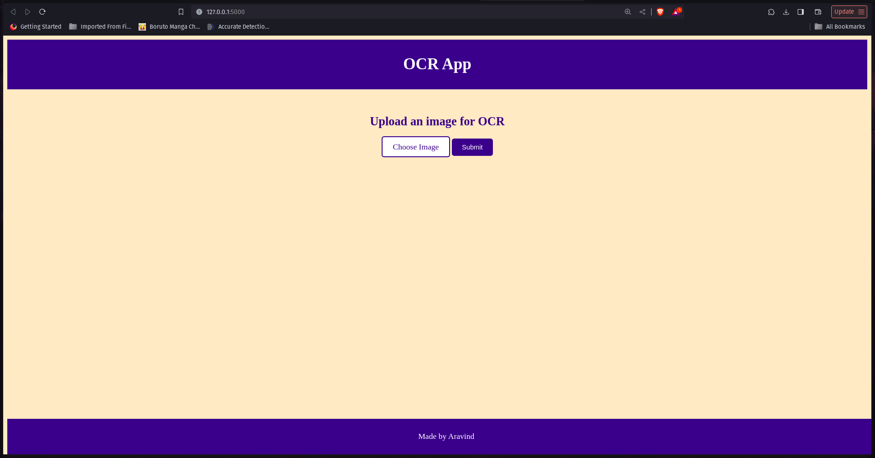

Fig: 3.3 Home page

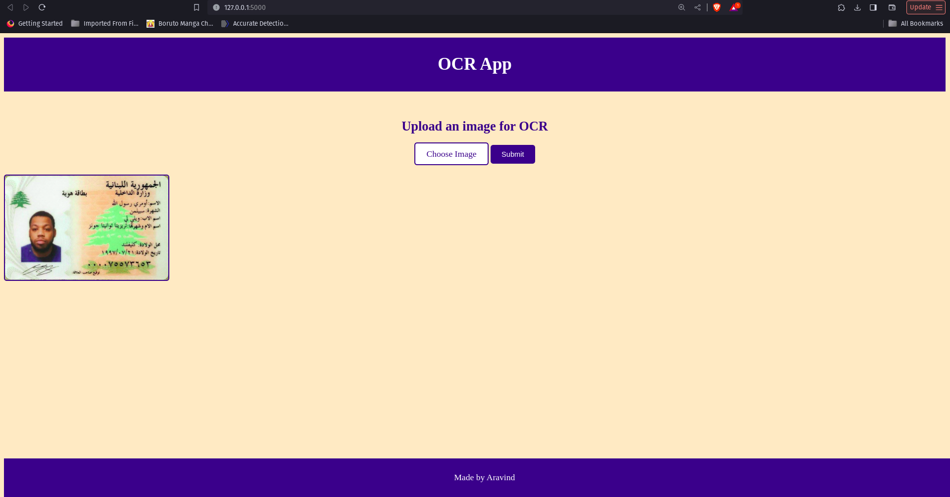

Fig: 3.4 Image Selected Page

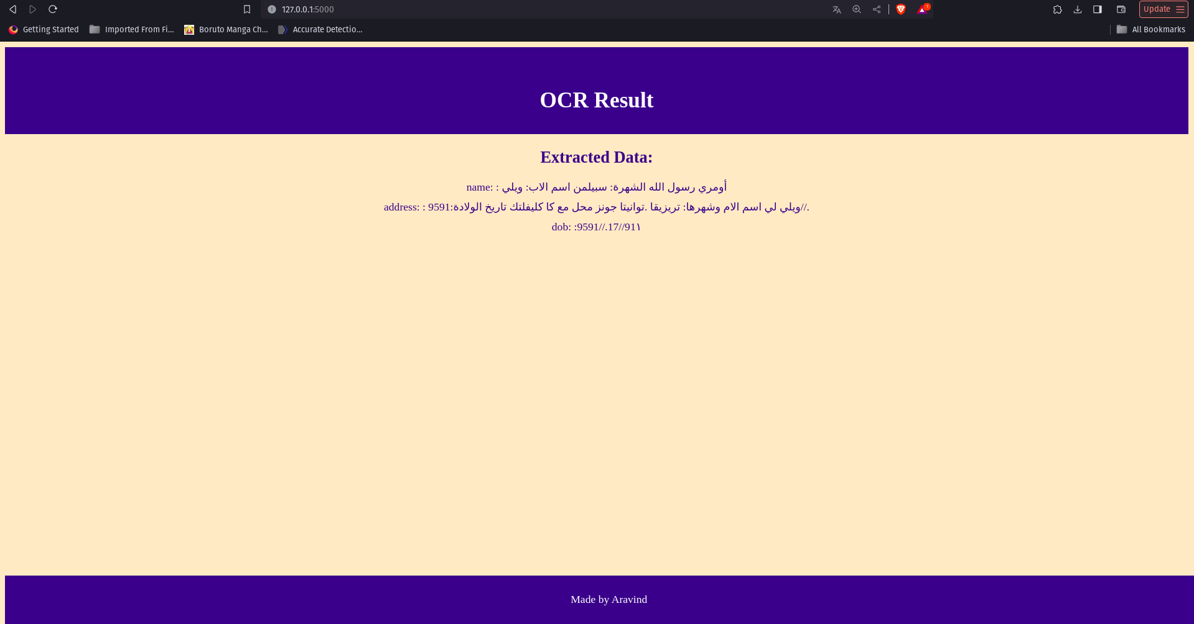

Fig: 3.5 Result Page

**CHAPTER 4**

**SPECIFIC OUTCOMES**

**4.1 TECHNICAL OUTCOMES**

The technical outcome of this project includes the successful implementation of an Optical Character Recognition (OCR) web application using Flask, Tesseract OCR, and OpenCV. Here are the key technical outcomes of the project:

* **Flask Web Application:** Developed a web application using Flask, a lightweight Python web framework. Flask was utilized to handle routing, request handling, and rendering HTML templates, providing a robust backend for the OCR application.
* **Image Upload Functionality:** Implemented image upload functionality, allowing users to upload images containing text to the web application. Flask's file handling capabilities were leveraged to accept and process image files uploaded by users.
* **Tesseract OCR Integration:** Integrated Tesseract OCR engine with Python using the pytesseract library. Tesseract OCR was utilized to extract text from uploaded images, enabling the conversion of image-based text into machine-readable text data.
* **OpenCV Image Processing:** Utilized OpenCV library for image preprocessing tasks to enhance OCR accuracy. OpenCV functionalities such as resizing, noise reduction, and thresholding were applied to optimize the quality of input images before performing OCR.
* **User Interface Development:** Designed and developed a user-friendly web interface using HTML, CSS, and Jinja2 templating engine. The interface provided users with intuitive options for uploading images, submitting OCR requests, and viewing extracted text results.

**4.2 NON TECHNICAL OUTCOMES**

The Internship program helped me in gaining self-confidence over the technical language and also the communication on how to interact with the teammates. The project coordinators were so helpful in teaching. This made me learn many things easily and effectively.

**Personality Development:**

This Internship program helped me in gaining control on how to deal with the project.

**Communication Skills:**

This Internship program helped me to communicate with the project managers, project co-coordinators and team members, which made me gain confidence in my communication skills.

**Time Management:**

Internship program helped me in maintaining time, completing tasks in a given time slot. Periodical interaction with the manager was undertaken so that any changes in the project would be carried out immediately. The assigned tasks were completed on time. This made me to learn time management

**CHAPTER 5**

**CONCLUSION**

In this 4-week duration of my internship, I have learnt many things. They include technical skills and interpersonal skills. I did learn many core concepts along with a stronghold on the basics of many technical skills.

In conclusion, this internship has provided interns with invaluable hands-on experience and practical skills in front-end web development and optical character recognition (OCR) technology. Throughout the internship, interns have gained proficiency in building web applications using Flask, a Python web framework, and have learned how to integrate external libraries such as Tesseract OCR and OpenCV for text extraction from images. The internship has not only enhanced interns' technical capabilities but also fostered critical thinking, problem-solving, and collaboration skills. As interns move forward in their careers, they can leverage the knowledge and experience gained from this internship to tackle real-world challenges and make meaningful contributions to the field of web development and technology.

Some of the key aspects that I observed, are:

* Result driven and goal focused approach to work.
* Enforcing discipline of performance management.
* Supportive employees with a wide range of training and further education opportunities, thereby, fuelling their personal as well as professional growth.
* Similar treatment and similar benefits for all the employees as well as for interns.

During the internship, the benefit I have achieved is to test out a job, employment setting, management style and other aspects of the workplace.

**REFERENCES**