ROOM RENTAL SYSTEM
( for the partial fulfillment of Bachelor of Computer Application)

Submitted by
PANKAJ PANDEY
RAJ SINGH SAINI

Under the guidance of
Mr. Gautam Kumar
Assistant Professor



DEPARTMENT OF COMPUTER SCIENCE AND ENGINEERING
GRAPHIC ERA HILL UNIVERSITY
2026-2027

CERTIFICATE

This is to certify that the thesis titled “ROOM RENTAL SYSTEM” submitted by PANKAJ PANDEY AND RAJ SINGH SAINI, to Graphic Era Hill University for the award of the degree of Bachelor of Computer Application, is a bona fide record of the research work done by him under our supervision. The contents of this project in full or in parts have not been submitted to any other Institute or University for the award of any degree or diploma.

Place: Haldwani Name of guide
Date: Mr. Gautam Kumar
Assistant Professor
GEHU,Haldwani

ACKNOWLEDGEMENT

We would like to express our sincere gratitude to our project guide Mr. Anuj Kumar for his constant guidance, encouragement, and valuable suggestions throughout the course of this project. His support helped us to understand the subject deeply and complete the project successfully.

We are thankful to the Head of the Department and all faculty members of the Department of Computer Science and Engineering, Graphic Era Hill University, for providing a supportive academic environment. We also thank our friends and family members for their continuous motivation and cooperation.

Name of Student 1: Pankaj Pandey Name of Student 2: Raj Singh Saini
Roll No. 2492120 Roll No. 2492140

ABSTRACT

The Room Rental System is a web-based application developed to simplify and digitize the process of renting rooms. In traditional methods, users rely on brokers, personal visits, and local contacts, which often results in time consumption, lack of transparency, and difficulty in comparing available options. This system provides a centralized online platform where users can search, view, and book rooms conveniently, while property owners can list and manage their rental properties efficiently.

The system is developed using modern web technologies such as Node.js and Express.js for backend development, and MongoDB for database management. The frontend is designed using HTML, CSS, and JavaScript to provide an interactive and user-friendly interface. Additional tools are used for image uploading and notification services to enhance functionality.

The application follows a modular and MVC-based architecture, ensuring proper separation of concerns and ease of maintenance. It includes key modules such as user authentication, room management, booking management, and image upload. The system allows users to register, log in, search for rooms, view detailed information, and make bookings, while property owners can add, update, and delete room listings.

Testing of the system has been carried out using various techniques including black box testing, white box testing, and system testing to ensure reliability and correctness. The results indicate that the system performs efficiently and meets the defined requirements.
Overall, the Room Rental System provides an effective and scalable solution for managing rental services. It enhances user experience, reduces manual effort, and demonstrates the practical application of web technologies in solving real-world problems in the rental and housing domain.
TABLE OF CONTENTS

ACKNOWLEDGEMENT...................................................................... i
ABSTRACT .......................................................................................... ii
LIST OF TABLES ................................................................................ v
LIST OF FIGURES ............................................................................... v
ABBREVIATIONS ................................................................................ vi
NOTATIONS ......................................................................................... vi

CHAPTER 1: INTRODUCTION ................................................... 1
  - Objectives of the System .............................................................. 3
  - Scope of the System ..................................................................... 4

CHAPTER 2: REQUIREMENT ANALYSIS ................................. 5
2.1 Functional Requirements ............................................................... 6
2.2 Non-Functional Requirements ....................................................... 7
2.3 System Requirement Specification (SRS) ..................................... 8
2.3.1 Use Case Description .......................................................... 9
2.3.2 Data Flow Diagram (DFD) ................................................ 10
2.3.3 Entity Relationship (ER) Diagram ..................................... 11
2.3.4 Class Diagram .................................................................... 12
2.4 System Architecture Overview ..................................................... 13
2.5 Module Description ...................................................................... 14

CHAPTER 3: SOFTWARE / PROJECT DESIGN ..................... 15
3.1 System Architecture Design ........................................................ 16
3.2 System Workflow ........................................................................ 17
3.3 Algorithm Design ........................................................................ 18
3.3.1 Algorithm for User Registration ....................................... 19
3.3.2 Algorithm for User Login ................................................. 20
3.3.3 Algorithm for Room Booking .......................................... 21
3.4 Module Design ............................................................................ 22
3.5 Database Design Overview ......................................................... 23
3.6 Blueprint of the System .............................................................. 24

CHAPTER 4: RESULT / TESTING OF PROJECT .................. 25
4.1 Test Case Design ........................................................................ 26
4.2 Black Box Testing ...................................................................... 27
4.3 White Box Testing ..................................................................... 27
4.4 System Testing ........................................................................... 28
4.5 Result Analysis .......................................................................... 28
4.6 Limitations ................................................................................. 29

CHAPTER 5: CONCLUSION AND FUTURE SCOPE ............ 30
5.1 Future Scope .............................................................................. 31
APPENDIX ..................................................................................... 32

LIST OF TABLES

Table 2.1: Module Description Table ..................................................... 08
Table 4.1: Test Cases for Room Rental System ...................................... 16

LIST OF FIGURES

Figure 2.1: Use Case Diagram of Room Rental System ......................... 4
Figure 2.2: Data Flow Diagram of Room Rental System ....................... 5
Figure 2.3: ER Diagram of Room Rental System .................................. 6
Figure 2.4: Class Diagram of Room Rental System .............................. 7
Figure 3.1: MVC Architecture of Room Rental System ........................ 9
Figure 3.2: System Workflow Diagram ................................................ 10
Figure 3.3: System Blueprint Diagram ................................................. 14
ABBREVIATIONS
API Application Programming Interface
DB Database
UI User Interface
JWT JSON Web Token
CRUD Create, Read, Update, Delete
MVC Model-View-Controller
HTML HyperText Markup Language
CSS Cascading Style Sheets
JS JavaScript
URL Uniform Resource Locator

NOTATIONS
U User (Tenant)
O Property Owner
A Admin
R Room
B Booking
DB Database
UI User Interface
API Application Programming Interface

CHAPTER 1

INTRODUCTION

The Room Rental System is a web-based application designed to simplify and digitize the process of renting rooms. In the traditional system, people usually depend on brokers, personal visits, and local contacts to find suitable rental accommodations. This approach is often time-consuming, inefficient, and lacks transparency. Many users face difficulties in comparing different options, verifying property details, and contacting owners. To overcome these problems, the Room Rental System provides a centralized online platform where users can search, view, and book rooms easily.
The system allows property owners to list their rooms by providing necessary details such as location, rent, amenities, and images. At the same time, users can browse available rooms, view detailed information, and make booking decisions based on their preferences. This eliminates the need for intermediaries and reduces the overall effort required to find rental properties. The platform ensures that users can access accurate and up-to-date information at any time.
The Room Rental System is developed using modern web technologies to ensure efficiency and scalability. The backend of the system is implemented using Node.js and Express.js, which handle server-side logic and routing. MongoDB is used as the database to store user data, room details, and booking information. The frontend is designed using HTML, CSS, and JavaScript to provide an interactive and user-friendly interface. Additional tools such as Multer are used for uploading room images, and Nodemailer is used for sending notifications to users.
The system follows a modular architecture, where different components are responsible for specific functionalities. The authentication module handles user registration and login, ensuring secure access to the system. The room management module allows property owners to add, update, and delete room listings. The booking module enables users to reserve rooms and view their booking history. This structured approach improves the maintainability and performance of the system.
The main objective of this project is to provide an efficient and reliable solution for managing rental services. It aims to reduce manual work, minimize errors, and improve the overall user experience. By providing a digital platform, the system enables faster communication between users and property owners. It also ensures that all data is stored securely and can be accessed easily whenever required.
Another important objective of the system is to provide convenience to users. The application is designed in such a way that even users with basic computer knowledge can operate it without difficulty. The interface is simple and intuitive, allowing users to perform actions such as searching for rooms, viewing details, and booking rooms with ease. The system also supports image uploads, which helps users get a clear understanding of the property before making a decision.
The scope of the Room Rental System includes multiple functionalities that cater to different types of users. Students and working professionals can use the system to find suitable accommodations, while property owners can use it to manage their listings effectively. The system also has the potential to be extended with additional features such as online payment integration, location-based services, and advanced search filters.
In addition, the system ensures data consistency and security by implementing proper authentication and validation mechanisms. User information is protected, and unauthorized access is restricted. The system is designed to handle multiple users simultaneously, making it suitable for real-world applications.
Overall, the Room Rental System provides a modern and efficient solution to the challenges faced in traditional rental systems. It improves accessibility, enhances user experience, and ensures better management of rental data. The project demonstrates the practical implementation of web technologies in solving real-world problems and highlights the importance of digital transformation in the housing and rental sector.
1.1 Objectives of the System
The primary objective of the Room Rental System is to provide a digital platform that simplifies the process of renting rooms. The system aims to reduce dependency on manual methods and improve efficiency in managing rental information.
The key objectives of the system are as follows:
• To provide an online platform for searching and booking rental rooms
• To enable property owners to list and manage their rooms easily
• To reduce the time and effort required to find suitable accommodation
• To ensure secure user authentication and data handling
• To provide accurate and up-to-date information about available rooms
• To enhance user experience through a simple and interactive interface
1.2 Scope of the System
The Room Rental System is designed to serve a wide range of users, including students, professionals, and property owners. It provides functionalities that support both searching and managing rental properties.
The scope of the system includes:
• User registration and login functionality
• Adding, updating, and deleting room listings
• Viewing detailed information about rooms
• Uploading images of rooms
• Booking rooms through the system
• Managing user and booking data
The system can be further expanded in the future to include advanced features such as online payments, mobile application support, and real-time communication between users and property owners.

CHAPTER 2

Requirement analysis
Requirement Analysis is a crucial phase in the development of the Room Rental System. It involves identifying the needs of users, defining system functionalities, and understanding how different components of the system interact. This phase ensures that the system is designed according to user expectations and operates efficiently.
The Room Rental System is developed to provide an online platform where users can search, view, and book rental rooms, while property owners can list and manage their properties. The system eliminates the limitations of traditional rental methods by providing a centralized and automated solution.
The requirements of the system are categorized into functional requirements and non-functional requirements.

2.1 Functional Requirements
Functional requirements define the core features and operations that the system must perform.
• Users should be able to register and log in to the system
• The system should allow secure authentication of users
• Property owners should be able to add, update, and delete room listings
• Users should be able to view available rooms with details
• The system should allow uploading images of rooms
• Users should be able to search and filter rooms based on criteria
• The system should allow booking of rooms
• Users should be able to view their booking history
• The system should maintain records of all users and bookings

2.2 Non-Functional Requirements
Non-functional requirements define the quality and performance aspects of the system.
• The system should be easy to use and user-friendly
• The response time of the system should be fast
• The system should ensure data security and privacy
• The system should be reliable and available at all times
• The system should support scalability for future enhancements
• Proper validation and error handling should be implemented

2.3 System Requirement Specification (SRS)
The Software Requirement Specification (SRS) describes the overall structure and behaviour of the Room Rental System. It includes various diagrams and models to represent system functionality.

2.3.1 Use Case Description
The Room Rental System involves three main actors:
• User (Tenant)
• Property Owner
• Admin
The interactions between these actors and the system are described below:
- User can register, login, search rooms, view details, and book rooms
- Property Owner can add, update, and delete room listings
- Admin can manage users, rooms, and bookings
These interactions form the basis of the Use Case Diagram.

Figure 2.1: Use Case Diagram of Room Rental System
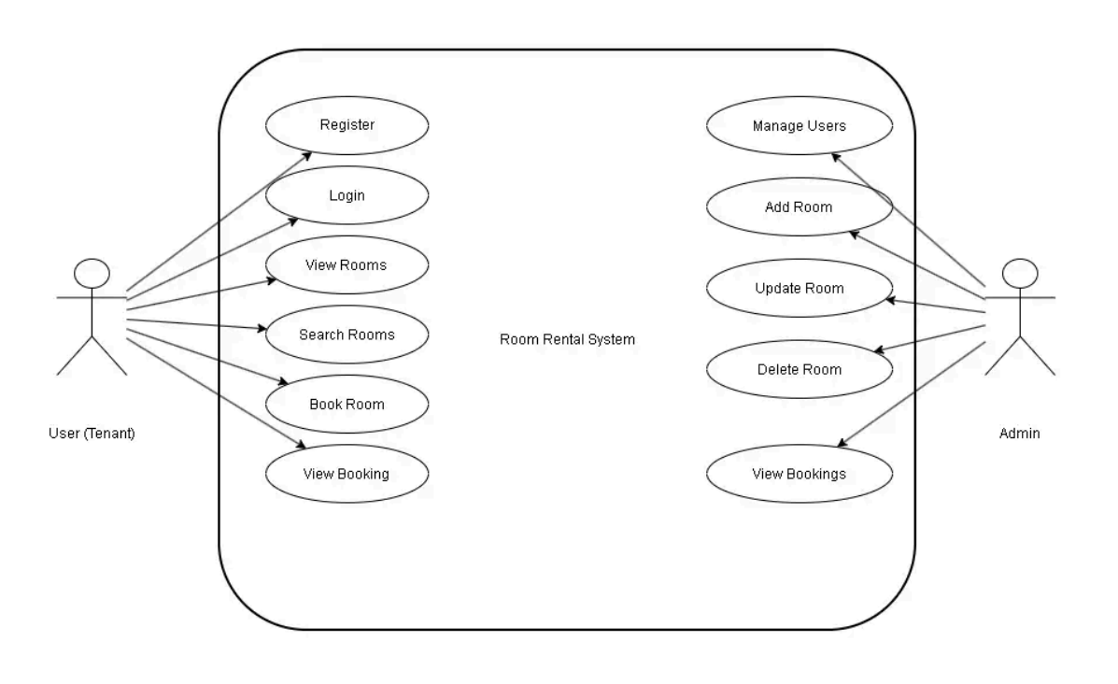
2.3.2 Data Flow Description (DFD)
The Data Flow Diagram (DFD) represents how data moves within the system.
- In Level 0 (Context Diagram), the system interacts with users and database
- In Level 1, the system is divided into processes such as:
  - User Authentication
  - Room Management
  - Booking Management
Data flows between users, processes, and database to perform operations.

Figure 2.2: Data Flow Diagram of Room Rental System
Level 0 :
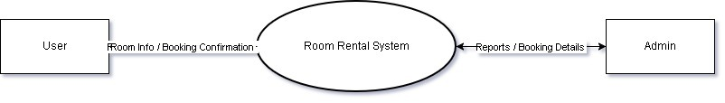
Level 1 :
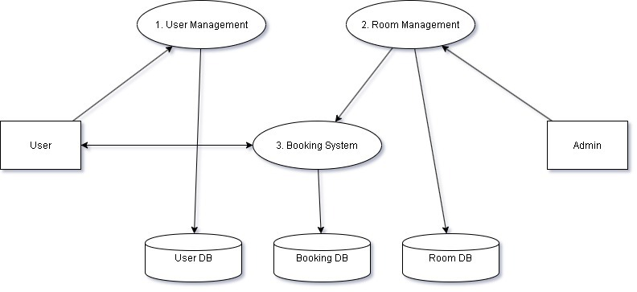

2.3.3 Entity Relationship (ER) Description
The Entity Relationship Diagram represents the database structure of the system.
Entities:
- User
- Room
- Booking

Relationships:
- One user can make multiple bookings
- One room can be booked multiple times
- Each booking is linked to a user and a room
The ER diagram helps in designing the database schema efficiently.

Figure 2.3: ER Diagram of Room Rental System

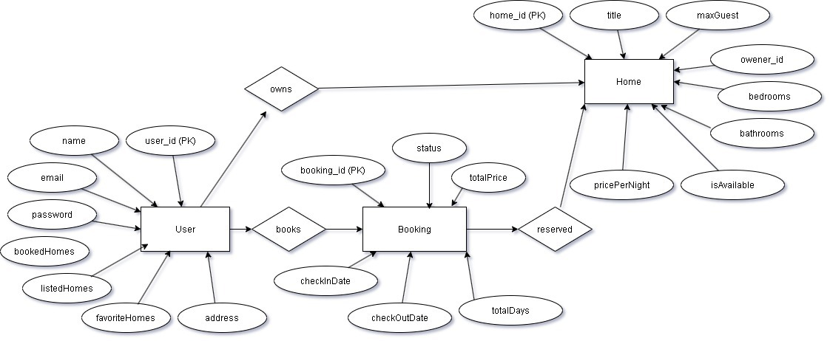

2.3.4 Class Description
The Class Diagram represents the structure of the system using object-oriented concepts.
Main Classes:
- User Class → stores user information
- Room Class → stores room details
- Booking Class → stores booking information
Each class contains attributes and methods that define its behavior and interaction with other classes.

Figure 2.4: Class Diagram of Room Rental System
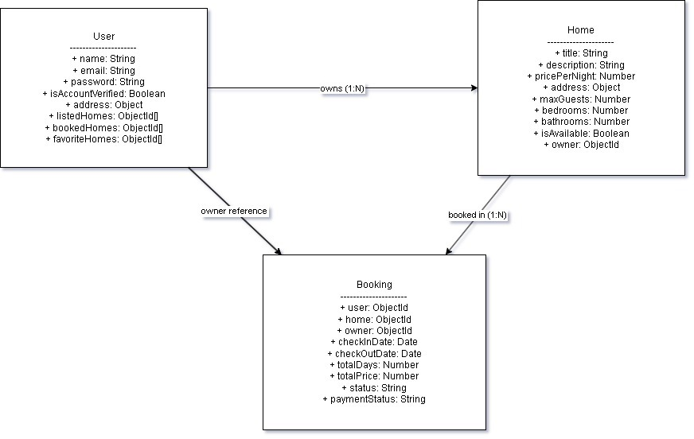

2.4 System Architecture Overview
The Room Rental System follows the MVC (Model-View-Controller) architecture.
- Model → Handles database (User, Room, Booking)
- View → Frontend interface (HTML, CSS, JavaScript)
- Controller → Handles logic and requests
This architecture separates concerns and improves system maintainability.

2.5 Module Description
The system is divided into different modules for better organization:
• Authentication Module – Handles login and registration
• Room Module – Manages room listings
• Booking Module – Handles booking operations
• Upload Module – Manages image uploads
• User Module – Handles user data

Table 2.1: Module Description Table
Module Name | Description
Authentication | Handles user login and registration
Room Management | Manages room listings
Booking | Handles room booking
Upload | Manages image upload
User | Stores user details

CHAPTER 3

softwrae / project design

The Software Design phase defines how the Room Rental System is structured and how different components interact to perform the required operations. This phase focuses on transforming requirements into a detailed system architecture, algorithms, and module designs.
The Room Rental System is designed using a modular approach, where each module is responsible for a specific functionality such as authentication, room management, and booking. The system follows a structured architecture that ensures scalability, maintainability, and efficient performance.
The application is developed using a web-based architecture in which the frontend interacts with the backend server, and the backend communicates with the database. This layered structure ensures proper separation of concerns and improves system efficiency.

3.1 System Architecture Design
The Room Rental System follows the MVC (Model-View-Controller) architecture.
- Model: Handles database operations (User, Room, Booking)
- View: User interface (HTML, CSS, JavaScript)
- Controller: Business logic and request handling
This architecture ensures that the system is easy to manage and extend in the future.

Figure 3.1: MVC Architecture of Room Rental System
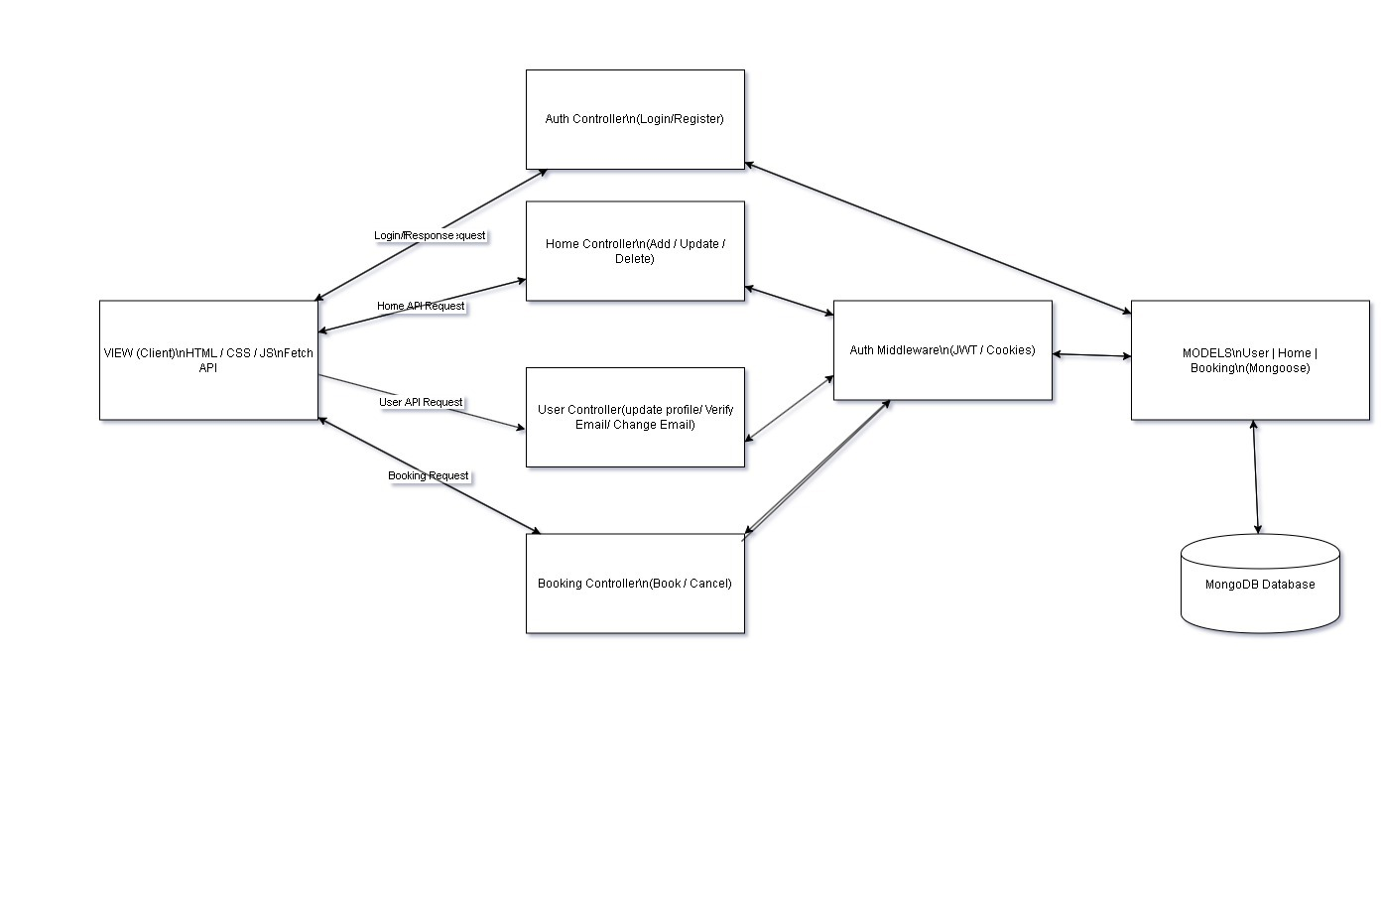
3.2 System Workflow
The system workflow describes how users interact with the application and how data flows through the system.
- User registers or logs into the system
- User searches for available rooms
- System retrieves room data from database
- User views room details
- User books a room
- Booking details are stored in the database
- Confirmation is provided to the user

Figure 3.2: System Workflow Diagram
Owner side :
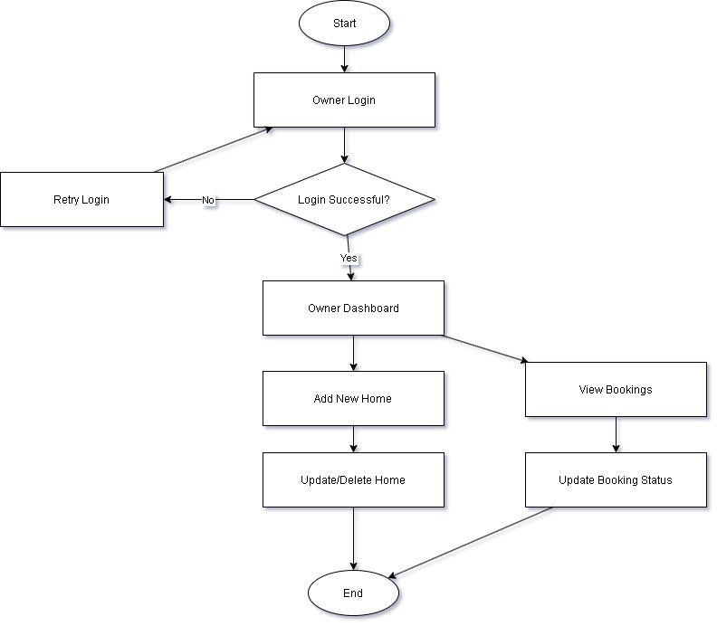

User side :
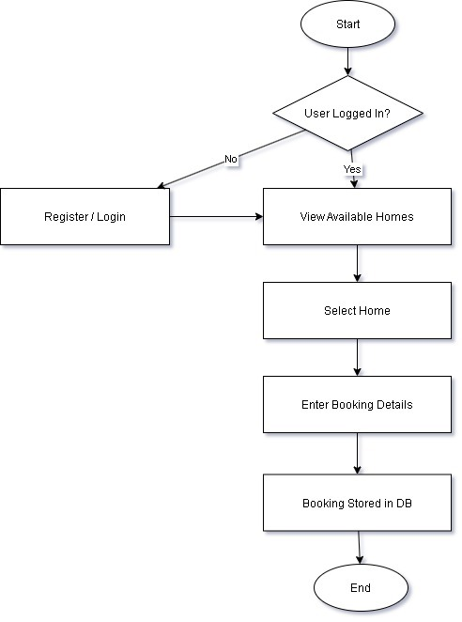

3.3 Algorithm Design
The algorithm defines step-by-step procedures for key operations in the system.

3.3.1 Algorithm for User Registration
Step 1: User enters registration details
Step 2: System validates input data
Step 3: Check if user already exists
Step 4: If not, store user data in database
Step 5: Display success message

3.3.2 Algorithm for User Login
Step 1: User enters login credentials
Step 2: System verifies credentials
Step 3: If valid, allow access
Step 4: Else, display error message

3.3.3 Algorithm for Room Booking
Step 1: User selects a room
Step 2: System checks room availability
Step 3: If available, proceed to booking
Step 4: Store booking details in database
Step 5: Confirm booking to user

3.4 Module Design
The Room Rental System is divided into different modules:

3.4.1 Authentication Module
- Handles user registration and login
- Ensures secure access

3.4.2 Room Management Module
- Add room listings
- Update room details
- Delete room listings

3.4.3 Booking Module
- Book rooms
- Store booking records
- View booking history

3.4.4 Image Upload Module
- Upload room images
- Store images in server

3.4.5 User Module
- Manage user data
- Handle user profiles

3.5 Database Design Overview
The database is designed using MongoDB and contains the following collections:
- User Collection → Stores user information
- Room Collection → Stores room details
- Booking Collection → Stores booking data
Each collection is related to ensure proper data management and retrieval.

3.6 Blueprint of the System
The blueprint represents the overall structure of the system, including frontend, backend, and database interaction.
- User interacts with frontend
- Frontend sends request to backend
- Backend processes request
- Database stores/retrieves data
- Response sent back to user

Figure 3.3: System Blueprint Diagram
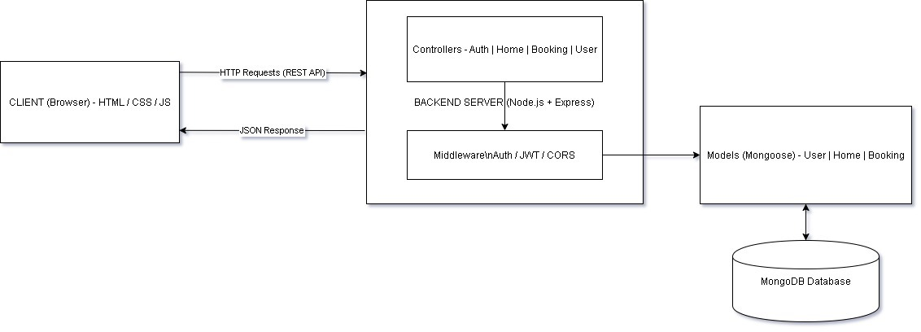

CHAPTER 4

Result/TESTING OF PROJECT / SOFTWARE

Testing is a crucial and indispensable phase in the development of the Room Rental System. It plays a significant role in ensuring that the entire system functions correctly, efficiently, and in accordance with the specified user requirements. Without proper testing, even a well-designed system may fail to deliver expected results. The primary purpose of testing is to identify errors, detect bugs, verify system functionality, and ensure that all modules and components perform accurately under different conditions. It also helps in improving the overall quality, reliability, and performance of the system before it is deployed for real-world use.

The Room Rental System has been tested using a variety of testing techniques and methodologies to validate its performance, reliability, usability, and correctness. Both manual and systematic testing approaches have been applied to examine different aspects of the system. All major functionalities, including user authentication, room listing, room booking process, payment handling (if applicable), and image upload features, have been tested thoroughly. Each module has been verified individually as well as in integration with other modules to ensure smooth interaction and proper data flow across the system. Special attention has been given to handling user inputs, validating data, and ensuring that incorrect or invalid inputs are managed effectively without causing system failure.

In addition to functional testing, the system has also been evaluated for performance and consistency under different scenarios. Various test cases have been executed to check how the system behaves with multiple users, different types of inputs, and edge cases. The results obtained from testing clearly indicate that the system performs efficiently and provides accurate and reliable outputs for a wide range of inputs. The system successfully handles user requests, processes data correctly, and maintains data consistency throughout operations. Furthermore, it ensures that all transactions and records are stored securely and retrieved accurately when required.

Overall, the testing phase confirms that the Room Rental System is stable, reliable, and ready for deployment. The system meets the intended objectives and provides a user-friendly and efficient platform for managing room rentals, thereby fulfilling both user expectations and project.

4.1 Test Case Design
Test cases are designed to verify whether the system meets the expected requirements. Each test case includes input, expected output, and actual result.

Table 4.1: Test Cases for Room Rental System
Test Case ID | Test Scenario | Input | Expected Output | Result
TC01 | User Registration | Valid user details | User registered successfully | Pass
TC02 | User Login | Correct credentials | Login successful | Pass
TC03 | User Login | Incorrect credentials | Error message displayed | Pass
TC04 | Add Room | Valid room data | Room added successfully | Pass
TC05 | View Rooms | Request room list | Room details displayed | Pass
TC06 | Book Room | Valid booking request | Booking confirmed | Pass
TC07 | Upload Image | Valid image file | Image uploaded successfully | Pass
TC08 | Delete Room | Valid request | Room deleted successfully | Pass

4.2 Black Box Testing
Black Box Testing is performed without considering the internal structure of the code. It focuses on testing the functionality of the system based on inputs and expected outputs.
In the Room Rental System, Black Box Testing is used to verify:
• User registration and login functionality
• Room search and display
• Booking process
• Form validation and error messages
All test cases passed successfully, indicating that the system behaves correctly for different input conditions.

4.3 White Box Testing
White Box Testing is used to test the internal logic and structure of the code. It ensures that all code paths, conditions, and loops are working correctly.
In the Room Rental System, White Box Testing is applied to:
• Authentication logic (login validation)
• Booking algorithm
• Database operations
• API request handling
The testing confirms that all internal processes function correctly and efficiently.

4.4 System Testing
System Testing is performed to evaluate the complete system as a whole. It ensures that all modules work together properly.
The following functionalities were tested:
• End-to-end user workflow (login → search → booking)
• Data storage and retrieval
• Interaction between frontend and backend
The system successfully passed all system-level tests.

4.5 Result Analysis
The results of testing indicate that the Room Rental System is functioning correctly and efficiently. All modules are integrated properly, and the system provides accurate outputs for given inputs.
The system is capable of handling multiple users and maintaining data consistency. It also ensures secure access through authentication mechanisms.

4.6 Limitations
Although the system performs well, there are some limitations:
• No online payment integration
• Limited advanced search filters
• No real-time communication between users and owners

CHAPTER 5

Conclusion AND fUTURE SCOpe
The Room Rental System has been successfully developed to provide an efficient and user-friendly platform for managing rental properties. The system simplifies the process of searching, listing, and booking rooms by replacing traditional manual methods with a digital solution. It reduces the time and effort required to find suitable accommodations and improves transparency in the rental process.
The application allows users to register, log in, view available rooms, and make bookings easily. Property owners can manage their listings by adding, updating, and deleting room details. The system ensures secure data handling through authentication mechanisms and maintains accurate records of users, rooms, and bookings.
The use of modern web technologies such as Node.js, Express.js, and MongoDB has enabled the development of a scalable and efficient system. The modular design of the application ensures that different components function independently while maintaining smooth interaction with each other. The system has been tested thoroughly and has shown reliable performance under various conditions.
Overall, the Room Rental System meets its objectives by providing a centralized platform that enhances user experience, reduces manual effort, and improves the management of rental data. It demonstrates how technology can be effectively used to solve real-world problems in the housing and rental domain.
5.1 Future Scope
Although the current system provides essential functionalities, it can be further enhanced by adding advanced features in the future.
• Integration of online payment systems for secure transactions
• Development of a mobile application for better accessibility
• Implementation of location-based services using maps
• Addition of chat functionality between users and property owners
• Advanced filtering and recommendation system using machine learning
• Notification system using SMS or email alerts
• Rating and review system for rooms and property owners
These enhancements will improve the functionality and usability of the system, making it more efficient and user-friendly.

APPENDIX A

Repository Structure:
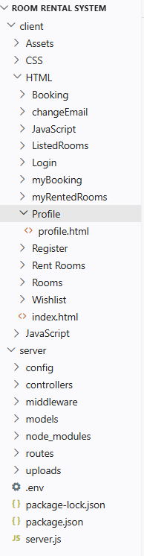
Client Side(a):

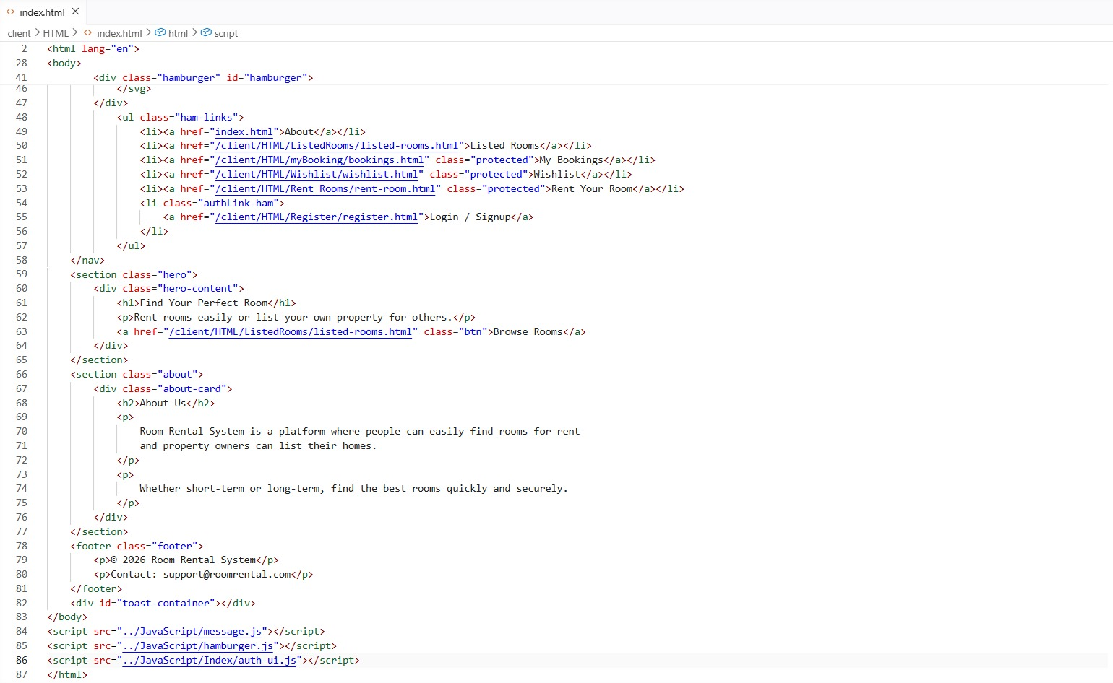

Client Side(b):

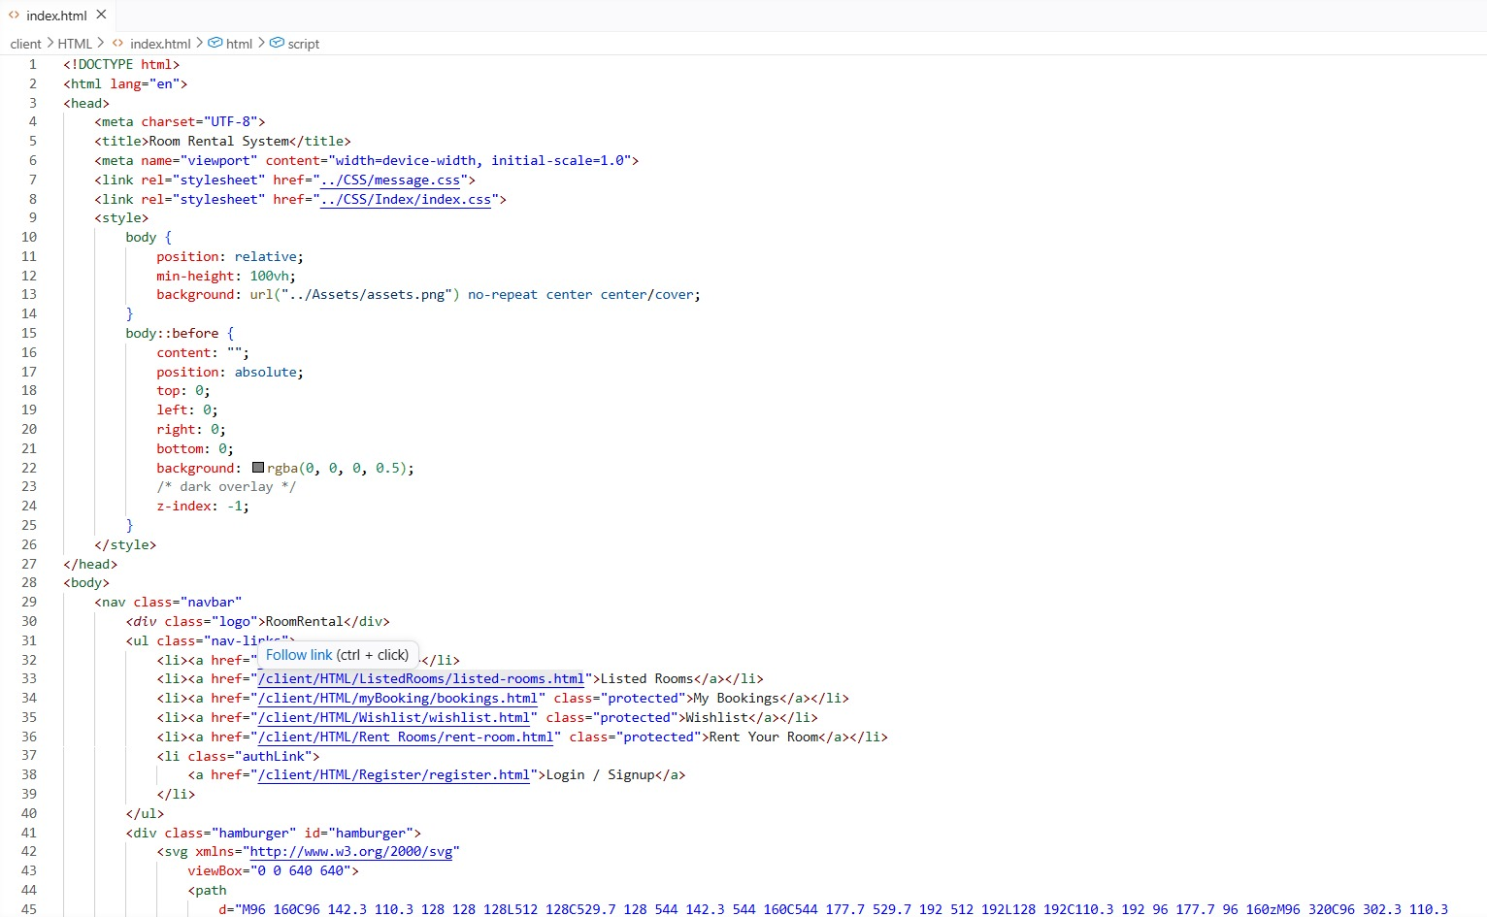

Server side :

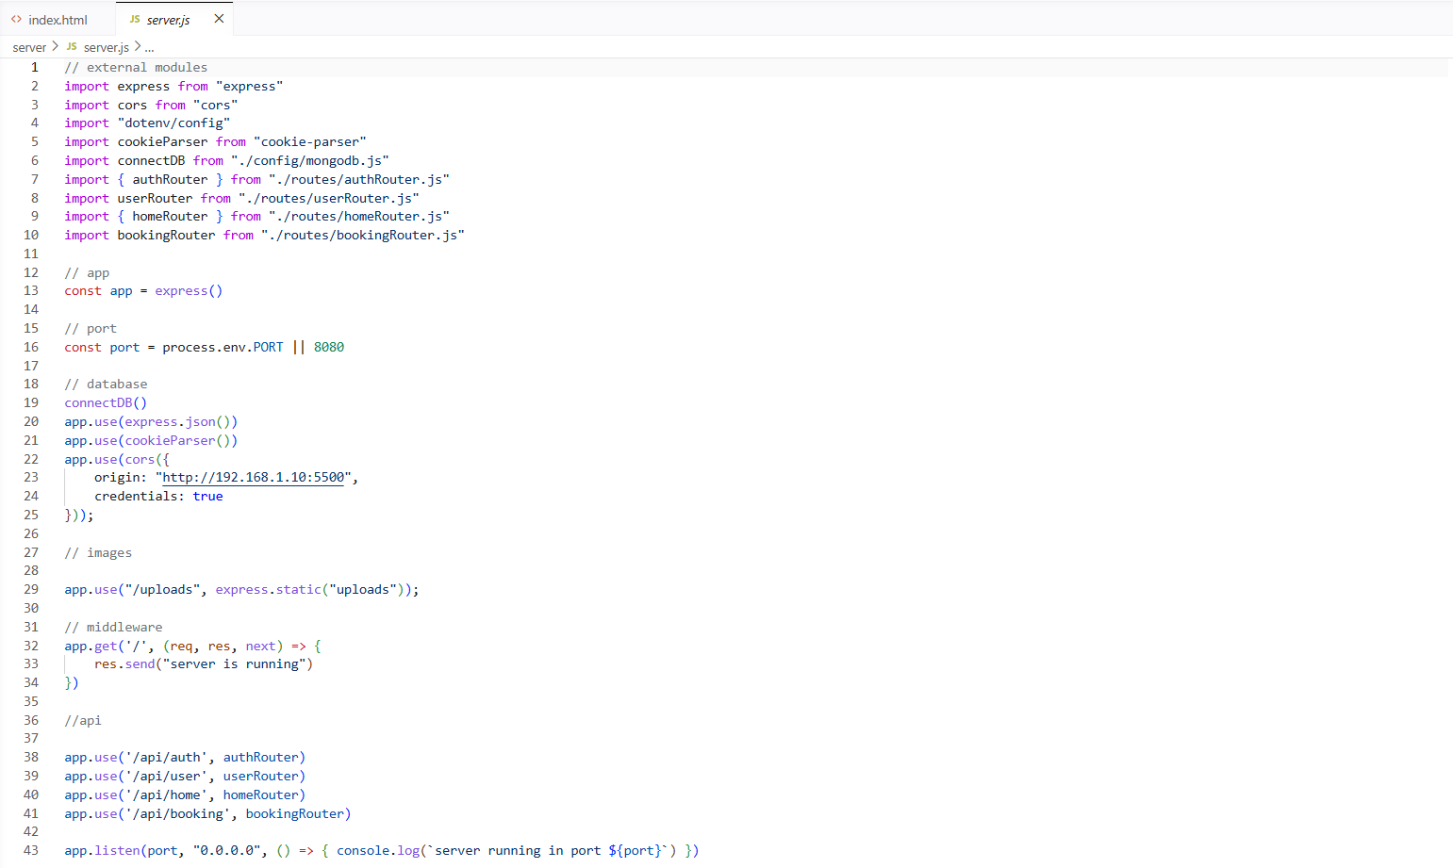

References

[1] Node.js Documentation, Available: https://nodejs.org
[2] Express.js Documentation, Available: https://expressjs.com
[3] MongoDB Documentation, Available: https://www.mongodb.com
[4] HTML & CSS Documentation, Available: https://developer.mozilla.org
[5] JavaScript Guide, Available: https://developer.mozilla.org
[6] Multer Documentation, Available: https://www.npmjs.com/package/multer
[7] Nodemailer Documentation, Available: https://nodemailer.com
[8] GitHub, Available: https://github.com

- Websites Used
- https://nodejs.org
- https://expressjs.com
- https://www.mongodb.com
- https://developer.mozilla.org
- https://www.npmjs.com
- https://github.com

- Any Other References
- Study material and lecture notes related to Web Development
- Online tutorials and documentation for full-stack development
- Academic resources on software engineering and system design

Publications

No formal publications have been made as part of this project work. The Room Rental System has been developed primarily as an academic project to demonstrate the practical implementation of web technologies and software development concepts.

Although the project has not been published in any journals or conferences, it reflects a comprehensive understanding of full-stack development using technologies such as Node.js, Express.js, and MongoDB. The work includes system design, requirement analysis, implementation, and testing, which together form a complete software solution.

The project has the potential to be further enhanced and documented for future publication in technical journals or online platforms. It can also be shared on platforms such as GitHub for collaboration, improvement, and reference by other developers and students.

