






ASSIGNMENT 2 REPORT
ADVANCED TOPICS IN DEEP LEARNING

DEFENSIVE DISTILLATION ON RESNET‑34 / CIFAR‑10

Submitted on : 21/10/2023
Submitted by : RAJU (2023UG000147)

Contents
Chapter 1: Introduction and Experimental Setup 3
1.1: Objective and Abstract 3
1.2: Experimental Setup 3
1.3: Summary of Key Results 3
Chapter 2: Question 1 – Defensive Distillation 4
2.1: Role of the T² Factor (Question 1a) 4
2.2: Training Curves, Clean Accuracy and Training Time (Question 1b) 5
2.3: Observations 5
Chapter 3: Question 2 – Adversarial Evaluation 5
3.1: Attack Implementation (Questions 2a, 2b) 5
3.2: Accuracy versus ε (Question 2c) 6
3.3: Five Test Samples under FGSM and PGD (Question 2d) 7
3.4: Discussion – Robustness and Gradients (Question 2e) 9
Chapter 4: Evaluation on 200 Unseen External Images 10
4.1: Setup and Overall Results 10
4.2: Per-class Accuracy 10
4.3: Findings 11
Chapter 5: Conclusions, Limitations and References 12
5.1: Conclusions 12
5.2: Limitations 12
5.3: References 12

Chapter 1: Introduction and Experimental Setup

1.1: Objective and Abstract
This report investigates whether defensive distillation (Papernot et al., 2016) improves the adversarial robustness of a ResNet-34 trained on CIFAR-10. Three models were trained for 50 epochs: a baseline B (hard labels, temperature T = 1), a teacher M1 (hard labels, T = 20) and a student M2 distilled from the frozen teacher at T = 20 with the T² loss scaling. The models are attacked with untargeted white-box FGSM and PGD-20 at inference temperature T = 1, and are finally tested on 200 external real-world images. All results are taken directly from the executed notebooks and the exported CSV files.

1.2: Experimental Setup
Model | Training targets | Temperature T
Baseline B | Ground-truth labels | 1
Teacher M1 | Ground-truth labels | 20
Student M2 | Soft targets of the frozen teacher M1 | 20

Table 1: The three models of the study.
- Architecture: ResNet-34 adapted to 32×32 inputs (3×3 stride-1 stem, no max-pool, 10-way linear head, 21,282,122 parameters).
- Normalisation: CIFAR mean/std normalisation is performed inside the model, so inputs, gradients and attack budgets live in raw [0, 1] pixel space.
- Optimisation: AdamW (learning rate 10⁻³, weight decay 10⁻⁴), cosine annealing, batch size 128, mixed precision, seed 42, 50 epochs on the 50,000 training images.
- Temperature: a temperature argument divides the logits by T. Clean accuracy is always measured on the 10,000 test images at T = 1.
- Student loss: the frozen teacher gives q = softmax(v/20); the student gives p = softmax(z/20); the loss is −(T²/N) Σ_{i} Σ_{k} q_{i,k} log p_{i,k} with T = 20.
- Hardware: NVIDIA GeForce RTX 2050, PyTorch 2.5.1 with CUDA 12.1.

1.3: Summary of Key Results
Metric | Baseline B | Teacher M1 | Student M2
Clean test accuracy, 10,000 images (%) | 84.62 | 82.35 | 81.90
Training time (min) | 64.92 | 63.34 | 88.54
FGSM accuracy at ε = 8/255 (%) * | 4.2 | 24.0 | 25.6
PGD-20 accuracy at ε = 8/255 (%) * | 0.4 | 11.8 | 11.2
Unseen external images, 200 images (%) | 54.5 | 46.5 | 45.5
Mean confidence on unseen images (%) | 64.4 | 97.6 | 96.9

Table 2: Key results. * Measured on the 500-image evaluation subset (clean accuracy on this subset: 56.4 / 52.2 / 50.8 %).
Main findings
- Training with T = 20 costs 2.3–2.7 points of clean accuracy, and the distillation stage adds about 36 % training time.
- Both T = 20 models resist FGSM and PGD far better than the baseline, but the distilled student is no better than its non-distilled teacher, and PGD pushes both to roughly chance level (about 10 %).
- The large gap between FGSM and PGD accuracy, together with larger (not smaller) input gradients, is consistent with gradient masking and not with genuine robustness.
- On unseen real-world images the distilled models are 8–9 points worse than the baseline and are about 97 % confident while being under 47 % accurate.

Chapter 2: Question 1 – Defensive Distillation

2.1: Role of the T² Factor (Question 1a)
Let z and v denote the student and teacher logits, K = 10 the number of classes, and L_{soft} = −Σ_{k} q_{k} log p_{k} the per-sample soft cross-entropy.
Step 1 – gradient of the soft loss
Differentiating the temperature softmax gives
∂L_{soft} / ∂z_{i} = (1/T) · (p_{i} − q_{i}).
Step 2 – high-temperature approximation
When T is much larger than the range of the logits, a first-order expansion e^{z/T} ≈ 1 + z/T gives p_{i} ≈ (1/K)·(1 + (z_{i} − z̄)/T), and in the same way q_{i} ≈ (1/K)·(1 + (v_{i} − v̄)/T) for the teacher. Substituting:
∂L_{soft} / ∂z_{i} ≈ [ (z_{i} − z̄) − (v_{i} − v̄) ] / (K · T²).
Step 3 – the effect of T²
The soft-target gradient therefore shrinks as 1/T², a factor of 400 at T = 20. Multiplying the loss by T² cancels this factor and leaves [(z_{i} − z̄) − (v_{i} − v̄)] / K, which no longer depends on T. In words: the student is trained to match the teacher’s centred logits with the same gradient scale that a T = 1 cross-entropy would have, so the learning signal is not suppressed by the high temperature.
Empirical check
The T²-scaled distillation loss decreased smoothly from 580.06 (epoch 1) to 85.20 (epoch 50). Dividing by T² = 400 gives 1.45 → 0.21 nats per sample. The loss does not approach zero because the cross-entropy to a soft target still contains the entropy of that target.
Caveat. No experiment without the T² factor was run. Because AdamW normalises its updates by the running gradient magnitude, the vanishing-gradient effect would be milder here than with plain SGD. The statement that training would stall without T² is therefore a theoretical prediction, not something this study measured.

2.2: Training Curves, Clean Accuracy and Training Time (Question 1b)
Model | Targets | T | Final train loss | Final train acc (%) | Clean test acc (%) | Train time (min)
Baseline B | Ground-truth | 1 | 0.1150 | 83.91 | 84.62 | 64.92
Teacher M1 | Ground-truth | 20 | 0.1644 | 81.67 | 82.35 | 63.34
Student M2 | Teacher soft targets | 20 | 85.20 (T²-scaled) | 80.35 | 81.90 | 88.54

Table 3: Clean performance after 50 epochs (source: q1_clean_metrics_table.csv). Training accuracy is the running average during the epoch (train mode).
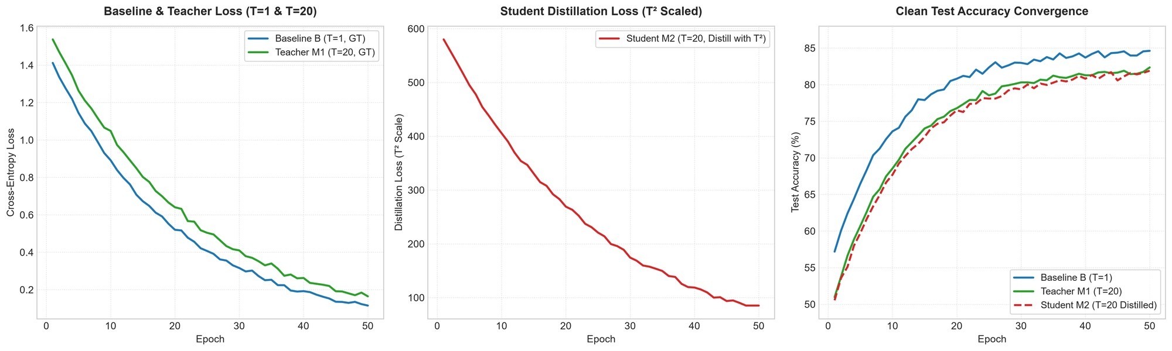
Figure 1: Left – cross-entropy of B and M1. Centre – T²-scaled distillation loss of M2. Right – clean test accuracy per epoch.

2.3: Observations
- Convergence: all three runs converge steadily. Test accuracy is still creeping upwards at epoch 50 (each model’s best epoch is its last), so longer training would probably help.
- Accuracy cost: training with T = 20 costs 2.27 points of clean accuracy (82.35 vs. 84.62 %), and distillation a further 0.45 points (81.90 %). The softened objective does not improve accuracy here.
- Training time: the student needs 88.54 min versus 64.92 min for the baseline (+36 %, about 106 s vs. 78 s per epoch) because every step also runs a teacher forward pass. Including the 63.34 min needed to train the teacher, the full distillation pipeline takes about 152 min.

Chapter 3: Question 2 – Adversarial Evaluation

3.1: Attack Implementation (Questions 2a, 2b)
All attacks are untargeted, white-box and use the true-label cross-entropy computed at T = 1. Perturbations are applied in raw pixel space and must satisfy
‖x_{adv} − x‖∞ ≤ ε and x_{adv} ∈ [0, 1]^{3×32×32}.
Input normalisation is part of the attacked model. For ε = 0 both attack functions return the input unchanged.
FGSM (Fast Gradient Sign Method)
x_{adv} = clip_{[0,1]}( x + ε · sign( ∇_{x} L(x, y) ) ).
A single gradient evaluation moves every pixel by exactly ±ε in the direction that locally increases the loss.
Role of ε. ε is the L∞ budget: the maximum change allowed per pixel and channel (8/255 ≈ 3.1 % of the dynamic range). A larger ε gives the attacker more freedom and lowers accuracy, but also makes the perturbation more visible. ε therefore sets the trade-off between attack strength and imperceptibility, and ε = 0 corresponds to the clean model.
PGD-20 (Projected Gradient Descent)
x⁽⁰⁾ = clip( x + U(−ε, ε) ), x^{(t+1)} = Π( x^{(t)} + α · sign( ∇ L ) ), t = 0 … 19.
Configuration: random start, 20 iterations, step size α = 2/255, with the projection Π onto the ε-ball and the valid pixel range [0, 1] after every step.
Difference between FGSM and PGD
Aspect | FGSM | PGD-20
Gradient evaluations | 1 | 20
Step | One step of size ε | 20 steps of size α = 2/255
Start point | The clean image | Random point inside the ε-ball
Loss surface | Assumes one linear approximation is enough | Follows the curved loss surface and re-projects each step
Strength | Weaker, can be fooled by gradient masking | Stronger; standard first test for gradient masking

Table 4: Comparison of the two attacks as implemented in this study.

3.2: Accuracy versus ε (Question 2c)
Both attacks were evaluated separately against every model for ε ∈ {0, 2/255, 4/255, 8/255, 16/255} on a 500-image evaluation subset.
ε | B – FGSM | B – PGD | M1 – FGSM | M1 – PGD | M2 – FGSM | M2 – PGD
0 (clean) | 56.4 | 56.4 | 52.2 | 52.2 | 50.8 | 50.8
2/255 | 21.8 | 16.4 | 31.0 | 25.6 | 36.2 | 31.6
4/255 | 9.4 | 3.6 | 27.2 | 18.8 | 30.8 | 18.8
8/255 | 4.2 | 0.4 | 24.0 | 11.8 | 25.6 | 11.2
16/255 | 6.6 | 0.0 | 21.0 | 10.0 | 22.2 | 10.2

Table 5: Adversarial accuracy (%) on the 500-image subset (source: adversarial_accuracy_table.csv). B = baseline, M1 = teacher, M2 = distilled student.
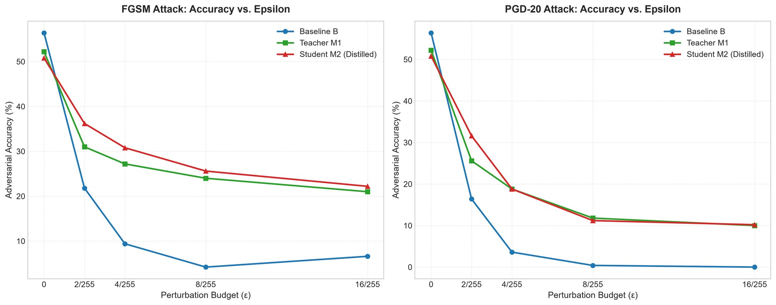
Figure 2: Accuracy versus perturbation budget for FGSM (left) and PGD-20 (right).
Check at ε = 0. Both attacks reproduce exactly the clean accuracy of the evaluation subset (56.4 / 52.2 / 50.8 %), as required. These are accuracies on a 500-image subset, not the 10,000-image test accuracies of Table 3; see Section 5.2. With 500 images the binomial standard error is about ±2.2 points near 50 %, ±1.9 near 25 % and ±1.3 near 10 %.
Observations
- PGD is stronger than FGSM for every model and every ε > 0.
- The baseline collapses immediately (FGSM 21.8 % at 2/255; PGD 0.4 % at 8/255 and 0.0 % at 16/255). Its FGSM accuracy even rises from 4.2 % to 6.6 % between 8/255 and 16/255, showing that one linearised step becomes unreliable at large ε.
- M1 and M2 degrade gracefully under FGSM (M2: 22.2–25.6 % at 8–16/255) but fall to 11.2 % and 11.8 % at 8/255 and about 10 % at 16/255 under PGD.
- M2 versus M1: M2 is a few points higher under FGSM (36.2 vs. 31.0 % at 2/255), but the PGD results are indistinguishable (18.8 vs. 18.8 % at 4/255; 11.2 vs. 11.8 % at 8/255; 10.2 vs. 10.0 % at 16/255), within sampling noise.

3.3: Five Test Samples under FGSM and PGD (Question 2d)
Five test images are shown with their FGSM and PGD-20 versions against the student M2 at ε = 8/255. Each row shows the original, FGSM, PGD-20 and the (magnified) perturbation; the maximum pixel difference is 8.0/255 in every row.
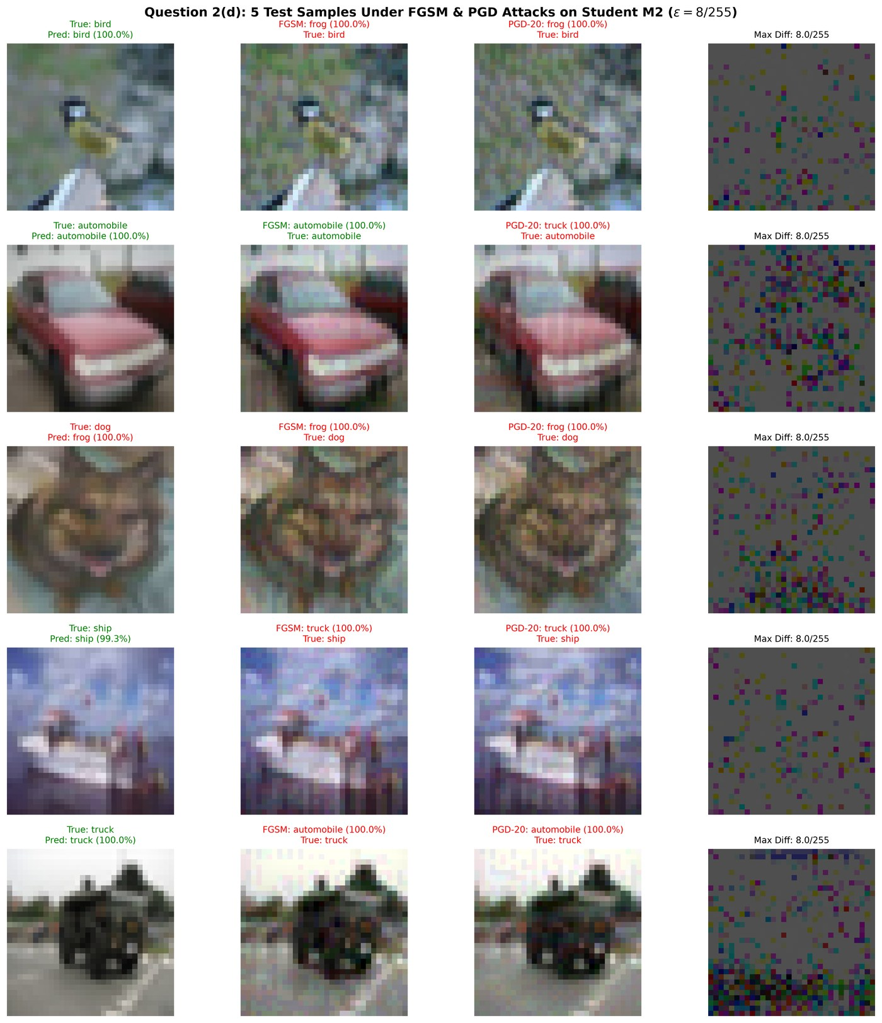
Figure 3: Original, FGSM and PGD-20 images against M2 at ε = 8/255, with true and predicted labels (green = correct, red = wrong).
True class | Clean prediction | FGSM prediction | PGD-20 prediction
bird | bird (100.0 %) | frog (100.0 %) | frog (100.0 %)
automobile | automobile (100.0 %) | automobile (100.0 %) | truck (100.0 %)
dog | frog (100.0 %) – already wrong | frog (100.0 %) | frog (100.0 %)
ship | ship (99.3 %) | truck (100.0 %) | truck (100.0 %)
truck | truck (100.0 %) | automobile (100.0 %) | automobile (100.0 %)

Table 6: Student predictions with confidence for the five samples of Figure 3.
- Of the four images the student classified correctly, PGD flips all four and FGSM flips three; only the automobile survives FGSM.
- The perturbations are visually negligible: the semantic content of each image is unchanged for a human observer.
- The wrong predictions are made with about 100 % confidence, so the softmax confidence of a distilled model is not a usable warning signal for adversarial inputs.
- Five images are an illustration, not a statistic; the quantitative evidence is Table 5.

3.4: Discussion – Robustness and Gradients (Question 2e)
Did distillation improve robustness?
Relative to the baseline, yes; as genuine robustness, no. At ε = 8/255 the distilled models keep 24.0–25.6 % accuracy under FGSM and 11.2–11.8 % under PGD, against 4.2 % and 0.4 % for the baseline. However:
- The gain comes from T = 20 training, not from distillation. The non-distilled teacher M1 is as hard to attack as the student under PGD, so the extra distillation stage adds nothing measurable (differences ≤ 0.6 points).
- The defence disappears under the stronger attack. PGD removes more than half of the FGSM accuracy (M2: 25.6 → 11.2 % at 8/255) and brings M1 and M2 to about 10 %, i.e. chance level for ten classes. A large FGSM–PGD gap and non-monotone FGSM curves are classic symptoms of gradient masking (Athalye et al., 2018).
- Clean accuracy is reduced. The defence costs 3.3–5.6 points on the evaluation subset (52.2 / 50.8 vs. 56.4 %).
- Confidently wrong. Adversarial predictions in Figure 3 carry about 100 % confidence.
- Consistent with the literature. Carlini and Wagner (2017) showed that defensive distillation is broken by stronger optimisation-based attacks. We did not run such attacks, so we claim only that our evidence is consistent with gradient masking.
Do smaller gradients imply robustness?
No. Three arguments support this answer.
- Sign-based attacks ignore magnitude. FGSM and PGD use only sign(∇_{x}L); the size of the gradient is irrelevant unless it underflows to exactly zero.
- The measurement shows the opposite. At T = 1 the mean input-gradient L2 norm of M1 and M2 (1.17 and 1.07) is about 17–18 times larger than that of B (0.063), yet M1 and M2 withstood FGSM better than B (Table 7).
- Robustness is a property of the whole ε-ball. A saturated softmax can give a tiny gradient at x while the loss is steep a few pixels away; PGD’s iterative steps and random start exploit exactly this.
Model | Mean L1 norm | Mean L2 norm | Mean L∞ norm
Baseline B | 2.2206 | 0.0634 | 0.0086
Teacher M1 | 38.9775 | 1.1653 | 0.1643
Student M2 | 35.5347 | 1.0702 | 0.1519

Table 7: Mean norm of the input-loss gradient at T = 1 (source: executed notebook, “Input Gradient Norm Measurements”).
Caveat. Table 7 is an average over inputs of a batch-mean loss and cannot show per-sample saturation. The hypothesis that part of the FGSM resistance of M1 and M2 comes from saturated softmax outputs at T = 1 was not tested directly; counting samples with zero gradient or attacking with a logit-margin loss would test it.

Chapter 4: Evaluation on 200 Unseen External Images

4.1: Setup and Overall Results
A balanced set of 200 real-world images (20 per class, collected outside CIFAR-10) was resized to 32×32 and classified zero-shot at T = 1 by the three trained models.
Model | Accuracy (%) | Correct / 200 | Mean confidence (%)
Baseline B | 54.5 | 109 | 64.4
Teacher M1 | 46.5 | 93 | 97.6
Student M2 | 45.5 | 91 | 96.9

Table 8: Overall accuracy and mean top-1 confidence on the unseen images (source: executed notebook output).

4.2: Per-class Accuracy
Class | Baseline B | Teacher M1 | Student M2
airplane | 85 | 45 | 50
automobile | 80 | 100 | 90
bird | 70 | 10 | 10
cat | 20 | 25 | 15
deer | 45 | 45 | 30
dog | 40 | 15 | 10
frog | 55 | 80 | 100
horse | 50 | 40 | 35
ship | 70 | 65 | 55
truck | 30 | 40 | 60

Table 9: Per-class accuracy (%) on the external images, 20 images per class.
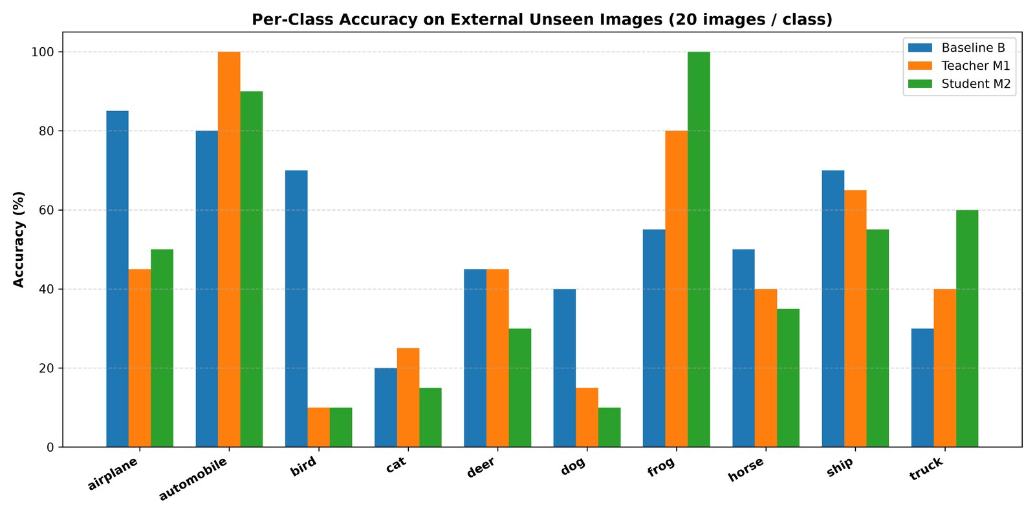
Figure 4: Per-class accuracy of the three models on the external images.
The baseline is better on airplane, bird, dog and ship; M1 and M2 are better on automobile, frog and (M2) truck. Accuracy depends strongly on the class for every model.
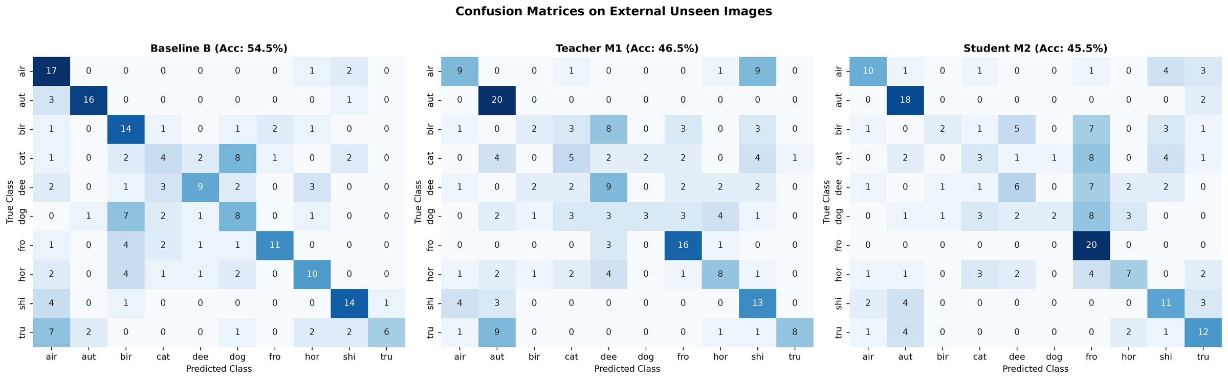
Figure 5: Confusion matrices on the external images (rows = true class, columns = predicted class).

4.3: Findings
- Domain shift: all models lose 30–40 points relative to CIFAR-10 test accuracy. B is 8.0 (M1) and 9.0 (M2) points better; with 200 images the standard error is about ±3.5 points, so this gap is suggestive while the 1-point M1/M2 difference is not meaningful.
- Over-confidence: M1 and M2 report about 97 % mean confidence at 46.5 % and 45.5 % accuracy, whereas B reports 64.4 % at 54.5 %. This is consistent with training on logits/20, which makes the T = 1 logits very sharp.
- Error patterns: B confuses cat→dog (8), dog→bird (7) and sends 7 trucks to airplane. M1 sends 9 airplanes to ship, 9 trucks to automobile and 8 birds to deer. M2 predicts “frog” for 55 of 200 images, so its perfect frog recall (20/20) comes with a precision of only about 36 %.
- Agreement: all three models agree on only 72 of 200 images (36.0 %); 57 are correct for all three, 60 are wrong for all three, and the models disagree on 128 (64.0 %).
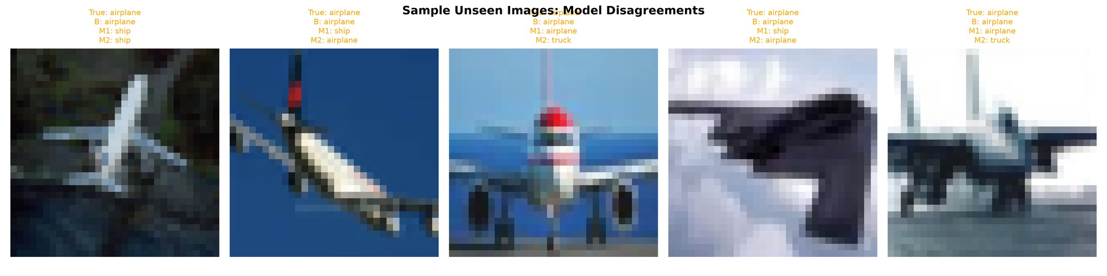
Figure 6: Five airplane images on which the models disagree. Left to right (B, M1, M2): airplane/ship/ship, airplane/ship/airplane, airplane/airplane/truck, airplane/ship/airplane, airplane/airplane/truck.

Chapter 5: Conclusions, Limitations and References

5.1: Conclusions
- The T² factor makes the T = 20 distillation loss gradient-scale-neutral. The student trained stably (loss 580 → 85.2) and reached 81.90 % clean accuracy, 2.72 points below the baseline, at 36 % higher training cost.
- Against FGSM and PGD-20 at T = 1, the T = 20 models are far harder to attack than the baseline, but distillation adds nothing over the teacher, PGD drives accuracy to about chance, and the FGSM–PGD gap points to gradient masking. On this evidence defensive distillation should not be regarded as a robust defence.
- The distilled models also generalise worse and are much more over-confident on unseen real-world images.

5.2: Limitations
- Single training run per model (seed 42), 50 epochs, no confidence intervals across seeds.
- The adversarial evaluation uses a 500-image subset whose clean accuracy (56.4 / 52.2 / 50.8 %) is about 28–31 points below the full test accuracy. The notebook loads saved results and does not show how the subset was chosen, so the absolute adversarial accuracies should be read as subset results; a re-run on all 10,000 images is recommended.
- Only cross-entropy PGD with one random start was used; no margin-loss (C&W) attack, AutoAttack, additional restarts or black-box transfer attacks.
- No T² ablation and no direct test of softmax saturation.
- The external set is small (200 images) and its collection protocol is not part of the notebook.

5.3: References
[1] Papernot, N., McDaniel, P., Wu, X., Jha, S., Swami, A. (2016). Distillation as a defense to adversarial
perturbations against deep neural networks. IEEE S&P.
[2] Hinton, G., Vinyals, O., Dean, J. (2015). Distilling the knowledge in a neural network. arXiv:1503.02531.
[3] Goodfellow, I., Shlens, J., Szegedy, C. (2015). Explaining and harnessing adversarial examples. ICLR.
[4] Madry, A., Makelov, A., Schmidt, L., Tsipras, D., Vladu, A. (2018). Towards deep learning models resistant to
adversarial attacks. ICLR.
[5] Carlini, N., Wagner, D. (2017). Towards evaluating the robustness of neural networks. IEEE S&P.
[6] Athalye, A., Carlini, N., Wagner, D. (2018). Obfuscated gradients give a false sense of security. ICML.

