A Two-Stage Deep Learning Pipeline for Automated Cell-Level Extraction and Defect Triage in Photovoltaic Modules

Abstract— Automated visual inspection of photovoltaic (PV) modules is essential for scalable quality control, yet existing approaches assume pre-cropped, single-cell inputs and reduce defect assessment to coarse binary labels. This paper presents a two-stage deep learning pipeline that operates directly on raw module-level electroluminescence (EL) images—full and partial captures spanning monocrystalline and polycrystalline technologies. Stage 1 performs cell extraction using YOLOv8-OBB (oriented bounding boxes), adopted after a systematic evaluation of fifteen classical OpenCV-based approaches across two dataset tracks (CellExtractOpenCV and FullModuleOpenCV), none of which generalised robustly. The YOLOv8-OBB detector, trained on 2,212 module images (80/20 split), outputs five parameters per cell—(cx, cy, w, h, θ)—enabling perspective-correct extraction of arbitrarily oriented cells without pre-rectification. Stage 2 performs binary quality triage (OK vs. B-grade) using CNN backbones (ResNet, EfficientNet) augmented with a Convolutional Block Attention Module (CBAM) and hyperparameters optimised via Optuna, targeting validation AUROC under realistic class imbalance. A third pixel-level defect segmentation stage is identified as key future work. We report [TBD] mAP@0.5 for Stage 1 and [TBD] AUROC for Stage 2.

Index Terms—photovoltaic inspection, electroluminescence imaging, YOLOv8-OBB, oriented bounding boxes, binary defect classification, CBAM, attention mechanism, Optuna, deep learning, solar energy quality control

I. INTRODUCTION
G
lobal V capacity is projected to exceed 10 TW by 2030, placing unprecedented demands on automated quality assurance at scale [1]. Electroluminescence (EL) imaging detects sub-surface cell defects invisible to conventional optical inspection, but manual EL review is labour-intensive and fails to match modern manufacturing throughput or drone-based fleet inspection rates.
Two critical gaps motivate this work. First, almost every published EL defect study—including the canonical ELPV benchmark [2]—assumes individual cell crops as input. In real deployment, module-level images arrive with arbitrary orientation, partial occlusion, and perspective distortion; no robust plug-in extraction stage exists. Second, binary pass/fail classification is the prevailing paradigm, discarding fault-mechanism information needed for rework prioritisation and predictive maintenance.
This paper’s contributions are:
- A systematic ablation of fifteen classical OpenCV iterations (11 on partial/single-cell images, 4 on full-module images) establishing root-cause failure modes of grid-line detection at deployment scale.
- A YOLOv8-OBB detector trained on 2,212 module EL images providing unified, format-agnostic cell extraction for full-module, partial-module, and single-cell inputs.
- A CBAM-augmented, Optuna-tuned binary triage classifier benchmarked across ResNet-18/50 and EfficientNet-B0/B3 backbones on the ELPV dataset supplemented with pipeline-extracted crops.
This work was carried out at the Indian Institute of Technology Mandi. The authors gratefully acknowledge the support of IIT Mandi and the guidance of their research supervisor.

II. METHODOLOGY

A. Overall Research Workflow
The workflow involves dataset preparation, image–mask augmentation, model training, prediction, quantitative and qualitative evaluation. The data splits, augmentation operations, hyperparameters and evaluation metrics were the same for all the architectures trained. To overcome the extreme pixel imbalance existing between the dominant pixel classes in the structural regions and the narrow pixel classes in the defect classes, class-weighted loss functions were introduced.

B. Electroluminescence Imaging for PV Inspection
Crystalline-silicon photovoltaic cells emit short wave infrared radiation under forward bias, which can be captured to form EL images [8], [9]. Generally, electrically active areas are visible as bright areas, while cracks, inactive areas, broken grid lines, damaged busbars and other defects are visible as dark or structurally distorted areas [5], [10]. Representative EL images of multicrystalline and monocrystalline samples are shown in Fig. 1. In addition to image-background variability, which is caused by the different cell textures.
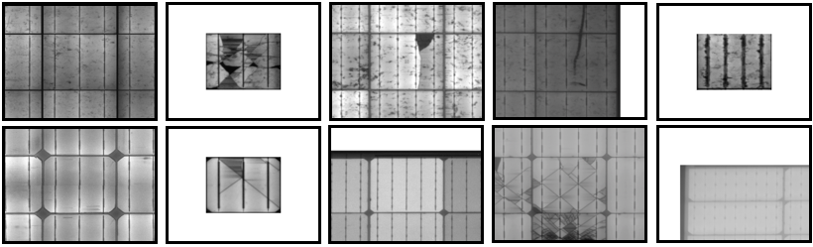
Fig. 1. Representative EL images of multicrystalline (top) and monocrystalline (bottom).

C. Dataset Preparation, Annotation and Augmentation
This work was carried out using the Benchmark EL images dataset_20221008 associated to [6] and available in [https://github.com/TheMakiran/BenchmarkELimages/tree/main/dataset_20221008]. The class selected was 593 pixel-annotated EL images and 29 semantic classes, such as background, photovoltaic structural features and defect related regions. The dataset was split to 461 training images, 72 validation images and 60 test images. All images and masks were scaled to 512 × 512 pixels. The training images were then augmented with 180-degree rotations, horizontal and vertical flipping, to form 1,844 image-mask pairs. The EL images and masks of representative samples are shown in Fig. 2. The all models were trained with 100 epochs, batch size of 4, and an initial learning rate of 0.0001 using the Adam optimizer.
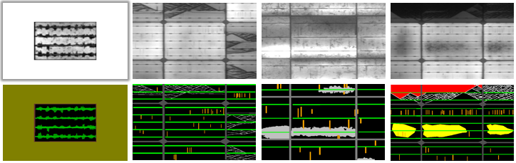
Fig. 2. Representative EL images with corresponding pixel-wise masks.

D. Segmentation Models
Four different semantic segmentation architectures were tested. U-Net++ adopts the concept of nested skip connections in aggregation multiscale encoder and decoder features [11]. The architecture of SEiPVNET is a lightweight encoder–decoder structure for multiclass PV EL defect segmentation [7]. SegFormer-B2 and SegFormer-B4 use hierarchical transformer encoders with light-weight multilayer-perceptron decoders to learn local and global contextual information [12]. The same data split, augmentation operations, hyperparameters, loss functions, and evaluation methods were used for all models. The average inference time and trainable parameters of their models are shown in Table I.
TABLE I
Model Complexity And Inference Time
Architecture | Trainable Parameters | Average Inference time
SegFormer-B2 | 27,368,925 | 0.0168 s
SegFormer-B4 | 64,015,325 | 0.026 s
SEiPVNET | 7,821,869 | 0.008 s
UNet++ | 20,817,173 | 0.023 s

E. Class-Weighting Strategies
Imbalanced segmentation problems can lead to overpowering optimization of the majority classes and thus to the under-representation of the minority classes [13]. Three weighting strategies were tested. Inverse-frequency weighting gave more weight to rare classes, while equal weighting had equal weights for all classes. As the actual region of interest varies from one task to another, the custom strategy assigns different weights to narrow or practically important parts of the image: gridlines, cracks, busbars, etc., and to the background. The values of the custom parameters in Table II were chosen heuristically and are not guaranteed to be mathematically optimal.
TABLE II
Custom Class Weights
Description | Class Weight | Description | Class Weight
Background | 0.2 | Gridline | 3.0
Ribbons | 2.0 | Inactive | 1.8
Border | 1.5 | Material | 2.8
Busbar | 2.5 | Crack | 2.0
Frame edge | 1.8 | Otherwise | 1.0
Brightening | 1.5

F. Evaluation Metrics
The following performance measures were evaluated macro-averaged precision, recall, F1-score, mean intersection over union (mIoU), and overall pixel accuracy. The emphasis was placed on macro-averaged measures as the overall accuracy can be greatly influenced by background and large structural regions in highly imbalanced segmentation datasets [14].

III. RESULTS
The IoU and loss curves of each model and class weighting setting are displayed in Fig. 3, and the left-hand side shows the training result and the right-hand side shows the validation result. The overall performance of the training loss reduced while the mIoU improved with the increasing number of epochs, which shows that the model is optimized correctly. The validation curves showed more variation with inverse-frequency weighting than with equal class weighting, which led to a more stable and smooth convergence. This phenomenon is perhaps due to the relative weight given to rare classes, which makes the system more sensitive to rare pixels but makes it more receptive to noisy or ambiguous areas. A more convergent pattern was achieved by use of custom weighting. In terms of validation mIoU, SegFormer-B4 outperformed others with custom weights, and SegFormer-B2 and U-Net++ had competitive convergence. The validation mIoU computed by SEiPVNET was relatively low, especially when using inverse-frequency weighting.
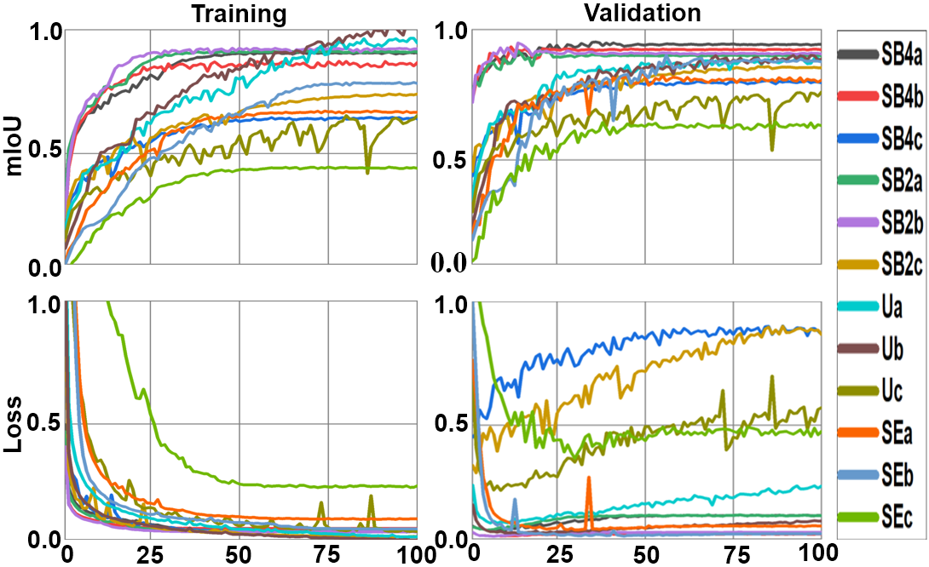
Fig. 3. Training and validation mean IoU and loss functions of under equal, inverse, and custom class-weighting. Here, SB4, SB2, SE, and U denote SegFormer-B4, SegFormer-B2, SEiPVNET, and U-Net++, respectively, while suffixes a, b, and c denote equal, inverse, and custom class weights.

The representative EL images and their ground-truth masks are compared with the validation predictions of the four architectures in Fig. 4. All models were able to reproduce the dominant structural regions more consistently than narrow defect regions. In general, there was good agreement with the ground truth for busbars, gridlines, ribbons and large inactive areas. But very thin cracks and inactive regions with cracks were often under-segmented or detected only partially. The errors were most prominent when two or more defect patterns overlapped or when the contrast between defect boundaries was not high. SegFormer-B4 made relatively stable predictions for large and irregular areas while U-Net++ maintained several thin boundaries well. Although the transformer backbone of SegFormer-B2 was smaller, it still performed competitively, while SEiPVNET exhibited more fragmentation in certain complex areas.
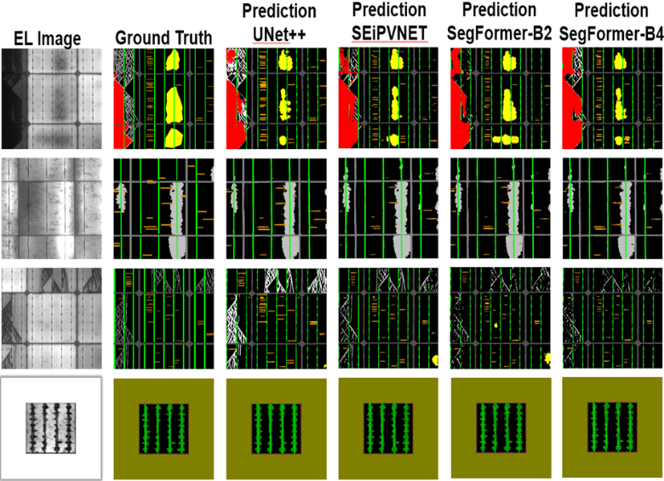
Fig. 4. EL images, corresponding ground truth masks, and validation prediction of the respective architectures.

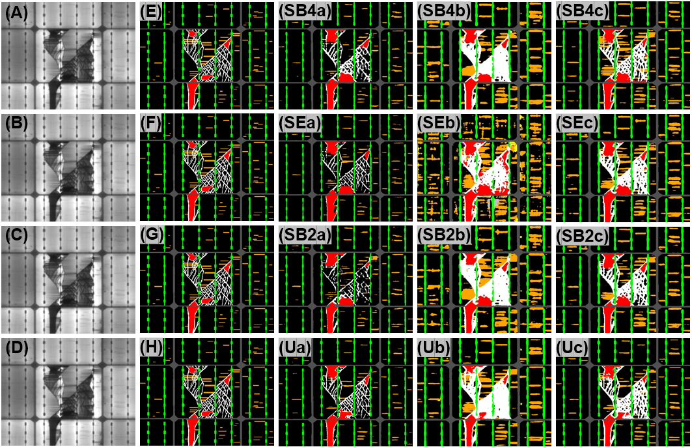
Fig. 5. Test prediction masks of EL image. First column is original EL image, second column is ground truth, and the remaining columns are test equal, inverse, and custom class weights.
The qualitative test prediction to the EL image sample (CFVS_00027_r4_c4) for equal, inverse, and custom class weighting is shown in Fig. 5. Equal weighting resulted in relatively smooth forecasts for major structural elements, but failed to respond to certain narrow defect types. The predicted size of minority classes was larger with inverse-frequency weighting, while extra defect pixels were identified, but more false-positive and fragmented areas were found. Custom weighting provided a better balance of minority class sensitivity and mask consistency. SegFormer-B4 kept the main inactive regions, busbars and grid line related structures relatively well segmented with clear boundaries.
SegFormer-B2 made similar predictions, but with a slightly lower accuracy of the boundary. U-Net++ proposed consistent boundaries for some slender structures and SEiPVNET was influenced by the overlapping crack and inactive-region patterns. Very thin cracks were still a challenge for all the architectures.

The class-wise results are displayed in Fig. 6. Generally, the large and more frequent classes such as background, ribbon, border, busbar, and frame edge were outperforming the narrow and less frequent classes in terms of F1-score, IoU, precision, and recall. Other defects such as cracks, gridline defects and inactive areas had more variations between models, since they are small regions of pixels, and their edges are often not well defined or easily discernable. A relatively small error in the predicted boundary and the ground truth boundary can thus lead to a significant reduction in IoU. For SegFormer-B4 and SegFormer-B2, the most balanced class-wise results were obtained by custom weighting. Equal weighting performed well on U-Net++, while inverse-frequency weighting gave a boost to recall but at the expense of precision and overlap accuracy.
The average performance of all defect and feature classes is summarized in Fig. 6(E) in terms of F1 score, mean IoU, mean recall, and mean precision. The comparison shows here that there is not one class-weighting that is optimal for all measures. For SegFormer-B4 and SegFormer-B2, custom class weighting is applied to improve the balance between precision and recall with IoU. Equal class weighting leads to more stable and competitive performance of U-Net++ when it comes to mean IoU and F1-scores. The inverse class weighting solution is one that provides a higher recall but comes at the expense of a lower precision and IoU due to higher number of false positive predictions. To summarize, the experimental results reveal that SegFormer-B4 trained using the customized class weight achieves the best quantitative performance, while U-Net++ performs very well in terms of detailed boundary segmentation.
The overall quantitative findings are summarized in Table III. SegFormer-B4 showed the best balanced performance with a mean precision of 58.51%, mean recall of 58.42%, mean F1 score of 57.32%, mean IoU of 48.30%, and overall accuracy of 95.02% using the custom weights. SegFormer-B4 achieved the highest F1 score, mIoU, and overall accuracy, while SegFormer-B2 achieved a slightly better mean precision of 58.79%. SegFormer-B2 was also very close with a mean F1-score of 56.70%, a mean IoU of 47.58% and overall accuracy of 94.95%, which shows that the smaller transformer configuration is also a competitive accuracy–complexity trade-off. U-Net++ achieved the custom-weighted recall of 58.40%, a mean F1-score of 56.22% and a mean IoU of 46.77%. SEiPVNET obtained a mean IoU of 42.85%, which was lower than SegFormer and U-Net++.
Inverse-frequency weighting yielded the largest recall value and consistently led to a decrease in precision and mIoU. Although SegFormer-B2 got the highest inverse-weighted recall of 72.11%, its mean precision was lowered to 41.40% and mIoU was lowered to 39.01%. SegFormer-B4 achieved the best performance on the inverse-weighted F1 score and mIoU, with scores of 52.40% and 42.29%, respectively. These results demonstrate the ability of inverse-frequency weighting to enhance the detection of minority-class pixels, but also produce some extra false-positive regions.
With equal weighting, the best performance in terms of mean precision, mean F1-score, mean IoU, and overall accuracy was obtained by U-Net++, with respective scores of 57.63%, 56.13%, 47.03%, and 94.27%. SegFormer-B4 obtained highest equal-weighted recall of 61.89%, and SegFormer-B2 got mean IoU of 46.48% and overall accuracy of 93.56%. In general, SegFormer-B4, with custom weighting showed the most fair and balanced performance on precision, recall, F1-score, mIoU, and accuracy. Compared to U-Net++, SegFormer-B2 achieved comparable performance with fewer parameters and remained very competitive under equal weighting.
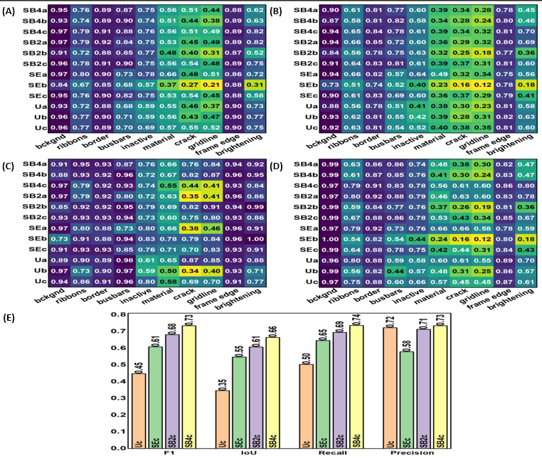
Fig. 6. (A) Mean F1 Score for ten classes across all models, (B) mean IoU for ten classes across all models, (C) mean recall for ten classes across all models, (D) mean precision for ten classes across all models, and (E) average performance of all defects and features in terms of F1 Score, mean IoU, mean recall, and mean precision for all models with custom class-weight.
TABLE III
Quantitative Comparison Of All Architectures
Class Weight | Architecture | Mean  Precision | Mean Recall | Mean F1 Score | Mean  IoU | Overall Accuracy
Custom | SegFormer-B4  SegFormer-B2  SEiPVNET  U-Net++ | 58.51%  58.79%  49.91%  54.14% | 58.42%  57.79%  53.26%  58.40% | 57.31%  56.70%  50.82%  56.22% | 48.29%  47.57%  42.84%  46.76% | 95.02%  94.95%  94.98%  93.79%
Inverse | SegFormer-B4  SegFormer-B2  SEiPVNET  U-Net++ | 44.60%  41.40%  34.06%  41.60% | 71.52%  72.11%  71.52%  63.96% | 52.40%  49.34%  41.61%  47.80% | 42.29%  39.01%  32.13%  37.88% | 90.45%  88.37%  80.22%  88.54%
Equal | SegFormer-B4  SegFormer-B2  SEiPVNET  U-Net++ | 48.34%  54.56%  42.18%  57.63% | 61.89%  61.22%  54.69%  56.94% | 53.18%  55.96%  46.61%  56.13% | 43.54%  46.47%  38.94%  47.02% | 92.44%  93.55%  92.72%  94.27%

IV. DISCUSSION
Results of the controlled comparison confirm that the segmentation architecture and the class-weighting strategy have significant impact on the performance achieved on the highly imbalanced photovoltaic electroluminescence data set. SegFormer-B4 achieves the best overall result by using custom class weighting, with a mean IoU of 48.30%, mean F1-score of 57.32%, mean recall of 58.42% and overall accuracy of 95.02%. The hierarchical transformer encoder seems to be useful for incorporating global contextual features along with local features of the defects, which leads to the enhancement of the segmentation of low-contrast and irregular areas. When computational efficiency is required, SegFormer-B2 provides lower-complexity and almost same performance with a mean IoU of 47.58%. The U-Net++ was also competitive, especially under the equal class weighting, thanks to the nested skip connections and the capability to retain fine boundary information. In contrast, the inverse-frequency weighting strategy gained in sensitivity to the rare defect classes but lost precision and IoU due to more false-positive predictions. Custom weighting thus gave a better trade-off between the detection of rare defects and segmentation accuracy. The qualitative and class-wise results also show that the segmentation of large structural area is more reliable than narrow defects like micro cracks and grid line cracks. The results demonstrate that SegFormer-B4 can be applied in the scenarios where maximum segmentation accuracy is demanded, while SegFormer-B2 and U-Net++ can be alternative choices in lower complexity and boundary sensitive application, respectively. The dataset used in the present work has a limited number of pixels annotated, the images are artificially controlled at the cell level, and there is no direct correlation between the defects segmented and the electrical power loss. The proposed new architecture will be then evaluated using module-level and field-acquired EL images, detailed ablation study and electrical performance measurement in future.

V. CONCLUSION
In this study, U-Net++, SEiPVNET, SegFormer-B2 and SegFormer-B4 are compared for the segmentation of 29 semantic classes in photovoltaic EL images, where the same, inverse-frequency, and custom class weightings are used. The best balanced performance was obtained by SegFormer-B4 with custom weighting, which reached the mIoU of 48.30% and achieved the overall accuracy of 95.02%. U-Net++ was competitive under equal weighting conditions, and SegFormer-B2 achieved similar performance while having fewer parameters. With inverse-frequency weighting, we achieved a higher recall at the cost of precision and IoU due to more false positives predictions. The results indicate that the optimization of the architecture selection and class weighting should be carried out jointly for highly imbalanced EL segmentation. Newly designed segmentation architectures, extensive module level data sets and correlations between the predicted defect geometry and electrical performance will be explored in future.
References
[1] R. del Prado Santamaría, M. Dhimish, G. A. dos Reis Benatto, T. Kari, P. B. Poulsen, and S. V. Spataru, “From Indoor to Daylight Electroluminescence Imaging for PV Module Diagnostics: A Comprehensive Review of Techniques, Challenges, and AI-Driven Advancements,” Apr. 01, 2025, Multidisciplinary Digital Publishing Institute (MDPI). doi: 10.3390/mi16040437.
[2] T. Hussain, M. Hussain, H. Al-Aqrabi, T. Alsboui, and R. Hill, “A Review on Defect Detection of Electroluminescence-Based Photovoltaic Cell Surface Images Using Computer Vision,” Energies (Basel)., vol. 16, no. 10, May 2023, doi: 10.3390/en16104012.
[3] A. S. Al-Waisy et al., “Identifying defective solar cells in electroluminescence images using deep feature representations,” PeerJ Comput. Sci., vol. 8, 2022, doi: 10.7717/PEERJ-CS.992.
[4] S. Deitsch et al., “Automatic classification of defective photovoltaic module cells in electroluminescence images,” Solar Energy, vol. 185, pp. 455–468, Jun. 2019, doi: 10.1016/j.solener.2019.02.067.
[5] L. Pratt, D. Govender, and R. Klein, “Defect detection and quantification in electroluminescence images of solar PV modules using U-net semantic segmentation,” Renew. Energy, vol. 178, pp. 1211–1222, Nov. 2021, doi: 10.1016/j.renene.2021.06.086.
[6] L. Pratt, J. Mattheus, and R. Klein, “A benchmark dataset for defect detection and classification in electroluminescence images of PV modules using semantic segmentation,” Systems and Soft Computing, vol. 5, Dec. 2023, doi: 10.1016/j.sasc.2023.200048.
[7] H. Eesaar, S. Joe, M. U. Rehman, Y. Jang, and K. T. Chong, “SEiPV-Net: An Efficient Deep Learning Framework for Autonomous Multi-Defect Segmentation in Electroluminescence Images of Solar Photovoltaic Modules,” Energies (Basel)., vol. 16, no. 23, Dec. 2023, doi: 10.3390/en16237726.
[8] K. Ramspeck, K. Bothe, D. Hinken, B. Fischer, J. Schmidt, and R. Brendel, “Recombination current and series resistance imaging of solar cells by combined luminescence and lock-in thermography,” Appl. Phys. Lett., vol. 90, no. 15, 2007, doi: 10.1063/1.2721138.
[9] T. Fuyuki and A. Kitiyanan, “Photographic diagnosis of crystalline silicon solar cells utilizing electroluminescence,” Appl. Phys. A Mater. Sci. Process., vol. 96, no. 1, pp. 189–196, Jul. 2009, doi: 10.1007/s00339-008-4986-0.
[10] S. Hassan and M. Dhimish, “Broad-scale Electroluminescence analysis of 5 million+ photovoltaic cells for defect detection and degradation assessment,” Renew. Energy, vol. 237, Dec. 2024, doi: 10.1016/j.renene.2024.121868.
[11] Z. Zhou, M. M. R. Siddiquee, N. Tajbakhsh, and J. Liang, “UNet++: Redesigning Skip Connections to Exploit Multiscale Features in Image Segmentation,” IEEE Trans. Med. Imaging, vol. 39, no. 6, pp. 1856–1867, Jun. 2020, doi: 10.1109/TMI.2019.2959609.
[12] E. Xie, W. Wang, Z. Yu, A. Anandkumar, J. M. Alvarez, and P. Luo, “SegFormer: Simple and Efficient Design for Semantic Segmentation with Transformers,” Oct. 2021, [Online]. Available: http://arxiv.org/abs/2105.15203
[13] T. Y. Lin, P. Goyal, R. Girshick, K. He, and P. Dollar, “Focal Loss for Dense Object Detection,” in Proceedings of the IEEE International Conference on Computer Vision, Institute of Electrical and Electronics Engineers Inc., Dec. 2017, pp. 2999–3007. doi: 10.1109/ICCV.2017.324.
[14] S. Minaee, Y. Boykov, F. Porikli, A. Plaza, N. Kehtarnavaz, and D. Terzopoulos, “Image Segmentation Using Deep Learning: A Survey,” IEEE Trans. Pattern Anal. Mach. Intell., vol. 44, no. 7, pp. 3523–3542, Jul. 2022, doi: 10.1109/TPAMI.2021.3059968.

