# EXPERIMENT 1

## PART A: FAMILIARISATION WITH PC SCOPE AND BREAD BOARD THROUGH RC CIRCUIT

**Aim** – To gain familiarity with Bread Board, oscilloscope and oscilloscope data logger through RC circuit  
  
**Apparatus** – Bread board, wires, Oscilloscope, Resistor, capacitor  
  
**Details of Bread Board:**

Breadboard familiarisation

* Hold the breadboard such that the horizontal side is longer than the vertical side.
* There are four independent portions (A, B, C and D) created by three notches as in Fig. 1. Here, independence means portions A, B, C and D are not connected with each other

***Portion A and D***

* Each portion of A and D is further subdivided into two regions as A1 and A2 shown in Fig. [3](#fig:Breadboard familiarisation).
* Each horizontal line (shown through arrows in the Fig. 1) of A1, A2, D1 and D2 represent a single potential. Usually, as a general practice, these points are considered as ground for a given built circuit.

***Portion B and C***

* In portion B and C, each vertical line (shown through arrows in Fig. 1) of B and C represents a single potential.
* The above explanation can be better understood through Fig. 2 showing same potential lines.

***Details of oscilloscope probe***  
Fig. 4 shows a typical oscilloscope probe.

* The Oscilloscope probe is a passive connector which is used to connect oscilloscope to the electrical circuit. It consists of three parts Retractable hook tip (or crocodile clip), a Crocodile clip and BNC connector.
* BNC connector: It is used to connect oscilloscope to the probe.
* Retractable Hook tip: It is used to connect the node of the electrical circuit to the oscilloscope where there is a need to measure the signal.
* Crocodile clip: It is connected to the ground of the electrical circuit in the bread board.
* Make sure the RED slider on the probe should be on the X1 position only. X1 means amplification is unity.

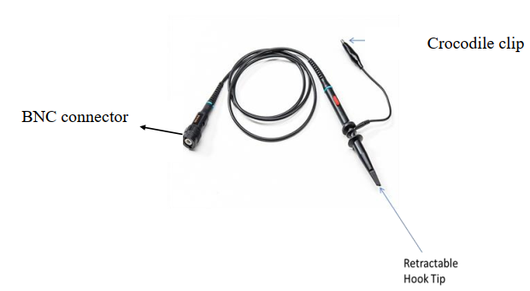

PC scope probe

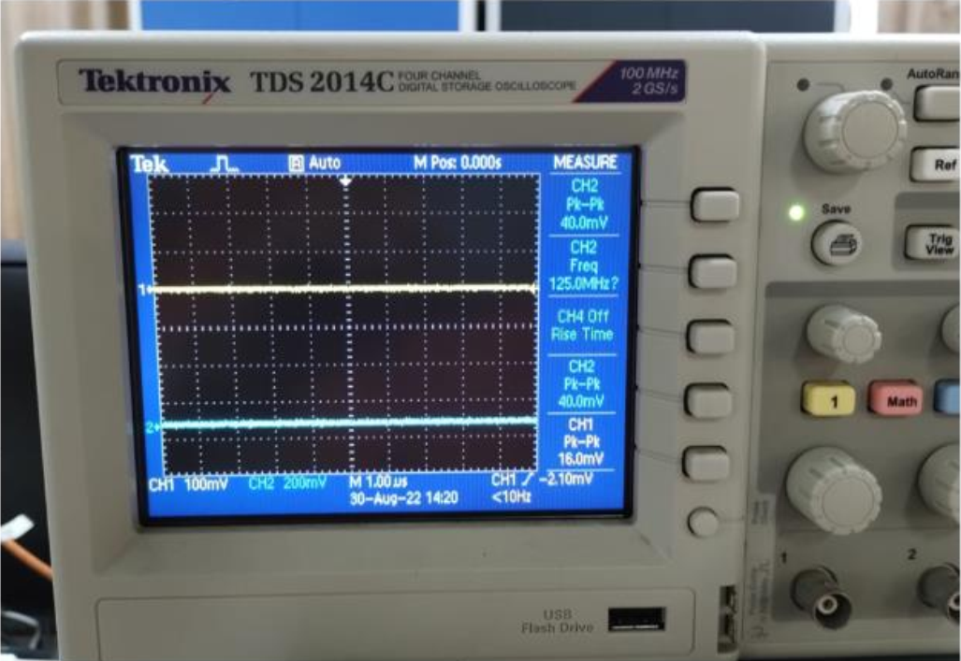

Four channel Oscilloscope with digital storage

Fig. 5 shows a four channel Oscilloscope with digital data storage system. There are four channels which displays the input/output signal. Input and output probes may be connected to any of these four channels to visualize and analyze the waveforms of the signal. There are scaling, vertical and horizontal controls to adjust the waveform in order to have better visualization. Peak to peak voltage and time scale can be conveniently read from the monitor using the adjustment knob after pressing the cursor button.

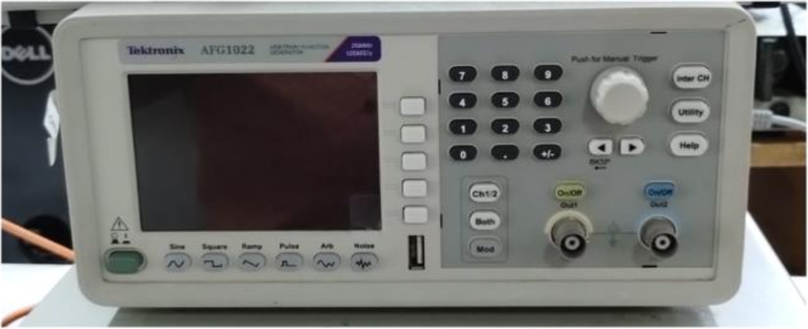

Function Generator

In order to obtain a desired input signal (sinusoidal, square, ramp, pulse or any arbitrary waveform) a function generator can be used (Fig. 6). The desired amplitude and frequency of the waveform can be obtained using the side controls near the monitor. The output probes may be connected to any of the two channels. One of the crocodile clip of the output probe needs to be grounded and the other end can be given as input signal to generate the signal in the circuit. Also, in order to check whether the function generator is working, the probe may be connected to the Oscilloscope.  
  
**Calculation of Resistance:**

* Turn the resistor so that the gold or silver stripe is at the right end of the resistor.
* Look at the color of the first two stripes on the left end. These correspond to the first two digits of the resistor value. Use the table given below to determine the first two digits.
* Look at the third stripe from the left. This corresponds to a multiplication value. Find the value using the table below.
* Multiply the two digit number from step two by the number obtained from step three. This is the value of the resistor in ohms. The fourth stripe indicates the accuracy of the resistor.

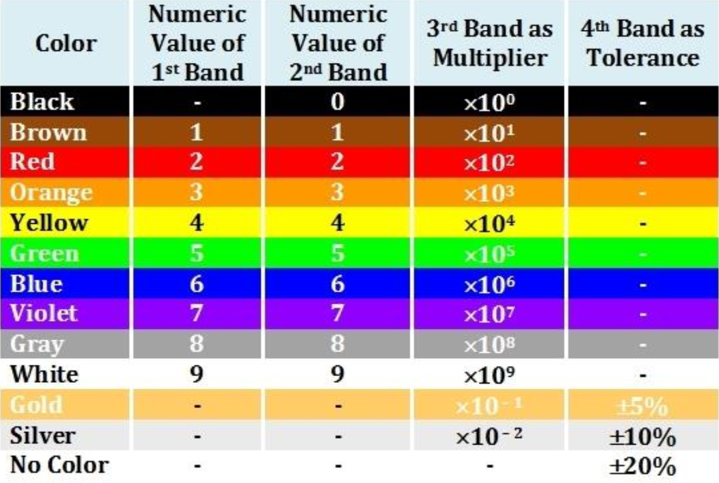

Resistance color code chart

**Sample:**

You are given a resistor whose stripes are colored from left to right as brown, black, orange, gold. Find the resistance value.

* The gold stripe is on the right so go to Step Two.
* The first stripe is brown which has a value of 1. The second stripe is black which has a value of 0. Therefore the first two digits of the resistance value are 10.
* The third stripe is orange which means x 1,000.
* The value of the resistance is found as 10 x 1000 = 10,000 ohms i.e., 10 k
* The gold stripe means the actual value of the resistor may vary by meaning the actual value will be somewhere between 9,500 ohms and 10,500 ohms. (Since of 10,000 = 0.05 x 10,000 = 500)

**Calculation of Capacitance:**

**Sample Calculation:**

* Step 1: In the Fig. [8](#fig:Ceramic capacitor), the first two digits from the left indicates the first two digits of the capacitor value. Here, in this case the first two digits are 1 and 0. Therefore, the first two digits of the capacitor value is 10.
* Step 2: The third digit is 4 which means that four zeroes would be followed by 1 (10,000 pF).
* The value of the capacitor is found out to be the product of the number obtained in step 1 and step 2. That is, 10 10000 = 10,0000 pF i.e 0.1 F.

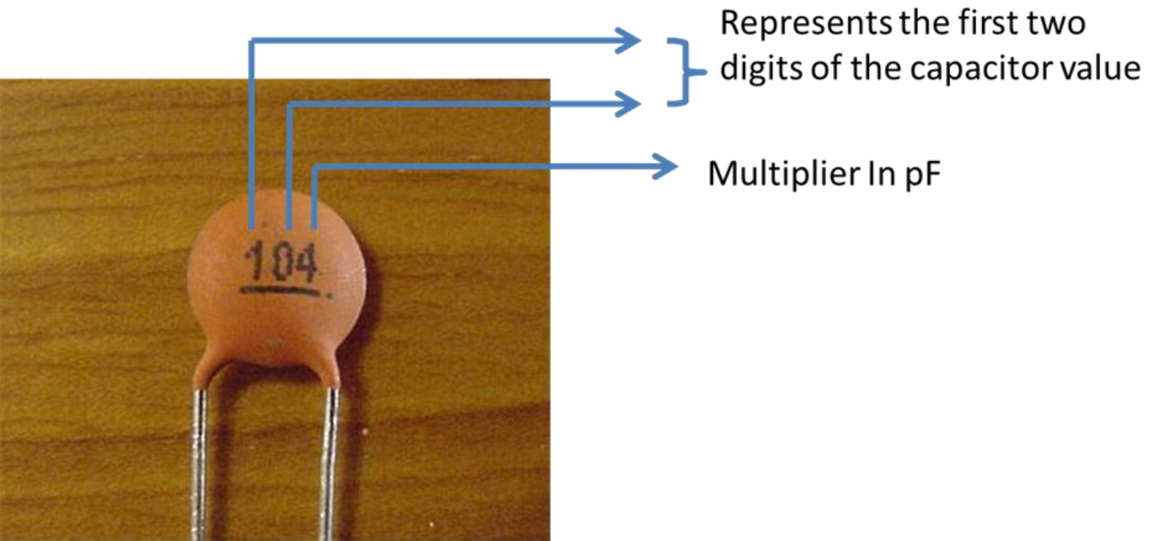

Ceramic capacitor

**Circuit Diagram:**

Figures. [[fig:RC circuit]](#fig:RC circuit) and [9](#fig:PC scope) show the RC circuit and PC scope

|  |  |
| --- | --- |
|  |  |

PC Scope.

**Experimental Procedure:**

* Build an RC circuit as shown in the Fig. [[fig:RC circuit]](#fig:RC circuit) on the bread board.
* ***Circuit input to the oscilloscope***  
  First PC scope probe is taken. BNC connector of this oscilloscope is connected to the input of the oscilloscope shown in Fig. [9](#fig:PC scope). Connect the retractable hook tip of the oscilloscope probe (inputprobe) to the open end of the resistor. The crocodile clip of this input PC scope probe is connected to the ground of the bread board.
* ***Circuit Output to the oscilloscope***  
  Second oscilloscope probe is taken. BNC connector of this oscilloscope is connected to the output of the scope shown in Fig. [9](#fig:PC scope). Connect the retractable hook tip of the scope probe (output probe) to common junction of resistor and capacitor. The crocodile clip of this input oscilloscope probe is connected to the ground of the bread board.
* ***Desired Signal Input to the oscilloscope***  
  Third oscilloscope probe is taken. BNC connector of this oscilloscope is connected to the signal generator of the oscilloscope shown in Fig. [9](#fig:PC scope). Connect the retractable hook tip of the oscilloscope probe (input probe) to the open end of the resistor. The crocodile clip of this input oscilloscope probe is connected to the ground of the bread board.

Following flow chart shows the flow of input and ouput signals.

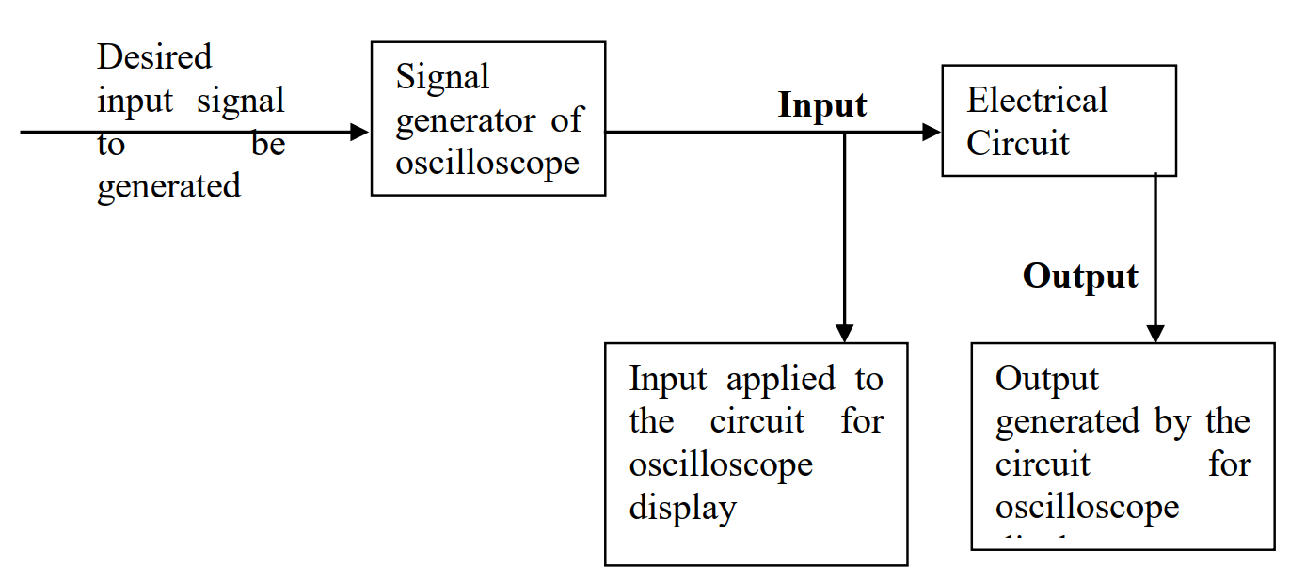

Flowchart indicating the flow of input and output signals

* There is switch on the probe. Make sure that switch is towards ‘X1’ side so that the values are not amplified by the probe.
* Give sinusoidal signal of very low amplitude (2 V) as input and observe the output.
* Increase the amplitude of the input signal and observe the output, repeat this step three times.
* Measure the peak voltage of both input and output signal using meter A and B.
* Try giving some other type of signal at some other frequency and observe/measure the output.

**Conclusions/Discussions on the results:**

## EXPERIMENT 1

## PART B: BASIC WORKING OF INSTRUMENTATION OP AMP (INA 129)

**Aim** – To study the basic working of Instrumentation op amp (INA129)  
  
**Apparatus** – INA 129, Bread board, wires, dc power supply, Oscilloscope

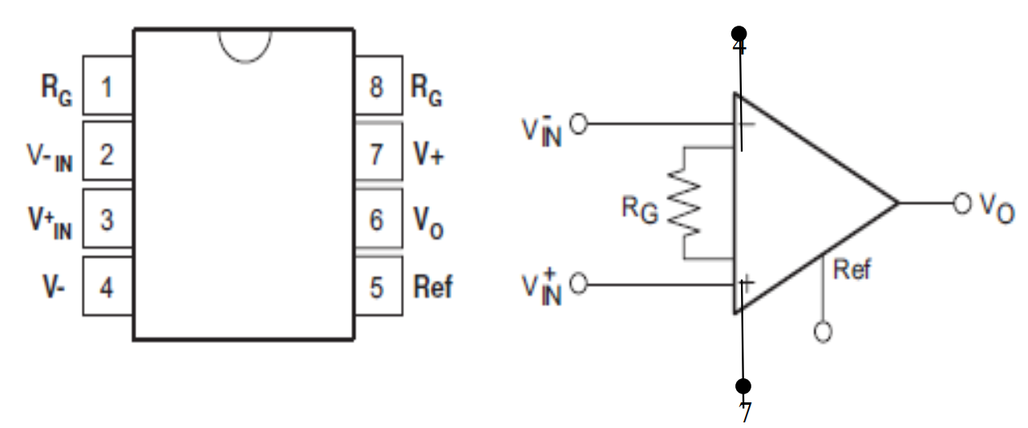

Schematic of the instrumentation operational amplifier with pins (INA 129)

**Experimental Procedure**

* Make the circuit as shown in the Fig. 1.8 on the bread board.
* Connect the Retractable hook tip of the input probe and signal generator probe of the oscilloscope at pin 3 and the crocodile clip of both the probe (input and signal generator) at pin 2 of INA 129.
* Connect the Retractable hook tip of the output probe at pin 6 and the crocodile clip of the output probe at pin 5 of INA 129. Make a virtual ground in the breadboard and connect pin 5 to this virtual ground.
* Select the value of RG based on desired gain. The relation between and gain/Amplification (G) is given in Table. [1](#tab:Rc and gain)
* Connect the resistance RG across pin 1 and 8 of INA 129.
* D.C power supply is set to 12V whose positive end is connected to pin 7 while its negative end is connected to pin 4.
* Give sinusoidal signal of 200mV amplitude and the frequency of 300 Hz in the signal generator and observe the output at the interface of oscilloscope in the monitor. Ensure that pin 5 is grounded.
* Change the value of , repeat the above procedure and observe the output.
* Note down the output in the observation Table.

Relation between and Desired gain

| **Observation Table:** | | | | | |
| --- | --- | --- | --- | --- | --- |
| **Sr.No** |  | **Selected Input** | **Measured Output** | **Measured Gain (G)** | **Calculated Gain** |
| 1 | 49.4K | 200mV | 408mV | 2.04 | 2 |
| 2 | 12.35 | 200mV | 1.06V | 5.3 | 5 |
| 3 | 1.008K | 200mV | 10.2V | 51 | 50 |

Desired Gain and Corresponding Values

| **Desired Gain (V/V)** | **(Ω)** | **Nearest 1% (Ω)** |
| --- | --- | --- |
| 1 | NC | NC |
| 2 | 49.4K | 49.9K |
| 5 | 12.35K | 12.4K |
| 10 | 5489 | 5.49K |
| 20 | 2600 | 2.61K |
| 50 | 1008 | 1K |
| 100 | 499 | 499 |
| 200 | 248 | 249 |
| 500 | 99 | 100 |
| 1000 | 49.5 | 49.9 |
| 2000 | 24.7 | 24.9 |
| 5000 | 9.88 | 9.76 |
| 10000 | 4.94 | 4.87 |

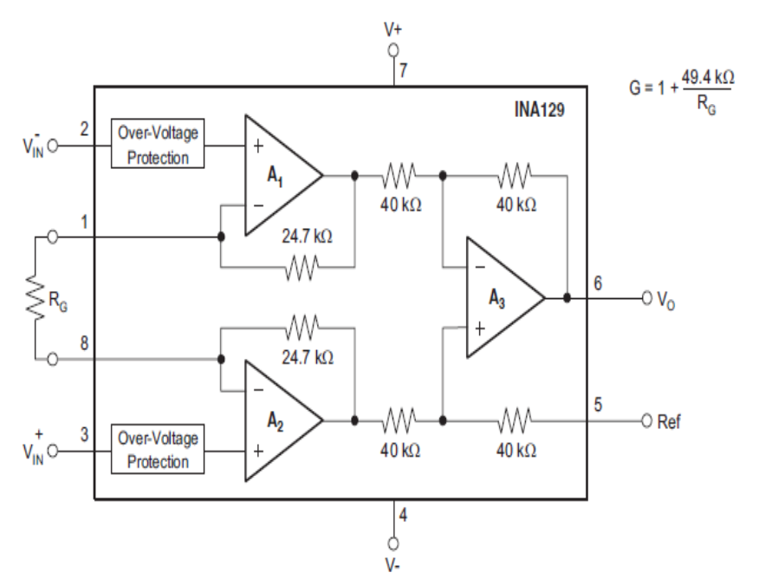

**Conclusions/Discussion on the Results:**

# EXPERIMENT 2

## DYNAMIC RESPONSE OF A FIRST ORDER SYSTEM USING R-C CIRCUIT

**Aim**

* To study and understand the behavior of a first order system simulated by an RC circuit using an oscilloscope-cum-signal generator with sinusoidal and ramp inputs. The output amplitude and the phase difference are studied with various frequencies of the input signal.
* Find the response characteristic of RC circuit for a generated square wave using Fourier series as input compare with the theoretical response

**Apparatus** – Resistor, capacitor, breadboard, oscilloscope  
  
**Procedure:**

* Construct the circuit as shown in Fig. 13 with given electronic components.
* 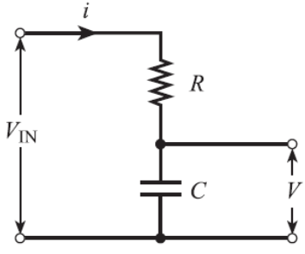
* R-C Circuit
* Chose appropriate resistance and capacitance ( and ). Calculate the cut off frequency
* Connect the oscilloscope-cum-signal generator output probe to supply the input as shown. Connect “Channel A” probes of the oscilloscope-cum-signal generator to the input probe and “Channel B” across the capacitor to extract the output.
* The input to the circuit will be sinusoidal and square signals of constant amplitude (  5 volts peak to peak) and variable frequency in order to obtain the frequency response characteristics.
* Apply a sinusoidal wave as the input to the RC circuit. Study the output across the capacitor on the screen and make quantitative observations (see Table. 3) regarding the amplitude and phase of input and output waveform.
* Using the oscilloscope function in the PC software, Export the input and output signals to a “.csv” file for further calculation. Measure the amplitude and phase difference between input and output in MS Excel.
* Take three different readings above, three readings below and one at the cut off frequency.
* Calculate the static gain in each case, plot the frequency response of the given RC circuit for the static gain, and phase difference on the graph sheets.
* Repeat the experiment for square wave as the input to the RC circuit. However, select input frequencies such that they are lower than the cut off frequency.
* **Observation Table:**

Sinusoidal input

| **Sr. No.** | **Frequency (Hz)** | **Input peak to peak (Volts)** | **Output peak to peak (Volts)** | **Measured gain voltage/input** | **Static Output/Input gain** | **Calculated static gain** | **Measured Phase difference** | **Calculated phase difference** |
| --- | --- | --- | --- | --- | --- | --- | --- | --- |
| 1 |  |  |  |  |  |  |  |  |
| 2 |  |  |  |  |  |  |  |  |
| 3 |  |  |  |  |  |  |  |  |
| 4 |  |  |  |  |  |  |  |  |
| 5 |  |  |  |  |  |  |  |  |
| 6 |  |  |  |  |  |  |  |  |
| 7 |  |  |  |  |  |  |  |  |

* Plot decibel value variation with frequency (Bode Plot) and measure the slope
* Take the input signal and output signal (generated from the circuit) from the generated .csv file. Calculate the output signal using the frequency response characteristics of first order system.

Square wave input using PC scope

| **Sr. No.** | **Frequency (Hz)** | **Input peak to peak (Volts)** | **Measured Output Peak to peak (Volts)** | **Measured Output Peak to peak / Measured input peak to peak (Volts)** |
| --- | --- | --- | --- | --- |
| 1 |  |  |  |  |
| 2 |  |  |  |  |
| 3 |  |  |  |  |
| 4 |  |  |  |  |
| 5 |  |  |  |  |
| 6 |  |  |  |  |

Comment on the comparison of measured response characteristic of RC circuit for a given of square wave input in terms of Fourier series with the calculated response.

Comment on RC circuit when used as High pass and Low pass filter.

**Conclusions/Discussion on the Results:**

# EXPERIMENT 3

## FREQUENCY RESPONSE OF A SECOND ORDER SYSTEM USING RLC CIRCUIT

**Aim**

* To study the frequency response of a series RLC circuit for different damping ratios.
* To determine the resonance frequency in a series RLC circuit and compare its value with the theoretical value

**Apparatus** – Bread-board, variable resistor (potentiometer), capacitor, inductor, multi-meter, Oscilloscope and connecting wires.  
  
**Procedure:**

1. Determination of resonance frequency
   * The function generator frequency is set to 50 Hz before making the connection. The signal generator output is set to 3V (peak to peak).
   * Using the breadboard and wire leads connect the resistor, capacitor and inductor along with the output of the function generator to construct the circuit shown in Fig. [fig:LCR_circuit]. Note that the peak to peak voltage is measured across the resistor using the oscilloscope.
   * Make sure that the resistance is less than 447 i.e. the system is underdamped , for Part 1 of the experiment. All the components are connected in series with the supply given by the function generator. All the ground connections are made at one end of the resistor.
   * Use following relation to compute the expected resonance frequency and record your results in Table [[tab:O/p volt vs freq]](#tab:O/p volt vs freq)
   * Set the function generator frequency to 100 Hz and record the peak to peak voltage from the oscilloscope. Then, adjust the excitation frequency to 200 Hz and record the voltage. Adjust the frequency to 300 Hz and record the voltage. Continue varying the excitation frequency to discrete values below the expected resonance frequency computed using the above equation. Record the voltage for each of these values.
   * Determine the experimental value for resonance frequency by finding the frequency that produces the largest voltage on the oscilloscope. Record this frequency and voltage.
   * Record the voltage for frequency values that are above the resonance frequency determined before.
   * Plot a graph between voltage and frequency ( f ) and determine the resonance frequency of the circuit.