1.How do you evaluate the performance of a project in agile?

The performance evaluation is based on the following points

- Frequent delivery
In agile methodology the project is delivered stage by stage. The more frequent the the parts of the project is delivered, more the progress of project completion. This also gives a better customer satisfaction.

- Colocation
In agile colacation is a neccessary factor. Here the plan and requirement may change from time to time. So there needs to be a better coordination and planning.
Colocation improves the interaction and coordination amoung the team members.Business people and developers must work together daily throughout the project. This also helps analyzing the progress and performance

- Daily Team Meeting
This meeting discusses about 1. what are tasks completed so far 2. what are tasks to be done 3. what are the impediments. A daily meeting will help analyze the progress of project team and a better understanding about the team members.

- Timebox Review Meeting
This consist of 2 parts
Product Demonstration : A part of the project completed is demonstrated. This gives a chance to evaluate the project so far and analyze the performance. And suggestions are also given.
Retrospective : This discuss about how to make more effective, analyze the performance, behaviour and how to improve it.

- Velocity
This gives the units of effort completed per sprint. Higher the velocity higher the performance.

- Hit Rate
Percentage of work allocated to a Timebox that was actually completed. The higher the hit rate higher the performance.

- Work Remaining on Tasks
Each day the team estimates the work remaining on each active Task. This gives the progress of the team and if over time is spent on a task. Lower the value of work remaining on task higher the performance

- Cost Performance Index (CPI)
A measure of the efficiency of expenses spent on a project. If the value of CPI is equal to 1, then it is according to the estimate, if more the value more than 1, then it is highly favorable condition, if less than 1 it is considered unfavorable.

- Schedule Performance Index (SPI)
The Schedule Performance Index (SPI) is a measure of schedule efficiency over the estimated schedule.
SPI > 1 is an indication that the project has finished earlier than expected.
SPI < 1 is an indication that the project has finished late than expedcted.
SPI = CPI = 1 : means that the project development is as according to the plan.

- Earned Business Value (EBV)
In agile methodology CPI and SPI values are not only the necessary criterion to measure the performance.Instead we do also consider the business value.It measures the outcomes rather than outputs.Customer’s satisfation is a measure that improve this value. It accounts for what all features (as demanded by the user) a0re there in the software produced.

2.Compare traditional monitoring & control with agile monitoring & control
with respect to metrics generation

- In traditional model monitoring is done according to a plan and for agile there is no such plan to monitor.
- In traditional there is no monitoring on the basis of frequent delivery as there is only final product where the customers get involved. But in agile, monitoring done by frequent delivery is an important factor.
- In traditional Project managers tracks factors such as cost, quality and effort while in agile Project managers tracks on the Sprints completed so far.
- Traditional method monitors on SPI and CPI on the success and performance of project. Agile monitors on SPI,CPI and Bussiness value.
- In traditional monitioring and controlling happens only in fixed phases and final phase. In agile this process happens frequently.
- Since in traditional it is a planned execution and in agile it is a iterative work, agile requires more monitoring and control than the other one.
- In agile daily meetings are done as monitoring and control. This is required as daily upadations happen in agile.
- In agile Timebox Review Meeting are important than traditional as agile is more prone to changes. In agile monitoring involves going back the process and improving the process which does not happen in traditional.
- In Agile Colocation is taken is an important part of monitoring and control which is not required in traditional. This is because in traditional the team can be scattered in different places while in agile the entire team needs to be in the same location for the smooth working.

3.With a total project budget of $ 175,000, and having completed one out of
four Iterations, we have this product backlog and these actuals:

In our example, after Iteration 1 we should be at 25% complete)
Calculate Planned Value
Actual % Complete
Earned Value

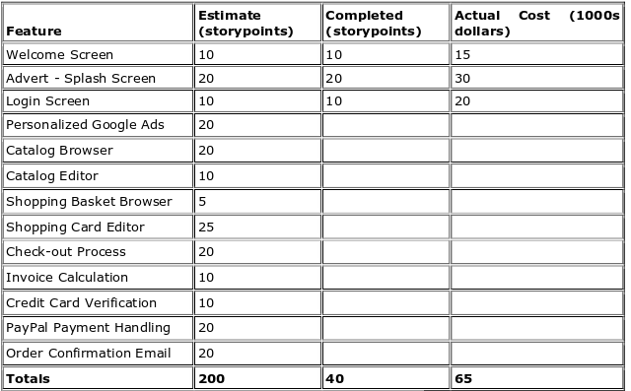

The total project budget is $1,75,000

Planned value = Budget at complete*Expected Percent Complete
= $175000*(Current sprint(n) / Total planned sprints)
= $175000*(1/4)
= $43,750

Actual % completed = Story points completed / Total planned story points
= 40/200
= 0.2
= 20%

Earned value = BAC * APC
= $175000 * 0.2
= $35,000

